Pratical - 2
Code
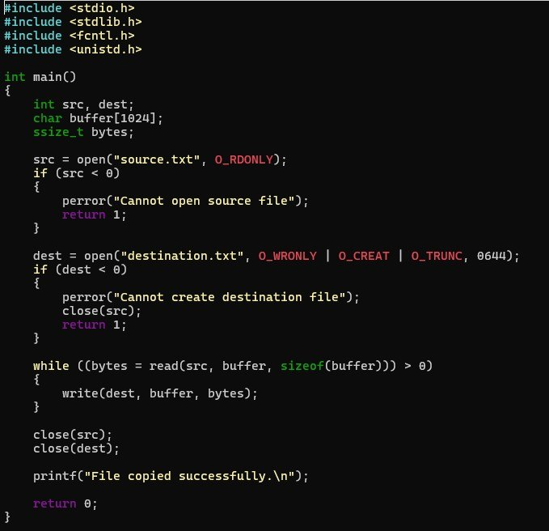

Out put:
