CREATION OF MYSQL TABLE

create table details (id int,salary int);

INSERTING VALUES INTO THE TABLE

insert into details values (1,1),(2,2),(3,3),(4,4);

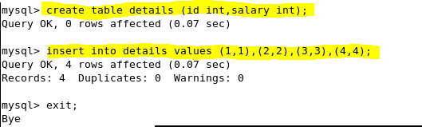

SQOOP COMMAND WITH INCREMENTAL IMPORT

sqoop job --create jobincremental -- import --connect jdbc:mysql://localhost/employee --username root --table details --m 1 --incremental append --check-column id

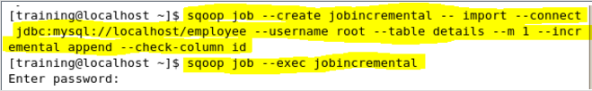

IMPORTED TABLE IN HDFS

hadoop fs –ls

