1. LOAD - Load data from the file system.

eg: st1 = load '/user/acadgild/dataset.txt' using PigStorage(',') as (id:int, name:chararray);

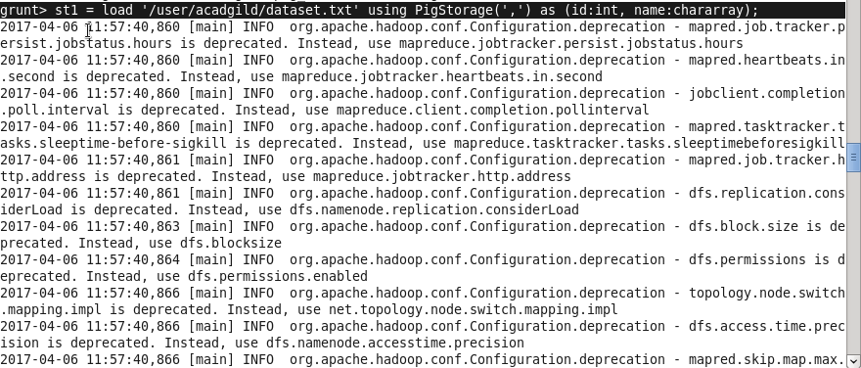

2. STORE - Store data into the file system.

eg: store demo1 into '/user/acadgild/demo1';

C:\Users\sadhana1\AppData\Local\Temp\Rar$DIa0.040\store.JPG

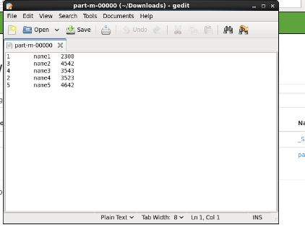

3. DUMP - Displays the result to the screen

eg: dump demo1;

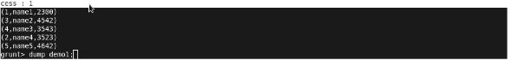

4. FOREACH - Iterate the tuples of a relation, generating a data transformation

eg: demo 2 = foreach demo1 generate id;

C:\Users\sadhana1\AppData\Local\Temp\Rar$DIa0.464\foreach.JPG

5. FILTER - Select a set of tuples from a relation based on condition.

eg: demo3 = filter demo1 by sal>2000;

C:\Users\sadhana1\AppData\Local\Temp\Rar$DIa0.234\filtercommand.JPG

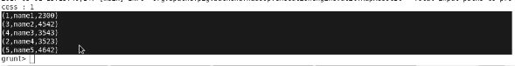

6. GROUP BY - Group data in one or more relations.

eg: demo4 = group demo1 by id;

C:\Users\sadhana1\AppData\Local\Temp\Rar$DIa0.672\groupby.JPG

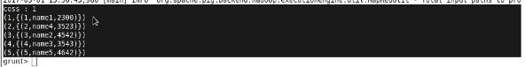

7. ORDER BY - Sort a relation based on one or more fields.

eg: demo5 = order demo2 by ASC;

C:\Users\sadhana1\AppData\Local\Temp\Rar$DIa0.033\order.JPG

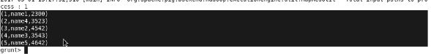

8. DESCRIBE - Returns the schema of an alias. 