**To find top 20 destinations**

1.TravelData = load '/user/acadgild/Desktop/TravelData.txt' using PigStorage('\t') as (CityPair:chararray, fromLocation:chararray, toLocation:chararray, Producttype:int, Adults:int, Seniors:int, Children:int, Youth:int, Infant:int, DateofTravel:chararray, TimeofTravel:chararray, DateofReturn:chararray, TimeofReturn:int, Price:float, Hotel:chararray);

// line 1 will load the data set into the pig storage.

2.group_destination = group TravelData by toLocation

//line 2 will group the data by the destination place.

3.count_destination = foreach group_destination generate group, COUNT(TravelData.toLocation)as cnt;

//line 3 will iterate the records having to find the count value of destination place.

4.orderby = order count_destination by cnt DESC;

//line 4 will order the count_destination based on the count value by descending.

5.top_destination = limit orderby 20;

//line 5 will find the records having top 20 records of destination travelled.

6.dump top_destination;

//line6 will display the result.

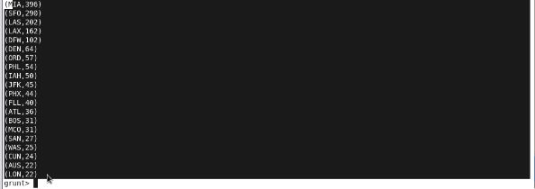

**To find top 20 source**

1.TravelData = load '/user/acadgild/Desktop/TravelData.txt' using PigStorage('\t') as (CityPair:chararray, fromLocation:chararray, toLocation:chararray, Producttype:int, Adults:int, Seniors:int, Children:int, Youth:int, Infant:int, DateofTravel:chararray, TimeofTravel:chararray, DateofReturn:chararray, TimeofReturn:int, Price:float, Hotel:chararray);

//line1 will load the dataset into the pig storage.

2.group_source = group TravelData by fromLocation;

//line 2 will group the data records based on source place.

3.count_source = foreach group_source generate group, COUNT(TravelData.fromLocation)as cnt;

//line 3 will iterate through the records to count the number of sources from where the people are coming from.

4.orderby = order count_source by cnt DESC;

//line 4 will order the count_source in descending order.

5.top_source = limit orderby 20;

//line 5 will generate the top 20 source locations.

6.dump top_source;

//line 6 will display the result

