**ASSIGNMENT 8.2**

**1. Find the number of students who scored less than 5(50%).**

**QUERY**

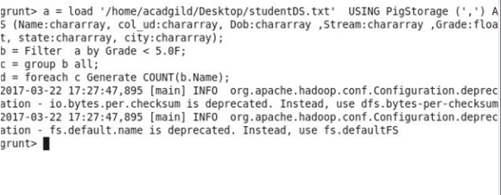

**OUTPUT**

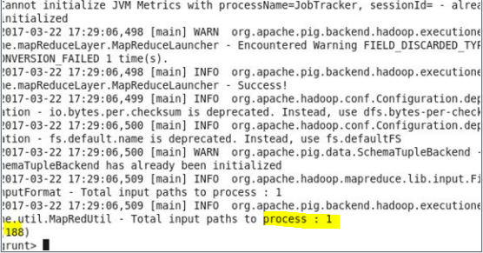

**2. List the name of students who are from Alaska.**

**QUERY**

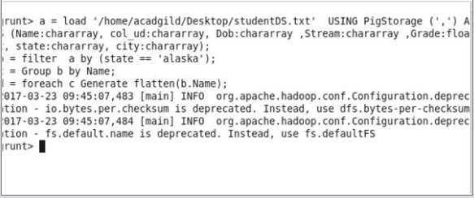

**OUTPUT**

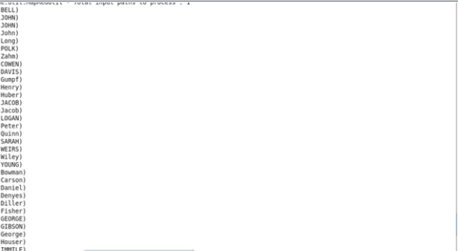

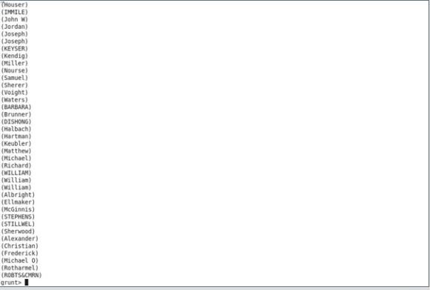

**3. How many government colleges are there in Alabama?**

**QUERY**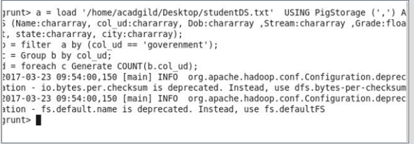

**OUTPUT**

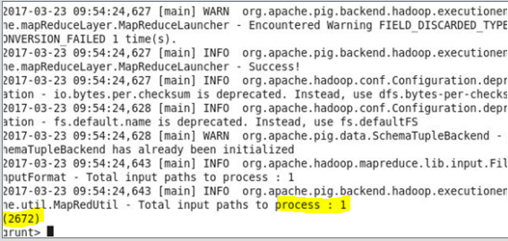

**4. List the name of students who are from Oregon and pursuing BE.**

**QUERY**

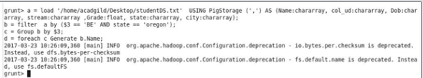

**OUTPUT**

