**ASSIGNMENT 8.3**

**1.Write a Pig UDF to find the tweets posted by @realDonaldTrump from the given dataset.**

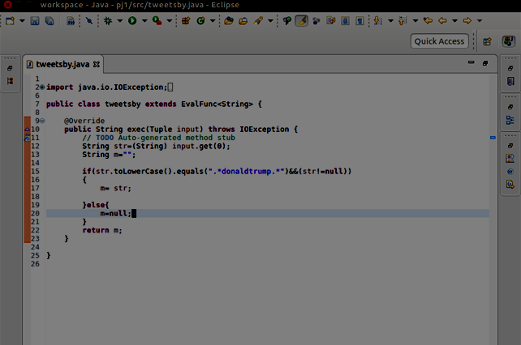

**CODE**

public class tweetsby extends EvalFunc<String>

{

@Override

Public String exec(Tuple input) throws IOException

{

//TODO Auto-generated method stub

String str=(String) input.get(0);

String m=” “;

if(str.toLowerCase().equals(“.*donaldtrump.*”)&&(str!=null))

{

m=str;

}

else

{

m=null;

}

return m;

}

}

**OUTPUT**

**3218**