**ASSIGNMENT9.4**

**1.Transfer streaming data from your local file system to HDFS using flume spool directory.**

**create folder in /var/spool with 2 files say sample1 and sample2**

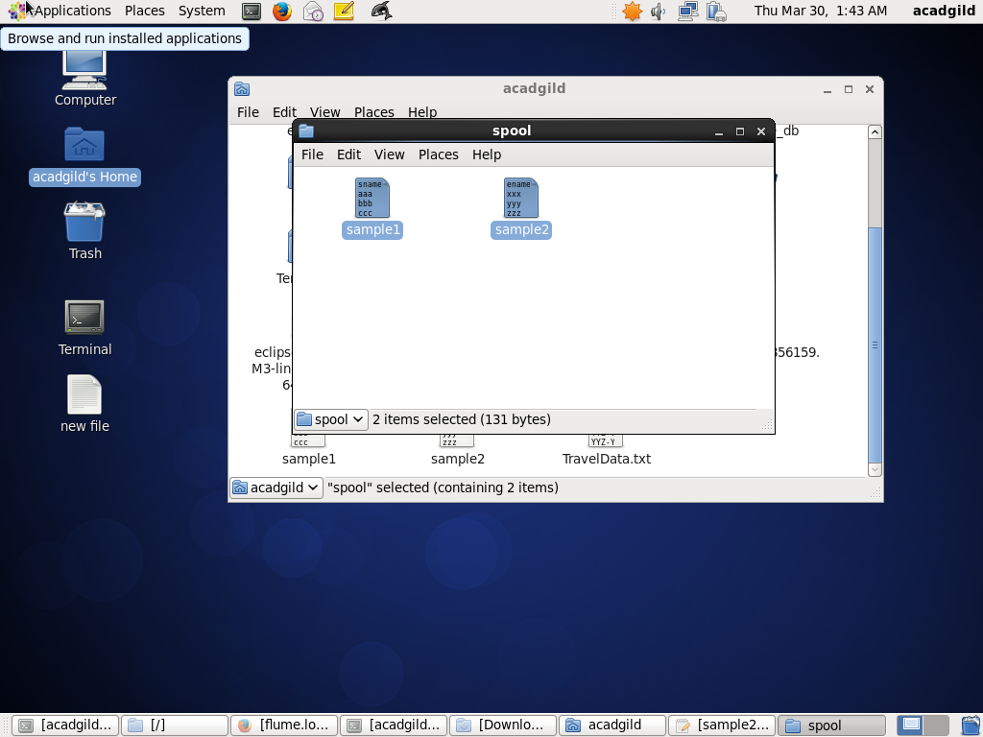

**moving the configuration file into conf folder of flume**

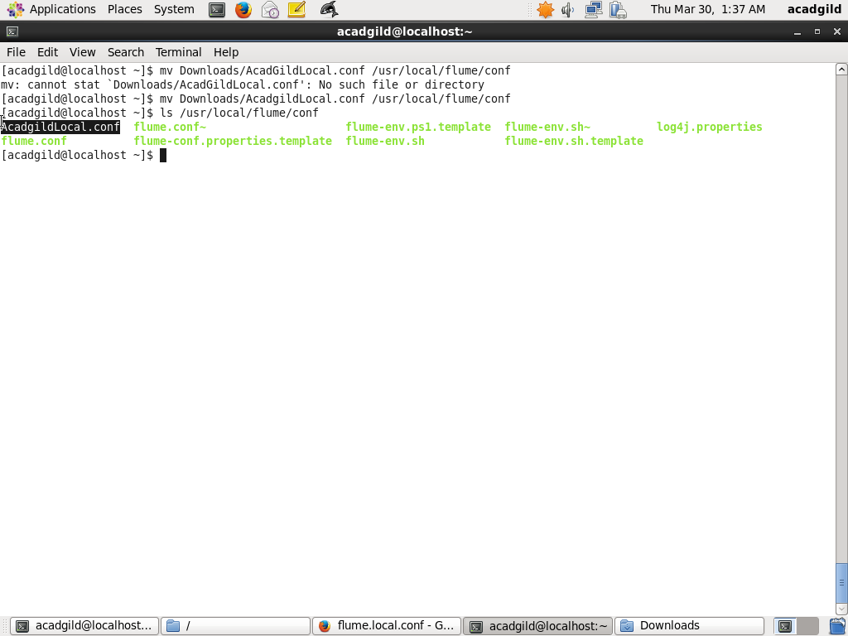

**creation of the output directory**

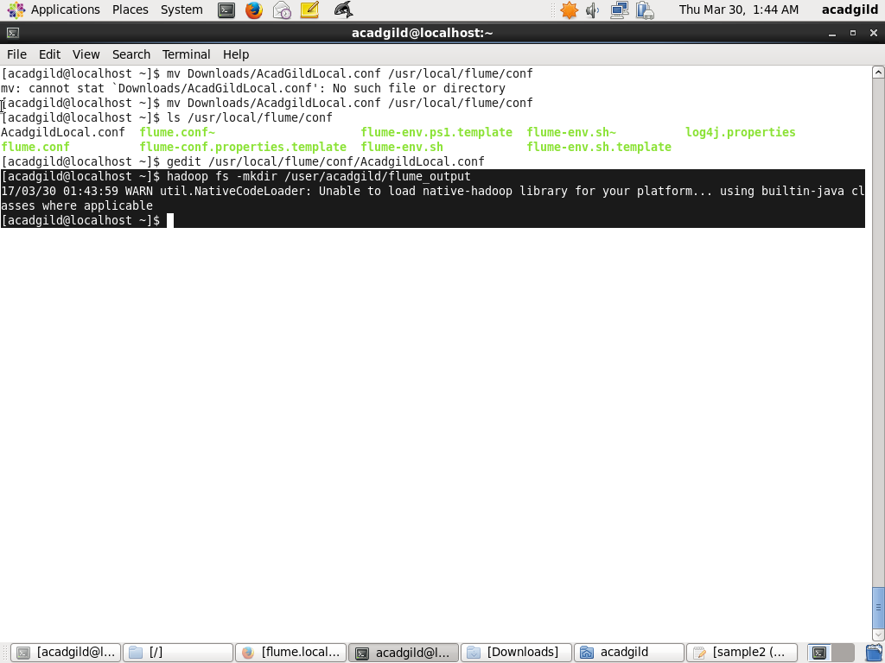

**modification of .conf file according to my path**

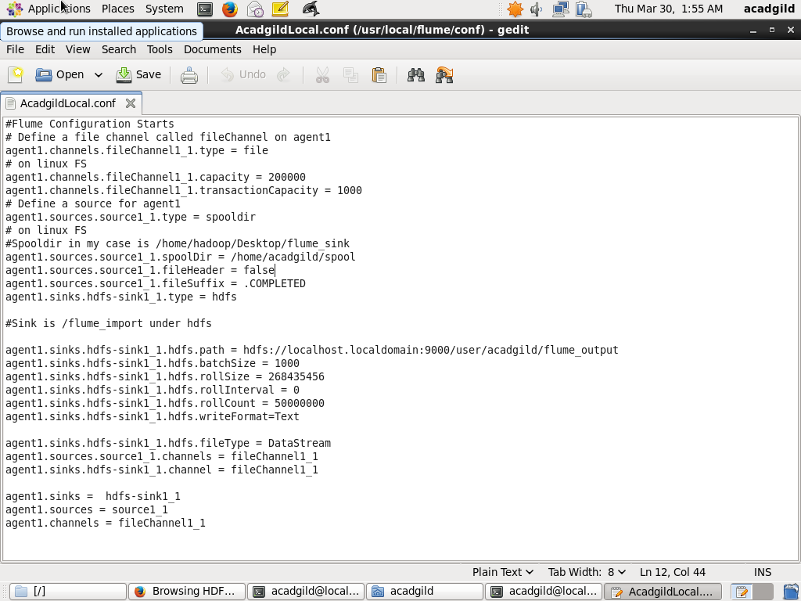

**running the flume agent**

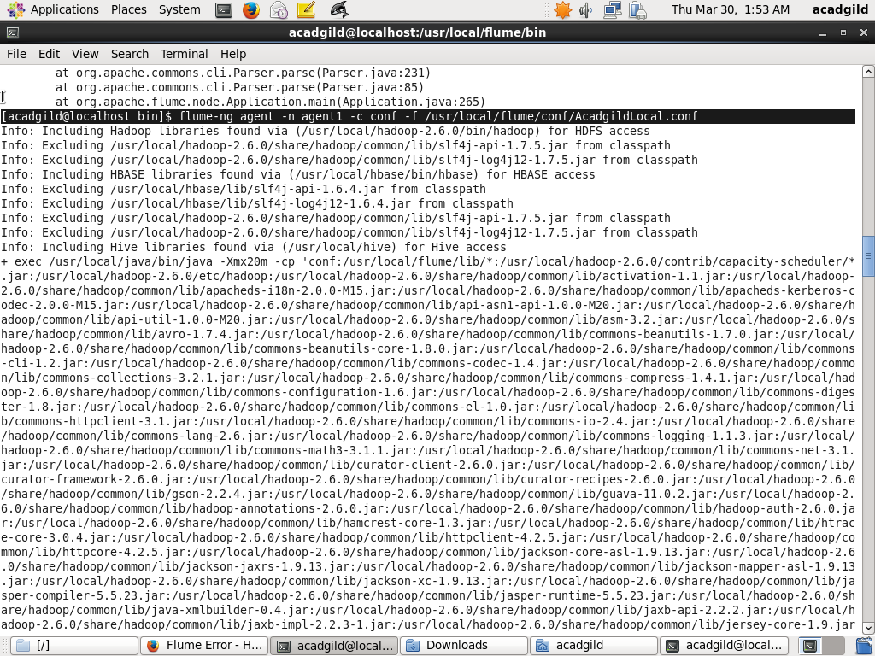

**output**

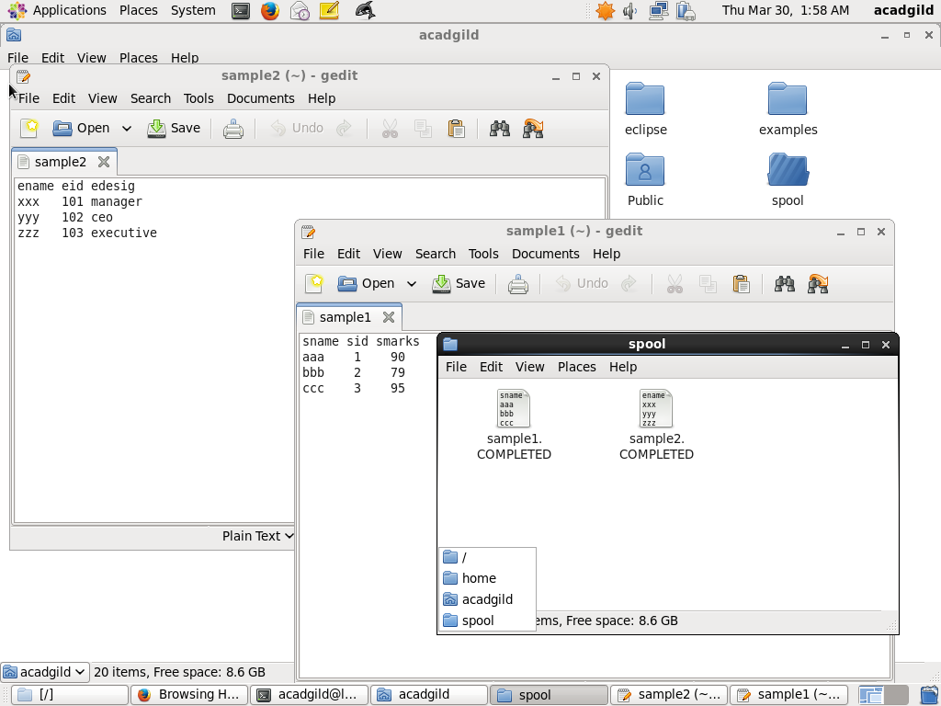

**output stored on hdfs-browser view**

