**Explain in brief the need of hive.**

**Hive** should be used for analytical querying of data collected over a period of time. e.g Calculate trends, summarize website logs but it can't be used for real time queries.

**Hive** can be used for ad-hoc data analysis but it can't support all un-structured data formats unlike PIG.

**HIVE** was created for people with **SQL** background. The queries written is similar to SQL named as **HIVEQL**. HIVE was developed to process completely **structured data**. It is not used for ustructured data.

**Is Hive suitable to be used for OLTP systems? Explain in brief.**

No Hive does not provide insert and update at row level. So it is not suitable for OLTP system.

Many operations in mysql is not efficient in hive. Hive is slower as takes time for mapreduce program.

**What is a metastore in Hive?**

• The Hive metastore service stores the metadata for Hive tables and partitions in a relational database, and provides clients (including Hive) access to this information via the metastore service API.

• The metastore is the central repository of Hive metadata.

• The metastore service runs in the same JVM as the Hive service and contains an embedded Derby database instance.

• However, only one embedded Derby database can access the database files on disk at any one time, which means we can have only one Hive session open at a time.

Derby Database is an open source relational database implemented entirely in Java and available under the Apache License, Version 2.0.

**Can we run unix shell commands from hive? Give 5 examples and share the screenshot**

**Add and list command in hive**



**Dfs –ls command and –cat command**

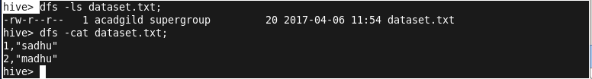

**Pwd, hostname,echo,cat commands**

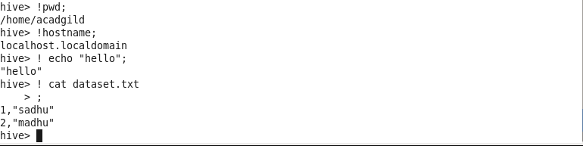

**Hive can process any type of data formats? Explain in brief**

Yes,hive uses the SerDe interface for IO operations.Different Serde interfaces can read and write any type of data.if normal directly process the data where as different type of data is in the Hadoop,hive use different SrDe interface to process such data.