**JAVA APIs for Copying Files from HDFS to LFS**

import java.io.BufferedOutputStream;

import java.io.FileOutputStream;

import java.io.InputStream;

import java.io.OutputStream;

import org.apache.hadoop.conf.Configuration;

import org.apache.hadoop.conf.Configured;

import org.apache.hadoop.fs.FileSystem;

import org.apache.hadoop.fs.Path;

import org.apache.hadoop.io.IOUtils;

import org.apache.hadoop.util.Tool;

import org.apache.hadoop.util.ToolRunner;

public class HdfsReader extends Configured implements Tool {

public int run(String[] args) throws Exception {

String localOutputPath = args[0];

Configuration conf = getConf();

FileSystem fs = FileSystem.get(conf);

InputStream is = fs.open(new Path("hdfs:/acadgild.txt"));

OutputStream os = new BufferedOutputStream(new FileOutputStream(localOutputPath)); // Data set is getting copied into local path in the file sysetm through buffer mechanism

IOUtils.copyBytes(is, os, conf);

return 0;

}

public static void main(String[] args) throws Exception {

int returnCode = ToolRunner.run(

new HdfsReader(), args);

System.exit(returnCode);

}

}

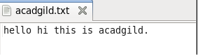

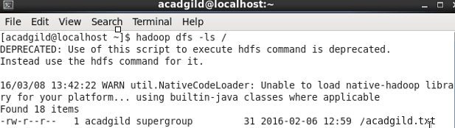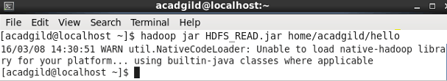



# JAVA APIs for copying File from Local File System to HDFS

import java.io.BufferedInputStream;

import java.io.FileInputStream;

import java.io.InputStream;

import java.io.OutputStream;

import org.apache.hadoop.conf.Configuration;

import org.apache.hadoop.conf.Configured;

import org.apache.hadoop.fs.FileSystem;

import org.apache.hadoop.fs.Path;

import org.apache.hadoop.io.IOUtils;

import org.apache.hadoop.util.Tool;

import org.apache.hadoop.util.ToolRunner;

public class HdfsWriter extends Configured implements Tool {

public int run(String[] args) throws Exception {

//String localInputPath = args[0];

Path outputPath = new Path(args[0]);// ARGUMENT FOR OUTPUT_LOCATION

Configuration conf = getConf();

FileSystem fs = FileSystem.get(conf);

OutputStream os = fs.create(outputPath);

InputStream is = new BufferedInputStream(new FileInputStream("/home/acadgild/hello.txt"));//Data set is getting copied into input stream through buffer mechanism.

IOUtils.copyBytes(is, os, conf); // Copying the dataset from input stream to output stream

return 0;

}

public static void main(String[] args) throws Exception {

int returnCode = ToolRunner.run(new HdfsWriter(), args);

System.exit(returnCode);

}

}

