**First step: put the dataset downloaded from the given link from localfilesysytem to hdfs**



**Mainclass**

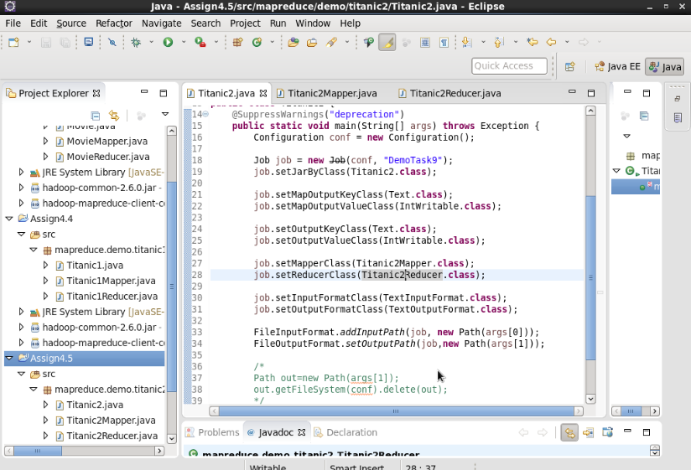

**Mapper class**

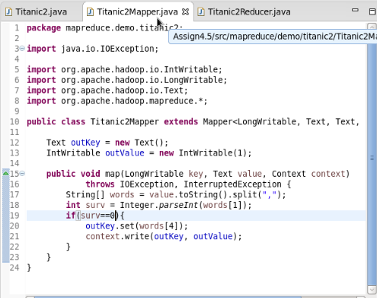

**Reducer class**

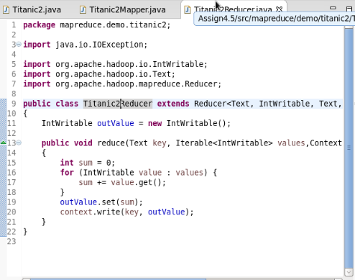

**Executing jarfile**

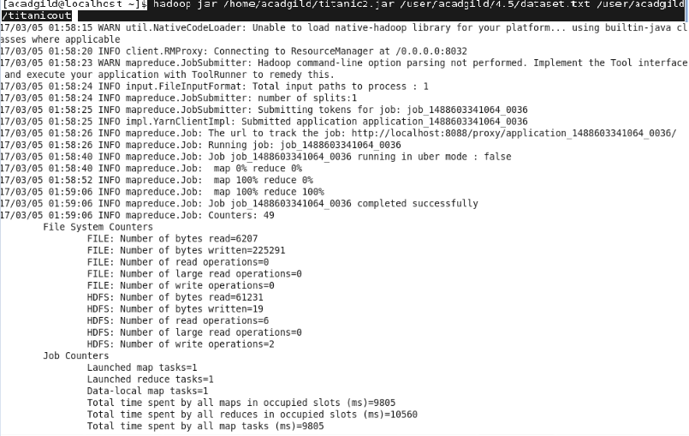

**The output fileis generated in hdfs in the given directory**

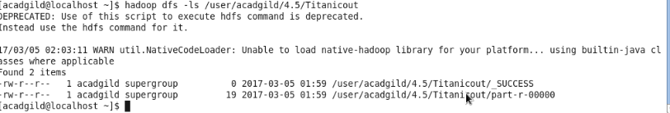

**The output file contains the result of number of males and females survived in the titanic tragedy**

