**NameNode**

*NameNode is the center piece of HDFS.

*NameNode is also known as the Master

*NameNode only stores the metadata of HDFS – the directory tree of all files in the file system, and tracks the files across the cluster.

*NameNode does not store the actual data or the dataset.

The data itself is actually stored in the DataNodes.

*NameNode knows the list of the blocks and its location for any given file

in HDFS. With this information NameNode knows how to construct the file

from blocks.

*NameNode is so critical to HDFS and when the NameNode is down,

HDFS/Hadoop cluster is inaccessible and considered down.

*NameNode is a single point of failure in Hadoop cluster.

*NameNode is usually configured with a lot of memory (RAM).Because the block locations are help in main memory.

• NameNode contains two important files on its hard disk:

1. fsimage (file system image)

It contains:

• All directory structure of HDFS, Replication level of file, Modification and access times of files, Access permissions of files and directories,Block size of files,The blocks constituting a file

2. Edits

• When any write operation takes place in HDFS, the directory structure

gets modified

• These modifications are stored in the memory as well as in edits files

• If existing fsimage file gets merged with edits, we’ll get an updated fsimage

file

• This process is called Checkpointing and is carried out by the Secondary

NameNode. It takes fsimage and edits files from NameNode and returns

updated fsimage file after merging

In Hadoop 1.x, NameNode is the single point of failure. If it fails, we won’t be able to access the

cluster

**basic Hadoop beginners commands**

**1.put command and ls command**

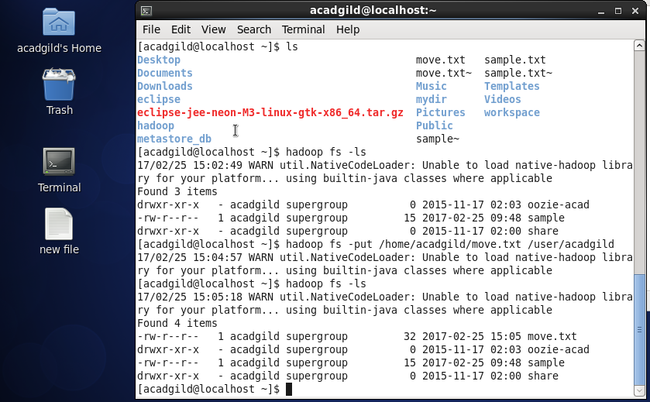

In home/acadgild the file move.txt is moved to Hadoop in location user/acadgild

Using ls command we can see the files before and after copying to Hadoop.

**2.get command**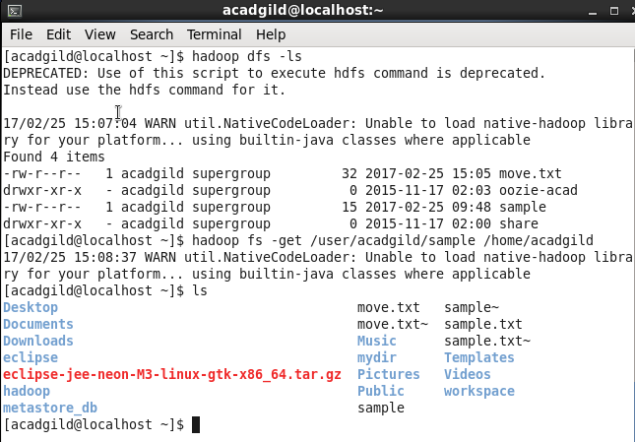

**Here sample file from hadoop is moved to local path using get.**

**3.mkdir ,copyfromlocal,copytolocal commands**

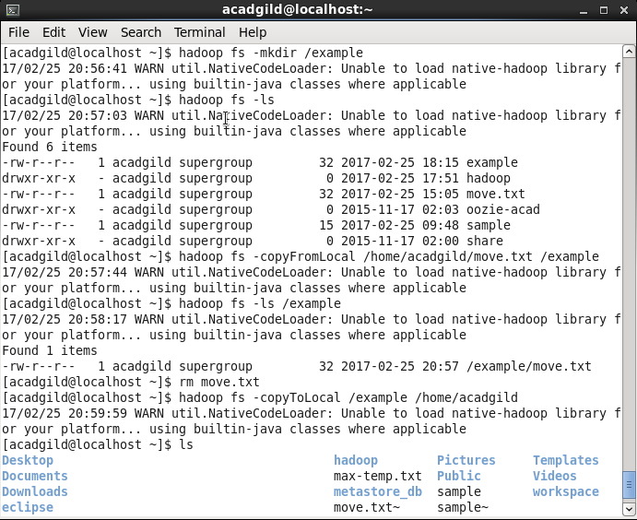

### 4.cat and rm command

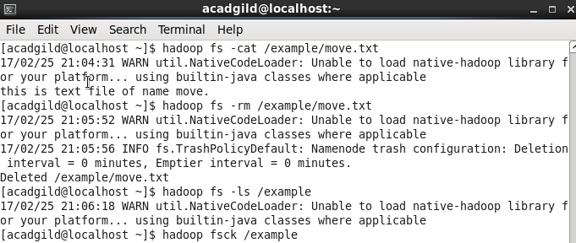

**Run a DFS Filesystem to Check Utility**

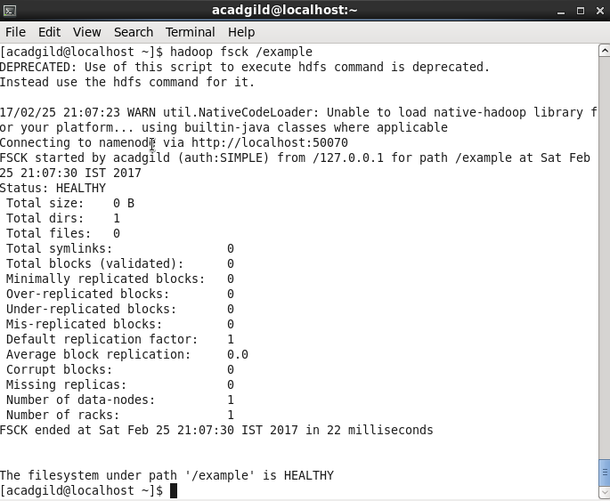

**Hadoop balancer**

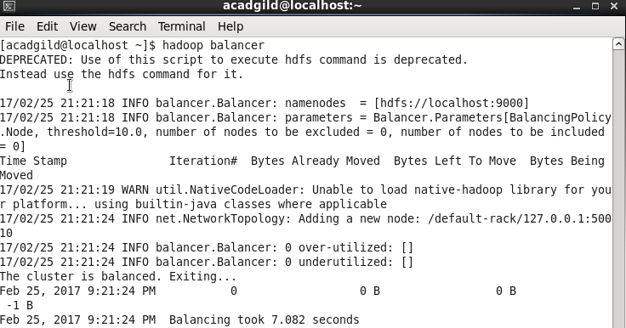

**Size of file in Hadoop**

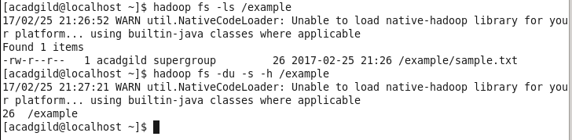

**Helpin Hadoop**

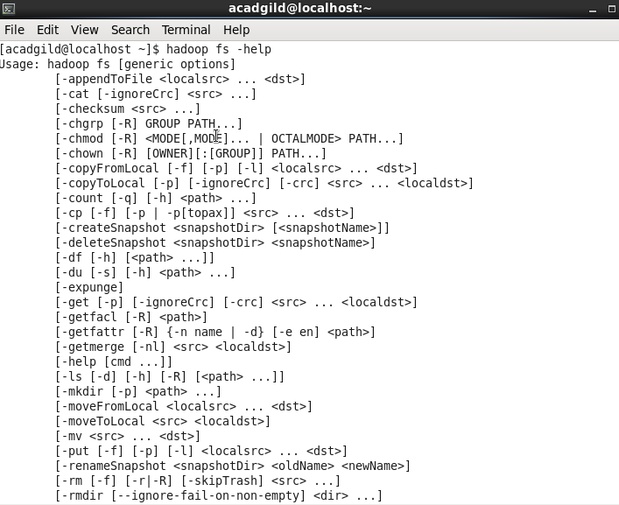

**Shell commands in Hadoop**

