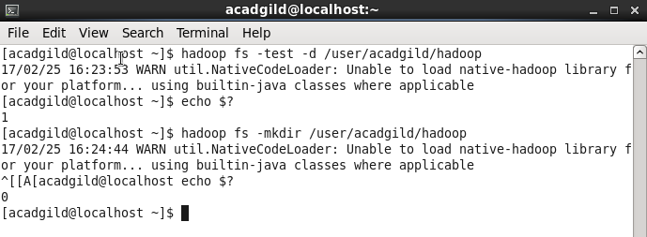

Hadoop fs -test –d /user/acadgild/Hadoop

Returns 0 if directory exists.else 1.

It returns 1.so we create a directory

Hadoop fs –mkdir /user/acadgild/Hadoop

And test whether it exists. Hence it returns 0.