**SOCIAL MEDIA ADDICTION**

**Keywords:**

**Social media addiction, mental health, academic performance, self-esteem, intervention**

This social media addiction is why a person spends so much time using social media such as facebook, twitter, Instagram etc.

**What:** Social media is an internet-based form of communication. Social media platforms allow users to have conversations, share information and create web content.

**Why:** Excessive social media use can not only cause unhappiness and a general dissatisfaction with life in users but also increase the risk of developing mental health issues such as anxiety and depression, It also causes the loss of time due to games and a person's illness due to social media and the impact on their mental health and having depression and anxiety due to social media interaction, While social media can seem like mindless and relaxing fun, it actually has a significant effect on your brain.

**How:** don't overly focus or soak up its use. Yes it does help us in different ways but our health can be affected. Provide the rest of the time, don't use the whole night to use it.

* 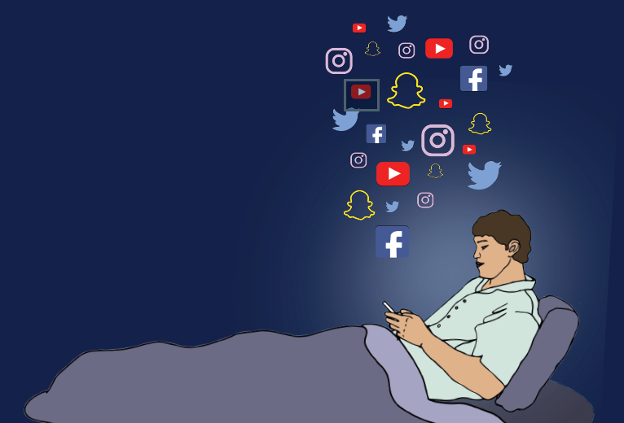

**POSITIVE EFFECT OF SOCIAL MEDIA**

Communicate and stay up to date with family and friends around the world. Find new friends and communities; network with other people who share similar interests or ambitions. Join or promote worthwhile causes; raise awareness on important issues.

**NEGATIVE EFFECT OF SOCIAL MEDIA**

**Poor sleep, eye fatigue, and physical inactivity,**

Social media can be incredibly addictive — we all know what it feels like to tell ourselves we’ll only check our notifications, and before we know it, we’ve been mindlessly scrolling for hours. Using devices can have an especially detrimental effect if done near bedtime, as the blue light emanating from our devices tricks our bodies into thinking it’s still daylight outside, which upsets our natural rhythms. We also blink less when looking at devices, which, in [combination with blue light](https://health.ucdavis.edu/health-news/newsroom/is-blue-light-from-your-cell-phone-tv-bad-for-your-health/2019/05#:~:text=Because%20computer%20screens%20and%20digital,dry%20eye%20and%20eye%20strain.), can lead to eye fatigue and strain

**Awereness of social media addition You can make to avoid of social media addiction to often found it difficult not to look at message on social media when you were doing something else. And I had serious problems to school or work because you were spending too much time on social media.**

**Social Media Awareness Social media addiction is its use without control, which already affects our daily activities. Aside from the fact that stressful content on social media such as various incidents of cyber bullying and bashing is harmful to our mental health, prolonged exposure to radiation, which in turn is released by gadgets, is also not good for our health. .**