Measures to mitigate biases and to facilitate a fair and inclusive hiring procedure

Composition of discussion groups and individual review stage
- The discussion groups consisted of professors, Mittelbau, and early-career researchers (13 persons in total). Each person committed to taking a DEI training of 2 half days before the beginning of the evaluation phase. (Course slides: DEI Training Slides.pdf)
- Each candidate was reviewed by 3 persons, one of whom was an IEE professor and one was an early-career researcher. CoI levels were minimized in the review assignment, which otherwise was done randomly.
- Discussion groups were briefed about the process at an orientation meeting (Orientation meeting slides.pdf); an evaluation sheet was used by all reviewers that defines the evaluation criteria and evidence: EvaluationSheet.xlsx
- Reviewers had 4 weeks to review their list of assigned candidates and to submit their grades; after that, all discussion group members had access to the list with the preliminary ranking to prepare for the discussions.

Discussion Group Meeting
- An external trained moderator was recruited to lead the discussion group meetings.
- In order to make power dynamics transparent, each group member had a name tag indicating their career stage, role and involvement in the process, etc.
- Candidates who received an A grade from two or three reviewers were automatically nominated for discussion; all discussion group members could nominate one or more additional candidates for discussion either before or at the discussion group meeting.
- D, C, and B-/B/B+-ranked candidates were successively removed from the discussion list in bulk after asking whether any discussion group member wanted to nominate one of the respective persons for the discussion.
- The final discussion list consisted of around 25 candidates.
- Each candidate from the discussion list was presented for 3 minutes by their reviewers, starting with the early-career researcher who reviewed them (one minute per review). For nominated candidates, the nominator (if not an original reviewer) received an additional minute to make a plea for the candidate. Additional comments from other discussion group members were allowed within the time frame.
- After all candidates had been presented, the discussion group was split into three small subgroups (mixed by career stage and field), who agreed within the group on a shortlist of 8 A candidates and 4 AB candidates.
- The group results were compared and the final A and AB lists were successively determined by the candidates’ joint ranking in the three groups, interspersed with discussions. In ambiguous cases, an anonymous vote was used to determine the final grade of the candidate.

Conflict of Interest levels

Before the assignment of reviewers and during the discussions (using colored cards), all discussion group members had to indicate their conflict of interest levels according to the following scale:

I declare that I:
0 Do not know the candidate, their supervisor(s), and their respective work
1 know the name of the candidate/know the supervisor and their work/have worked at one of the institutions of the candidate’s career trajectory
2 have met the candidate/know their supervisor(s) well/read some of their works
3 know the candidate well (e.g., had a scheduled 1-1 meeting; hosted for a seminar; shared an AirBnB during a conference/was on PhD jury)/have collaborated with their supervisor(s)/am friends with the candidate
4 have a collaboration/supervisor or close personal relationship with the candidate

4’s were explicitly excluded from the evaluation of that candidate and asked to leave the room during group discussions of the candidate. CoI levels were indicated by the discussion group members in the Master evaluation sheet before the assignment of reviewers. During discussions, committee members were asked to indicate their CoI level with colored cards, and to speak up in increasing order of CoI levels. When possible, reviewers were assigned such that each candidate was evaluated only by persons with CoI level <3.

Extended Lausanne model – candidates were split into 3 review groups

Under the Lausanne model, women and men are reviewed separately and consecutively in the first round of the hiring process. At the discussion group/commission meeting, a joint shortlist is assembled. The Lausanne model has been successfully implemented at the University of Bern and other Swiss Universities to increase the number of shortlisted women applicants. In the structural report for this hire, we proposed to use the Lausanne model and to extend it by a third, “Global South”, review group for applicants who originate from academically and/or economically underserved countries. Applicants were assigned as follows:

- Review Group 1: Persons with education and/or position in countries categorized as providing little academic/economic opportunities (referred to as GS for simplicity)
- Review Group 2: Among non-GS candidates: women & persons with self-disclosed non-binary gender identity
- Review Group 3: Among non-GS candidates: men & non-disclosed gender identity

Determining a “Global South” review group of countries

We compiled Human Development Index (HDI) scores for 1990 and counts of PhD-level researchers per million inhabitants for 2012 to classify countries as academically and/or economically privileged (“Global North”) or underserved (“Global South”). Whenever HDI 1990 or R&D 2012 figures were missing, we substituted the closest available year (HDI data nearest to 1990; R&D data nearest to 2012) to maintain consistency. Plotting the two indicators confirmed the expected strong exponential relationship between economic privilege (HDI) and academic opportunity (researcher density), as shown in the figure below (Switzerland highlighted in orange). On the graph we super-imposed the agreed-upon threshold lines—separating low/medium from high/very-high HDI, and fewer than vs. more than 1,000 PhD researchers per million citizens—which showed that most nations cluster on the same side of both cut-offs. A small subset exhibits high economic opportunity but limited academic capacity, and vice versa. Because either attribute can substantially offset the absence of the other, we allocated those outliers to the Global North. The Global South consequently comprises the large group of nations lying in the lower-left quadrant of the plot, characterized by simultaneous economic and academic under-provision. There are 4 or 5 countries with no data; we did not receive any applicants from these countries.

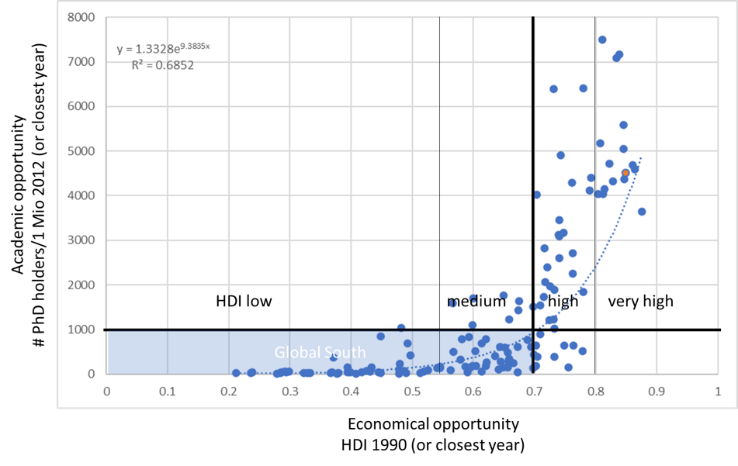

The resulting assignment to GN and GS for each country from this procedure is found in the file country categories for Committee.xlsx.

