[](http://academy.telerik.com)

**Team "Diaspore"**

1. Evgeni Tochev (evgenitochev)
2. Yordan Bankov (bankoff)
3. Borislav Gotov (bgotov)
4. Nina Krusteva (nina.krusteva)
5. Ivan Dimitrov (Ivan.Dimitrov.bg)

# Project Purpose

The application Athletics Guide allows the arrangement of information on individual competition organized in a tournament.

* Create tournament (name, city, dates);
* Adding athletes and trainers (name, team, age, gender, etc.)
* Arrange information sheets
* Adding , editing and saving information

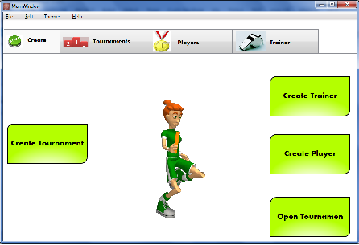

[](http://academy.telerik.com)

**Class diagram**

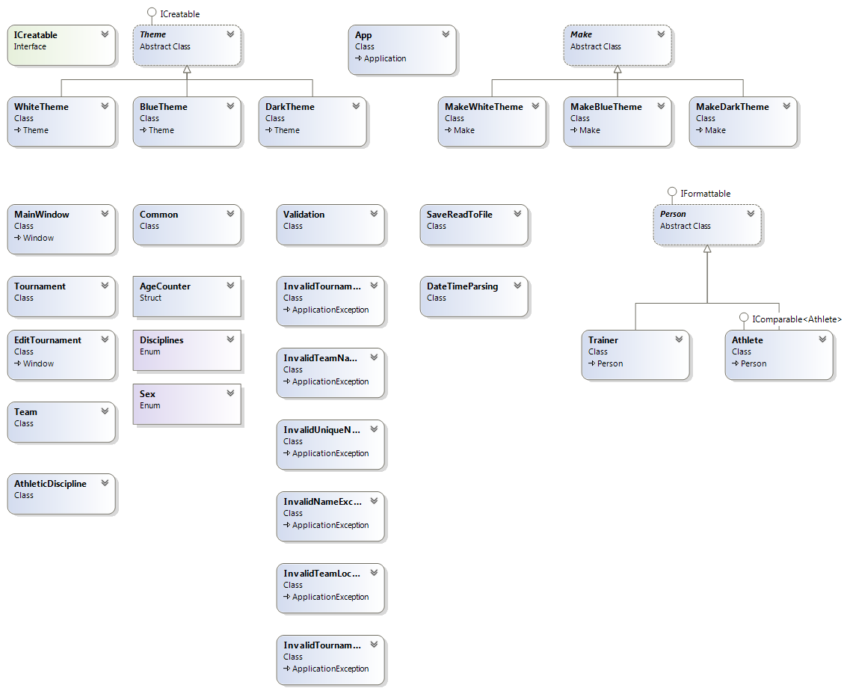

[](http://academy.telerik.com)

The project **satisfies completely** the general requirements of the assignment.

It has the following classes, interfaces, structures, enumerations and design patterns:

1. **Classes**:

* ***Person***: **abstract** class; Person can be ***Athlete*** or ***Trainer***
* ***Tournament*** : declaring the name, start and end dates, and the town where the tournament is held
* ***Athlete***: derived from Person. Defines athlete’s unique number (no other athlete can have the same), team name, date of birth, gender, personal results, etc.
* ***Trainer***: derived from ***Person***
* ***Team:*** defines the team name and the town where the team is located
* ***AthleticDiscipline***
* ***SaveReadToFile***: defines methods Serialize() and Deserialize(), returning object; these methods are used for saving the data from the application in text files and extracted back when needed
* ***DateTimeParsing***: custom parsing of the date fields in the UI
* ***Validation***: class that holds several validation methods for various type of data; validation is made through methods, using regular expressions
* ***ProjectExceptions –*** 6custom exception classes, designed according the specific needs of the application

Required Classes: 10, Classes in app: **over 25**

1. **Interfaces**:

* ***ICreatable***: custom interface, defines method Create(), used to create themes (skins) for the app
* ***IFormattable***: defines method ToString(), used to represent the class objects in human-readable form
* ***IComparable***: defines method CompareTo(), used to compare athletes by their unique number

Required Interfaces: 3, Interfaces in app: **3**

[](http://academy.telerik.com)

1. **Abstract Classes:**

* ***Person***
* ***Make***
* ***Theme***

Required Abstract Classes: 1, Abstract Classes in app: **3**

1. **Exception classes**:

* ***InvalidNameException***
* ***InvalidUniqueNumberException***
* ***InvalidTeamLocationException***
* ***InvalidTeamNameException***
* ***InvalidTournamentNameException***
* ***InvalidTournamentLocationException***

All exception classes inherit ***ApplicationException.***

Required Exception Classes: 1, Exception Classes in app: **6**

1. **Structures:**

* ***AgeCounter:*** defines the athlete’s age by the time the competition ends

Required Structures: 1, Structures in app: **1**

1. **Enumerations:**

* ***Disciplines***
* ***Sex:*** defines the person’s gender (either athlete or trainer) – Male or Female

Required Enumerations: 1, Enumerations in app: **2**

[](http://academy.telerik.com)

1. **Design Pattern**

* ***FactoryMethod –*** used for creating themes for the application

Required Design Patterns: 1, Design Patterns in app: **1**

1. **Events:**

Since all the methods in the UI work with events, there is no need to define custom ones.

Required Events: 1, Events in app: **more than 1**

SVN Repository:

[**http://code.google.com/p/athletics-guide-teamproject/**](http://code.google.com/p/athletics-guide-teamproject/)