Opencart Module for Layer Payment

for Opencart v4.x

Caution: Always keep backup of your existing Opencart installation including Mysql Database, before installing a new module.

Install via Opencart Extension Installer:-

1. Login to Opencart Admin panel and goto Extension Installer. Make sure Extension installer is already configured and working.

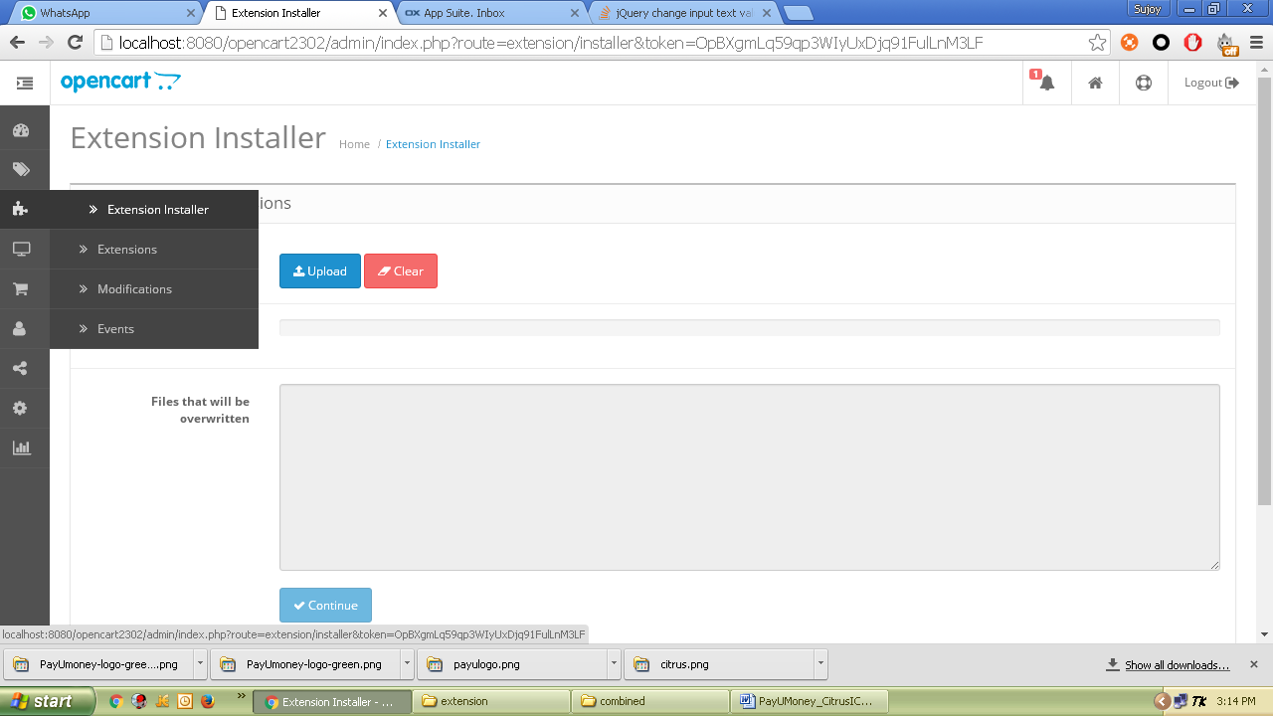

1. Click on Upload and select the downloaded module zip – *Opencart4_Layer.ocmod.zip*
2. If you are installing the module for the first time then all files will be uploaded automatically to the appropriate locations, or else, a list of files will be shown to be overwritten and clicking on Continue button will perform the copy/installation.

Manual Installation:-

1. Unzip the content of the module zip in a folder. Upload the content of “upload” folder (admin, catalog) to your Opencart root folder.

Configure Module:-

1. Now in Opencart, login to your admin account and go to Extensions-> Payments option.

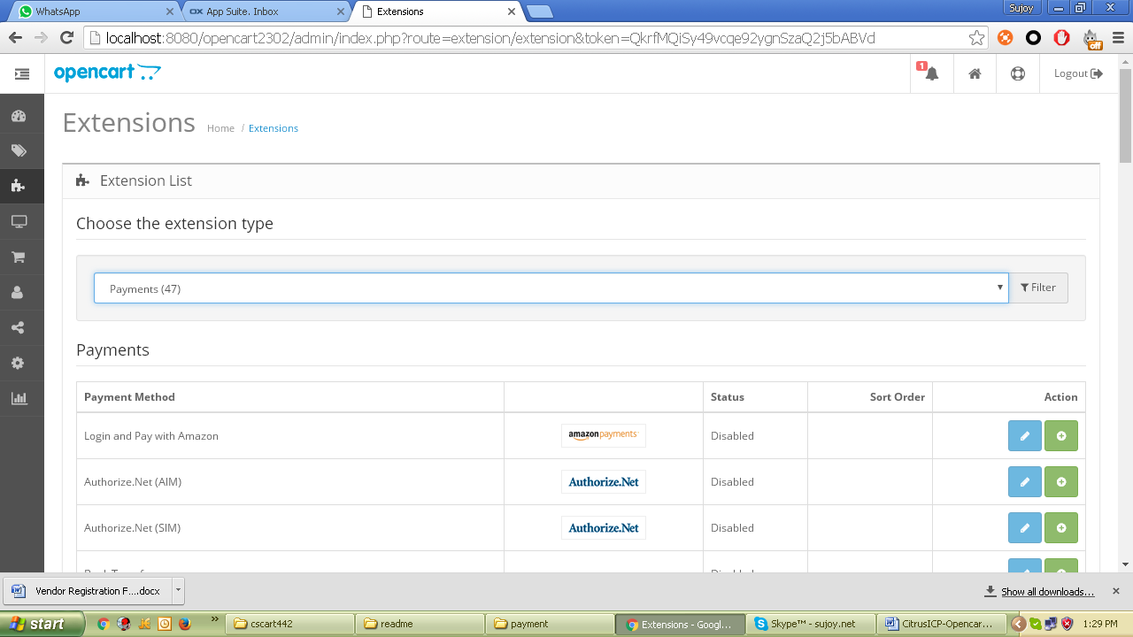

It will show you Layer Payment module as highlighted in the above image.

1. Click Install option in the right to install the module in Opencart engine.
2. After installation is over you will see Edit button. Click on Edit option to setup the options.

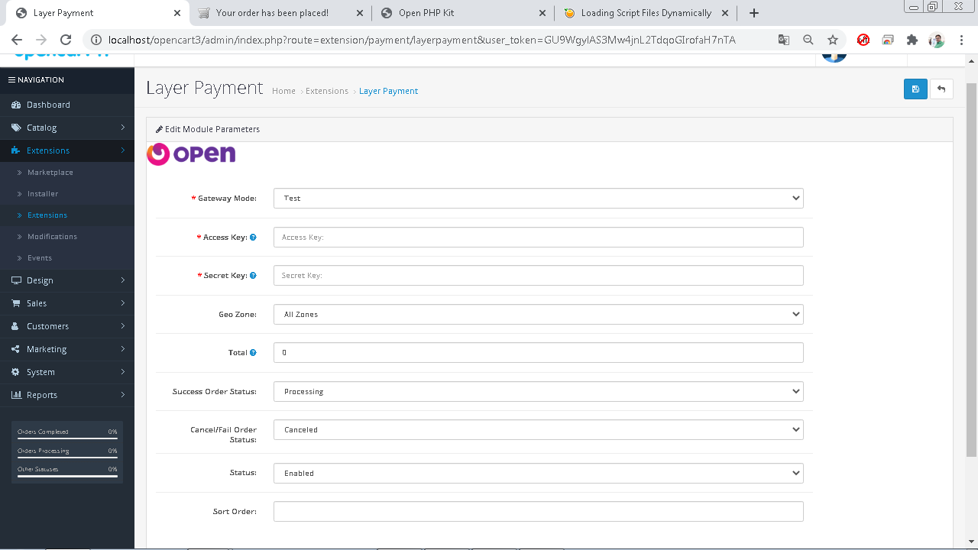

1. Now click save and customer will get Layer Payment option during checkout process.