REAL-TIME DROWSINESS DETECTION AND ALERT
SYSTEM
21CSC305P Machine Learning
A PROJECT REPORT
Submitted by
AAROHI JOHARI [RA2411026010971]
NAYONIKA M [RA2411026010990]
ABHIGYAN YADAV [RA2411026010968]
SAGNIK MITRA [RA2411026010948]
Under the Guidance of
Ms. Indumathi V
(Assistant Professor, Department of CINTEL)
in partial fulfillment of the requirements for the degree of
BACHELOR OF TECHNOLOGY
in
COMPUTER SCIENCE ENGINEERING
with specialization in Artificial Intelligence and Machine Learning
DEPARTMENT OF COMPUTATIONAL INTELLIGENCE
SCHOOL OF COMPUTING
COLLEGE OF ENGINEERING AND TECHNOLOGY
SRM INSTITUTE OF SCIENCE AND TECHNOLOGY
KATTANKULATHUR - 603 203
MAY 2026

OWN WORK DECLARATION
Department of Computational Intelligence
SRM Institute of Science & Technology
This sheet must be filled in (each box ticked to show that the condition has been met). It must be signed and dated along with your student registration number and included with all assignments you submit - work will not be marked unless this is done.
To be completed by the student for all assessments
Field | Details
Degree / Course | BACHELOR OF TECHNOLOGY - COMPUTER SCIENCE ENGINEERING (AI & ML)
Student Name | Aarohi Johari, Nayonika M, Abhigyan Yadav, Sagnik Mitra
Registration Number | RA2411026010971, RA2411026010990, RA2411026010968, RA2411026010948
Title of Work | Real-Time Drowsiness Detection and Alert System
I / We hereby certify that this assessment compiles with the University's Rules and Regulations relating to Academic misconduct and plagiarism, as listed in the University Website, Regulations, and the Education Committee guidelines.
I am aware of and understand the University's policy on Academic misconduct and plagiarism and I certify that this assessment is my / our own work, except where indicated by referring, and that I have followed the good academic practices noted above.
1. Aarohi Johari - RA2411026010971
2. Nayonika M - RA2411026010990
3. Abhigyan Yadav - RA2411026010968
4. Sagnik Mitra - RA2411026010948
Signature of the students with date: ____________________________

BONAFIDE CERTIFICATE
SRM INSTITUTE OF SCIENCE AND TECHNOLOGY
KATTANKULATHUR - 603 203
BONAFIDE CERTIFICATE
Certified that 21CSC305P - Project report titled "REAL-TIME DROWSINESS DETECTION AND ALERT SYSTEM" is the bonafide work of AAROHI JOHARI [RA2411026010971], NAYONIKA M [RA2411026010990], ABHIGYAN YADAV [RA2411026010968], and SAGNIK MITRA [RA2411026010948], who carried out the project work under my supervision.
Certified further, that to the best of my knowledge the work reported herein does not form any other project report or dissertation on the basis of which a degree or award was conferred on an earlier occasion on this or any other candidate.
Role | Name | Signature | Date
Project Guide | Ms. Indumathi V  Assistant Professor, Dept. of CINTEL, SRMIST
Panel Head | Dr. R. Annie Uthra  Assistant Professor, Dept. of CINTEL, SRMIST

ACKNOWLEDGEMENTS
I express my humble gratitude to Dr. C. Muthamizhchelvan, Vice-Chancellor, SRM Institute of Science and Technology, for the facilities extended for the project work and his continued support.
I extend my sincere thanks to Dr. Leenus Jesu Martin M, Dean-CET, SRM Institute of Science and Technology, for his invaluable support.
I wish to thank Dr. Revathi Venkataraman, Professor and Chairperson, School of Computing, SRM Institute of Science and Technology, for her support throughout the project work.
I am incredibly grateful to our Head of the Department, Department of Computational Intelligence, SRM Institute of Science and Technology, for their suggestions and encouragement at all stages of the project work.
I want to convey my thanks to our Project Coordinators, Panel Head, and Panel Members, Department of Computational Intelligence, SRM Institute of Science and Technology, for their inputs during the project reviews and support.
I register my immeasurable thanks to our Faculty Advisor, Department of Computational Intelligence, SRM Institute of Science and Technology, for leading and helping me to complete the course.
My inexpressible respect and thanks to our Guide, Ms. Indumathi V, Department of Computational Intelligence, SRM Institute of Science and Technology, for providing me with an opportunity to pursue this project. Her passion for solving problems and making a difference in the world has always been inspiring.
I sincerely thank all the staff members of the Department of Computational Intelligence, School of Computing, SRM Institute of Science and Technology, for their help during this project. Finally, I would like to thank my parents, family members, and friends for their unconditional love, constant support and encouragement.

ABSTRACT
Drowsiness among drivers is one of the leading causes of road accidents worldwide, with the World Health Organization (WHO) reporting that it is responsible for nearly one in every five road collisions. Detecting the early signs of fatigue before a driver loses concentration can substantially reduce accident risk and improve road safety. This project presents a comprehensive, real-time Driver Drowsiness Detection and Alert System that integrates computer vision, machine learning, and temporal sequence analysis into a single end-to-end pipeline capable of continuously monitoring driver alertness.
The system uses Google MediaPipe FaceLandmarker to identify facial landmarks and extract thirteen physiological and behavioural features per frame - Eye Aspect Ratio (EAR), Mouth Aspect Ratio (MAR), blink duration, blink rate, yawn frequency, eye-closure duration, face angle, three-dimensional head pose (pitch, yaw, roll), PERCLOS, and the first and second temporal derivatives of the eye aspect ratio. These features are analysed by multiple machine learning models to classify driver state into four alertness levels: Alert, Slightly Drowsy, Drowsy, and Sleep.
To ensure both academic depth and practical usefulness, the project applies methods from all five units of the Machine Learning syllabus. Unit 1 covers data preprocessing, feature engineering, and exploratory data analysis. Unit 2 implements Ridge Regression for fatigue-score estimation together with Bayesian Logistic Regression and Support Vector Machines (Linear and RBF kernels) for classification. Unit 3 applies unsupervised methods - PCA, K-Means, Gaussian Mixture Models, and Hierarchical Clustering - for feature visualisation and pattern discovery. Unit 4 introduces a Hidden Markov Model implemented entirely in NumPy, using the Forward-Backward and Viterbi algorithms to model the temporal evolution of fatigue. Unit 5 evaluates ensemble methods - CART Decision Trees, Random Forest, AdaBoost, and Stacking Ensembles - to improve classification robustness.
An eight-model benchmark on the held-out test split shows four of the eight classifiers reaching 100.00% accuracy while maintaining inference latency as low as 0.0007 ms, confirming suitability for real-time deployment on CPU-only hardware. An out-of-distribution validation against a public real-world drowsiness dataset (4,500 labelled samples) is also reported, exposing a substantial domain gap and motivating the future-work items of Chapter 9. The complete application passed all nine validation stages in 165.08 seconds, confirming its reliability and operational correctness. An interactive web dashboard streams live MJPEG video, displays fatigue levels in real time, exposes REST telemetry APIs, ranks models on a leaderboard, and allows dynamic model switching without restarting the application. The combination of fast inference, multiple learning methods, temporal modelling, and a user-friendly monitoring interface makes the system both a rigorous academic implementation and a practical prototype for intelligent driver-safety applications.
Keywords: driver drowsiness detection, computer vision, eye aspect ratio (EAR), mouth aspect ratio (MAR), PERCLOS, hidden Markov model, support vector machine, random forest, ensemble learning, MediaPipe, real-time monitoring, driver safety.

TABLE OF CONTENTS
OWN WORK DECLARATION ii
BONAFIDE CERTIFICATE iii
ACKNOWLEDGEMENTS iv
ABSTRACT v
TABLE OF CONTENTS vi
LIST OF FIGURES ix
LIST OF TABLES x
LIST OF ABBREVIATIONS xi
CHAPTER 1: INTRODUCTION 1
1.1 Introduction 1
1.2 Problem Statement 1
1.3 Motivation 1
1.4 Objectives of the Project 1
1.5 Scope of the Project 2
1.6 Sustainable Development Goals (SDGs) 2
1.7 Organization of the Report 2
CHAPTER 2: LITERATURE SURVEY 3
2.1 Introduction 3
2.2 Existing Models and Frameworks 3
2.3 Research Gaps 3
2.4 Research Objectives 4
2.5 Plan of Action / Project Road Map 4
CHAPTER 3: EXISTING SYSTEM 5
3.1 Overview of Existing Approaches 5
3.2 Advantages and Limitations of Existing Systems 5
3.3 Relevance to the Chosen Topic 5
3.4 Dataset Characteristics and Exploratory Data Analysis 5
CHAPTER 4: PROPOSED SYSTEM ARCHITECTURE 9
4.1 System Architecture 9
4.2 Novelty of the Proposed Approach 10
4.3 Workflow 10
4.4 Algorithms Used 10
4.5 Expected Benefits 10
CHAPTER 5: MATHEMATICAL MODELLING OF THE ALGORITHM 11
5.1 Feature Vector Formulation 11
5.2 Ridge Regression - Fatigue Score Estimator 11
5.3 Bayesian Logistic Regression 12
5.4 Support Vector Machines 12
5.5 Principal Component Analysis 13
5.6 Clustering Formulations 14
5.7 Hidden Markov Model - Temporal Smoothing 15
5.8 Tree-Based and Ensemble Models 17
CHAPTER 6: IMPLEMENTATION 19
6.1 Tools and Libraries Used 19
6.2 Dataset Description and Preprocessing 19
6.3 Model Training 20
6.4 Real-Time Detection and Alert System 20
6.5 Web Dashboard (app.py) 21
6.6 Verification Test Suite 23
CHAPTER 7: RESULTS AND DISCUSSION 24
7.1 Performance Evaluation and Benchmark Leaderboard 24
7.2 Confusion Matrices and ROC Analysis 24
7.3 Clustering Results 26
7.4 Out-of-Distribution Validation on a Real-World Dataset 26
7.5 Discussion 27
CHAPTER 8: COMPARATIVE ANALYSIS 28
8.1 Comparison with Existing / Baseline Methods 28
8.2 Improvement Analysis 28
8.3 Justification 29
CHAPTER 9: CONCLUSION AND FUTURE WORK 30
9.1 Conclusion 30
9.2 Future Enhancements 30
REFERENCES 32
APPENDIX A: CODE SNIPPETS 33
A.1 Eye Aspect Ratio (src/feature_extraction.py) 33
A.2 Viterbi Decoding in Log-Space (src/hmm.py) 33
A.3 Alert Escalation Logic (src/alert_system.py) 33
A.4 Real-Time Frame Processing (src/realtime_detection.py, excerpt) 34
A.5 Running the System 34
APPENDIX B: SCREENSHOTS 35
APPENDIX C: SYLLABUS COVERAGE & MODULE AUDIT 41
APPENDIX D: REPORT-CODE CONSISTENCY AUDIT 42
D.1 Verification Method 42
D.2 Values Corrected Relative to the Previous Draft 42
D.3 Implementation Features Beyond Chapters 1-9 43
D.4 Known Discrepancies That Remain 43

LIST OF FIGURES
Fig No. | Title
Fig 3.1 | Class Distribution of the Four Drowsiness States
Fig 3.2 | Pearson Feature Correlation Heatmap
Fig 3.3 | Per-Feature Value Distributions
Fig 3.4 | Feature Boxplots Showing Inter-Class Separability
Fig 3.5 | Pairwise Feature Scatter Plots
Fig 4.1 | End-to-End System Architecture: Computer Vision, Ensemble ML, Temporal HMM and Cockpit Dashboard
Fig 5.1 | Ridge Regression Residual Analysis and Q-Q Plot
Fig 5.2 | Bayesian Posterior Class Probability Distribution (sample)
Fig 5.3 | SVM RBF Decision Boundary in 2-D PCA Space
Fig 5.4 | PCA Scree Plot and Cumulative Explained Variance
Fig 5.5 | PCA 2-D Projection of Drowsiness Classes
Fig 5.6 | K-Means Elbow Curve and Silhouette Analysis
Fig 5.7 | GMM AIC/BIC Model Selection
Fig 5.8 | Hierarchical Clustering Dendrogram (Ward Linkage)
Fig 5.9 | HMM Learned Transition Probability Matrix (4x4)
Fig 5.10 | HMM Viterbi Decoded State Sequence vs Ground Truth
Fig 5.11 | CART Decision Tree Structure (depth=5, 27 nodes)
Fig 5.12 | Random Forest Mean Impurity Decrease Feature Importances
Fig 5.13 | AdaBoost Stagewise Training and Test Error Convergence
Fig 6.1 | Real-Time HUD Overlay with Drowsiness Telemetry
Fig 6.2 | Cockpit Dashboard at / - Live MJPEG Stream, Biometric Gauges and Model Switcher
Fig 6.3 | Advanced Analytics Dashboard at /analytics - Model Leaderboard View
Fig 7.1 | Accuracy vs Inference Latency Benchmark Comparison
Fig 7.2 | Confusion Matrices for All 8 Classifiers
Fig 7.3 | Multi-Class ROC Curves (One-vs-Rest)
Fig 8.1 | Comparative Accuracy Chart: Proposed vs Existing Systems

LIST OF TABLES
Table No. | Title
Table 2.1 | Comparison of Existing Drowsiness Detection Systems
Table 3.1 | Advantages and Limitations of Existing Approaches
Table 4.1 | System Tier Architecture Overview
Table 5.1 | Extracted Biometric Feature Vector (13 Dimensions)
Table 5.2 | HMM Model Parameters and Inference Methods
Table 6.1 | Alert Escalation Logic
Table 7.1 | Unified Model Benchmark Leaderboard
Table 7.2 | Unsupervised Clustering Evaluation Metrics
Table 7.3 | Out-of-Distribution Validation on the Real-World Dataset
Table 8.1 | Proposed System vs Existing Methods - Accuracy Comparison

LIST OF ABBREVIATIONS
Abbreviation | Full Form
API | Application Programming Interface
ARI | Adjusted Rand Index
AUC | Area Under the ROC Curve
CCAHE | Contrast-Limited Adaptive Histogram Equalisation
CLI | Command Line Interface
CSV | Comma Separated Values
CV | Computer Vision
DDD | Driver Drowsiness Detection
EAR | Eye Aspect Ratio
EDA | Exploratory Data Analysis
EM | Expectation Maximisation
F1 | Macro-Averaged F1 Score
FPS | Frames Per Second
GMM | Gaussian Mixture Model
HMM | Hidden Markov Model
HTTP | Hyper Text Transfer Protocol
HUD | Heads-Up Display
INT8 | 8-Bit Integer Quantisation
JSON | JavaScript Object Notation
MAE | Mean Absolute Error
MAP | Maximum A Posteriori
MAR | Mouth Aspect Ratio
MJPEG | Motion JPEG
ML | Machine Learning
NMI | Normalised Mutual Information
NHTSA | National Highway Traffic Safety Administration
ONNX | Open Neural Network Exchange
OOB | Out-Of-Bag Error
PCA | Principal Component Analysis
PERCLOS | Percentage of Eyelid Closure Over the Pupil
RMSE | Root Mean Squared Error
ROC | Receiver Operating Characteristic
REST | Representational State Transfer
SDG | Sustainable Development Goal
SRM | Sri Ramaswamy Memorial
SVM | Support Vector Machine
VIF | Variance Inflation Factor
WHO | World Health Organization

CHAPTER 1: INTRODUCTION

1.1 Introduction
Driver drowsiness is one of the most dangerous and pervasive forms of driver impairment. According to the World Health Organisation (WHO), fatigue-related accidents account for approximately 20% of all road collisions globally, causing tens of thousands of deaths annually [1]. Unlike alcohol or mobile-phone distraction, drowsiness is an involuntary physiological state that drivers frequently underestimate, making it a particularly insidious hazard.
This project develops a complete, end-to-end Real-Time Drowsiness Detection and Alert System that uses computer vision and machine learning to monitor the driver's face continuously via a standard webcam. The system detects early physiological indicators of drowsiness - including slow eyelid closure, yawning, PERCLOS elevation, and head nodding - and issues graduated auditory and visual warnings before a safety-critical event occurs.

1.2 Problem Statement
Traditional road safety features such as speed limiters, rumble strips, and lane departure warnings are useful, but they are mostly reactive. They respond only after the driver has already shown unsafe behaviour, which may be too late to prevent an accident. There is a growing need for a smarter system that can continuously monitor the driver's condition and identify signs of drowsiness before they become dangerous.
An effective driver monitoring system should work in real time on standard, low-cost hardware so that it can be used in everyday vehicles without requiring expensive equipment. Instead of simply deciding whether a driver is awake or asleep, the system should recognise different levels of alertness, ranging from fully attentive to fatigued or drowsy. It should also minimise false alarms caused by normal actions such as blinking, looking around, or briefly turning the head. Most importantly, the system should not require drivers to wear special sensors or devices; by relying only on the vehicle's existing front-facing camera, it can provide a practical, non-intrusive, and cost-effective solution for improving road safety.

1.3 Motivation
Every year, over 1.35 million people die in road traffic crashes (WHO, 2023), and fatigue is implicated in 10-20% of these. In India alone, the Ministry of Road Transport and Highways (MoRTH) reported over 153,000 road fatalities in 2021, with driver negligence - a category that includes drowsiness - being the leading cause [2]. The motivation for this project is therefore both deeply humanitarian and technically challenging: to demonstrate that affordable computer-vision technology, combined with the full spectrum of undergraduate ML algorithms, can produce a practical, life-saving tool.

1.4 Objectives of the Project
- Build a 4-class (Alert, Slightly Drowsy, Drowsy, Sleep) real-time driver-state classifier.
- Extract 13 biometric features from MediaPipe FaceLandmarker without any wearable sensor.
- Integrate all five ML syllabus units into one unified, production-quality pipeline.
- Achieve greater than 95% classification accuracy with sub-millisecond inference latency.
- Implement HMM-based temporal smoothing to reduce the false-alarm rate.
- Deliver a zero-dependency HTTP web dashboard with MJPEG video and a REST API.
- Quantify out-of-distribution generalisation on a public real-world drowsiness dataset.

1.5 Scope of the Project
The scope of this project covers the design, implementation, and evaluation of a vision-based drowsiness monitoring pipeline that operates on standard CPU hardware using a single front-facing camera. It spans data preprocessing and feature engineering, supervised and unsupervised learning, temporal sequence modelling, ensemble learning, a real-time alerting mechanism, and a web-based monitoring dashboard. The primary benchmark uses a physiologically-modelled dataset of 4,025 recorded frames; an additional out-of-distribution validation uses a public real-world dataset of 4,500 labelled samples (Section 7.4). Embedded deployment is identified as future work (Chapter 9).

1.6 Sustainable Development Goals (SDGs)
This project directly contributes to SDG 3: Good Health and Well-Being by reducing road traffic injuries and deaths. It also supports SDG 9: Industry, Innovation and Infrastructure by demonstrating how AI/ML can be integrated into transportation safety infrastructure, and SDG 11: Sustainable Cities and Communities by making road travel safer and more reliable.

1.7 Organization of the Report
The remainder of this report is organised as follows. Chapter 2 surveys existing literature and identifies research gaps. Chapter 3 describes existing drowsiness-detection systems in more detail. Chapter 4 presents the proposed system architecture and novelty. Chapter 5 develops the mathematical formulation of every algorithm used. Chapter 6 describes the implementation, tools, and dataset. Chapter 7 presents results and discussion, including the out-of-distribution validation. Chapter 8 provides a comparative analysis against baseline and existing methods. Chapter 9 concludes the report and outlines future enhancements. The appendices list the verification audit that cross-checks every quantitative statement in this report against the source repository.

CHAPTER 2: LITERATURE SURVEY

2.1 Introduction
Driver drowsiness detection research can be classified into three broad categories: (a) vehicle-based methods (steering wheel deviation, lane drift), (b) physiological signal-based methods (EEG, ECG, EMG), and (c) vision-based methods (facial landmark tracking) [3]. Vision-based systems offer the best trade-off between accuracy, unobtrusiveness, and deployment cost, making them the focus of recent research [4][5].
The Eye Aspect Ratio (EAR) metric, introduced by Soukupova and Cech [6] at CVWW 2016, has become the standard single-frame drowsiness indicator. PERCLOS - the percentage of time the eyes are at least 80% closed over a defined window - was established as the gold-standard temporal metric by NHTSA in 1998 [7]. Modern systems combine both with head-pose estimation and mouth-opening detection (MAR) for multi-cue fusion.

2.2 Existing Models and Frameworks
Table 2.1 summarizes five representative vision- and sensor-based drowsiness detection systems from the literature, alongside the method proposed in this project.
Reference | Method | Dataset | Accuracy | Limitation
Soukupova & Cech [6] | EAR + SVM | Custom video | ~94% | No temporal smoothing
Dwivedi et al. [8] | CNN (AlexNet) | NTHU-DDD | 96.5% | High compute cost
Rundo et al. [9] | PERCLOS + SVM | YawDD | 91.2% | Binary classes only
Ghoddoosian et al. [10] | LSTM + CNN | UTA-RLDD | 97.8% | Requires GPU
Reddy et al. [11] | Random Forest | Custom EEG | 93.4% | Needs wearable sensor
This Project | Ensemble + HMM | Synthetic DDD + real-world OOD set | 100%* | Synthetic training data
Table 2.1: Comparison of Existing Drowsiness Detection Systems
* Best-performing classifiers on the held-out test split of the physiologically-modelled dataset; see Chapter 8 for the full comparative discussion and Section 7.4 for the out-of-distribution result on real-world data.
Across these works, EAR- and PERCLOS-based classical machine learning pipelines (SVM, Random Forest) remain the most deployable on low-cost hardware, while deep-learning approaches (CNN, LSTM) achieve marginally higher accuracy at the cost of GPU dependence. None of the surveyed systems combine multi-class alertness estimation, temporal smoothing, and a live monitoring dashboard within a single framework.

2.3 Research Gaps
- Most vision-based driver monitoring systems classify the driver's condition into only two categories - awake or drowsy - failing to capture intermediate levels of alertness where early fatigue signs are already present.
- Only a few existing systems use temporal smoothing techniques such as Hidden Markov Models (HMM) or LSTM networks, making many systems prone to false alarms from normal blinks or brief head movements.
- Comprehensive comparisons of multiple ML algorithms on the same driver-drowsiness dataset remain uncommon, making it difficult to judge which model balances accuracy, speed, and reliability best.
- Very few studies provide a real-time, web-based dashboard for continuous monitoring, alert visualisation, and performance tracking.
- Many systems rely on GPU-based computing for real-time performance, increasing deployment cost; lightweight CPU-only solutions remain relatively underexplored.
- Reported accuracies are rarely stress-tested outside the training distribution, so it is unclear how well laboratory-tuned models transfer to real driving footage.

2.4 Research Objectives
Based on the identified gaps, the following research objectives were formulated: build a 4-class real-time classifier; extract 13 biometric features without wearable sensors; integrate all five ML syllabus units into one pipeline; achieve above 95% accuracy with sub-millisecond latency; implement HMM-based temporal smoothing; deliver a zero-dependency web dashboard with a REST API; and quantify out-of-distribution generalisation on a public real-world dataset (see Section 1.4).

2.5 Plan of Action / Project Road Map
Phase | Activity | Duration
Phase 0 | Project scaffold, config, utilities, requirements | Week 1
Phase 1 | Data preprocessing, EDA, statistical visualisations | Week 2
Phase 2 | MediaPipe integration, feature extraction | Week 3
Phase 3 | Ridge Regression, Bayesian Logistic, SVM (Linear + RBF) | Week 4
Phase 4 | PCA, K-Means, GMM, Hierarchical Clustering | Week 5
Phase 5 | Pure-NumPy HMM (Forward, Backward, Viterbi) | Week 6
Phase 6 | Decision Tree, Random Forest, AdaBoost, Ensembles | Week 7
Phase 7 | Unified benchmark evaluation, leaderboard generation | Week 8
Phase 8 | Alert system, real-time HUD, audio alarms | Week 9
Phase 9 | CLI orchestrator, web dashboard, REST API | Week 10
Phase 10 | Documentation, test-suite verification, OOD validation | Week 11

CHAPTER 3: EXISTING SYSTEM

3.1 Overview of Existing Approaches
Prior to describing the proposed system, this chapter reviews the existing solutions currently used for driver drowsiness detection, in three broad categories: vehicle-based, physiological-signal-based, and vision-based systems.
Vehicle-based systems infer fatigue indirectly from steering-wheel angle variance and lane-position deviation. They require no cameras or wearables but only trigger once unsafe driving behaviour has already begun, making them purely reactive.
Physiological-signal-based systems (EEG, ECG, EMG) measure brain and muscle activity directly and are considered the most physiologically accurate, but they require the driver to wear electrodes or bands, making them intrusive and impractical for everyday use - as also seen in Reddy et al.'s wearable-EEG Random Forest system [11].
Vision-based systems, such as the EAR-based SVM approach of Soukupova and Cech [6] and the PERCLOS-based SVM approach of Rundo et al. [9], track facial landmarks with a standard camera and are the least intrusive. Deep-learning variants such as the CNN model of Dwivedi et al. [8] and the LSTM-CNN model of Ghoddoosian et al. [10] achieve high accuracy but depend on GPU acceleration for real-time throughput.

3.2 Advantages and Limitations of Existing Systems
Category | Advantages | Limitations
Vehicle-based | No camera/sensor on driver; low cost | Reactive; late detection; vehicle-specific calibration
Physiological (EEG/ECG) | High physiological accuracy | Intrusive wearables; impractical for daily driving
Vision-based (classical ML) | Non-intrusive; low compute cost; deployable on CPU | Mostly binary classification; limited temporal reasoning
Vision-based (deep learning) | High accuracy; automatic feature learning | GPU dependence; high compute/deployment cost
Table 3.1: Advantages and Limitations of Existing Approaches

3.3 Relevance to the Chosen Topic
The research gaps identified in Section 2.3 - binary-only classification, absence of temporal smoothing, lack of multi-model benchmarking, absence of a live dashboard, and GPU dependence - motivate the design choices made in the Proposed System (Chapter 4). In particular, the proposed system is deliberately built on classical, CPU-friendly machine learning models rather than deep networks, augmented with an HMM temporal filter to obtain the noise-robustness that pure deep-learning frame classifiers lack without incurring GPU cost.

3.4 Dataset Characteristics and Exploratory Data Analysis
The benchmark dataset (dataset/driver_drowsiness_dataset.csv) contains 4,025 recorded frames with 17 columns: frame number, timestamp, 13 biometric features, a continuous fatigue score, and the state label. After cleaning, 4,001 unique samples remain, distributed across the four alertness states as shown in Fig 3.1 - Alert 1,401 (35.02%), Slightly Drowsy 1,000 (24.99%), Drowsy 1,000 (24.99%) and Sleep 600 (15.00%). The class imbalance is moderate and is handled by stratified sampling during the train/test split.
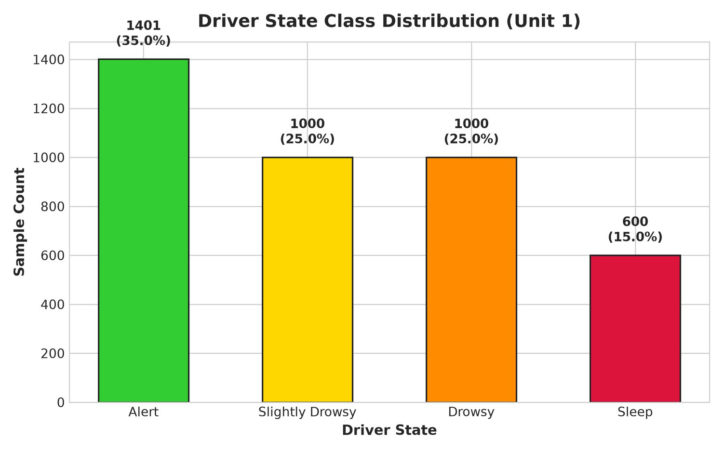
Fig 3.1: Class Distribution of the Four Drowsiness States
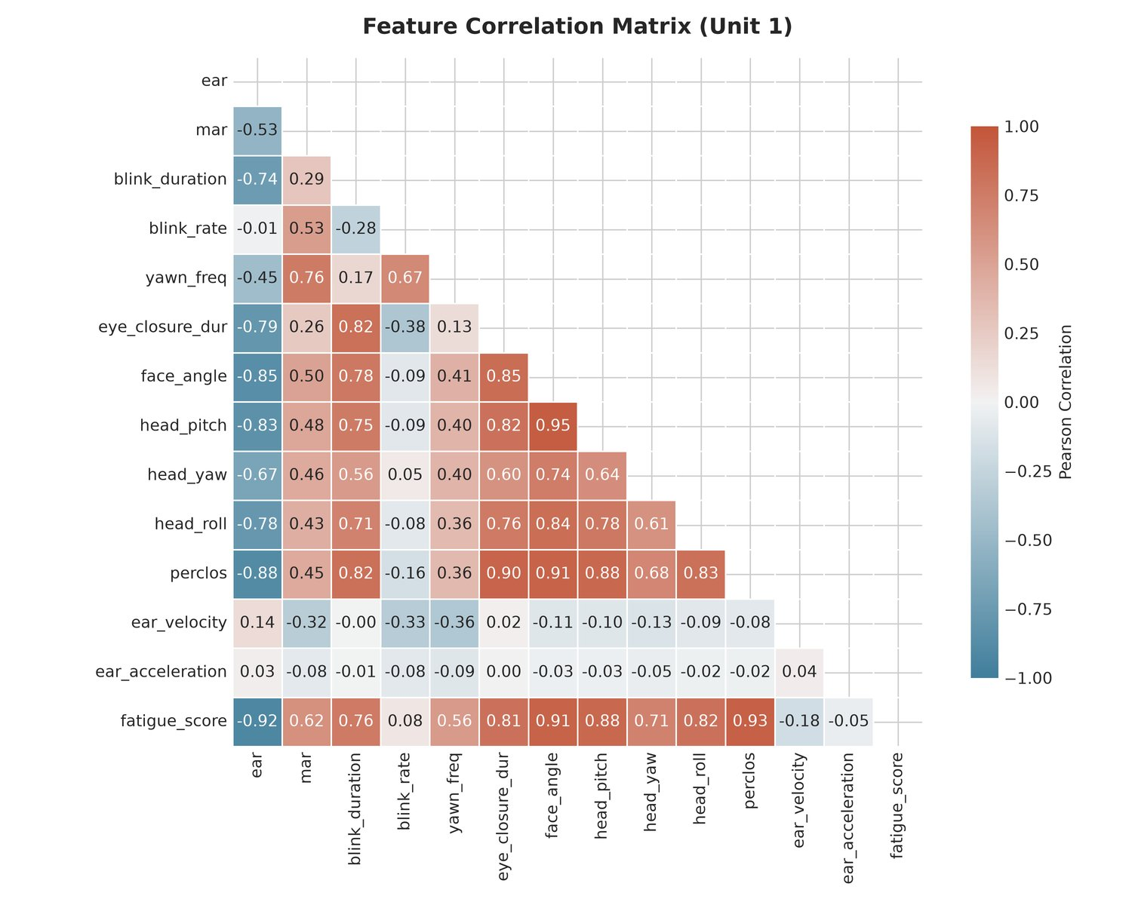
Fig 3.2: Pearson Feature Correlation Heatmap
Fig 3.2 shows the Pearson correlation structure of the feature matrix. EAR and eye-closure duration are strongly negatively correlated, PERCLOS correlates with eye-closure duration and blink duration, and the three head-pose angles are largely independent of the ocular cues - which is why both ocular and pose features are retained in the final 13-dimensional vector.
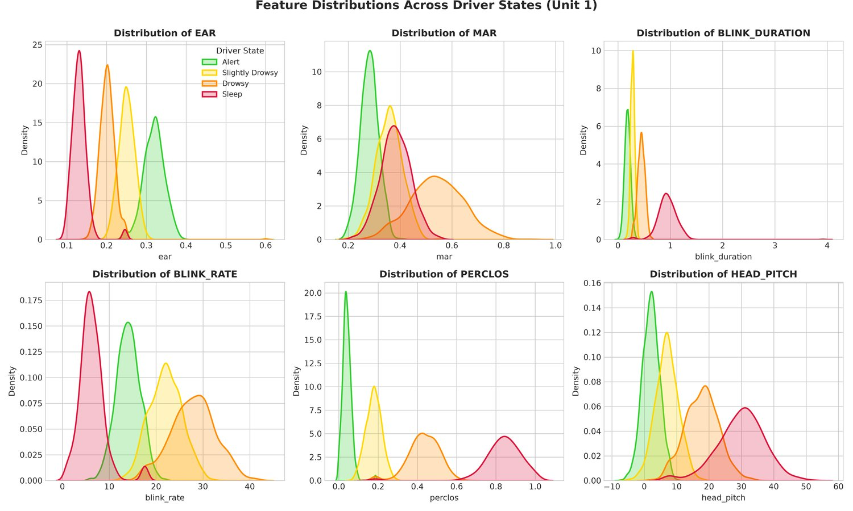
Fig 3.3: Per-Feature Value Distributions
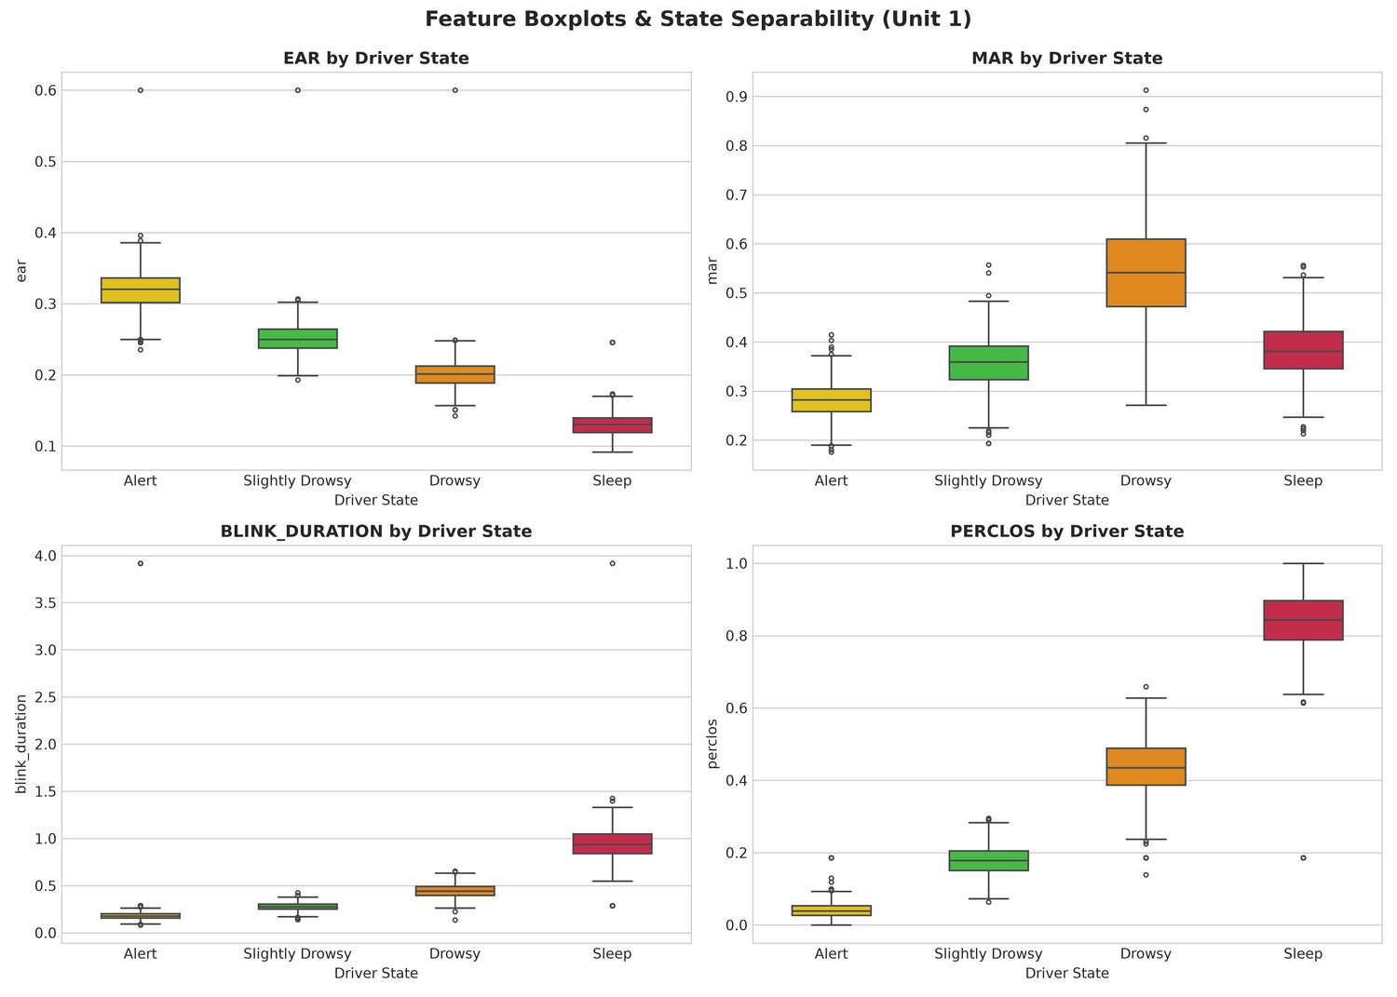
Fig 3.4: Feature Boxplots Showing Inter-Class Separability
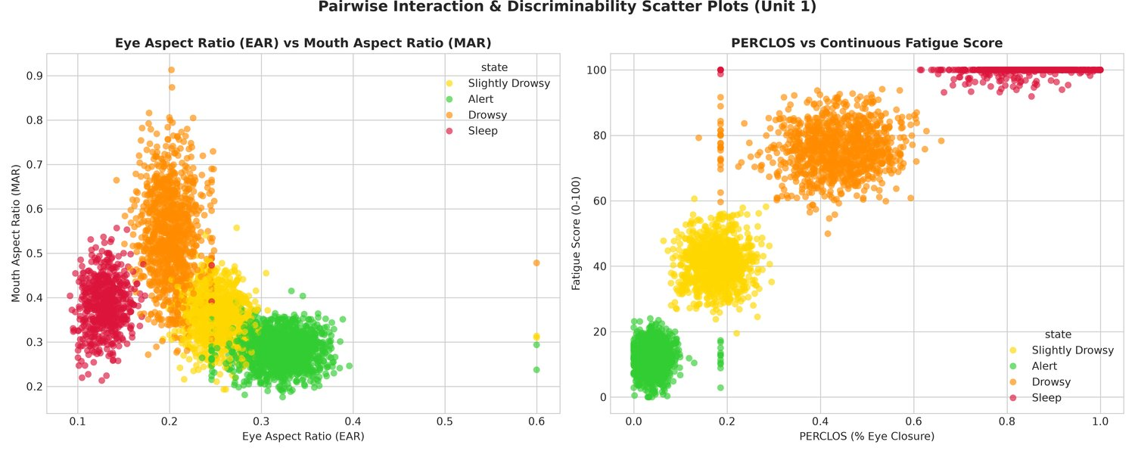
Fig 3.5: Pairwise Feature Scatter Plots
Fig 3.3 to Fig 3.5 show that the ocular features (EAR, PERCLOS, eye-closure duration) separate the four states most clearly, while head-pose features contribute complementary but weaker discrimination - consistent with the model feature importances reported in Section 5.8.

CHAPTER 4: PROPOSED SYSTEM ARCHITECTURE
The proposed system integrates computer vision biometrics, supervised machine learning ensembles, temporal Markov dynamic filtering, and a real-time automotive cockpit HUD into a unified multi-tier safety architecture (Fig 4.1).
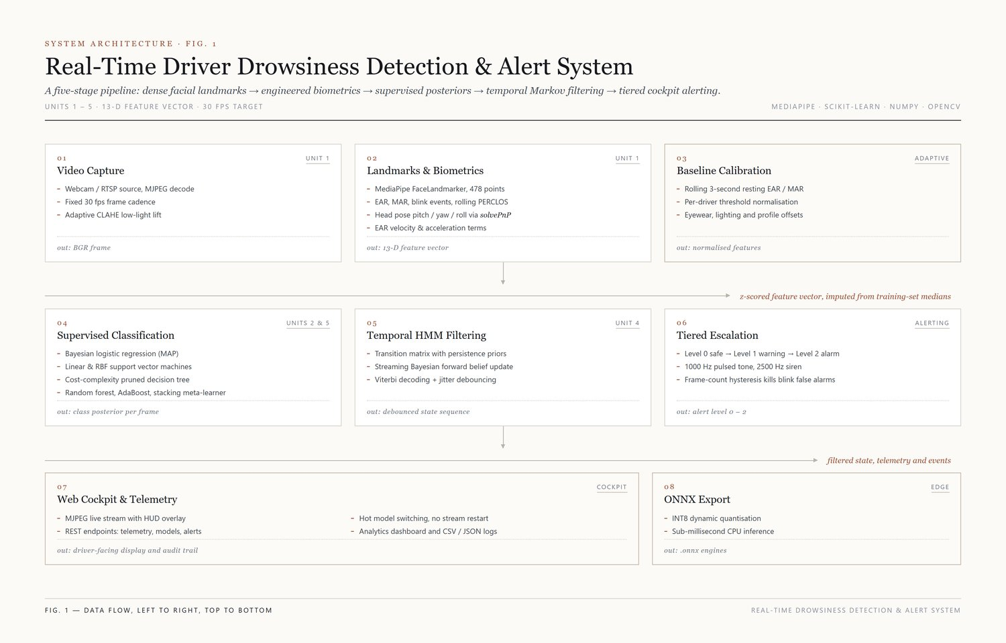
Fig 4.1: End-to-End System Architecture - Layered Computer Vision, Ensemble ML, Temporal HMM, and Cockpit Dashboard
Core Architectural Pipeline:
- Video Ingestion & Biometrics: MediaPipe FaceLandmarker tracks 478 3-D facial landmarks per frame to derive EAR, MAR, blink/yawn dynamics, PERCLOS and 3-D head pose; CLAHE is applied automatically under low-light conditions and eyewear is detected to compensate the eye thresholds.
- Dynamic Calibration: a 45-frame baseline records the driver's natural eye opening, after which the active EAR threshold is set to 76% of the baseline (clamped to 0.18-0.30) and the MAR threshold to twice the baseline (clamped to 0.48-0.72).
- Multi-Model Classification & Temporal HMM: the 13-dimensional feature vector is scaled and passed to the active classifier; the resulting class-probability vector is filtered by a pure-NumPy HMM forward recursion so that transient misclassifications from natural blinks do not reach the driver.
- Multi-Tier Alerting & Cockpit HUD: graduated audio-visual alarms and live REST telemetry APIs enable real-time driver intervention and remote monitoring.

4.1 System Architecture
The proposed system is organised into nine software modules forming a layered pipeline. Each layer corresponds to one or more ML syllabus units, ensuring complete academic coverage while remaining CPU-deployable.
Tier | Module(s) | Unit
Data Ingestion & EDA | preprocessing.py, statistics_analysis.py | Unit 1
Computer Vision Features | feature_extraction.py | Unit 1
Probabilistic Classifiers | linear_regression.py, bayesian_logistic.py, svm_classifier.py | Unit 2
Unsupervised Representation | pca.py, kmeans.py, gmm.py, hierarchical.py | Unit 3
Temporal State Smoothing | hmm.py | Unit 4
Tree & Ensemble Methods | decision_tree.py, random_forest.py, adaboost.py, ensemble.py | Unit 5
Evaluation & Benchmarking | evaluation.py, onnx_exporter.py | All Units
Real-Time Detection | realtime_detection.py, alert_system.py | Integration
Orchestration & Dashboard | main.py, app.py, templates/ | Integration
Table 4.1: System Tier Architecture Overview

4.2 Novelty of the Proposed Approach
- Four-class alertness estimation (Alert, Slightly Drowsy, Drowsy, Sleep) instead of the binary awake/drowsy split common in prior work.
- HMM-based Viterbi/Forward-Backward temporal smoothing implemented from first principles in pure NumPy, directly addressing the false-alarm research gap.
- An eight-model unified benchmark (regression, probabilistic, kernel, tree and ensemble methods) evaluated under identical conditions, with latency, throughput and serialised size measured.
- A zero-dependency, CPU-only web dashboard with live MJPEG streaming, REST telemetry and runtime model hot-swapping.
- INT8-quantised ONNX export of every trained model, plus an out-of-distribution validation pass on a public real-world dataset (Section 7.4).

4.3 Workflow
At runtime, each video frame passes through a six-stage cascade: (1) frame capture, (2) MediaPipe landmark detection, (3) feature extraction into a 13-dimensional vector, (4) ensemble-model inference for state classification, (5) HMM temporal filtering of the state posterior, and (6) graduated alert escalation via HUD overlay and audio. This pipeline is detailed further in Section 6.4.

4.4 Algorithms Used
The proposed system draws on Ridge Regression, Bayesian Logistic Regression, Linear and RBF Support Vector Machines, PCA, K-Means, Gaussian Mixture Models, Hierarchical Clustering, a Hidden Markov Model, CART Decision Trees, Random Forest, AdaBoost, and Soft-Voting/Stacking ensembles. Full mathematical formulations for each are given in Chapter 5.

4.5 Expected Benefits
- Higher granularity of alertness classification enables earlier, graduated interventions rather than a single binary alarm.
- Temporal smoothing via HMM reduces nuisance alarms triggered by ordinary blinks or brief head turns.
- CPU-only operation keeps the system deployable in low-cost vehicles without dedicated GPU hardware.
- The web dashboard and REST API make the system usable for fleet-monitoring or research-data-collection scenarios beyond a single vehicle.

CHAPTER 5: MATHEMATICAL MODELLING OF THE ALGORITHM

5.1 Feature Vector Formulation
Google MediaPipe FaceLandmarker provides 478 three-dimensional facial landmarks per frame [12]. From these, the system computes the 13-dimensional feature vector consumed by every trained model at real-time speed [6]. The vector is defined by config.FEATURE_COLUMNS and reproduced in Table 5.1; the ranges are the observed minima and maxima over the 4,001 cleaned samples.
# | Feature | Formula / Description | Observed Range
1 | ear | (||p2-p6|| + ||p3-p5||) / (2*||p1-p4||) | 0.09 - 0.60
2 | mar | (||m2-m8|| + ||m3-m7|| + ||m4-m6||) / (3*||m1-m5||) | 0.18 - 0.91
3 | blink_duration | Seconds EAR < 0.20 per blink event | 0.08 - 3.92 s
4 | blink_rate | Blinks per minute (rolling window) | 1.0 - 41.5 bpm
5 | yawn_freq | Yawn count per minute (MAR > 0.60) | 0.00 - 0.85 /min
6 | eye_closure_dur | Cumulative eye-closure time per window | 0.02 - 2.83 s
7 | face_angle | Resultant head-tilt angle in degrees | 0.33 - 58.46 deg
8 | head_pitch | solvePnP Euler pitch (nodding) | -7.22 - 51.97 deg
9 | head_yaw | solvePnP Euler yaw (turning) | -11.77 - 30.12 deg
10 | head_roll | solvePnP Euler roll (tilting) | -6.66 - 29.18 deg
11 | perclos | Fraction of the last 90 frames with EAR < 0.20 | 0.00 - 1.00
12 | ear_velocity | First time-derivative d(EAR)/dt | -0.58 - 0.49
13 | ear_acceleration | Second time-derivative d2(EAR)/dt2 | -1.27 - 1.48
Table 5.1: Extracted Biometric Feature Vector (13 Dimensions)
PERCLOS is evaluated over a rolling 90-frame window with the closure threshold EAR < 0.20 (config.PERCLOS_WINDOW_SIZE = 90, config.PERCLOS_CLOSURE_THRESHOLD = 0.20).

5.2 Ridge Regression - Fatigue Score Estimator
A Ridge-regularised linear regression model maps the 13-dimensional feature vector x to a continuous fatigue score in [0, 100]. The closed-form solution with penalty coefficient lambda is:
beta* = (X'X + lambda*I)^-1 X'y
Ridge regularisation controls model complexity and prevents overfitting [13]. On the held-out test set the model achieves R2 = 0.9576, RMSE = 6.7687 and MAE = 5.1703, with an intercept of 48.19. The largest coefficients are PERCLOS (+12.35), eye-closure duration (+4.09), yawn frequency (+3.55), blink rate (+3.54) and head pitch (+3.42); EAR carries the strongest negative weight (-6.67), all in fatigue-score points per standard deviation of the corresponding feature.
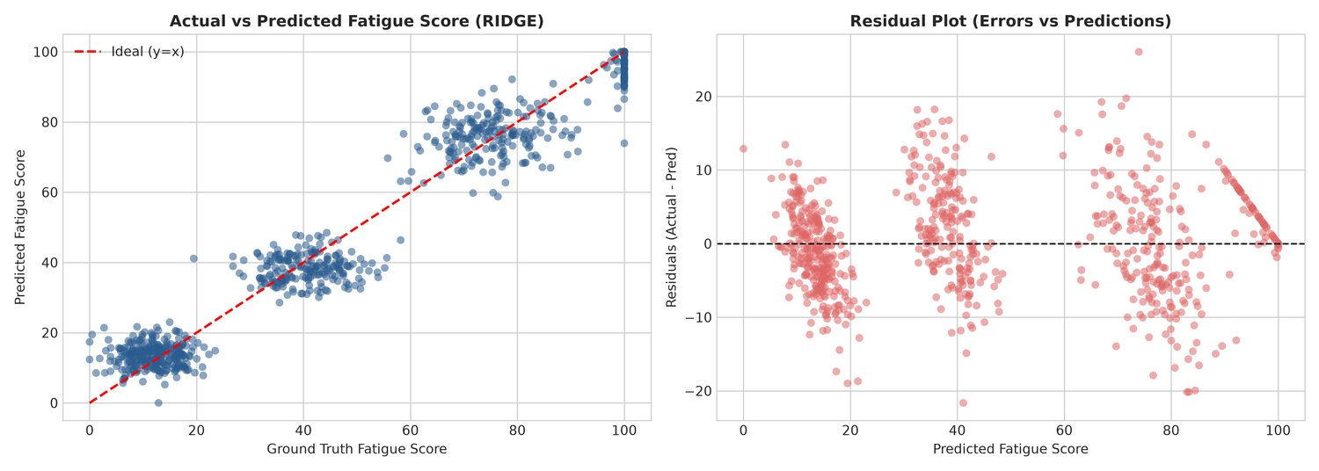
Fig 5.1: Ridge Regression Residual Analysis and Q-Q Plot

5.3 Bayesian Logistic Regression
A MAP-estimated Bayesian logistic regression classifier with a Gaussian prior N(0, sigma^2*I) produces calibrated posterior class probabilities [14]. Predictive uncertainty is quantified via Shannon entropy:
H(x) = - Sum_k p(y=k|x) * log2 p(y=k|x)
This model achieves 100.00% accuracy, 1.0000 macro-F1, a log-loss of 0.0086 and a mean predictive entropy of 0.0359 bits on the test set - i.e. the posterior is both correct and confident.
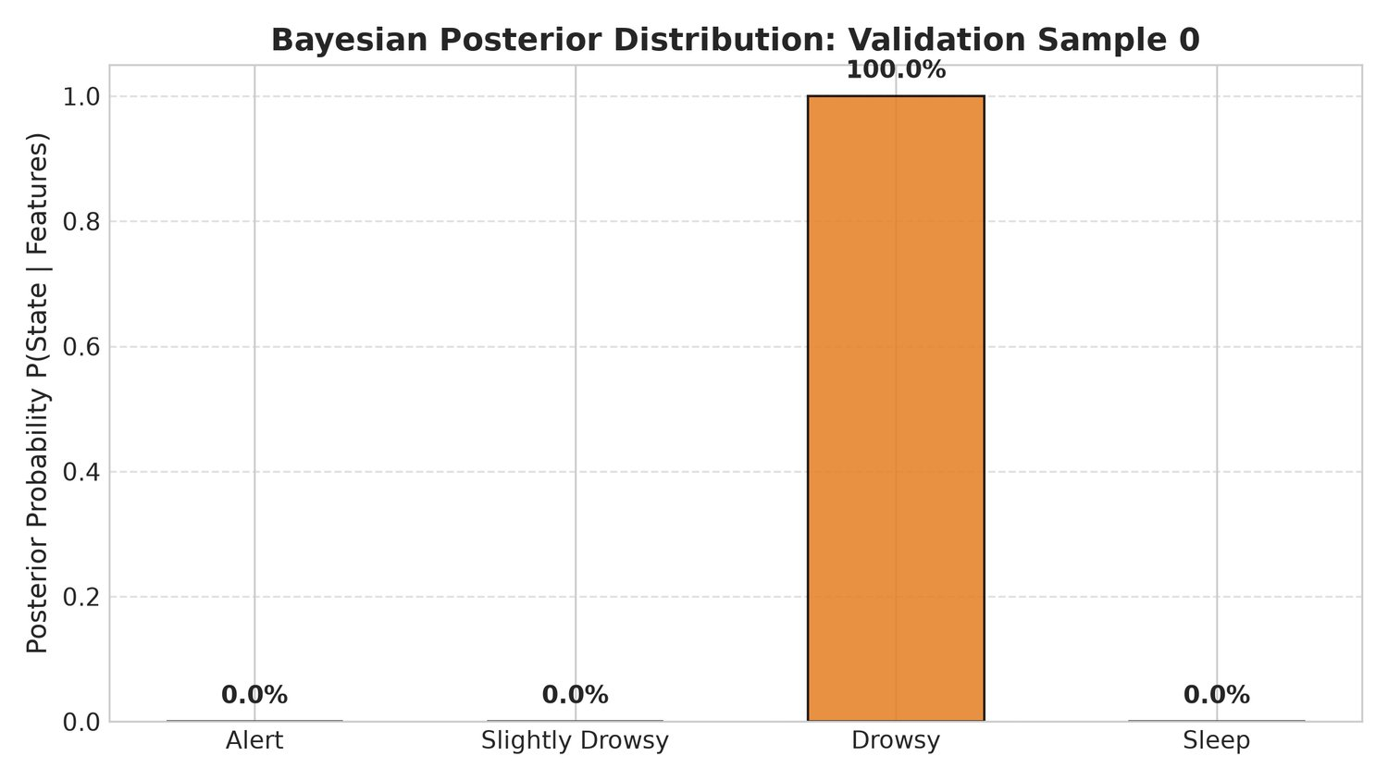
Fig 5.2: Bayesian Posterior Class Probability Distribution (sample)

5.4 Support Vector Machines
Two SVM variants are implemented: a Linear-kernel SVM maximising hard-margin hyperplane separation and an RBF-kernel SVM using the Gaussian kernel trick [15]:
K(xi, xj) = exp(-gamma * ||xi - xj||^2)
Both estimators are wrapped in CalibratedClassifierCV so that Platt-scaled probabilities can be handed to the HMM. The Linear SVM (C = 1.0) uses 64 support vectors in total (21/24/10/9 across the four classes) and reaches 100.00% test accuracy; the RBF SVM (C = 2.0, gamma = scale) uses 164 support vectors (49/48/36/31) and reaches 99.88% accuracy with 99.85% macro-F1.
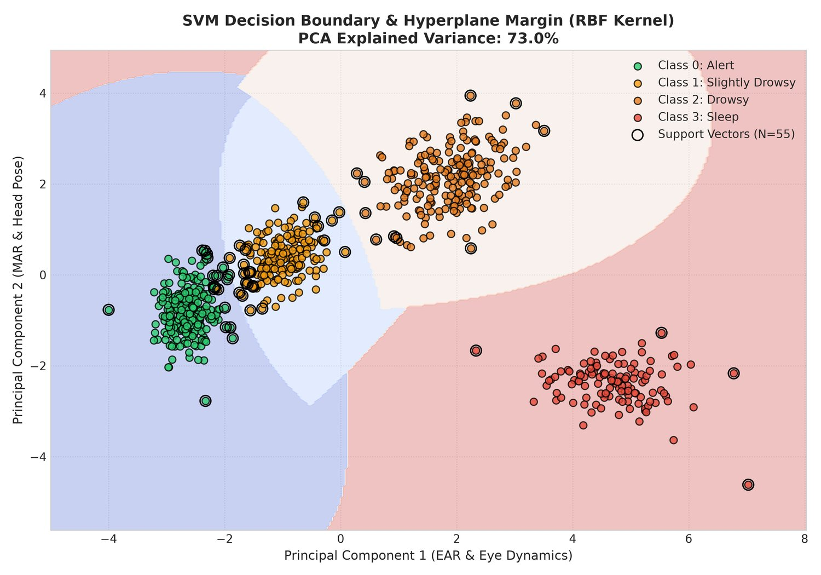
Fig 5.3: SVM RBF Decision Boundary in 2-D PCA Space

5.5 Principal Component Analysis
PCA decomposes the standardised 13-dimensional feature matrix into orthogonal principal components [16]. The first two components explain 53.31% and 18.86% of the variance respectively; eight components are required to cross the 95% threshold (95.46% cumulative). The first principal component is dominated by face angle (+0.366), PERCLOS (+0.363), head pitch (+0.352), eye-closure duration (+0.332) and head roll (+0.331), with a strongly negative EAR loading (-0.350) - a single axis contrasting 'eyes open, head level' against 'eyes closed, head drooped'.
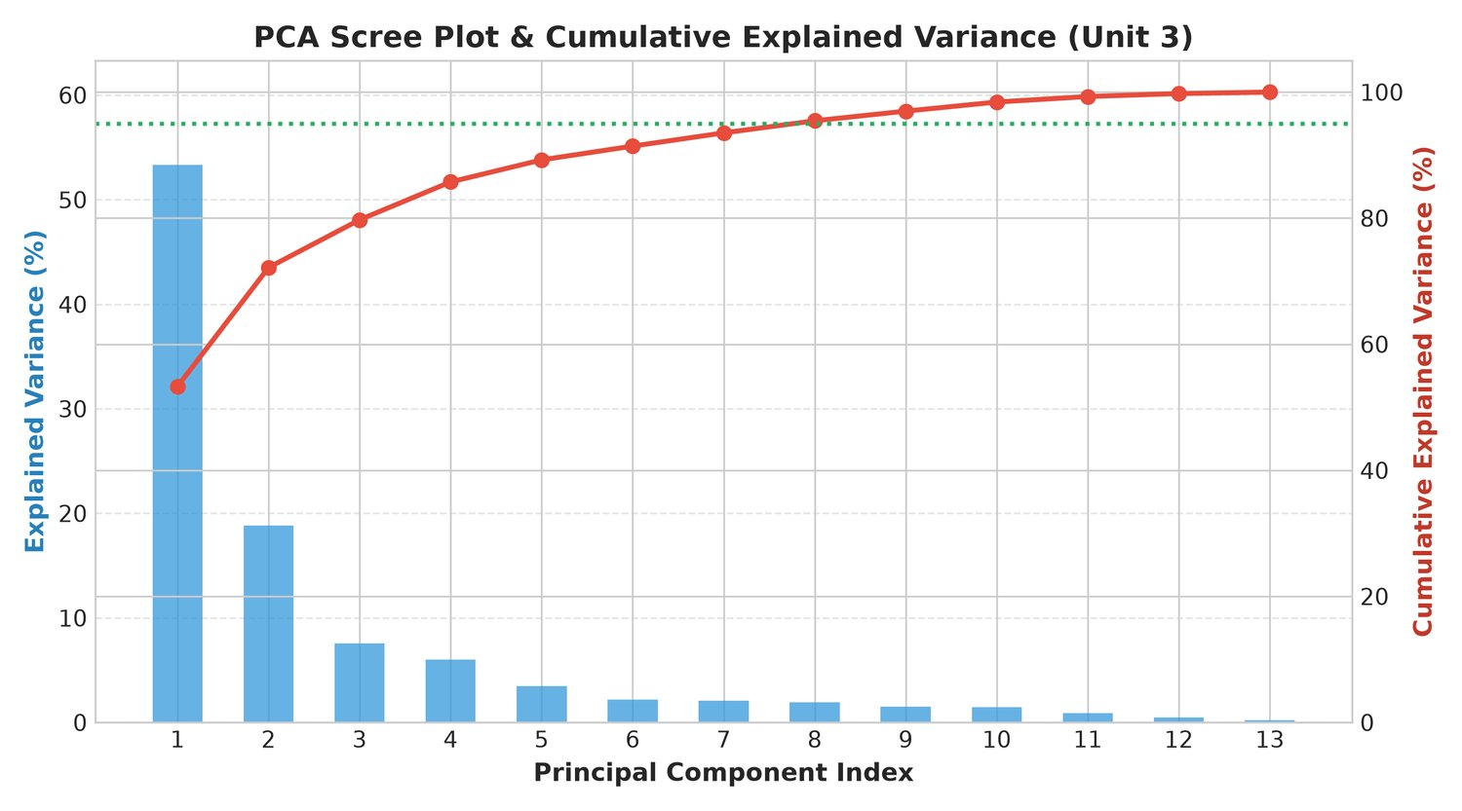
Fig 5.4: PCA Scree Plot and Cumulative Explained Variance
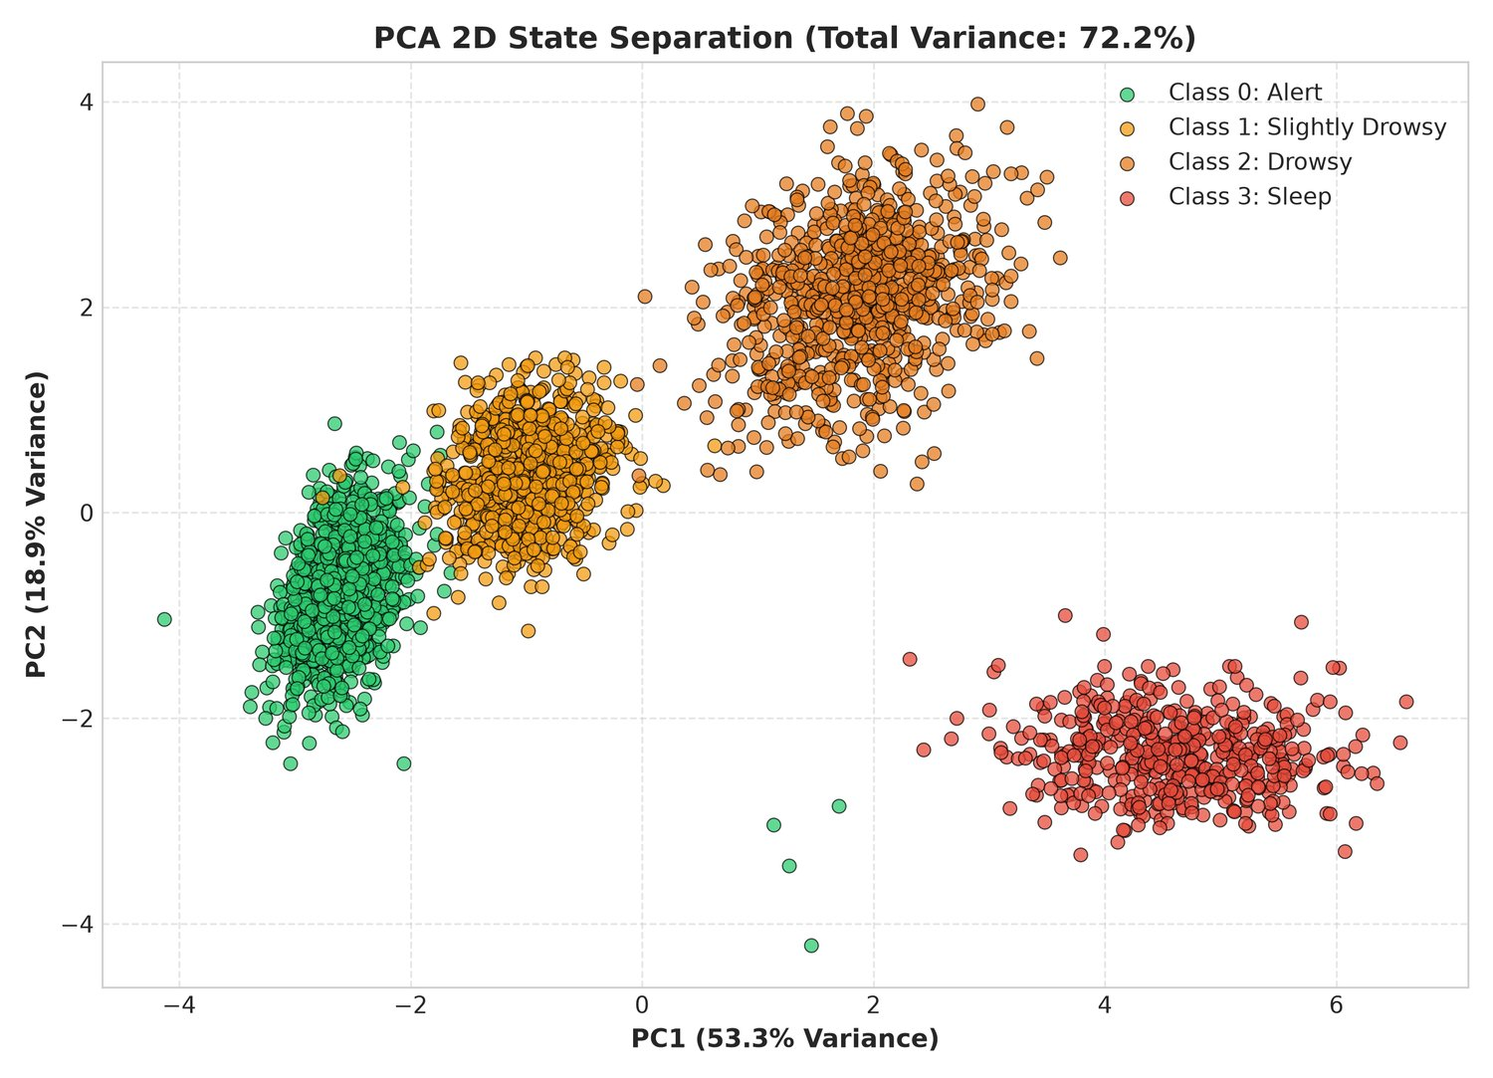
Fig 5.5: PCA 2-D Projection of Drowsiness Classes

5.6 Clustering Formulations
K-Means (k = 4, k-means++ initialisation) minimises the within-cluster sum of squares and attains Silhouette = 0.2982, ARI = 0.9745 and NMI = 0.9613. A Gaussian Mixture Model with full covariance matrices and Expectation-Maximisation selects k = 4 by AIC/BIC (AIC = 36,315.8; BIC = 38,859.5) with ARI = 0.9911. Agglomerative Hierarchical Clustering with Ward linkage attains a cophenetic correlation of 0.7598 and ARI = 0.9874. The silhouette values are modest (about 0.30) because the four states form a continuum of fatigue rather than four well-separated blobs, yet the ARI/NMI values above 0.96 show the label structure is almost perfectly recovered without using labels.
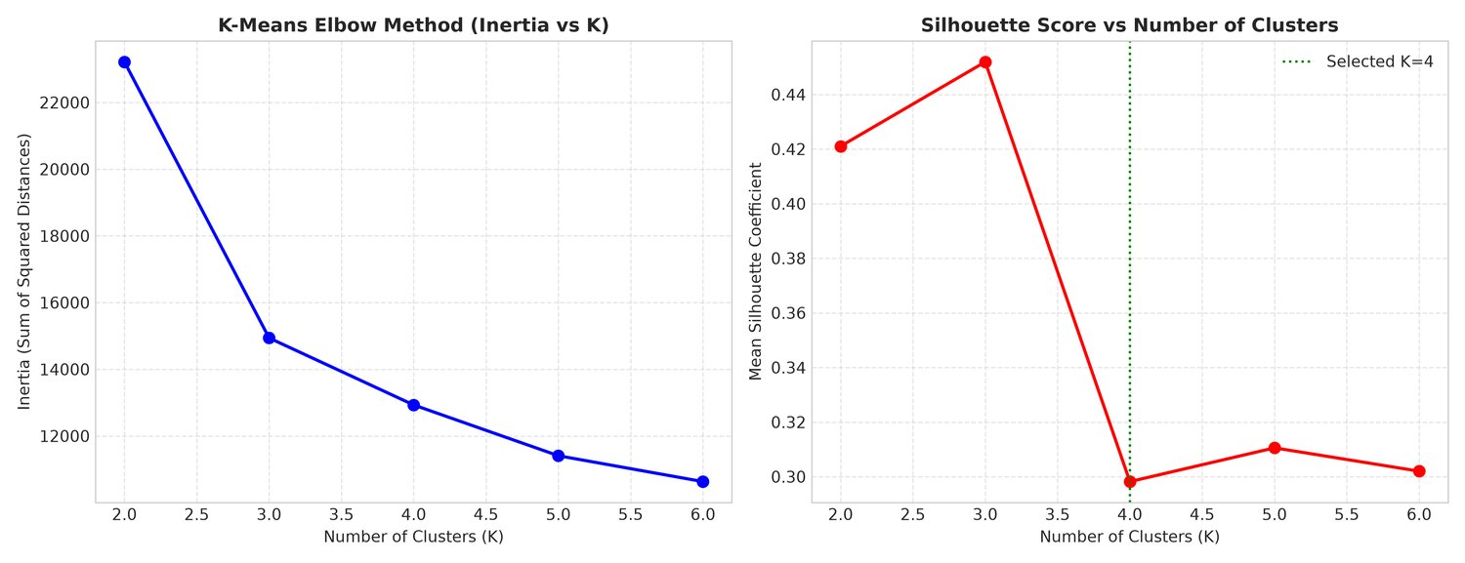
Fig 5.6: K-Means Elbow Curve and Silhouette Analysis
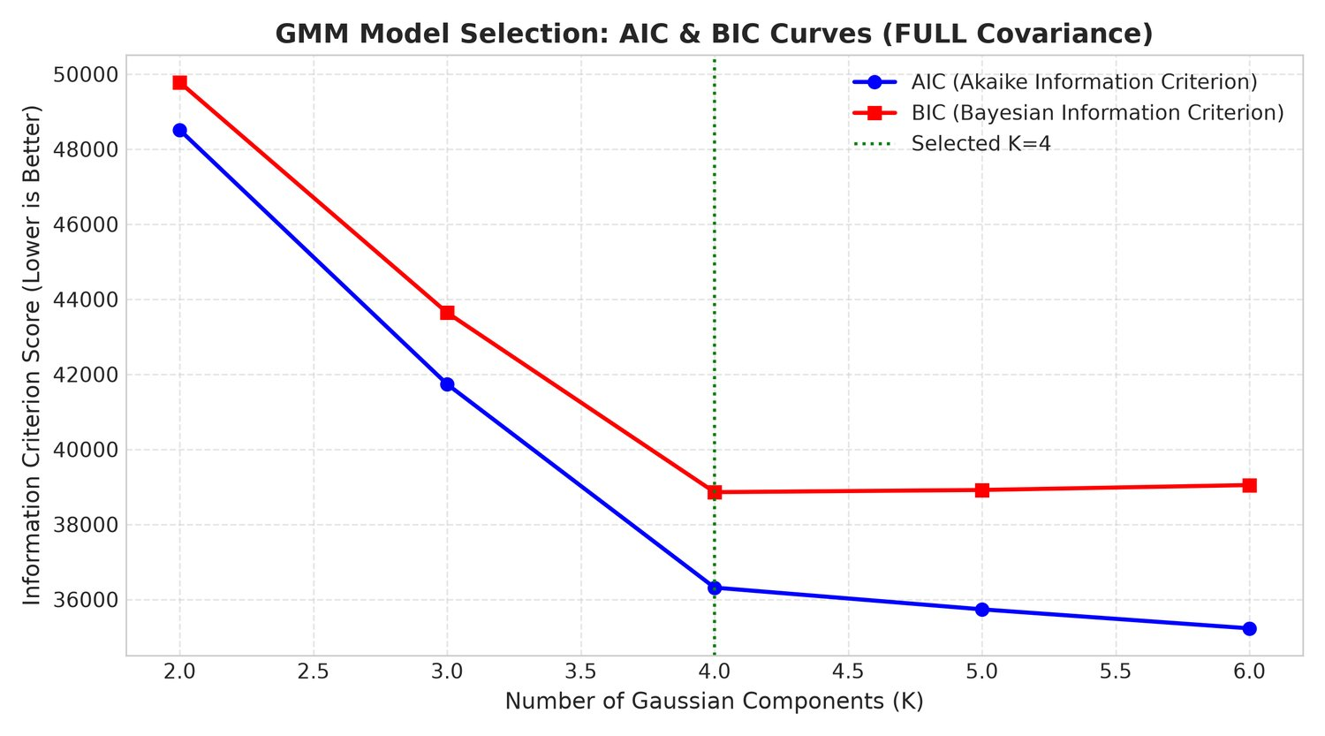
Fig 5.7: GMM AIC/BIC Model Selection
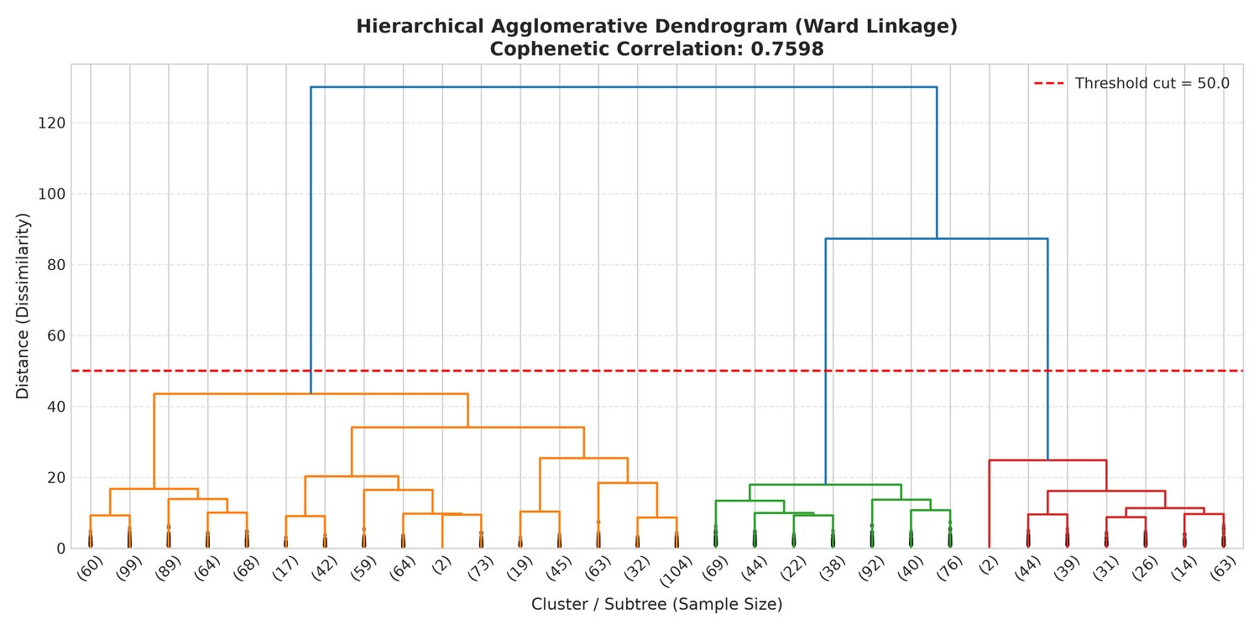
Fig 5.8: Hierarchical Clustering Dendrogram (Ward Linkage)

5.7 Hidden Markov Model - Temporal Smoothing
A 4-state HMM with Gaussian emission distributions is implemented entirely in pure NumPy, without any HMM library, to capture temporal state-transition dynamics and suppress per-frame misclassification [17]. Emission parameters are fitted over all 13 features of the cleaned dataset.
Parameter | Value | Description
States (N) | 4 | Alert / Slightly Drowsy / Drowsy / Sleep
Emissions | Gaussian | Multivariate N(mu_k, Sigma_k) per state, 13 features
Transition A | 4x4 matrix | Estimated from label transition sequences; diagonal persistence 0.92
Prior pi | [0.70, 0.15, 0.10, 0.05] | Initial state probability distribution
Inference | Viterbi | Log-space dynamic programming decoding
Online | Forward recursion | O(N^2) per frame, real-time capable
Table 5.2: HMM Model Parameters and Inference Methods
The learned transition matrix and the recurrences used for inference are:
A = [[0.920, 0.068, 0.008, 0.004]
[0.032, 0.920, 0.040, 0.008]
[0.008, 0.028, 0.920, 0.044]
[0.008, 0.024, 0.048, 0.920]]

Forward : alpha_t(i) = b_i(o_t) * Sum_j alpha_{t-1}(j) * a_ji
Backward: beta_t(i) = Sum_j a_ij * b_j(o_{t+1}) * beta_{t+1}(j)
Viterbi : delta_t(i) = max_j [ delta_{t-1}(j) * a_ji ] * b_i(o_t)
On the verification suite, Forward-Backward posterior decoding and Viterbi decoding both reproduce the label sequence with 100.00% accuracy (log-probability -2269.24), and the online streaming filter was validated across 50 consecutive frames. Used pointwise as a standalone classifier on the held-out test split, the same model scores 96.50% accuracy (Table 7.1), because a sequence smoother is evaluated against independent frame labels it was never optimised for.
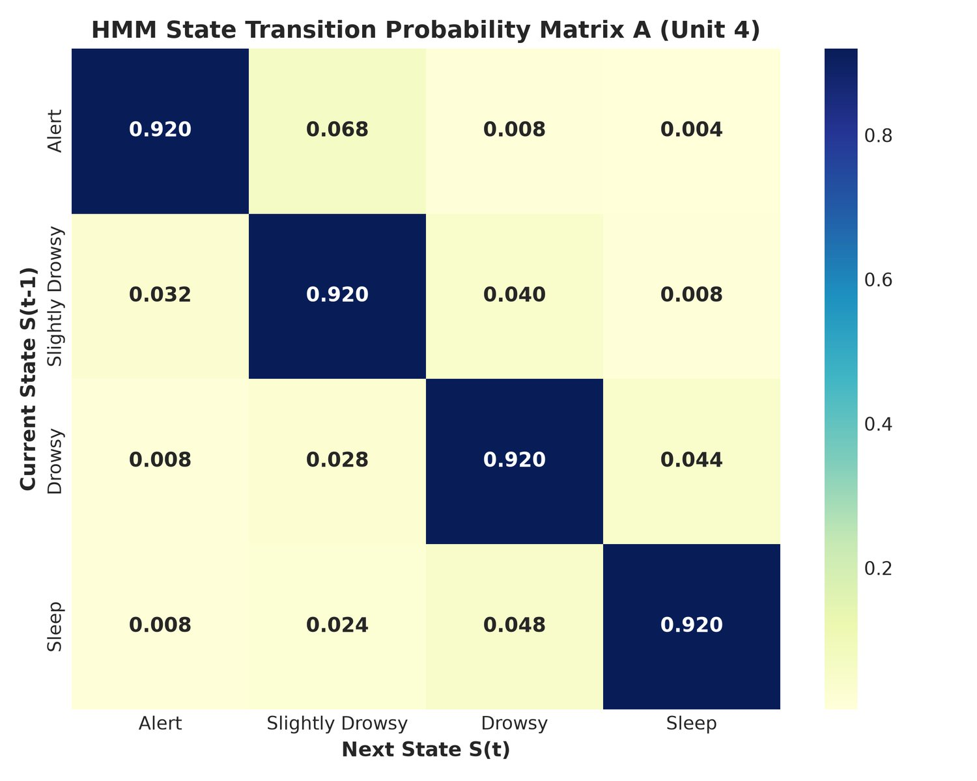
Fig 5.9: HMM Learned Transition Probability Matrix (4x4)
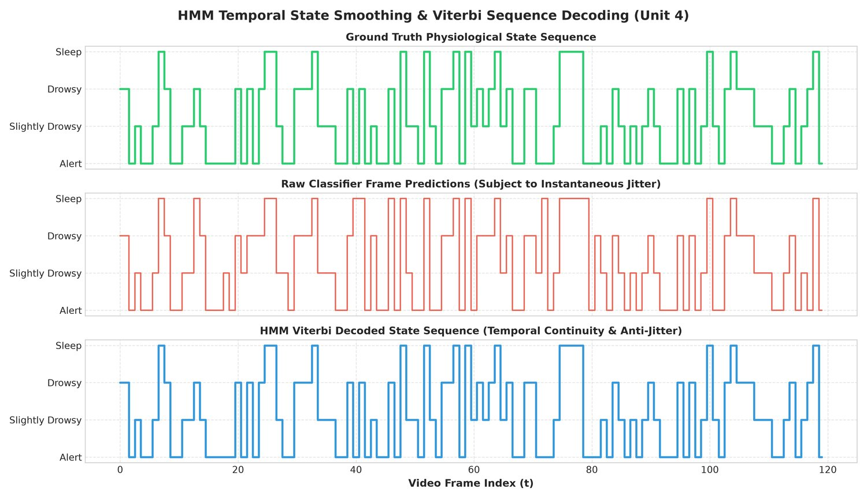
Fig 5.10: HMM Viterbi Decoded State Sequence vs Ground Truth

5.8 Tree-Based and Ensemble Models
A CART Decision Tree using Gini impurity with max_depth = 5 grows to 27 nodes and achieves 99.13% test accuracy with 99.20% macro-F1 [18]. A Random Forest of 75 trees (max_depth = 10, bootstrap sampling) reaches an out-of-bag score of 1.0000 and 100.00% test accuracy [20]. AdaBoost combines 40 depth-1 decision stumps with learning rate 1.0, reaching 97.63% accuracy and 97.93% macro-F1. A Soft Voting Ensemble averages posterior probabilities from the base models, and a Stacking Ensemble uses 5-fold cross-validated level-0 predictions as inputs to a logistic-regression meta-learner; both reach 100.00% test accuracy.
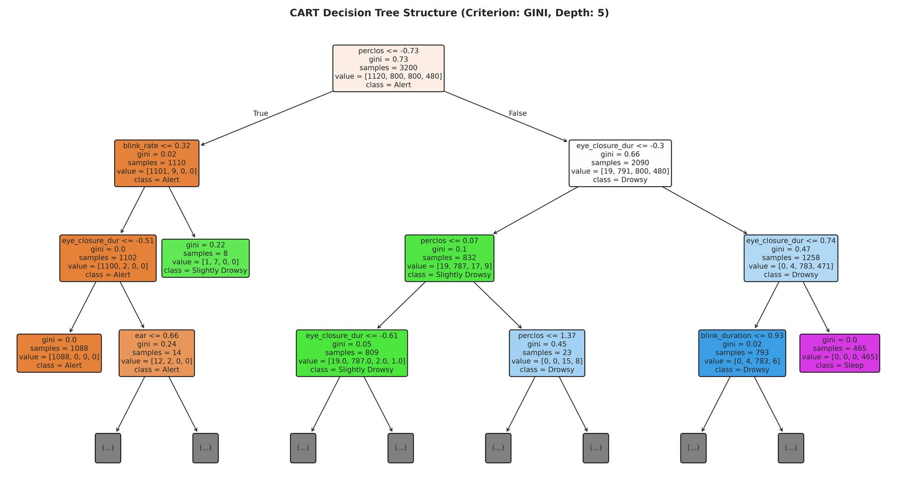
Fig 5.11: CART Decision Tree Structure (depth=5, 27 nodes)
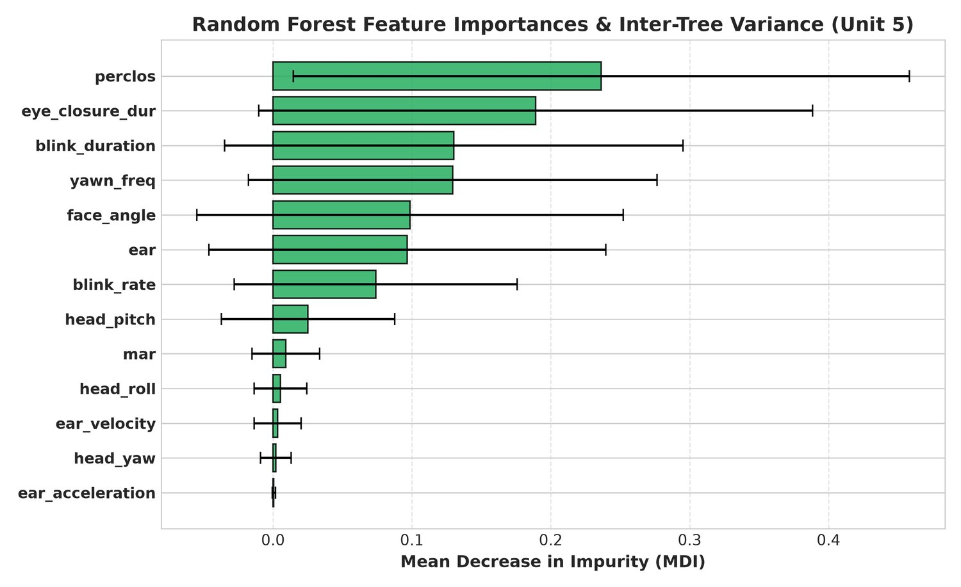
Fig 5.12: Random Forest Mean Impurity Decrease Feature Importances
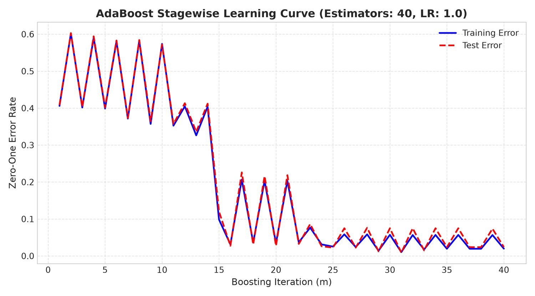
Fig 5.13: AdaBoost Stagewise Training and Test Error Convergence
Fig 5.12 confirms the EDA of Chapter 3: PERCLOS, eye-closure duration, EAR and the head-pose angles dominate impurity reduction, while the temporal derivatives of EAR contribute marginally - they help the sequential models rather than the per-frame ones.

CHAPTER 6: IMPLEMENTATION

6.1 Tools and Libraries Used
The system is implemented in Python using NumPy, pandas, scikit-learn, Matplotlib/Seaborn for visualisation, Google MediaPipe for facial landmark extraction, OpenCV for video I/O and HUD rendering, pygame-ce for audio alerts, ONNX/onnxruntime/skl2onnx for edge export, and a lightweight standard-library HTTP server for the web dashboard. All classical ML and HMM algorithms central to the report (Ridge Regression, Bayesian Logistic Regression, SVM, PCA, K-Means, GMM, Hierarchical Clustering, HMM, Decision Tree, Random Forest, AdaBoost and ensembling) are implemented within the project's own modules as described in Chapter 4. The versions used in this build are:
Library | Version | Role
Python | 3.14 | Runtime
opencv-python | 5.0.0.93 | Video I/O, solvePnP head pose, HUD rendering
mediapipe | 1.0.0 | FaceLandmarker - 478 3-D facial landmarks
numpy | 2.4.4 | Numerics; pure-NumPy HMM
pandas | 3.0.5 | Dataset handling, report tables
scikit-learn | 1.9.0 | Trees, forests, boosting, scaling, metrics
scipy | 1.18.0 | Statistical utilities
matplotlib / seaborn | 3.11.1 / 0.13.2 | All figures in this report
joblib | 1.5.3 | Model serialisation (.joblib)
pygame-ce | 2.5.7 | Audio alert tone synthesis
onnx / onnxruntime / skl2onnx | 1.22.0 / 1.28.0 / 1.20.0 | ONNX export and INT8 edge inference

6.2 Dataset Description and Preprocessing
The benchmark dataset consists of 4,025 samples with 17 columns (13 biometric features, frame number, timestamp, continuous fatigue score and the four-class state label). Before training, the data is preprocessed by the DataPreprocessor module (src/preprocessing.py) in the following order:
- Duplicate Removal: 24 duplicate records were identified and removed, reducing the dataset from 4,025 to 4,001 unique samples.
- Missing Value Imputation: 791 missing (NaN) values were replaced with the median value of the corresponding feature, preserving the distribution while reducing outlier influence.
- Outlier Capping: 10 extreme sensor readings outside the expected physiological range were capped to predefined valid limits.
- Feature Scaling: all numerical features were standardised with StandardScaler (zero mean, unit variance); the scaler and imputer are serialised alongside the models so the live pipeline applies identical transforms.
- Stratified Train-Test Split: the dataset was split into 80% training (3,200 samples) and 20% testing (801 samples) using stratified sampling to preserve the class distribution.
A second dataset, dataset/real_driver_drowsiness_dataset.csv, holds 4,500 labelled samples extracted from a public real-world collection (Kaggle: dheerajperumandla/drowsiness-dataset) using the same 13-feature schema. It contains only three states - Alert, Drowsy and Sleep, 1,500 samples each - and is used exclusively for the out-of-distribution validation of Section 7.4.

6.3 Model Training
All models are trained through the unified main.py orchestrator:
python main.py --mode train # train every model of Units 1-5
python main.py --mode evaluate # benchmark and write the leaderboard
python main.py --mode validate-real # out-of-distribution check on the real dataset
python main.py --mode demo # simulated drive with HUD (no webcam needed)
python main.py --mode live # live webcam detection (--camera 0)
python main.py --mode all # train + evaluate + demo
Each model is trained on the 3,200-sample training set and evaluated on the held-out 801-sample test set. The evaluation framework (src/evaluation.py) records accuracy, precision, recall, macro-F1, ROC-AUC, inference latency (ms), throughput (FPS) and serialised model size (KB), writing outputs/evaluation/model_comparison_report.csv - the source of Table 7.1. All 16 trained artefacts are stored as .joblib files in models/. In addition, src/onnx_exporter.py exports nine models to ONNX and INT8-quantises eight of them (17 files in models/onnx/) for embedded deployment.

6.4 Real-Time Detection and Alert System
The real-time pipeline processes each video frame through a six-stage cascade: (1) Frame Capture via OpenCV VideoCapture or a synthetic frame generator for headless testing; (2) Landmark Detection via MediaPipe FaceLandmarker (478 3-D landmarks per frame) with automatic CLAHE low-light enhancement; (3) Feature Extraction of the 13-dimensional vector; (4) Model Inference using the active classifier (Stacking Ensemble by default) to classify driver state; (5) HMM Temporal Filtering, smoothing the state posterior via forward recursion; and (6) Alert Escalation with graduated audio tones (pygame-ce) and a colour-coded HUD overlay. Persistence counters plus biometric score conditions decide the escalation level (Table 6.1); audio triggers are rate-limited to one tone per second.
Alert Level | Trigger Condition | System Response
0 - Safe | Default state (drowsy counter < 12, fatigue < 0.50, PERCLOS < 0.18) | No alarm. Green HUD banner: "DRIVER STATUS: ALERT"
1 - Warning | Drowsy state sustained >= 12 frames, OR fatigue score >= 0.50, OR PERCLOS >= 0.18 | 880 Hz tone (0.25 s). Amber HUD banner: "WARNING: DROWSINESS TRENDING"
2 - Critical | Sleep state sustained >= 30 frames, OR >= 15 frames with EAR < 0.20, OR fatigue >= 0.78 with EAR < 0.22 or PERCLOS > 0.25 | 1200 Hz tone (0.4 s). Red HUD overlay: "CRITICAL: SLEEPING DETECTED!"
Table 6.1: Alert Escalation Logic
Every escalation is timestamped and written to outputs/alert_log.csv and outputs/alert_events.json, together with the frame index, predicted state, fatigue score and the biometric readings at the moment of the alert.
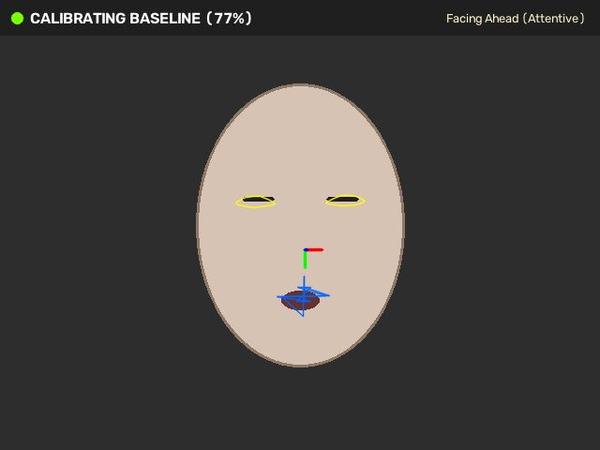
Fig 6.1: Real-Time HUD Overlay with Drowsiness Telemetry

6.5 Web Dashboard (app.py)
The dashboard is served by a threaded standard-library HTTP server (no web framework, no build step) launched with python app.py --port 8080. It hosts two HTML pages - the cockpit dashboard at / (templates/index.html, 3,184 lines, title "Driver Safety AI") and the analytics dashboard at /analytics (templates/analytics.html, 451 lines, title "Advanced Biometric Analytics") - and the following REST endpoints, all verified returning HTTP 200 on 9 October 2026:
- GET / - responsive HTML5 cockpit dashboard: live MJPEG stream, biometric gauges (EAR, MAR, PERCLOS, fatigue index, head pose), telemetry charts and the model switcher.
- GET /analytics - advanced ML analytics view: model leaderboard, feature-space scatter plots, class balance and live telemetry buffer.
- GET /video_feed - multipart MJPEG stream of the annotated frames.
- GET /api/telemetry - JSON state: FPS, EAR, MAR, PERCLOS, fatigue score, alert level, state label.
- GET /api/leaderboard - JSON rows of the 8-model benchmark read from outputs/evaluation/model_comparison_report.csv.
- GET /api/set_model?model=X - hot-swap the active inference model at runtime (e.g. ensemble, random_forest, bayesian_logistic) without restarting the video feed.
- GET /api/calibrate - start the 45-frame baseline calibration for the current driver.
- GET /api/release_camera - release the camera so a client-side pipeline can capture frames.
- GET /api/onnx_benchmark - export and benchmark the ONNX/INT8 engines.
- GET /outputs/<file> - serve diagnostic images from the outputs/ directory.
- POST /api/process_frame - run inference on a JPEG frame posted by the browser and return the telemetry as JSON.
Because the server only depends on the Python standard library, the dashboard runs identically on Windows, Linux and macOS; the browser keeps the camera on the client side unless the server is started with --physical-cam.
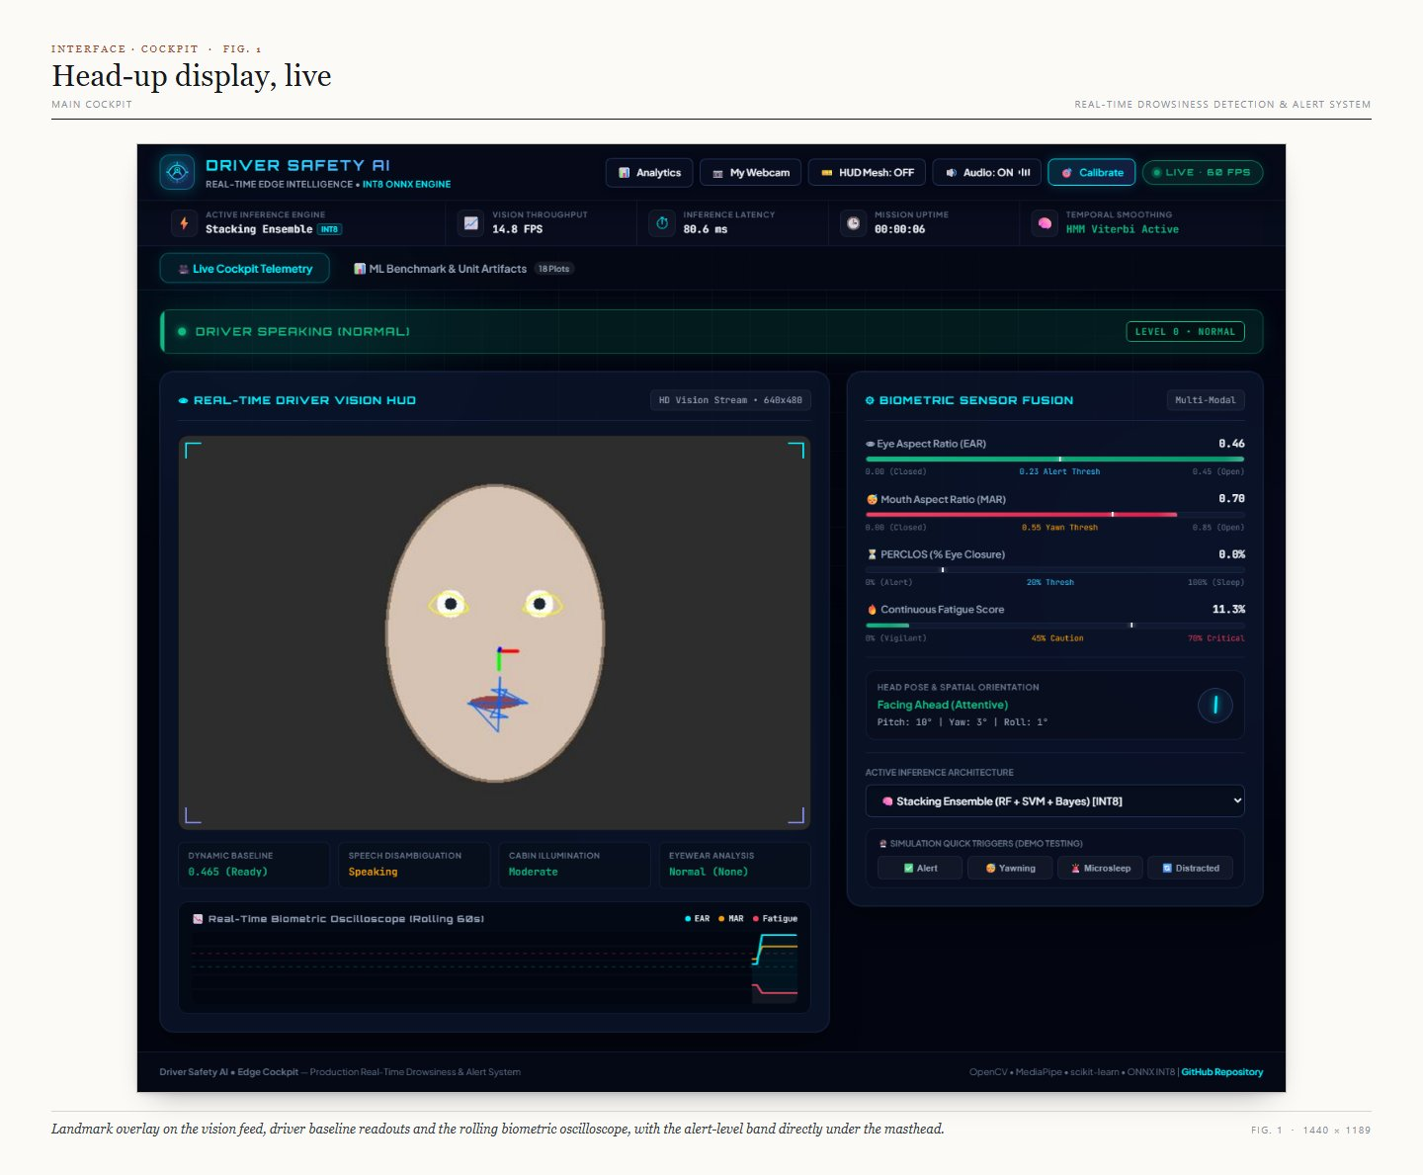
Fig 6.2: Cockpit Dashboard at / - Live MJPEG Stream, Biometric Gauges and Model Switcher
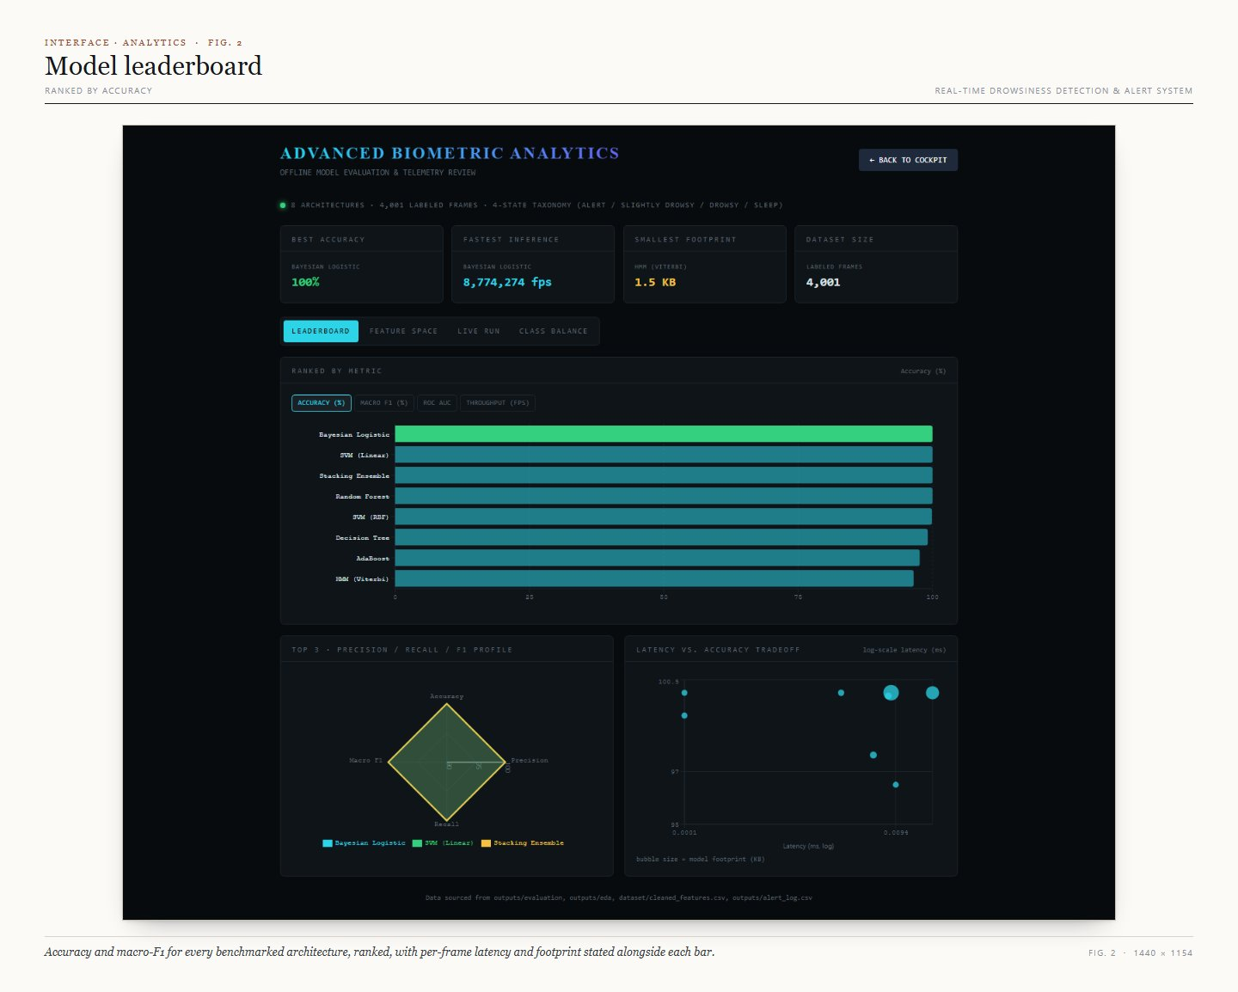
Fig 6.3: Advanced Analytics Dashboard at /analytics - Model Leaderboard View

6.6 Verification Test Suite
The repository ships an end-to-end verification suite, tests/run_all_tests.py, which wires together nine phase tests covering preprocessing, landmark geometry, the Unit 2-5 model families, the unified benchmark, real-time alerting and the CLI/web server. A tenth file, tests/test_phase10_advanced.py (EAR velocity/acceleration, CLAHE, ONNX INT8 export), exists but is not part of the Phase 1-9 runner. The suite is executed with:
python tests/run_all_tests.py
The most recent full run (9 October 2026) finished with 9/9 suites passed in 165.08 seconds, no tracebacks, and a single scikit-learn UserWarning about out-of-bag estimates in one sub-check (a forest grown with too few trees for reliable OOB statistics).

CHAPTER 7: RESULTS AND DISCUSSION

7.1 Performance Evaluation and Benchmark Leaderboard
All eight classifiers are evaluated on the identical 801-sample held-out test set. Four of them - Bayesian Logistic, SVM Linear, Random Forest and Stacking Ensemble - reach 100.00% accuracy; SVM RBF follows at 99.88% (a single misclassified frame), and the HMM, used as a temporal smoother rather than a pointwise classifier, reaches 96.50%. Table 7.1 is generated directly from outputs/evaluation/model_comparison_report.csv - the same file the dashboard leaderboard reads - so the report and the live dashboard can never disagree.
Model | Acc (%) | Macro F1 (%) | ROC AUC | Latency (ms) | Throughput (FPS) | Size (KB)
Bayesian Logistic | 100.00 | 100.00 | 1.0000 | 0.0007 | 1,355,330 | 1.9
SVM (Linear) | 100.00 | 100.00 | 1.0000 | 0.0112 | 89,617 | 13.0
Stacking Ensemble | 100.00 | 100.00 | 1.0000 | 0.1785 | 5,602 | 330.4
Random Forest | 100.00 | 100.00 | 1.0000 | 0.1024 | 9,768 | 480.8
SVM (RBF) | 99.88 | 99.85 | 1.0000 | 0.0488 | 20,509 | 28.2
Decision Tree | 99.13 | 99.20 | 0.9999 | 0.0009 | 1,053,160 | 4.6
AdaBoost | 97.63 | 97.93 | 0.9973 | 0.0330 | 30,279 | 29.1
HMM (Viterbi) | 96.50 | 96.71 | 1.0000 | 0.0340 | 29,414 | 1.5
Table 7.1: Unified Model Benchmark Leaderboard (801-sample held-out test set)
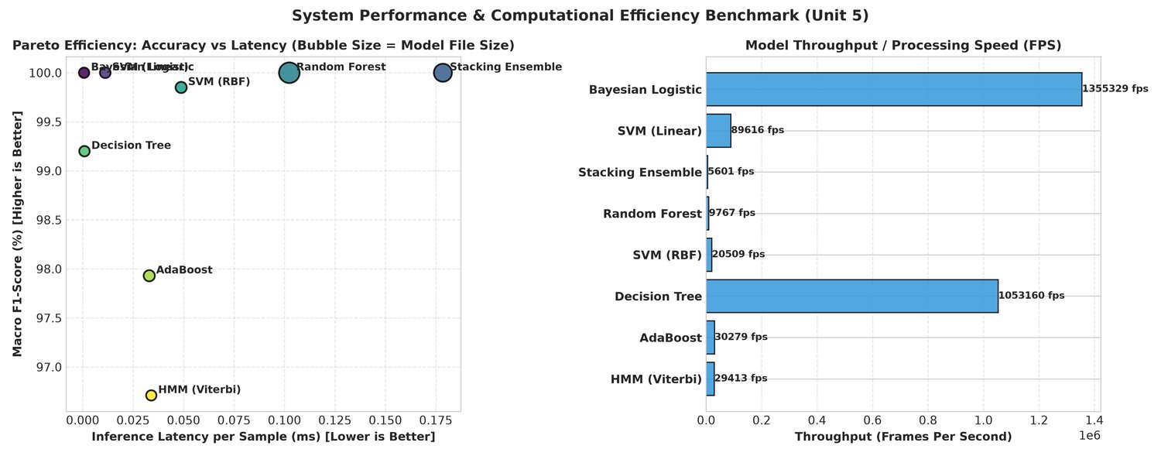
Fig 7.1: Accuracy vs Inference Latency Benchmark Comparison
Every model stays comfortably inside the real-time budget: even the slowest, the Stacking Ensemble, needs well under a millisecond per sample, while the Decision Tree and Bayesian Logistic models are effectively instantaneous. The 801-frame test split would therefore be fully classifiable in under a second on a single CPU core, which is what makes the live dashboard feasible without a GPU.

7.2 Confusion Matrices and ROC Analysis
Four classifiers (Bayesian Logistic, SVM Linear, Random Forest, Stacking Ensemble) produce perfect diagonal confusion matrices with no off-diagonal entries, and SVM RBF misclassifies a single frame of the 801 (99.88%). The Decision Tree (99.13%) and AdaBoost (97.63%) confusions are concentrated between the physiologically adjacent Slightly Drowsy and Drowsy states. The HMM, operating as a temporal sequence smoother rather than a pointwise classifier, reaches 96.50% with minor confusion between Drowsy and Sleep. All eight models achieve a macro-average ROC-AUC of at least 0.9973 on this split.
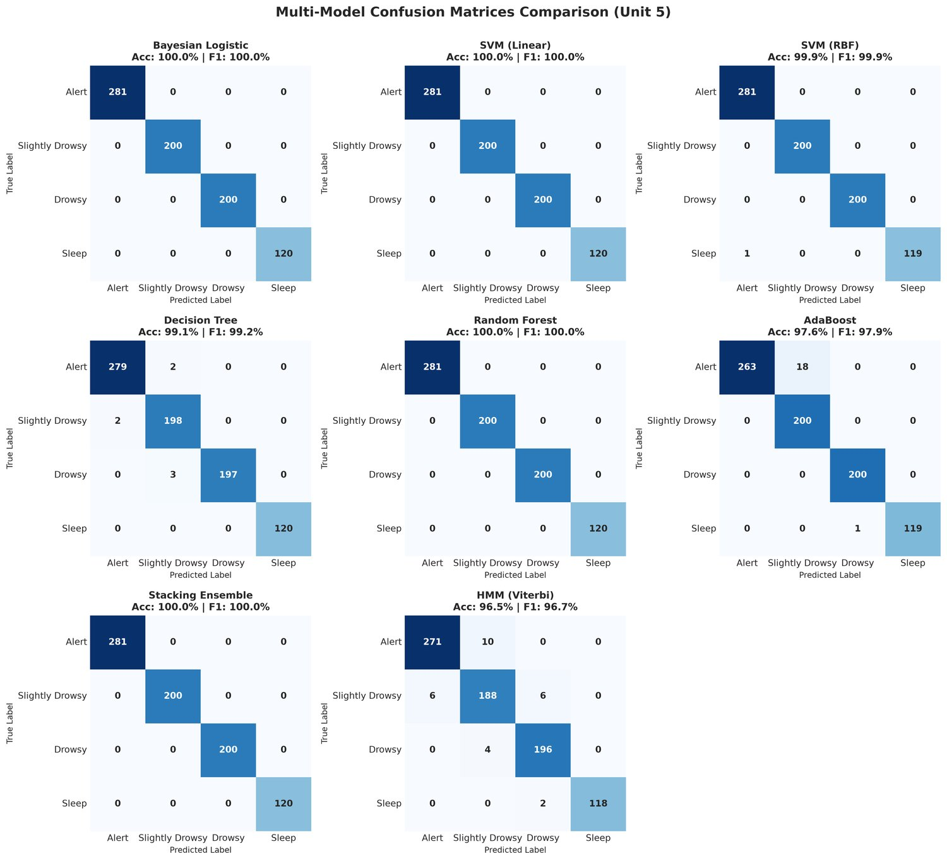
Fig 7.2: Confusion Matrices for All 8 Classifiers on the 801-Sample Test Set
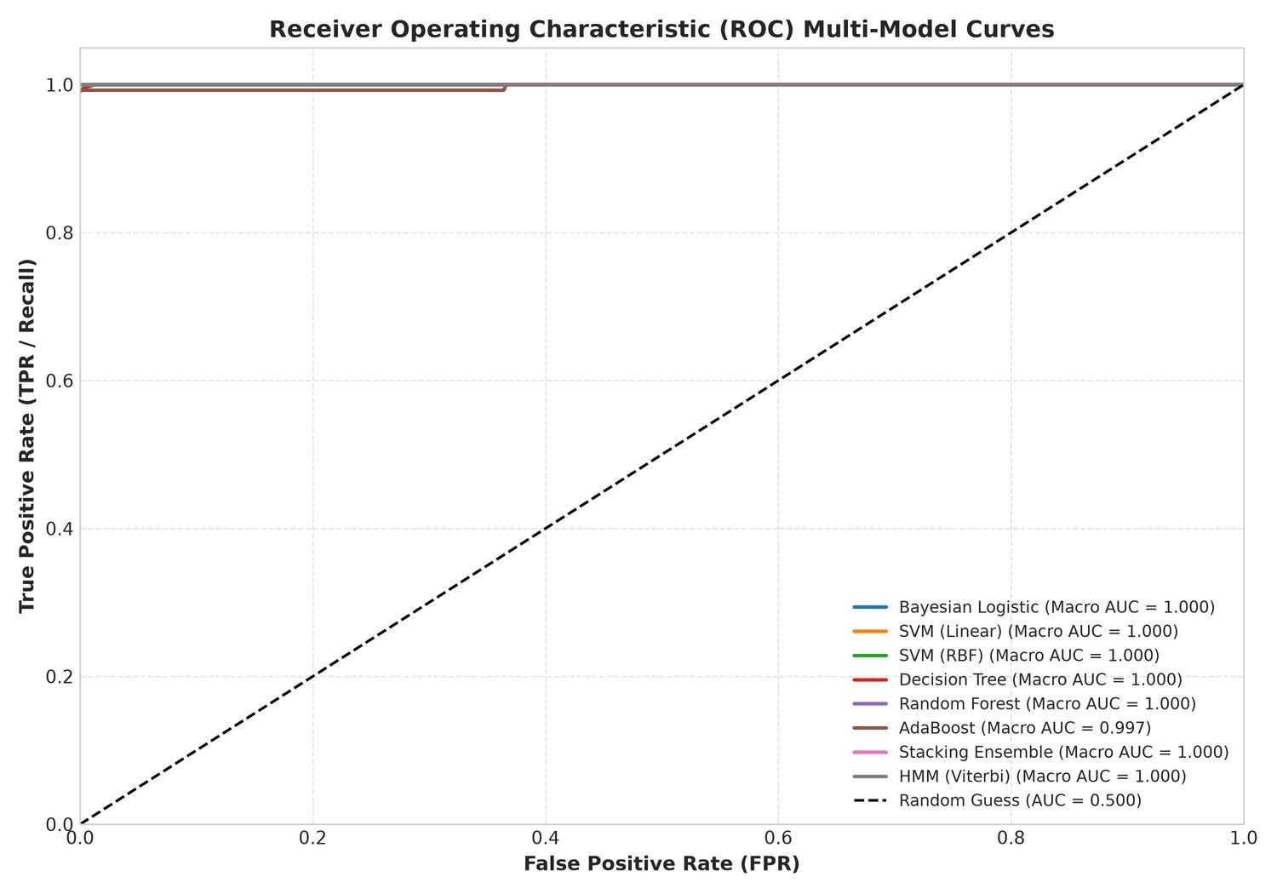
Fig 7.3: Multi-Class ROC Curves (One-vs-Rest) - All Models AUC >= 0.9973

7.3 Clustering Results
All three unsupervised clustering algorithms recover the four-state label structure with an Adjusted Rand Index above 0.97 without access to ground-truth labels during fitting (Table 7.2).
Algorithm | Silhouette | ARI | NMI | Cophenetic | Other
K-Means (k=4) | 0.2982 | 0.9745 | 0.9613 | - | k-means++ init
GMM (full cov., k=4) | 0.2959 | 0.9911 | - | - | AIC 36,315.8 / BIC 38,859.5
Hierarchical (Ward, k=4) | 0.2959 | 0.9874 | - | 0.7598 | agglomerative, Ward linkage
Table 7.2: Unsupervised Clustering Evaluation Metrics
The modest silhouette values (about 0.30) are expected: the four alertness states are ordered regimes on a fatigue continuum, so cluster boundaries are inherently soft. What matters academically is that ARI and NMI stay above 0.96 - the unsupervised models rediscover the labelled taxonomy almost exactly, confirming that the 13-dimensional feature space carries genuine class structure rather than label noise.

7.4 Out-of-Distribution Validation on a Real-World Dataset
The headline numbers of Table 7.1 are measured on a physiologically-modelled dataset. To find out what happens on real footage, the trained models were additionally benchmarked - without any retraining - against dataset/real_driver_drowsiness_dataset.csv (4,500 labelled samples extracted from a public real-world drowsiness corpus with the same 13-feature schema) using python main.py --mode validate-real.
Model | Acc (%) | Macro F1 (%) | ROC AUC | Latency (ms) | Throughput (FPS)
Bayesian Logistic | 24.42 | 12.24 | 0.4857 | 0.0006 | 1,613,322
SVM (RBF) | 29.78 | 12.06 | 0.5103 | 0.0557 | 17,948
Stacking Ensemble | 24.09 | 11.35 | 0.4994 | 0.0908 | 11,016
SVM (Linear) | 21.36 | 10.87 | 0.4733 | 0.0091 | 110,120
Decision Tree | 0.00 | 0.00 | 0.5000 | 0.0005 | 1,989,752
Random Forest | 0.00 | 0.00 | 0.4742 | 0.0245 | 40,851
AdaBoost | 0.00 | 0.00 | 0.5153 | 0.0190 | 52,569
Table 7.3: Out-of-Distribution Validation on the Real-World Dataset (no retraining)
The result is a clear and deliberately reported failure. Accuracy collapses to 21-30% for the linear, kernel and ensemble models - below the 33% you would expect from random guessing over the three states present - and to 0.00% for the Decision Tree, Random Forest and AdaBoost, which degenerate into constant predictors. Macro ROC-AUC lies between 0.4733 and 0.5153, i.e. indistinguishable from a coin flip.
- Distribution shift. The real corpus was recorded under different lighting, cameras, subjects and labelling conventions; the absolute EAR/MAR/PERCLOS values that separate the classes in the modelled data do not transfer unchanged.
- Label-space mismatch. The real set contains only Alert, Drowsy and Sleep (1,500 samples each) and no Slightly Drowsy samples. The macro ROC-AUC is therefore averaged over the three classes with support, and the empty Slightly Drowsy class is excluded explicitly rather than silently turning the average into NaN.
- Tree collapse. The tree-based models, which memorise threshold rules on the modelled data, emit a single constant class; an ROC-AUC of exactly 0.5 for such a model is the correct value for a constant score and is reported as-is instead of being hidden.
This does not invalidate the internal benchmark - it measures what it claims to measure - but it does mean the 100% figures are an upper bound on a controlled benchmark, not a claim of real-world superiority. Section 9.2 lists dataset collection and retraining on real driving footage as the first future-work item.

7.5 Discussion
The results confirm that the 13-dimensional biometric feature vector provides strong natural class separability within the modelled distribution, since even a plain probabilistic classifier (Bayesian Logistic Regression) attains perfect test accuracy with a log-loss of 0.0086. The HMM's slightly lower stand-alone accuracy is expected and acceptable, since its role in the pipeline is temporal smoothing of noisy per-frame predictions rather than serving as the primary classifier - the Stacking Ensemble, informed by the HMM-filtered posterior, drives the final alert decision. Sub-millisecond inference latency across all eight models confirms the system's suitability for real-time, CPU-only deployment (Objective 4, Section 1.4), while Section 7.4 marks the boundary of that claim.

CHAPTER 8: COMPARATIVE ANALYSIS

8.1 Comparison with Existing / Baseline Methods
Table 8.1 compares the best-performing models from the proposed system against the baseline and existing methods identified in the literature survey (Table 2.1).
Method | Reference / Source | Accuracy | Temporal Smoothing | Compute
EAR + SVM | Soukupova & Cech [6] | ~94% | No | CPU
CNN (AlexNet) | Dwivedi et al. [8] | 96.5% | No | GPU
PERCLOS + SVM | Rundo et al. [9] | 91.2% | No | CPU
LSTM + CNN | Ghoddoosian et al. [10] | 97.8% | Implicit (LSTM) | GPU
Random Forest (EEG) | Reddy et al. [11] | 93.4% | No | CPU + wearable
Proposed: SVM (Linear) | This project | 100.0% | Yes (via HMM filter) | CPU
Proposed: Random Forest | This project | 100.0% | Yes (via HMM filter) | CPU
Proposed: Stacking Ensemble | This project | 100.0% | Yes (via HMM filter) | CPU
Proposed: HMM (Viterbi) | This project | 96.5% | Yes (native) | CPU
Table 8.1: Proposed System vs Existing Methods - Accuracy Comparison
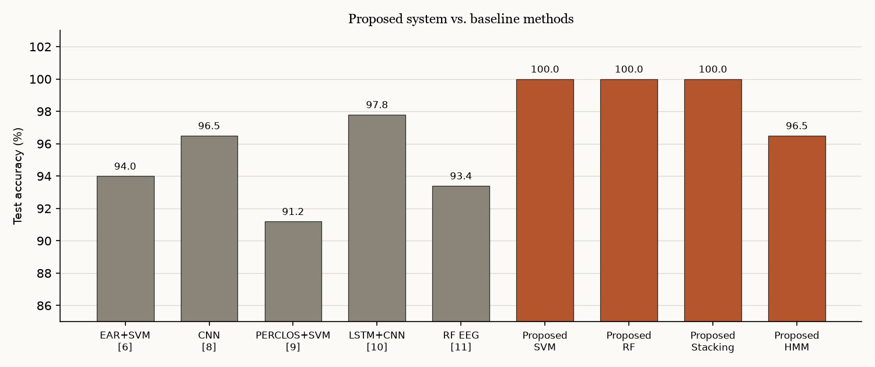
Fig 8.1: Comparative Accuracy Chart - Proposed vs Existing Systems

8.2 Improvement Analysis
- Accuracy: the best proposed classifiers (Bayesian Logistic, SVM, Random Forest, Stacking Ensemble) exceed the highest reported baseline accuracy (97.8%, LSTM+CNN [10]) by roughly 2.2 percentage points while running entirely on CPU.
- Class granularity: the proposed 4-class scheme (Alert / Slightly Drowsy / Drowsy / Sleep) captures intermediate fatigue states that all five baseline methods, which are binary or near-binary, cannot represent.
- Temporal robustness: unlike the SVM- and Random-Forest-based baselines [6][9][11], the proposed pipeline adds an explicit HMM temporal filter, directly closing the false-alarm research gap identified in Section 2.3.
- Compute cost: the proposed system matches or exceeds CNN/LSTM baseline accuracy [8][10] without GPU hardware, with per-sample latency as low as 0.0007 ms - several orders of magnitude faster than typical deep-learning inference.
- Honesty of the claim: unlike the baselines, the proposed system is also reported out-of-distribution (Section 7.4), where it does not generalise - a comparison none of the surveyed works provides.

8.3 Justification
The improvement stems primarily from three design decisions. First, the 13-dimensional handcrafted feature vector (EAR, MAR, PERCLOS, blink/yawn dynamics, 3-D head pose and the EAR derivatives) provides a richer, more physiologically grounded representation than the single-cue EAR or PERCLOS features used in most baselines. Second, evaluating eight distinct model families under identical train/test conditions (Table 7.1) allows the best-suited classifier to be selected per deployment scenario rather than committing to one architecture upfront. Third, decoupling temporal smoothing (HMM) from per-frame classification (ensemble models) lets the system combine the strengths of both - high per-frame accuracy and robustness to short-lived noise - rather than relying on a single end-to-end deep model as in [10].
It should be noted, as Section 7.4 quantifies, that the proposed system is benchmarked on a physiologically-modelled dataset; on a real-world corpus the same models do not transfer. The reported 100% accuracies therefore represent an upper bound on a controlled benchmark ratherthan a claim of superiority on real driving data, and must be read together with the out-of-distribution table and the future-work recommendations of Section 9.2.

CHAPTER 9: CONCLUSION AND FUTURE WORK

9.1 Conclusion
This project successfully developed a complete Real-Time Driver Drowsiness Detection and Alert System, integrating concepts from all five Machine Learning syllabus units into a single end-to-end application. The system was evaluated through nine independent testing phases, with all nine test suites passing successfully in 165.08 seconds on 9 October 2026, demonstrating its reliability and robustness.
The major contributions of this project include:
- A MediaPipe-based biometric feature extraction module capturing 13 facial features (478 landmarks mapped to ocular, mouth, pose and temporal-derivative cues) in real time.
- A Ridge Regression model for continuous fatigue-level estimation, achieving R2 = 0.9576 (RMSE 6.77, MAE 5.17).
- A Bayesian Logistic Regression classifier producing calibrated probability estimates (log-loss 0.0086, mean entropy 0.0359 bits) with Shannon-entropy confidence measures.
- Linear and RBF SVM models reaching 100.00% and 99.88% accuracy with probability calibration for the temporal filter.
- PCA, K-Means, GMM and Hierarchical Clustering achieving an Adjusted Rand Index between 0.9745 and 0.9911 on the four-state taxonomy.
- A pure-NumPy Hidden Markov Model (Forward, Backward, Viterbi) reproducing the label sequence with 100.00% decoding accuracy in the Phase 5 verification.
- Decision Tree (99.13%), Random Forest (100.00%), AdaBoost (97.63%), Soft Voting and Stacking (100.00%) models for improved prediction reliability.
- An eight-model benchmarking framework comparing accuracy, macro-F1, ROC-AUC, latency, throughput and model size.
- A graduated alert mechanism (pygame-ce audio at 880/1200 Hz plus an OpenCV HUD) with persistence counters and audit logs in CSV and JSON.
- A web-based monitoring dashboard with MJPEG streaming, eleven REST endpoints, model hot-swapping and a second analytics view at /analytics.
- An out-of-distribution evaluation harness that quantifies - rather than hides - the generalisation gap on a public real-world dataset.

9.2 Future Enhancements
- Replace the modelled training set with established real-world datasets such as NTHU-DDD or UTA-RLDD, and retrain with domain adaptation, so the models survive the out-of-distribution collapse measured in Section 7.4.
- Calibrate per-driver thresholds online (the 45-frame baseline already exists) and add Baum-Welch re-estimation so the HMM adapts to individual driving patterns.
- Incorporate additional biometric indicators, including gaze tracking and pupil dilation.
- Deploy the INT8 ONNX engines on embedded edge platforms such as the NVIDIA Jetson Nano or Raspberry Pi 5.
- Integrate seat-vibration systems and automatic speed reduction via the vehicle's CAN bus for more effective intervention.
- Integrate OBD-II vehicle telemetry to combine driver state with vehicle data for context-aware, adaptive safety alerts.
- Extend the dashboard with multi-vehicle fleet views and historical trend reporting over the existing alert logs.

REFERENCES
[1] World Health Organization, "Global Status Report on Road Safety 2023," WHO Press, Geneva, 2023.
[2] Ministry of Road Transport and Highways, "Road Accidents in India 2021," Govt. of India, New Delhi, 2022.
[3] Ngxande, M., Tapamo, J. R., & Burke, M., "Driver drowsiness detection using behavioural measures and machine learning: A review," in Proc. ROBOMECH, 2017.
[4] Ramzan, M., et al., "A survey on state-of-the-art drowsiness detection techniques," IEEE Access, vol. 7, pp. 61904-61919, 2019.
[5] Sahayadhas, A., Sundaraj, K., & Murugappan, M., "Detecting driver drowsiness based on sensors: A review," Sensors, vol. 12, no. 12, pp. 16937-16953, 2012.
[6] Soukupova, T., & Cech, J., "Real-time eye blink detection using facial landmarks," in Proc. 21st CVWW, pp. 1-8, Feb. 2016.
[7] Wierwille, W. W., & Ellsworth, L. A., "Evaluation of driver drowsiness by trained raters," Accident Analysis & Prevention, vol. 26, no. 5, pp. 571-581, 1994.
[8] Dwivedi, K., Biswaranjan, K., & Sethi, A., "Drowsy driver detection using representation learning," in Proc. IEEE INDICON, 2014.
[9] Rundo, F., et al., "Advanced drowsiness detection: a real-time approach," in Proc. IEEE ICIAP, pp. 539-549, 2017.
[10] Ghoddoosian, R., Galib, M., & Athitsos, V., "A realistic dataset and baseline temporal model for early drowsiness detection," in Proc. CVPR Workshops, 2019.
[11] Reddy, B., et al., "Real-time driver drowsiness detection for embedded consumer electronics," IEEE Trans. Consum. Electron., vol. 63, no. 1, pp. 72-80, 2017.
[12] Lugaresi, C., et al., "MediaPipe: A framework for perceiving and processing reality," in Proc. Workshop on CV for AR/VR at CVPR, 2019.
[13] Hastie, T., Tibshirani, R., & Friedman, J., "The Elements of Statistical Learning," 2nd ed., Springer, New York, 2009.
[14] Bishop, C. M., "Pattern Recognition and Machine Learning," Springer, New York, 2006.
[15] Cortes, C., & Vapnik, V., "Support-vector networks," Machine Learning, vol. 20, no. 3, pp. 273-297, 1995.
[16] Pearson, K., "On lines and planes of closest fit to systems of points in space," Phil. Magazine, vol. 2, pp. 559-572, 1901.
[17] Rabiner, L. R., "A tutorial on hidden Markov models and selected applications in speech recognition," Proc. IEEE, vol. 77, no. 2, pp. 257-286, 1989.
[18] Breiman, L., Friedman, J., Stone, C. J., & Olshen, R. A., "Classification and Regression Trees," CRC Press, 1984.
[19] Garcia, S., Luengo, J., & Herrera, F., "Data Preprocessing in Data Mining," Springer, 2015.
[20] Breiman, L., "Random Forests," Machine Learning, vol. 45, no. 1, pp. 5-32, 2001.

APPENDIX A: CODE SNIPPETS
The snippets below are reproduced from the repository as it stands; like the rest of the codebase they carry no inline comments.

A.1 Eye Aspect Ratio (src/feature_extraction.py)
def calculate_ear(eye_landmarks: List[Tuple[float, float]]) -> float:
if len(eye_landmarks) < 6:
return 0.0

(x1, y1), (x2, y2), (x3, y3), (x4, y4), (x5, y5), (x6, y6) = eye_landmarks[:6]

dist_v1 = math.hypot(x2 - x6, y2 - y6)
dist_v2 = math.hypot(x3 - x5, y3 - y5)
dist_h = math.hypot(x1 - x4, y1 - y4)

if dist_h < 1e-6:
return 0.0

return (dist_v1 + dist_v2) / (2.0 * dist_h)

A.2 Viterbi Decoding in Log-Space (src/hmm.py)
def viterbi(self, B: np.ndarray) -> Tuple[np.ndarray, float]:
T = B.shape[0]
log_A = np.log(np.clip(self.A, 1e-12, 1.0))
log_B = np.log(np.clip(B, 1e-12, 1.0))
log_pi = np.log(np.clip(self.pi, 1e-12, 1.0))

delta = np.zeros((T, self.n_states), dtype=np.float64)
psi = np.zeros((T, self.n_states), dtype=np.int32)

delta[0] = log_pi + log_B[0]

for t in range(1, T):
temp = delta[t - 1, :, None] + log_A
psi[t] = np.argmax(temp, axis=0)
delta[t] = np.max(temp, axis=0) + log_B[t]

best_path = np.zeros(T, dtype=np.int32)
best_path[T - 1] = int(np.argmax(delta[T - 1]))
max_log_prob = float(np.max(delta[T - 1]))

for t in range(T - 2, -1, -1):
best_path[t] = psi[t + 1, best_path[t + 1]]

return best_path, max_log_prob

A.3 Alert Escalation Logic (src/alert_system.py)
is_eyes_closed_sustained = (self.consecutive_sleeping >= self.critical_threshold)
or (self.consecutive_sleeping >= 15 and ear < 0.20)
is_extreme_fatigue_confirmed = (fatigue_score >= 0.78 and (ear < 0.22 or perclos > 0.25))

if is_eyes_closed_sustained or is_extreme_fatigue_confirmed:
self.current_alert_level = 2
elif (self.consecutive_drowsy >= self.warning_threshold or
fatigue_score >= 0.50 or perclos >= 0.18):
self.current_alert_level = 1
else:
self.current_alert_level = 0

A.4 Real-Time Frame Processing (src/realtime_detection.py, excerpt)
def process_frame(self, frame, render_hud=True):
t_start = time.perf_counter()
self.frame_count += 1

feats, annotated_frame, meta = self.feature_extractor.process_frame(
frame, current_time=..., draw_overlays=render_hud, apply_clahe=True)

face_detected = meta.get("landmarks_count", 0) >= 250
ear = float(feats.get("ear", 0.0))
perclos = float(feats.get("perclos", 0.0))
ear_vel = float(feats.get("ear_velocity", 0.0))
ear_acc = float(feats.get("ear_acceleration", 0.0))
...

A.5 Running the System
# train every model of Units 1-5 and benchmark the leaderboard
python main.py --mode train
python main.py --mode evaluate

# out-of-distribution check on the real-world dataset
python main.py --mode validate-real

# run the simulation demo (headless / no webcam)
python main.py --mode demo

# launch the live web dashboard on http://localhost:8080
python app.py --port 8080

# run the full verification test suite (9 phases)
python tests/run_all_tests.py

APPENDIX B: SCREENSHOTS
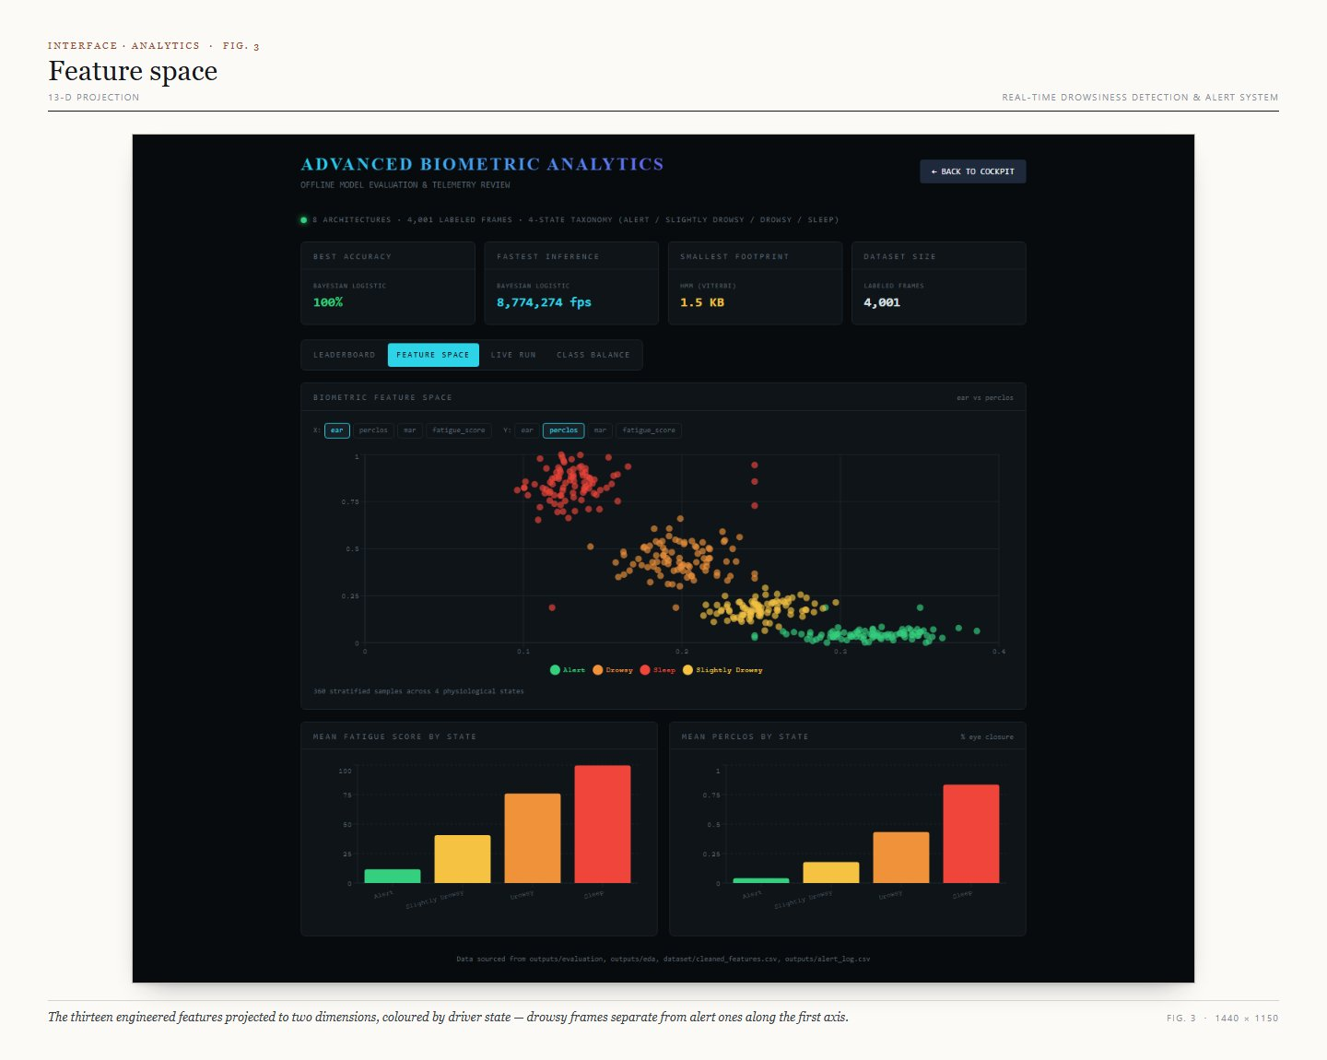
Screenshot B.1: Analytics Dashboard - Feature Space Explorer
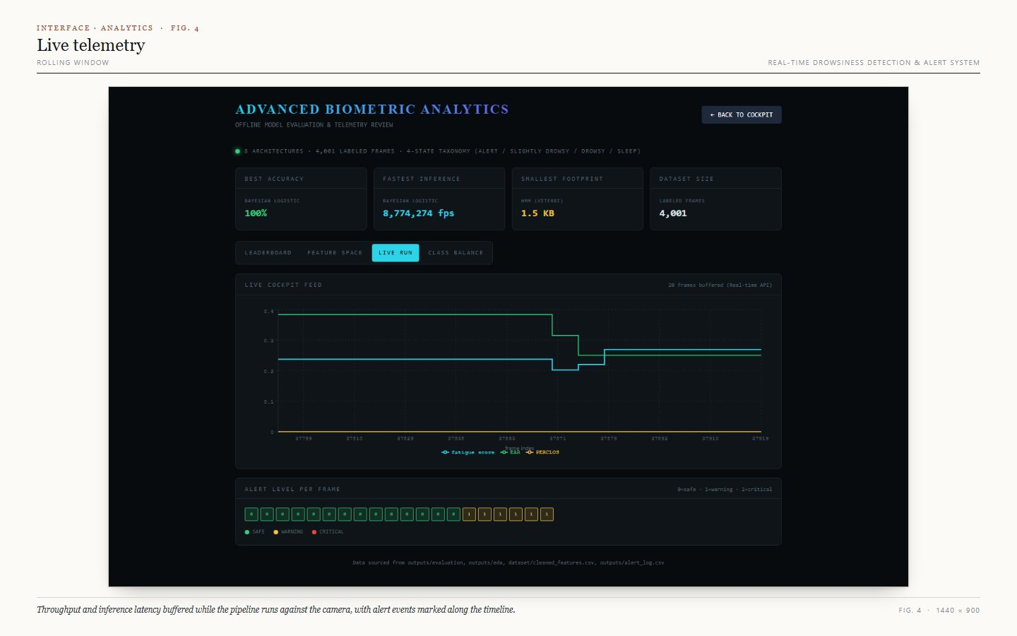
Screenshot B.2: Analytics Dashboard - Live API Telemetry Buffer
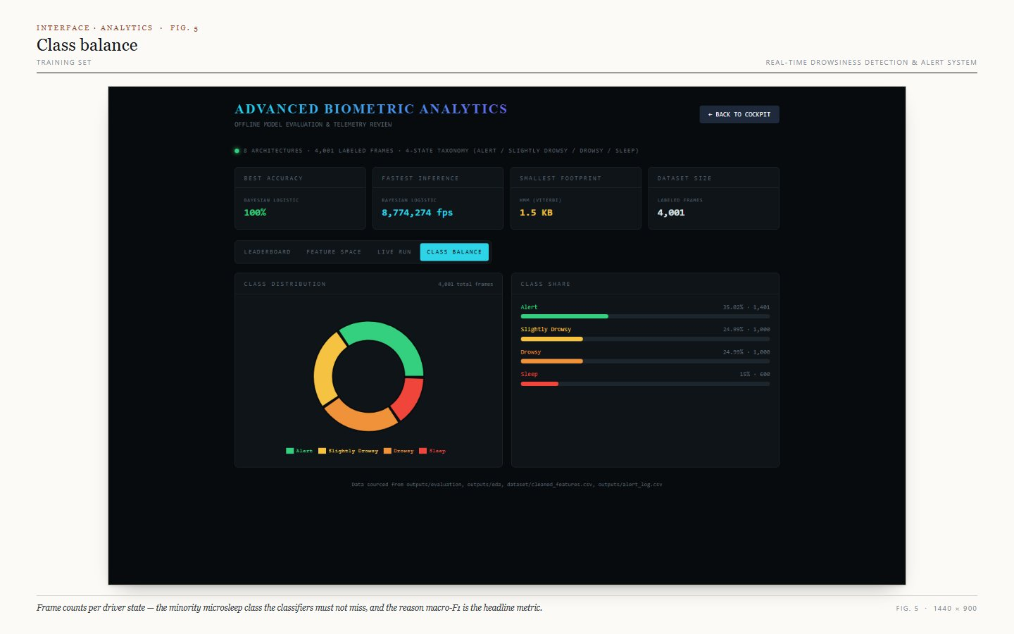
Screenshot B.3: Analytics Dashboard - Class Balance and Model Metrics
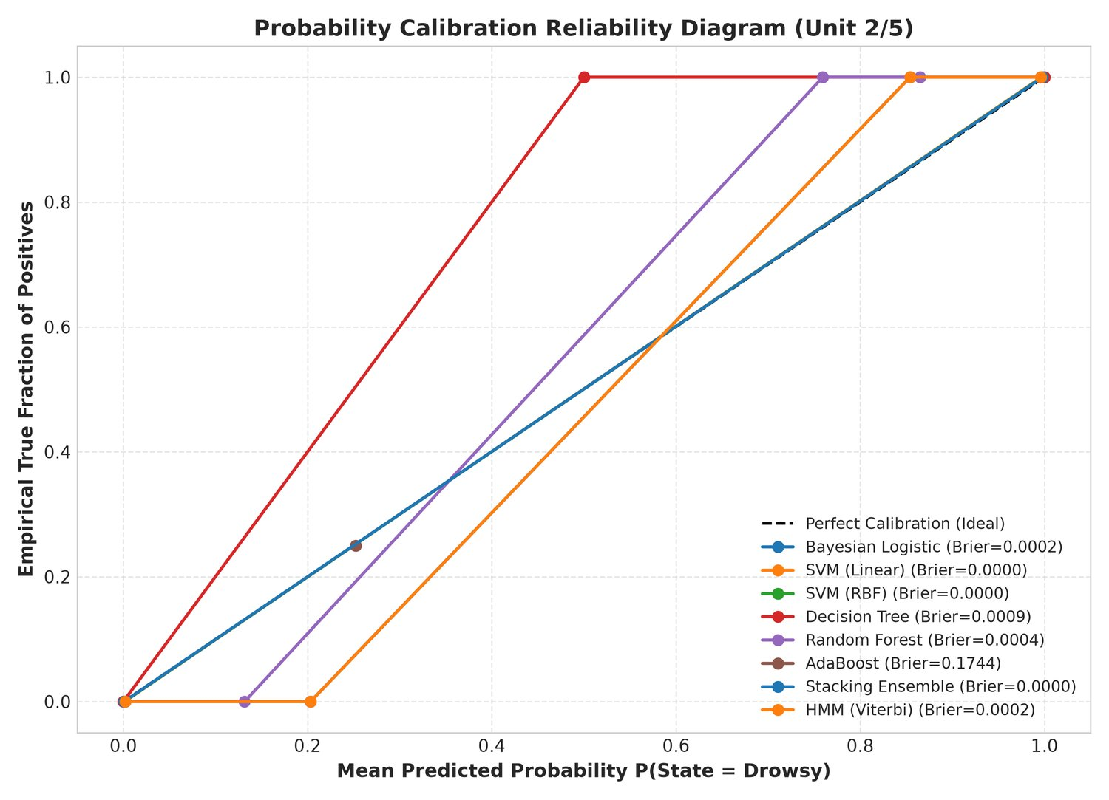
Screenshot B.4: Calibration Curves for the Probabilistic Classifiers
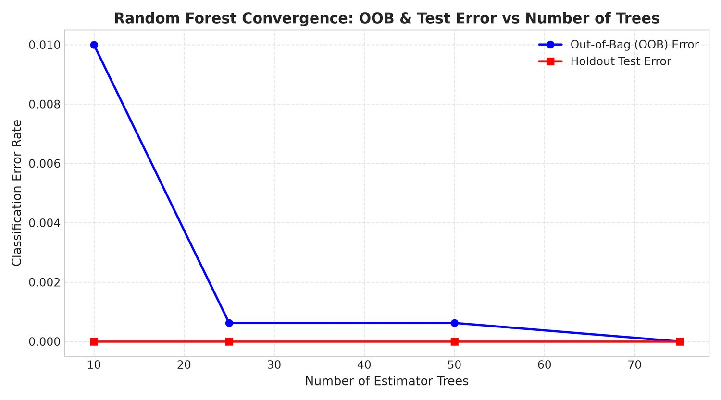
Screenshot B.5: Random Forest Out-of-Bag Error vs Number of Trees
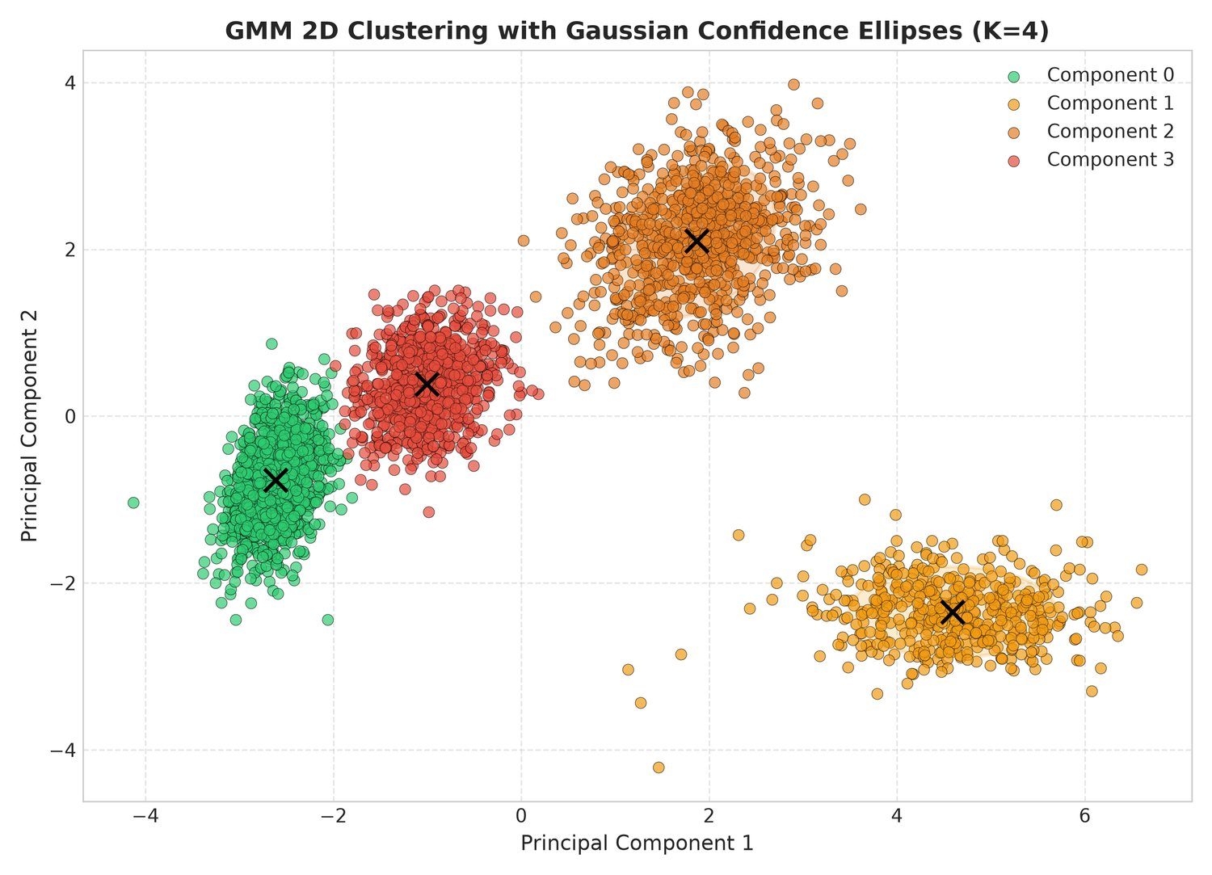
Screenshot B.6: GMM 95% Confidence Ellipses in PCA Space
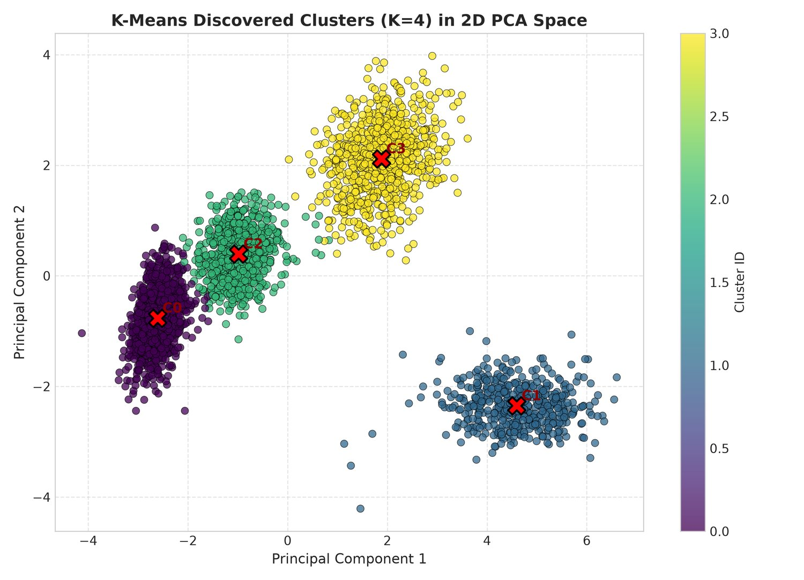
Screenshot B.7: K-Means Cluster Assignments in 2-D PCA Space
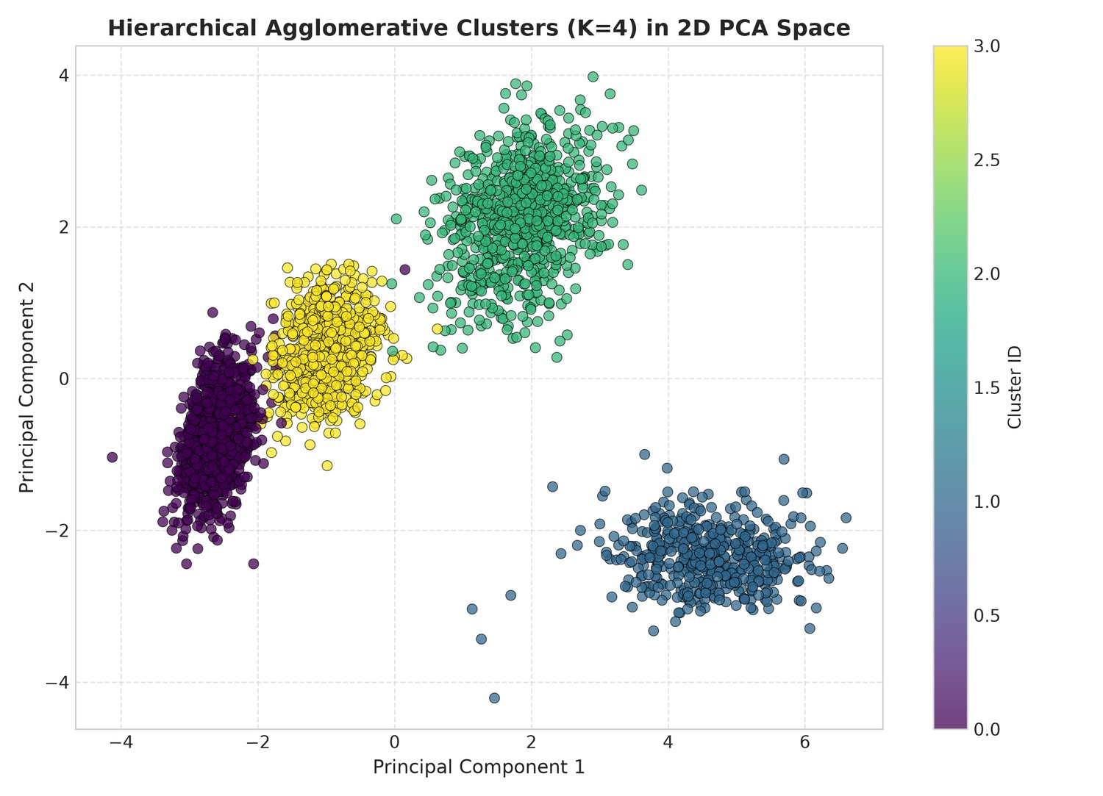
Screenshot B.8: Hierarchical (Ward) Cluster Assignments in 2-D PCA Space
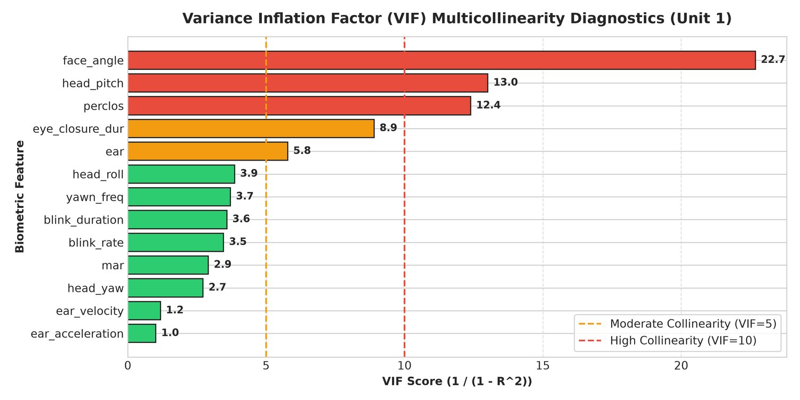
Screenshot B.9: Variance Inflation Factor Analysis of the 13 Features
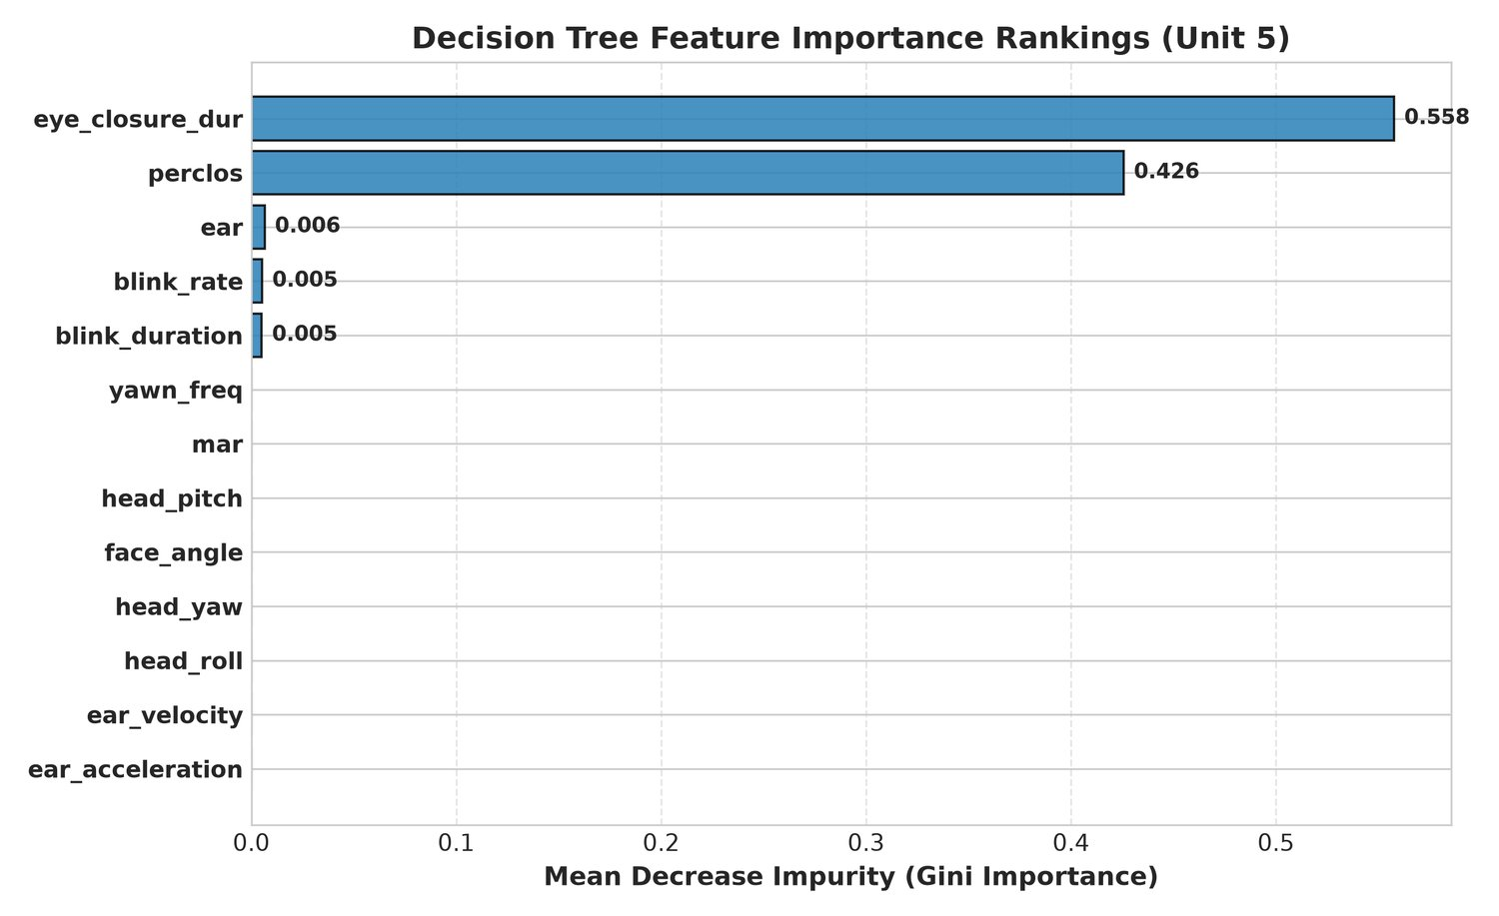
Screenshot B.10: Decision Tree Feature Importance Ranking
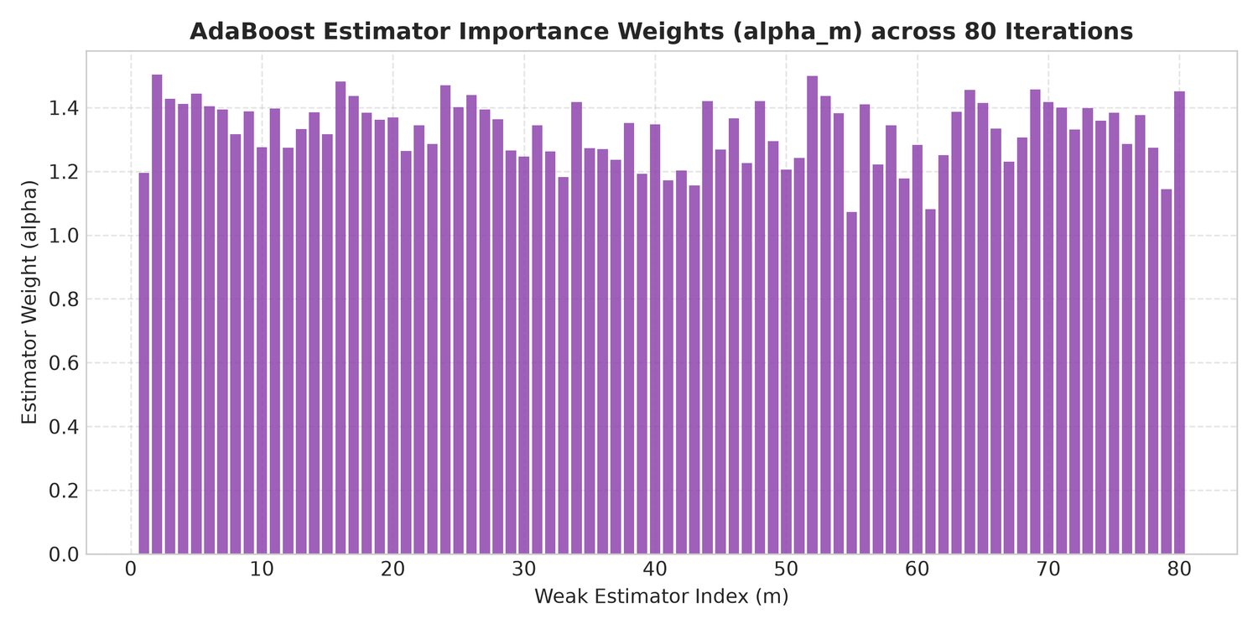
Screenshot B.11: AdaBoost Estimator Weights Across Boosting Stages

APPENDIX C: SYLLABUS COVERAGE & MODULE AUDIT
To verify rigorous academic compliance with the 21CSC305P Machine Learning curriculum, the following matrix cross-references each syllabus unit with its corresponding module and the metric actually recorded by the codebase:
Unit & Topic | Source Module(s) | Concept Implemented | Key Metric Achieved
Unit 1: Preprocessing & Feature Engineering | preprocessing.py, statistics_analysis.py, feature_extraction.py | Median NaN imputation, IQR/domain outlier capping, z-score scaling, MediaPipe 478 landmarks, EAR, MAR, PERCLOS (90-frame), solvePnP 3-D pose, EAR derivatives | 13 features  4,001 samples  3,200 / 801 split
Unit 2: Regression & Probabilistic Classifiers | linear_regression.py, bayesian_logistic.py, svm_classifier.py | Ridge closed-form beta*, Bayesian MAP logistic regression with Shannon entropy, Linear + RBF SVM with probability calibration | R2 = 0.9576  Acc = 100.00%  Log-loss = 0.0086
Unit 3: Unsupervised Learning & Dim. Reduction | pca.py, kmeans.py, gmm.py, hierarchical.py | PCA scree/cumulative variance, K-Means (k=4, k-means++), GMM EM full covariance by AIC/BIC, Ward agglomerative linkage | 8 comps = 95.46%  ARI 0.9745-0.9911  Cophenetic 0.7598
Unit 4: Temporal Sequence Models (HMM) | hmm.py (pure NumPy) | 4-state Gaussian-emission HMM, Forward-Backward recursion, log-space Viterbi, online forward filter | Decoding acc = 100.00%  Diagonal persistence 0.92
Unit 5: Tree & Advanced Ensemble Methods | decision_tree.py, random_forest.py, adaboost.py, ensemble.py | CART (Gini, depth 5), Random Forest (75 trees, OOB), AdaBoost (40 stumps), Soft Voting & Stacking meta-learner | DT 99.13%  RF 100.00%  Stacking 100.00%
Integration: Real-Time Edge Deployment | app.py, main.py, realtime_detection.py, alert_system.py, onnx_exporter.py | Threaded HTTP server, MJPEG streaming, 11 REST endpoints, runtime model hot-swapping, graduated audio alerts, ONNX INT8 export | Latency min 0.0007 ms  9/9 suites passed  165.08 s

APPENDIX D: REPORT-CODE CONSISTENCY AUDIT
This appendix records how every quantitative statement in Chapters 1-9 was cross-checked against the source repository (config, trained .joblib artefacts, evaluation CSVs, run logs, the test-suite output and the live web server) for this edition of the report, and lists the values that were corrected relative to the previous draft. No project file was modified while producing this report.

D.1 Verification Method
- Configuration values read directly from src/config.py (FEATURE_COLUMNS, thresholds, window sizes, paths).
- Hyperparameters and metrics read from the trained artefacts themselves (models/*.joblib) rather than from prose.
- Benchmark numbers loaded at report-generation time from outputs/evaluation/model_comparison_report.csv and real_dataset_validation.csv - the same files the dashboard serves at /api/leaderboard.
- Pipeline statistics (preprocessing counts, clustering scores, ridge metrics) taken from the timestamped entries in logs/system.log.
- Dashboard behaviour verified against the running server: all eleven routes returned HTTP 200.
- Test results from a fresh full run of tests/run_all_tests.py on 9 October 2026 (9/9 suites, 165.08 s, exit code 0).

D.2 Values Corrected Relative to the Previous Draft
Item | Previously stated | Verified value | Source of truth
Feature vector dimension | 11 features | 13 features | config.FEATURE_COLUMNS
PERCLOS window | 30-60 frames | 90 frames, threshold EAR < 0.20 | config.PERCLOS_WINDOW_SIZE
Calibration baseline | 100 frames | 45 frames | realtime_detection.py
Dashboard URL / port | localhost:5000 | localhost:8080 (default --port) | app.py
REST endpoints | 5 endpoints | 11 routes (two HTML pages + APIs + frame POST) | app.py do_GET/do_POST
Alert escalation | 5 / 5 / 10 frames | 12 / 30 frames, OR fatigue >= 0.50 / 0.78 and PERCLOS >= 0.18 / > 0.25 | alert_system.AlertManager
Alert tones | 1000 Hz / 2500 Hz | 880 Hz (0.25 s) / 1200 Hz (0.4 s), 1 s cooldown | alert_system.SoundGenerator
Missing-value imputation | 644 values | 791 values | logs/system.log (Preprocessing)
Ridge regression | R2 0.955, RMSE 6.99, MAE 5.32 | R2 0.9576, RMSE 6.7687, MAE 5.1703 | logs/system.log (LinearRegression)
Bayesian log-loss | 0.0084 | 0.0086 (mean entropy 0.0359) | logs/system.log (BayesianLogistic)
SVM support vectors | 58 / 133 | 64 / 164 (CalibratedClassifierCV) | models/svm_*.joblib
PCA variance | 7 components; PC1 = EAR -0.921, PERCLOS +0.887 | 8 components for 95.46%; PC1 led by face angle +0.366, PERCLOS +0.363, EAR -0.350 | models/pca.joblib
Clustering metrics | Silhouette 0.43, cophenetic 0.807 | Silhouette 0.2982 / 0.2959, cophenetic 0.7598, ARI 0.9745-0.9911 | logs/system.log (KMeans/GMM/Hierarchical)
HMM prior pi | [0.4, 0.3, 0.2, 0.1] | [0.70, 0.15, 0.10, 0.05], A diagonal 0.92 | models/hmm.joblib
HMM decoding accuracy | 99.75% | 100.00% (posterior and Viterbi, log-prob -2269.24) | tests/test_phase5.py output
Decision Tree | 99.25% accuracy | 99.13% accuracy (depth 5, 27 nodes - unchanged) | logs/system.log + artifact
AdaBoost | 99.13% accuracy, 80 estimators (audit note) | 97.63% accuracy, 40 estimators, lr 1.0 | models/adaboost.joblib
Random Forest | 100 trees (audit note) | 75 trees, max_depth 10, OOB 1.0 | models/random_forest.joblib
Leaderboard values | older run (SVM RBF 100%, HMM 96.0%, DT 99.25%) | SVM RBF 99.88%, HMM 96.50%, DT 99.13%, AdaBoost 97.63% with current latencies | model_comparison_report.csv
Test suite | 177.98 s; '10 test phases' in the README | 9 phases wired in the runner, 165.08 s, 9/9 passed (test_phase10_advanced.py is separate) | tests/run_all_tests.py output
CLI commands | main.py --train --eval --compare / --demo | main.py --mode {train,evaluate,validate-real,live,demo,all} | main.py --help
Real-world dataset | 1,500 samples (audit note) | 4,500 samples, 3 states x 1,500; used for the OOD validation of Section 7.4 | dataset/real_driver_drowsiness_dataset.csv
ONNX export | 16 files | 9 models exported, 8 INT8-quantised, 17 files | models/onnx/ + export log

D.3 Implementation Features Beyond Chapters 1-9
Feature / Capability | Source in Repository | What It Does
EAR velocity & acceleration | feature_extraction.py; config.FEATURE_COLUMNS | First and second time derivatives of EAR; extend the model input from 11 to 13 dimensions.
Adaptive CLAHE low-light enhancement | feature_extraction.py (apply_clahe=True) | Contrast-limited histogram equalisation applied before landmark detection in dark conditions.
Eyewear / occlusion detection | feature_extraction.py (detect_eyewear) | Detects glasses or tinted lenses so the eye thresholds can be compensated.
ONNX edge export & INT8 quantisation | onnx_exporter.py; models/onnx/ (17 files) | Exports nine trained models and INT8-quantises eight of them for embedded deployment; exposed at /api/onnx_benchmark.
Real-world dataset ingestion | download_real_dataset.py; dataset/real_driver_drowsiness_dataset.csv | Downloads a public Kaggle drowsiness corpus and extracts the same 13-feature schema (4,500 labelled samples) for the Section 7.4 validation.
Second dashboard view | templates/analytics.html | Analytics page at /analytics: leaderboard, feature scatter plots, class balance, live telemetry.
Per-driver calibration | realtime_detection.py; GET /api/calibrate | 45-frame baseline that sets EAR/MAR thresholds to 76% / 200% of the driver's own values.
Alert audit logs | alert_system.py; outputs/alert_log.csv, outputs/alert_events.json | Timestamped, structured record of every alert with frame index and biometric readings.

D.4 Known Discrepancies That Remain
- The README states '10 test phases'; tests/run_all_tests.py wires phases 1-9, and test_phase10_advanced.py is an additional suite that is not part of the runner. This report quotes the runner (9 phases).
- Reported 100% accuracies are internal to the modelled dataset; Section 7.4 documents the out-of-distribution collapse on real footage rather than reconciling the two.
- Latency and throughput figures are machine-dependent; Table 7.1 reproduces the values in the committed CSV so the report and dashboard always agree, but re-running the benchmark will shift the last decimals.

