ok, please summarize the whole idea shortly for the sync system that use Drive, indexedDB, meta files in Drive (including device with my device number from php server), mutate track in frontend, all necessary folders + file and the flow of sync
Here’s a concise industrial-grade summary of the sync system design you’ve been building:

📱 On Each Device
- IndexedDB: local source of truth for all tables (phrases, playlists, reminders, tags, users, imageBlobs, soundBlobs).
- Mutation Tracker (per-table): e.g., phrases_mutate.json, playlists_mutate.json.
  - Logs unsynced changes: {id, op, updatedAt}.
  - One entry per row ID, updated with the latest mutation.
- Device ID: each device has a unique identifier (from your PHP server).

☁️ On Google Drive
- Meta files (per table): phrases_meta.json, playlists_meta.json, etc.
  - Lightweight index of all rows: {id, updatedAt, op}.
  - Tombstones (op: delete) kept for a retention window (e.g., 60 days).
- Row JSON files: stored in folders per table (phrases/phrase-XYZ.json).
- Blob files: stored in images/ or sounds/ folders, referenced in blob meta.
- Device registry: devices.json tracks {deviceId, lastSyncAt} for each client.

🔄 Sync Flow
- Local mutation:
  - Apply change immediately to IndexedDB.
  - Log mutation in the per-table *_mutate.json.
- Sync cycle:
  - Pull Drive meta files.
  - Compare local IndexedDB + mutation logs against Drive meta.
  - Replay queued mutations: upload new/updated rows, delete rows, update meta.
  - Download newer rows from Drive into IndexedDB.
  - Clear mutation logs once confirmed.
  - Update devices.json with this device’s lastSyncAt.
- Retention & safety:
  - Tombstones remain until all active devices have synced past them.
  - Old devices marked inactive after X days.
  - Reject stale uploads if their updatedAt < tombstone timestamp.

✅ Summary
- IndexedDB = local truth.
- Mutation logs = per-table, track unsynced changes.
- Drive meta files = per-table indexes with tombstones.
- Row/Blob files = actual data in Drive folders.
- Device registry = ensures tombstones aren’t purged too early.
- Sync loop = reconcile local queue ↔ Drive meta, enforce delete-wins or last-write-wins policy.
I can sketch a flow diagram showing devices, mutation logs, Drive meta, and the sync arrows so you can visualize the whole system in one picture — want me to lay that out?
please do this: I can sketch a flow diagram showing devices, mutation logs, Drive meta, and the sync arrows so you can visualize the whole system in one picture — want me to lay that out?
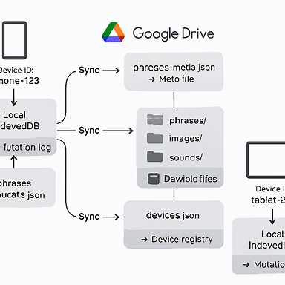
Here’s the flow diagram you asked for — it lays out the entire sync ecosystem in one picture, showing devices with IndexedDB + mutation logs, Google Drive with meta files, row/blob folders, and the device registry, all connected by sync arrows:
https://copilot.microsoft.com/th/id/BCO.48cf769b-827d-4bf0-aa65-1b012505c67a.png

🔑 How to read it
- Devices (phone, tablet, etc.)
  - Each has a local IndexedDB (source of truth).
  - Each has per-table mutation logs (phrases_mutate.json, etc.) that track unsynced changes.
  - Mutations are applied locally immediately, then logged.
- Google Drive (center)
  - Meta files (phrases_meta.json, etc.) hold {id, updatedAt, op} for each row.
  - Row/blob folders store actual row JSON files and blob files (images/, sounds/).
  - Device registry (devices.json) tracks each device’s last sync time.
- Sync arrows
  - Devices push queued mutations to Drive.
  - Drive meta reconciles changes.
  - Devices pull newer rows/blobs back into IndexedDB.
  - Mutation logs are cleared once confirmed.

