# Bug 1

Describe the bug

In the file “full_retirement_calc.py”, the first condition in the if statement:

**if** birth_year >= CURRENT_YEAR:  
 **return** -1, -1

is returning a -1 per the assertion in pytest. The statement should only be “birth_year > CURRENT_YEAR” .

Program

jtclark52 / wtccjava-CSC256PublicChangeDoc /build 3/2019-Sept 30 6:00PM

Component

full_retirement_calc.py

Error Type

Design error.

Severity

Severe

Priority

TBD

## State

Open

To Reproduce

Steps to reproduce the behavior:

1. Enter year of birth as 2019
2. Enter any birth month

Expected behavior

When user enters birth_year as current year, the output should be 67 years and whatever month of birth

Screenshots

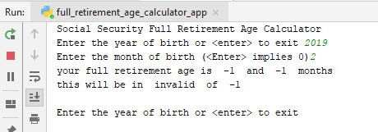

Assigned

unassigned