# Bug 2

Describe the bug

When a string is entered, a Value Error is thrown.

Program

jtclark52 / wtccjava-CSC256PublicChangeDoc /build 3/2019-Sept 30 6:00PM

<https://github.com/jtclark52/wtccjava-CSC256PublicChangeDoc>

Component

full_retirement_age_calculator_app.py

Error Type

Design error.

Severity

Fatal

Priority

TBD

## State

Open

To Reproduce

Steps to reproduce the behavior:

1. Enter any year of birth
2. Enter a string for example: Jan

Expected behavior

When user enters birth_month, the code should be graceful enough to either be able to accept a string entry for the equivalent month or throw an error message stating the boundaries of the proper entries.

Screenshots

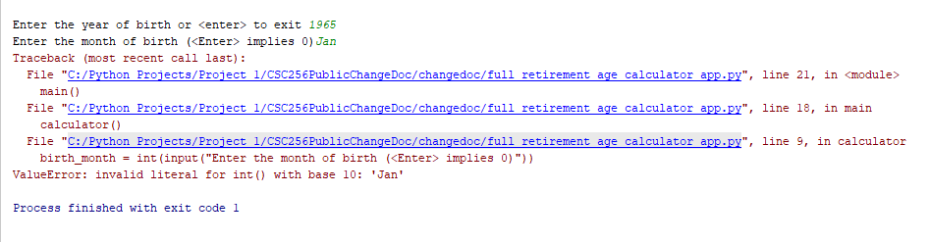

Assigned

Unassigned