Algorithm:
To implement the A* algorithm for the 8-puzzle problem, we will define two heuristics, h(n):

1. Number of Misplaced Tiles: This is the number of tiles that are not in their goal positions.

2. Manhattan Distance: The sum of the absolute differences between the current position and the goal position of each tile.

The A* algorithm will use f(n) = g(n) + h(n), where:

g(n) is the depth of the node (the cost to reach the current state).

h(n) is the heuristic, either misplaced tiles or Manhattan distance.

Algorithm for A*:

1. Initialize:

Start with the initial state of the puzzle.

Use a priority queue to hold the nodes, ordered by f(n) = g(n) + h(n).

Add the start state to the priority queue with g(n) = 0 and h(n) depending on the chosen heuristic.

Keep a set of visited nodes to avoid re-exploring nodes.

2. Expand Nodes:

While the priority queue is not empty:

Remove the node with the lowest f(n) from the queue.

If this node is the goal, return the solution.

Generate all possible child nodes (neighboring states) by moving the blank tile.

For each child:

Calculate g(n) (increment depth by 1 from the parent).

Calculate h(n) using the chosen heuristic.

If the child has not been visited or if it has a better f(n) than before, add it to the queue.

3. Termination:

If the goal is found, return the path and total cost.

If no solution is found, return failure.

PseudoCode:
A* Algorithm (initial_state, goal_state, heuristic)
open_list ← priority_queue
closed_set ← empty set
g ← 0
f ← g + heuristic(initial_state, goal_state)
open_list.push((f, g, initial_state, [])) # (f, g, state, path)
while open_list is not empty:
(f, g, current_state, path) ← open_list.pop()
if current_state == goal_state:
return path + [current_state]
closed_set.add(current_state)
for each neighbor in get_neighbors(current_state):
if neighbor in closed_set:
continue
new_g ← g + 1
new_f ← new_g + heuristic(neighbor, goal_state)
open_list.push((new_f, new_g, neighbor, path + [current_state]))
return None

Misplace Tiles Code:

import heapq
# Define the goal state for the puzzle
goal_state = [[1, 2, 3], [8, 0, 4], [7, 6, 5]]
# Helper function to calculate the misplaced tiles heuristic
def misplaced_tiles(state, goal_state):
"""Calculate the number of misplaced tiles."""
count = 0
for i in range(3):
for j in range(3):
if state[i][j] != 0 and state[i][j] != goal_state[i][j]:
count += 1
return count
def is_goal(state):
"""Check if the current state is the goal state."""
return state == goal_state
def get_neighbors(state):
"""Generate neighbors for a given state."""
neighbors = []
# Find the position of the empty space (0)
x, y = [(ix, iy) for ix, row in enumerate(state) for iy, i in enumerate(row) if i == 0][0]
# Possible moves: up, down, left, right
moves = [(x-1, y), (x+1, y), (x, y-1), (x, y+1)]
for move_x, move_y in moves:
if 0 <= move_x < 3 and 0 <= move_y < 3:
# Create a copy of the current state and swap the empty space
new_state = [row[:] for row in state]
new_state[x][y], new_state[move_x][move_y] = new_state[move_x][move_y], new_state[x][y]
neighbors.append(new_state)
return neighbors
# A* algorithm using misplaced tiles heuristic
def a_star_misplaced(initial_state):
"""A* algorithm implementation for 8-puzzle problem with misplaced tiles heuristic."""
open_list = []
closed_set = set()
# Initial cost
g = 0
f = g + misplaced_tiles(initial_state, goal_state)
# Add the initial state to the open list
heapq.heappush(open_list, (f, g, initial_state, []))
while open_list:
f, g, current_state, path = heapq.heappop(open_list)
if is_goal(current_state):
return path + [current_state]
closed_set.add(tuple(map(tuple, current_state)))
for neighbor in get_neighbors(current_state):
if tuple(map(tuple, neighbor)) in closed_set:
continue
new_g = g + 1
new_f = new_g + misplaced_tiles(neighbor, goal_state)
heapq.heappush(open_list, (new_f, new_g, neighbor, path + [current_state]))
return None
# Helper function to print a state
def print_state(state):
for row in state:
print(row)
print()
# Initial state
initial_state = [[2, 8, 3], [1, 6, 4], [7, 0, 5]]
# Run the A* algorithm with misplaced tiles heuristic
print("Solution using misplaced tiles heuristic:")
solution_misplaced = a_star_misplaced(initial_state)
if solution_misplaced:
for step in solution_misplaced:
print_state(step)
else:
print("No solution found using misplaced tiles heuristic.")

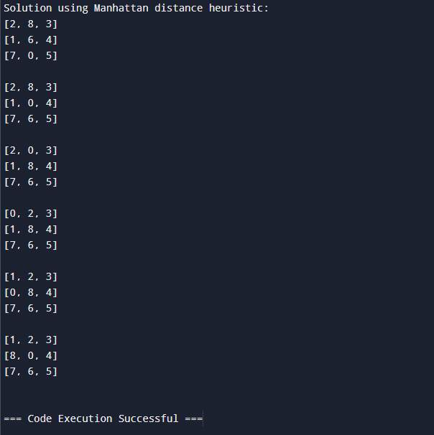

Manhattan distance
import heapq
# Define the goal state for the puzzle
goal_state = [[1, 2, 3], [8, 0, 4], [7, 6, 5]]
# Helper function to calculate the Manhattan distance heuristic
def manhattan_distance(state, goal_state):
"""Calculate the Manhattan distance heuristic."""
distance = 0
for i in range(3):
for j in range(3):
if state[i][j] != 0:
# Get current tile number (1-8)
value = state[i][j]
# Find its goal position in the goal state
goal_x, goal_y = divmod(value, 3)
# Calculate Manhattan distance
distance += abs(i - goal_x) + abs(j - goal_y)
return distance
def is_goal(state):
"""Check if the current state is the goal state."""
return state == goal_state
def get_neighbors(state):
"""Generate neighbors for a given state."""
neighbors = []
# Find the position of the empty space (0)
x, y = [(ix, iy) for ix, row in enumerate(state) for iy, i in enumerate(row) if i == 0][0]
# Possible moves: up, down, left, right
moves = [(x-1, y), (x+1, y), (x, y-1), (x, y+1)]
for move_x, move_y in moves:
if 0 <= move_x < 3 and 0 <= move_y < 3:
# Create a copy of the current state and swap the empty space
new_state = [row[:] for row in state]
new_state[x][y], new_state[move_x][move_y] = new_state[move_x][move_y], new_state[x][y]
neighbors.append(new_state)
return neighbors
# A* algorithm using Manhattan distance heuristic
def a_star_manhattan(initial_state):
"""A* algorithm implementation for 8-puzzle problem with Manhattan distance heuristic."""
open_list = []
closed_set = set()
# Initial cost
g = 0
f = g + manhattan_distance(initial_state, goal_state)
# Add the initial state to the open list
heapq.heappush(open_list, (f, g, initial_state, []))
while open_list:
f, g, current_state, path = heapq.heappop(open_list)
if is_goal(current_state):
return path + [current_state]
closed_set.add(tuple(map(tuple, current_state)))
for neighbor in get_neighbors(current_state):
if tuple(map(tuple, neighbor)) in closed_set:
continue
new_g = g + 1
new_f = new_g + manhattan_distance(neighbor, goal_state)
heapq.heappush(open_list, (new_f, new_g, neighbor, path + [current_state]))
return None
# Helper function to print a state
def print_state(state):
for row in state:
print(row)
print()
# Initial state
initial_state = [[2, 8, 3], [1, 6, 4], [7, 0, 5]]
# Run the A* algorithm with Manhattan distance heuristic
print("Solution using Manhattan distance heuristic:")
solution_manhattan = a_star_manhattan(initial_state)
if solution_manhattan:
for step in solution_manhattan:
print_state(step)
else:
print("No solution found using Manhattan distance heuristic.")


Observation:
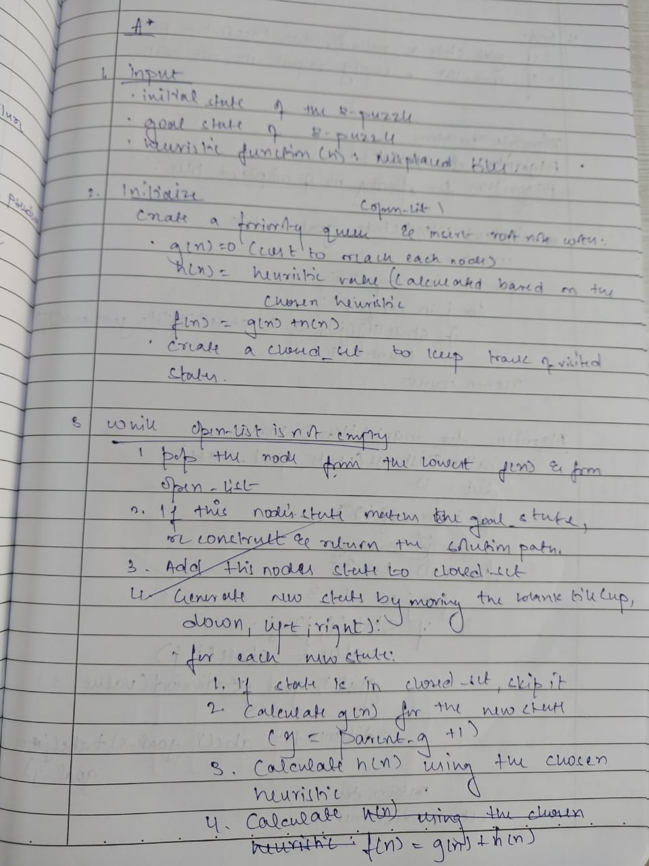
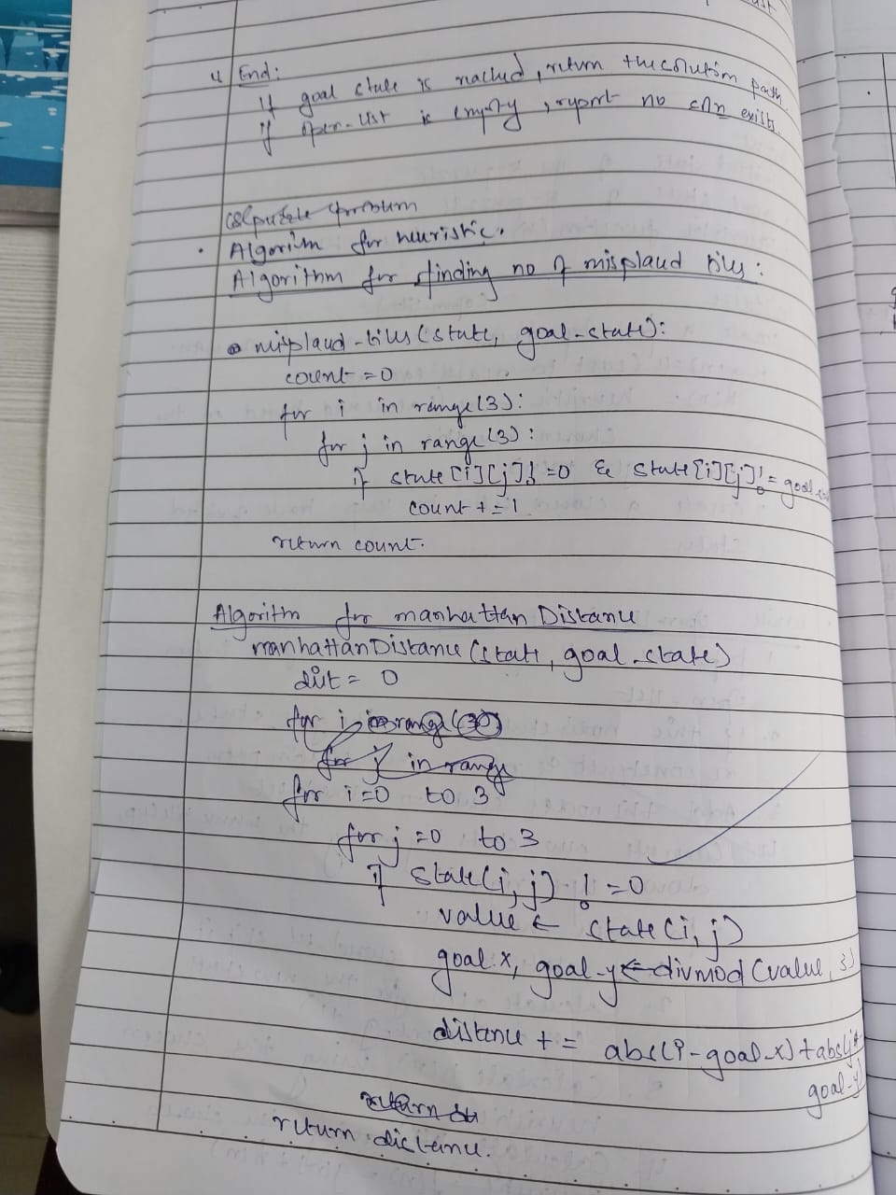
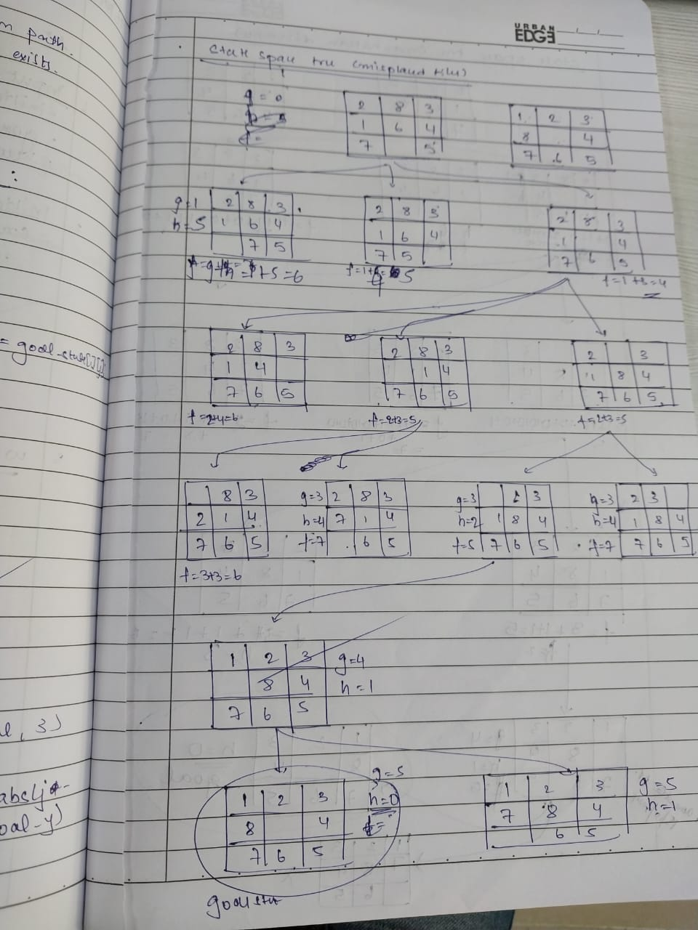
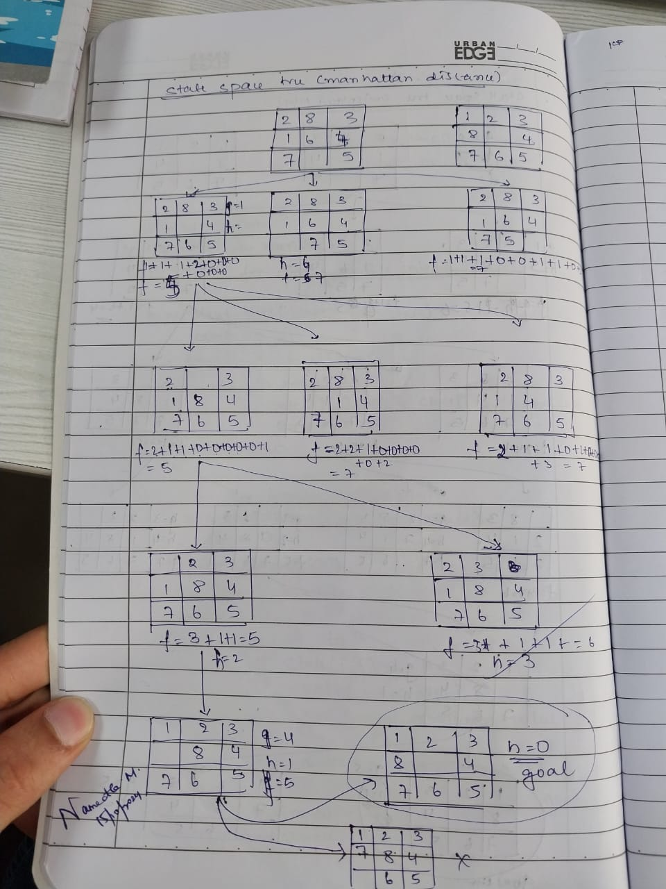s

