CREDIT CARD PROCESSING

SRS DOCUMENT

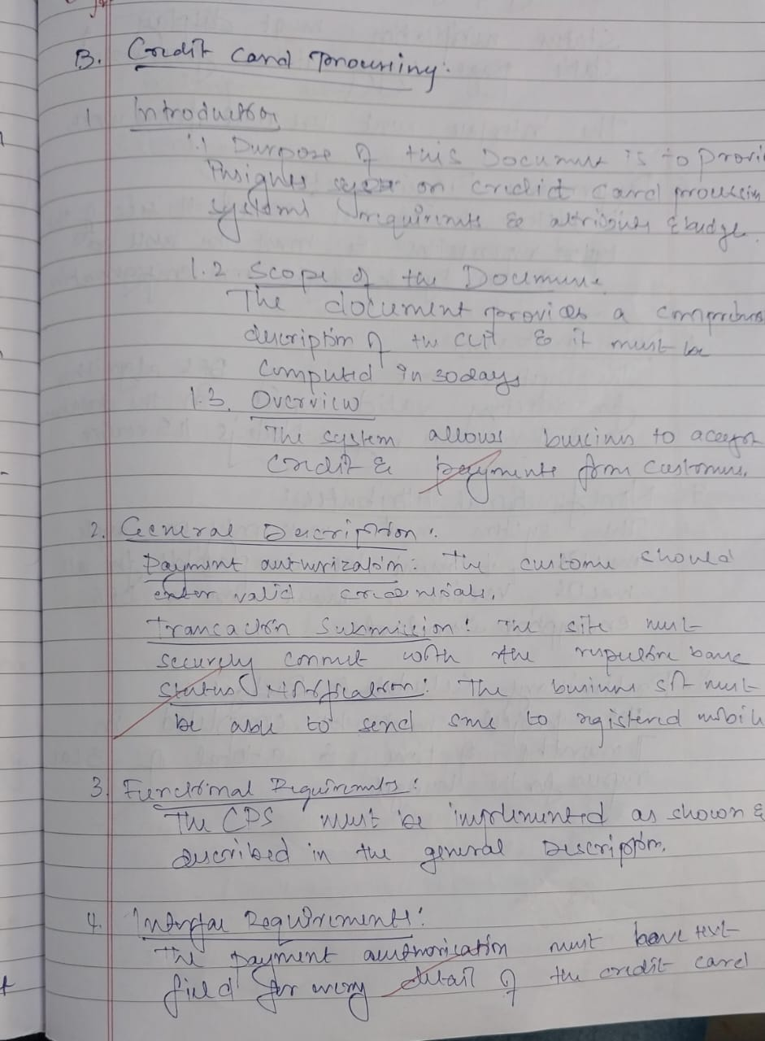

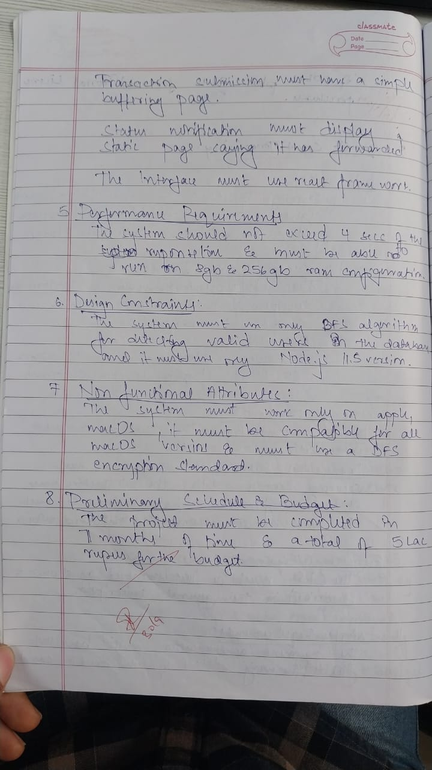

ADVANCED STATE SPACE DIAGRAM

