**Data Structures Project- Sparse Matrix**

**Snake**

**Bereczki Anna**

Snake is a classic video game that has been popular worldwide since 1976. The objective is to keep the snake alive while collecting as many points as possible. The game becomes progressively more challenging as each collected apple increases the snake’s length. The snake must avoid colliding with walls or its own tail to stay alive.

With the sparse array data structure, we can efficiently store the snake's current position in terms of memory usage.

***Gameplay:***

• At the start of the game, the snake is always two units long and moves to the right from the top-left corner. Its movement speed varies between 50 and 250 milliseconds, depending on the game mode difficulty.

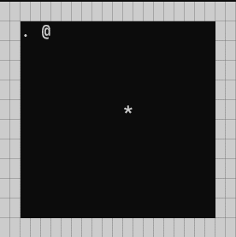

. character represents the length of the snake

@ character represents the head of the snake

* character represents the apple

• Apples appear randomly in empty spaces, and the snake's movement direction can be changed using the arrow keys.

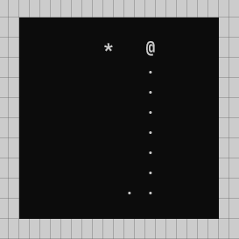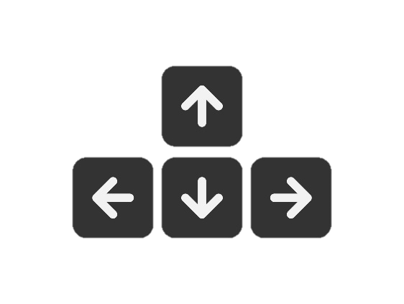

* 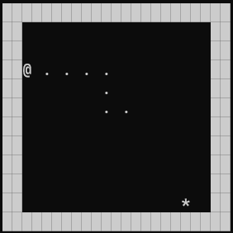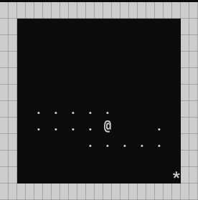The game ends if the snake tries to eat its own tail or the wall.
* To win the game the snake has to grow big enough to cover the whole board without dying.

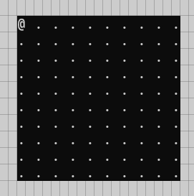

This being a difficult goal the game will congratulate players if they reach a new highscore.

***Game Modes:***

1. *Easy Mode*

20x20 sized board

Based on difficulty the snakes speed changes

2. *Medium Mode*

3. *Hard Mode*

4. *Extreme Mode*

5. *No Wall Mode* (instead of dying when reaching a wall in this game mode the game continues by the snake appearing on the opposite side of the board)

6. *Custom Mode* (this mode lets the player decide if they want wall or no wall, also the size of the board and the speed of the snake)

***Highest scores:***

The game has a menu item called „Highest Score” where the player can view the current best scores for each game mode except custom