HACKATHON PROJECT • MERN STACK
FoodBridge
Food should find people — not landfills.
A Real-Time Marketplace Connecting Surplus Food from Donors to NGOs
PROJECT DOCUMENTATION
Design, implementation, usage and future scope
Live application: https://rule-replicator.lovable.app
Technology: React + Vite • Node.js • Express.js • MongoDB + Mongoose • JWT + bcrypt
Version 1.0 • October 2026

Abstract
Every day, edible food is discarded by restaurants, hostels, canteens and households while nearby organisations struggle to source meals for the people they serve. The food is rarely the problem; coordination is. Surplus food has a short shelf life, pickup windows are narrow, and donors and receivers have no common, trustworthy place to find each other in time.
FoodBridge is a full-stack web application that closes this coordination gap. Donors post surplus food with its quantity, pickup location, pickup time and expiry time. Verified-by-login NGOs discover those listings in real time, filter them by food type and status, reserve what they can collect, and mark the food collected once the handoff is complete. Every listing moves through a clear lifecycle of Available, Reserved and Collected, so both sides always know where a donation stands.
The system is built on the MERN stack. A React interface talks to Node.js and Express REST APIs, backed by MongoDB. Passwords are hashed with bcrypt, requests are authorised with JSON Web Tokens and role checks, and an atomic reservation built on MongoDB’s findOneAndUpdate guarantees that only one NGO can claim a donation, even when several click at the same moment. An expiry guard stops expired food from ever being claimed.
This document describes the problem, the requirements, the architecture, the data and API design, the core algorithms, the user interface, testing and the roadmap for taking the prototype to community scale.

Item | Detail
Project name | FoodBridge (tagline: Food Forward)
Domain | Food waste, social impact, web development
User roles | Donor and NGO
Stack | React + Vite, Node.js, Express.js, MongoDB + Mongoose, JWT, bcrypt
Live application | https://rule-replicator.lovable.app
Keywords | Surplus food, food redistribution, MERN, REST API, atomic reservation, JWT

Table of Contents
Abstract 2
1. Introduction 4
2. Problem Statement and Objectives 5
3. Domain Study 6
4. Proposed System 7
5. Key Features 8
6. Functional Requirements 9
7. Non-Functional Requirements and Constraints 10
8. System Architecture 11
9. Database Design 12
10. API Design 13
11. Core Algorithms 14
12. Security and Data Integrity 15
13. User Interface Walkthrough (I) 16
14. User Interface Walkthrough (II) 17
15. Access, Demo and Deployment 18
16. Testing 19
17. Results and Impact 20
18. Future Scope 21
19. Conclusion and References 22

1. Introduction

1.1 Background
Food waste is one of the most visible failures of modern supply chains. Food that is perfectly safe to eat is thrown away because it cannot be moved to someone who needs it before it expires. At the same time, community kitchens, shelters and other NGOs depend on irregular donations and often learn about surplus only through phone calls, messaging groups or personal contacts.

1.2 Motivation
The motivation for FoodBridge is simple: a donor with twenty spare meals at closing time should be able to make them visible to every nearby NGO in under a minute, and an NGO should be able to claim them with confidence that the food is still fresh and that nobody else will turn up for the same tray. The project turns that everyday moment into a short, trustworthy digital flow.

1.3 Purpose and scope of this document
This document is the technical and functional record of the FoodBridge hackathon prototype. It is written for evaluators, mentors, teammates and future contributors. It covers:
- the problem being solved and the objectives set for the prototype;
- functional and non-functional requirements;
- the system architecture, database schema and REST interface;
- the algorithms that make reservations safe and discovery fast;
- a walkthrough of the user interface with screenshots;
- how to access the live demo, how the system was tested, and where it goes next.
The prototype deliberately focuses on the smallest feature set that proves the idea end to end: authentication, role-based access, create-read-update operations on donations, and a safe reservation workflow.

2. Problem Statement and Objectives

2.1 Problem statement
There is no simple, real-time channel through which donors with surplus food and NGOs with unmet demand can find each other, agree on a pickup, and be certain that the food is still safe and still available. As a result, edible food is wasted and organisations miss meals they could have served.

2.2 Challenges to solve
- Tight pickup windows. Food is perishable, so the time between posting and collection is short.
- Donor trust. Donors will only post if they believe the food reaches a genuine receiver.
- Double booking. Two NGOs must never be promised the same donation.
- Stale listings. Expired food must disappear from the list of things that can be claimed.

2.3 Objectives
Six objectives were set for the prototype. Each is verifiable in the running application:
# | Objective | What it means for FoodBridge
1 | MERN stack | React, Node.js, Express and MongoDB working together as one system.
2 | CRUD | Donors create, view and update donations; statuses change over time.
3 | REST | A clean HTTP API between the interface and the database.
4 | UI | A simple, responsive interface for both roles.
5 | Auth and roles | Secure sign-in with separate Donor and NGO capabilities.
6 | Clear results | Visible statuses, counters and persistent records.

3. Domain Study

3.1 The scale of food waste
The United Nations Environment Programme’s Food Waste Index Report 2024 estimates that about 19% of the food available to consumers was wasted in 2022. That wasted food represents meals that were grown, transported and prepared, then never eaten. The report frames food waste as a problem that sits at the intersection of three concerns, which FoodBridge also uses to frame its own purpose.
Dimension | Why it matters
Hunger | NGOs and the people they serve need timely, reliable supply, not occasional windfalls.
Waste | Edible surplus is discarded because there is no fast route to someone who can use it.
Climate | Wasted food carries avoidable emissions from production, transport and disposal.

3.2 How surplus food is shared today
In practice, redistribution depends largely on informal channels: phone calls, messaging groups, and personal relationships between a few donors and a few organisations. These channels work when everyone is available, but they have predictable weaknesses.
- There is no shared, searchable view of what is available right now.
- Nothing prevents two receivers from being promised the same food.
- There is no record of what was donated, reserved or collected.
- Expiry information is passed along by word of mouth and can be lost.

3.3 The gap FoodBridge fills
FoodBridge replaces ad-hoc coordination with a single marketplace that has structured listings, role-based access, enforced rules about expiry and ownership, and a visible lifecycle. It does not change how food is cooked or moved; it makes sure that the decision to share it can be taken quickly and safely.
Source: UNEP, Food Waste Index Report 2024 — unep.org/resources/publication/food-waste-index-report-2024

4. Proposed System
FoodBridge is organised around two roles and one trusted flow. A donor lists food; an NGO discovers, reserves and collects it. Between them sits a live listing board whose entries carry a status that can only move forward through well-defined steps.
Role | Capabilities
Donor | Signs in, posts surplus food with quantity, location and time, and tracks the status of every donation they have shared.
NGO | Signs in, discovers live listings, searches and filters, reserves a donation, and marks it collected after pickup.

The landing experience explains the flow in three steps: donors list what they can share, NGOs reserve a donation, and the community completes the handoff.
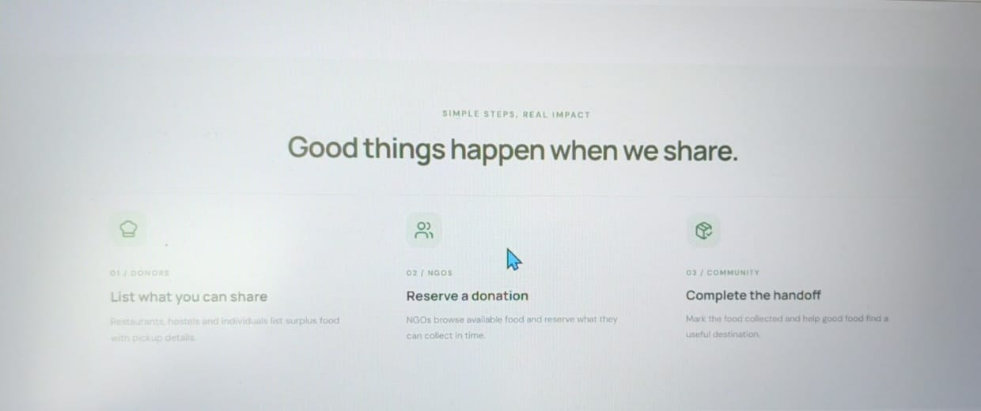
Figure 4.1 — “Good things happen when we share”: the three-step flow shown to visitors.
The design principles that guided the prototype were:
- Speed: posting or reserving should take a handful of clicks.
- Safety: invalid actions, such as claiming expired food, are refused by the server, not just hidden in the interface.
- Clarity: every donation shows its current status at all times.

5. Key Features
The table below summarises the features delivered in the prototype and the benefit each one provides.
Feature | Description | Benefit
Donor posting | Form capturing food name, type, donor type, quantity, unit, pickup location, pickup time, expiry time and an optional description. | Listing in under a minute.
Live food listings | A shared board of donations with search, filters and status labels. | Real-time discovery for NGOs.
Search and filters | Free-text search across food name, location and donor, plus status and food-type filters. | Find the right donation fast.
Atomic reservation | The reserve operation succeeds for exactly one NGO and fails for everyone else. | Eliminates double booking.
Expiry guard | Expired food cannot be claimed, whatever the client sends. | Protects food safety and trust.
Status lifecycle | Available → Reserved → Collected, persisted in the database. | Transparent, trackable handoffs.
JWT + bcrypt | Hashed passwords and token-based, role-aware access control. | Secure sign-in and role separation.
Impact counters | Dashboard tiles for available, reserved, collected and total food in circulation. | At-a-glance community impact.
One-click demo access | Demo Donor and Demo NGO buttons on the sign-in page. | Instant evaluation without sign-up.

6. Functional Requirements
Functional requirements describe what the system must do. Each is traceable to a feature in the running prototype.
ID | Requirement | Role
FR-1 | The system shall let a new user create an account and choose a role (Donor or NGO). | All
FR-2 | The system shall authenticate users by email and password and issue a signed token. | All
FR-3 | The system shall restrict actions according to the user’s role. | All
FR-4 | A donor shall be able to create a donation with all required fields validated. | Donor
FR-5 | A donor shall be able to view and track the status of their donations. | Donor
FR-6 | An NGO shall be able to browse all available donations. | NGO
FR-7 | An NGO shall be able to search by food name, location or donor, and filter by status and food type. | NGO
FR-8 | An NGO shall be able to reserve a donation only if it is Available and not expired. | NGO
FR-9 | The system shall allow a reserved donation to be marked Collected. | NGO
FR-10 | The system shall persist every change so that records survive a page refresh. | All

7. Non-Functional Requirements and Constraints

7.1 Non-functional requirements
Quality | Requirement
Security | Passwords are stored only as bcrypt hashes; every protected route verifies a token and the caller’s role.
Consistency | Reservation must be atomic so concurrent requests cannot both succeed.
Performance | Listing queries use an index on status and pickup time; search results are capped at 200 per request.
Usability | Clean forms, clear status labels, and helpful empty states such as “No donations found just yet”.
Reliability | Records persist in MongoDB and survive refreshes and restarts.
Maintainability | Separate interface, API and data layers so each can change independently.
Portability | Runs in any modern browser; the backend runs anywhere Node.js and MongoDB are available.

7.2 Constraints and assumptions
- The project was built within a hackathon timeframe, so the scope is a working prototype rather than a production service.
- Users are assumed to have internet access and a modern browser.
- NGO identity is established through account sign-in; formal verification is future work.
- Pickup logistics (transport, packaging, hygiene) are handled by the parties themselves.

8. System Architecture
FoodBridge follows a classic three-tier architecture. The browser renders a React interface; the interface calls a REST API implemented in Express on Node.js; the API reads and writes MongoDB through Mongoose models.
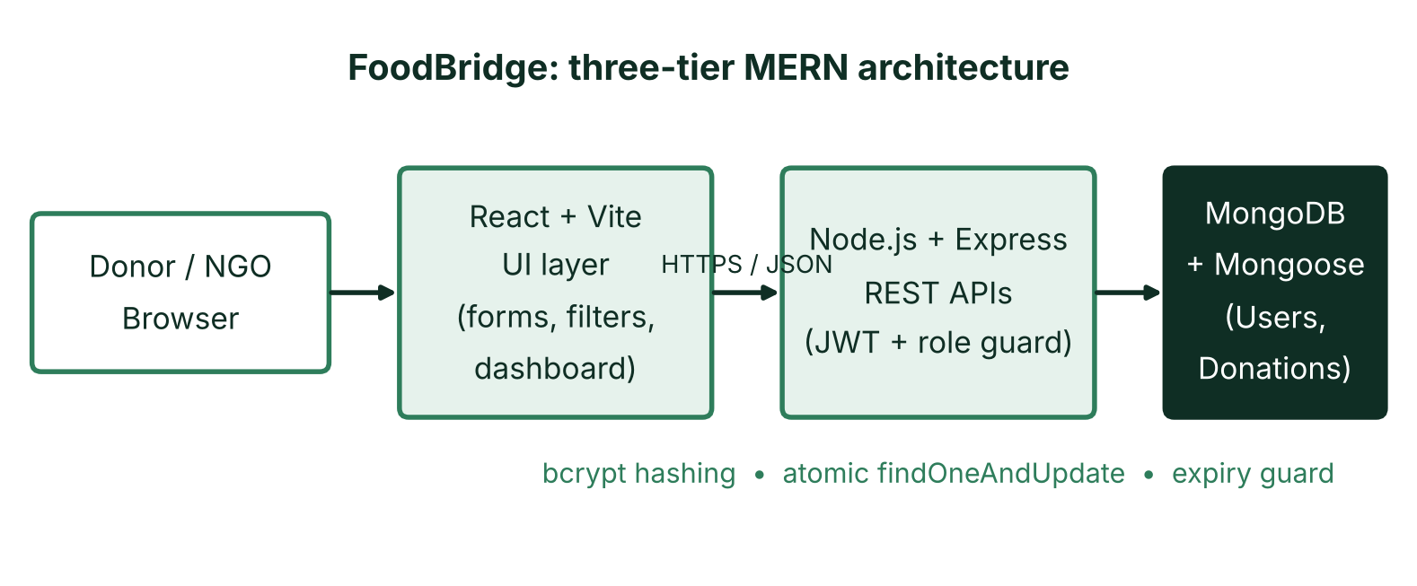
Figure 8.1 — Three-tier MERN architecture of FoodBridge.
Layer | Responsibility
Presentation (React + Vite) | Forms, dashboards, filters and status labels. Sends JSON requests with the token attached.
Application (Node.js + Express) | Validates input, verifies tokens and roles, applies business rules (expiry, ownership) and exposes the REST endpoints.
Data (MongoDB + Mongoose) | Stores Users and Donations, enforces schemas and indexes, and performs atomic updates.

Keeping the rules on the server is deliberate: even if a client is modified, the API still refuses to reserve food that is expired or already claimed.

9. Database Design
Two collections carry the data model. Field names below describe the stored information; the exact identifiers in the codebase may differ slightly.

9.1 Users collection
Field | Type | Notes
name | String | Display name shown in the header.
email | String | Unique; used to sign in.
password | String | bcrypt hash; the plain text is never stored.
role | String | Donor or NGO; drives access control.
createdAt | Date | Account creation time.

9.2 Donations collection
Field | Type | Notes
foodName | String | Required, e.g. “Fresh vegetable rice”.
foodType | String | Vegetarian, Non-Vegetarian, Vegan, Bakery or Other.
donorType | String | Kind of donor, e.g. Restaurant.
quantity / unit | Number / String | Amount and unit, e.g. 20 meals.
location | String | Building, street or landmark for pickup.
pickupTime | Date | When the food can be collected.
expiryTime | Date | After this moment the food cannot be claimed.
description | String | Optional packaging or pickup notes.
status | String | Available, Reserved or Collected.
donor / reservedBy | ObjectId | References to the posting donor and the claiming NGO.

9.3 Indexing
A compound index on status and pickupTime supports the most common query, which lists available food ordered by upcoming pickups.

10. API Design
The interface follows REST conventions: resources are nouns, verbs are HTTP methods, and responses are JSON. The table shows the representative endpoints that the screens rely on. Exact route names in the code may vary.
Method | Route | Access | Purpose
POST | /api/auth/register | Public | Create an account with a role.
POST | /api/auth/login | Public | Verify credentials and return a token.
GET | /api/donations | Signed in | List donations; supports search, status and food-type filters.
POST | /api/donations | Donor | Create a new donation.
PUT | /api/donations/:id/reserve | NGO | Atomically reserve an Available, unexpired donation.
PUT | /api/donations/:id/collect | NGO | Mark a reserved donation as Collected.

10.1 Request and response conventions
- Protected routes expect an Authorization header carrying the token.
- Validation failures return a 400 status with a readable message.
- Missing or invalid tokens return 401; wrong-role calls return 403.
- A reservation that loses the race, or targets expired food, returns a conflict-style error that the interface shows to the user.

10.2 Error handling
Errors are returned as small JSON objects so the interface can display a friendly message. The server never exposes internal details such as stack traces to the browser.

11. Core Algorithms

11.1 Atomic reservation
The central problem of any claim-based marketplace is the race condition: two users press Reserve at the same instant. FoodBridge solves it with a single conditional update in MongoDB using findOneAndUpdate. The filter and the change are applied as one indivisible operation, so only one request can match.
Reserve(donationId, ngoId)
1. Find the donation where _id = donationId AND status = Available AND expiryTime > now.
2. In the same operation, set status = Reserved and reservedBy = ngoId.
3. If a document was returned, the reservation succeeded.
4. If nothing matched, it was already claimed or has expired, so return an error.

11.2 Expiry guard
The expiry check is part of the same filter, so there is no window between “check” and “update” in which food could expire or be claimed. The safety rule is: reserve only when status = Available AND expiryTime > now.

11.3 Search and filtering
Search combines a case-insensitive regular expression over food name, location and donor with equality filters on status and food type. Results are capped at 200 entries.
Operation | Approach | Complexity
Indexed lookup | status + pickupTime index | ≈ O(log n)
Search / filter | Regex scan over matches | ≈ O(n), capped at 200
Reserve | Single conditional update | O(1) on the document

12. Security and Data Integrity

12.1 Password protection
Passwords are hashed with bcrypt before storage. Bcrypt applies a salt and a deliberately slow computation, so stolen records cannot be reversed cheaply and identical passwords do not produce identical hashes. No plain-text credentials exist in the database or in logs.

12.2 Token-based authentication
After a successful sign-in the server issues a JSON Web Token that carries the user’s identity and role. The token is sent with later requests, so the server can authorise them without keeping session state. Tokens are signed with a secret that never leaves the server.

12.3 Role-based access control
Action | Donor | NGO
Create donation | Allowed | Denied
View listings | Allowed | Allowed
Reserve donation | Denied | Allowed
Mark collected | Denied | Allowed

12.4 Data integrity
- Required fields are validated before a donation is saved.
- Atomic updates prevent two NGOs from holding the same donation.
- The expiry guard prevents expired food from being claimed.
- Status changes are written to MongoDB, so records survive a refresh.
Recommended hardening for production, such as rate limiting and stricter CORS, is listed in the future scope.

13. User Interface Walkthrough (I)

13.1 Sign in and account creation
The entry screen pairs the project message, “Share more. Waste less.”, with a card that offers Sign in and Create account tabs. Users enter an email address and password; a single green button signs them in. A short note beneath it explains that the account helps coordinate donations responsibly.
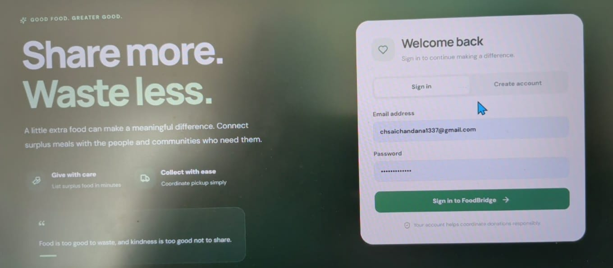
Figure 13.1 — Sign-in screen with “Welcome back” card.

13.2 Donor dashboard
After signing in, the header shows the user’s name and role (for example, Donor account) with a Sign out control. The hero invites the donor to turn extra food into extra good, with a Share surplus food button. Four tiles summarise the community: available now, reserved, collected, and food in circulation.
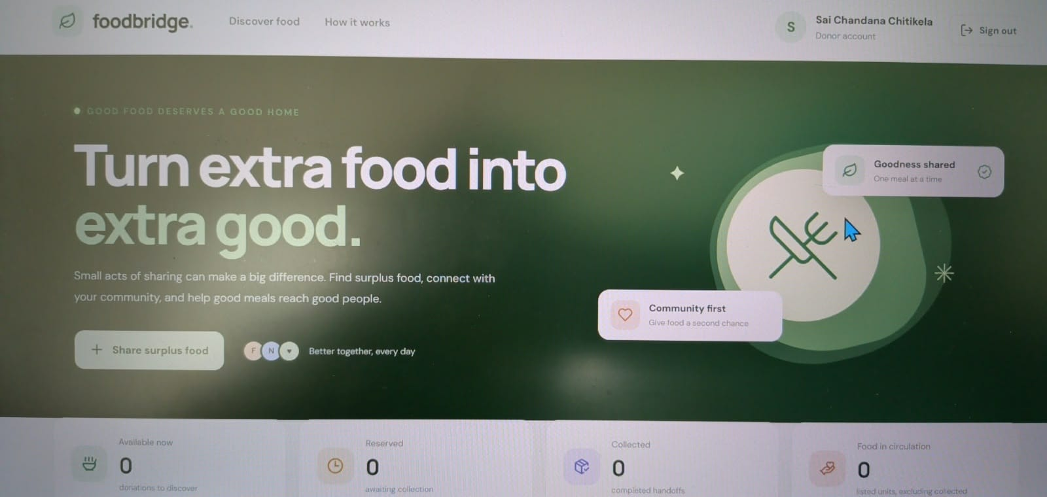
Figure 13.2 — Donor dashboard with hero and impact counters.

14. User Interface Walkthrough (II)

14.1 Add donation form
The “Share a food donation” form gathers everything an NGO needs: food name, food type, donor type, quantity and unit, pickup location, pickup and expiry date-times, and an optional description.
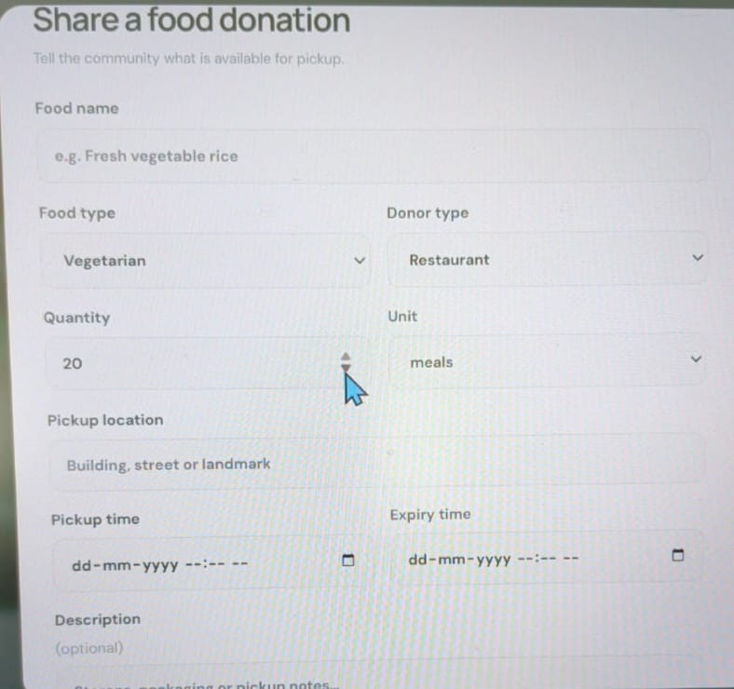
Figure 14.1 — Add donation form.

14.2 Community donations and filters
“Your community’s donations” lists every donation. A search box covers food and pickup location, while two drop-downs filter by status and by food type (Vegetarian, Non-Vegetarian, Vegan, Bakery, Other). When nothing matches, a friendly empty state invites the first donation.
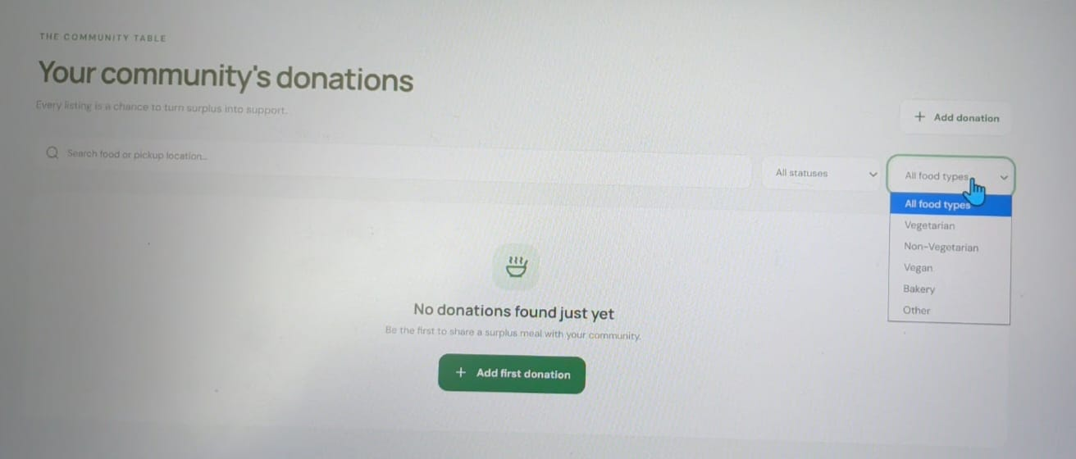
Figure 14.2 — Search and filter controls on the donations page.

15. Access, Demo and Deployment

15.1 Live application
Public link: https://rule-replicator.lovable.app
The sign-in page has Demo Donor and Demo NGO buttons. One click signs you in with a ready-made account, so reviewers can try both roles without registering.

15.2 Preview link
Preview: https://id-preview--45c20245-ee21-4304-8ba6-5e8eedacbc50.lovable.app
The preview link needs a Lovable login, so it is meant for the team and is not for posting publicly. Use the public link above when sharing.

15.3 Suggested demo script
Step | Action | What to observe
1 | Open the live link and click Demo Donor. | You land on the dashboard with counters.
2 | Click Share surplus food and submit a donation. | The donation appears with status Available.
3 | Sign out and click Demo NGO. | The NGO sees the new listing.
4 | Use search and the food-type filter. | The list narrows to matching donations.
5 | Reserve the donation. | Status changes to Reserved for everyone.
6 | Mark it Collected. | Status becomes Collected; the record persists on refresh.

15.4 Running locally
A MERN project is run by installing dependencies in the client and server folders, providing environment variables (a MongoDB connection string and a token secret), starting the API with Node, and starting the interface with the Vite dev server.

16. Testing
Testing focused on the rules that matter most: who can do what, and whether food can be double-claimed or claimed after expiry. The cases below form the functional test plan used to validate the prototype.
ID | Scenario | Expected result | Area
T-1 | Register as Donor and as NGO. | Accounts created with correct roles. | Auth
T-2 | Sign in with a wrong password. | Request rejected with an error. | Auth
T-3 | Donor submits the form with a required field empty. | Validation message; nothing saved. | Validation
T-4 | Donor submits a complete donation. | Listing saved, status Available. | CRUD
T-5 | NGO searches by food name or location. | Only matching listings shown. | Search
T-6 | NGO filters by food type and status. | List narrows correctly. | Filters
T-7 | Two NGOs reserve the same donation together. | Exactly one succeeds. | Atomicity
T-8 | NGO reserves expired food. | Rejected by the expiry guard. | Safety
T-9 | Donor tries to reserve a donation. | Denied by role check (403). | Roles
T-10 | Refresh after changing a status. | Status is unchanged. | Persistence

Cases T-7 and T-8 are the most important, because they protect trust: NGOs must never be promised the same food twice, and expired food must never be offered.

17. Results and Impact

17.1 Objectives achieved
As specified for the prototype, all six of six objectives were met: the MERN stack, CRUD operations, a REST interface, a usable UI, authentication with roles, and clear, persistent results.

17.2 Intended impact
Outcome | How FoodBridge contributes
Less waste | Surplus becomes visible to receivers before it expires.
Faster pickup | Search, filters and one-step reservation shorten the time to collect.
More meals reaching people | Atomic reservation and expiry rules make each claim dependable.

17.3 Limitations of the prototype
- No map view, notifications or distance sorting yet.
- NGOs are not formally verified beyond account sign-in.
- No analytics dashboard of meals saved over time.
- Not yet load-tested or hardened for production traffic.

17.4 Lessons learned
Putting business rules in a single atomic database operation was simpler and safer than coordinating them in application code. Starting with two clear roles and one lifecycle kept the interface focused and the demo easy to follow.

18. Future Scope
The vision is to move from prototype to community impact. The roadmap groups future work into three themes.

18.1 Connect
- Maps and distance-aware sorting so NGOs see the nearest food first.
- SMS and WhatsApp alerts when new donations match an NGO’s preferences.

18.2 Build trust
- NGO verification so donors know exactly who will collect.
- A meals-saved dashboard that shows cumulative community impact.
- Ratings and a history of completed handoffs.

18.3 Scale
- Cloud deployment with monitoring and automated backups.
- Caching of frequent listing queries.
- Rate limiting to protect the API from abuse.
- Pagination so listings stay fast as data grows.

Horizon | Focus | Outcome
Today | Working full-stack prototype | CRUD, authentication and roles
Next | Connect and build trust | Maps, alerts, verification
Later | Scale | Cloud, caching, rate limits, pagination

19. Conclusion and References

19.1 Conclusion
FoodBridge shows that a small, focused system can make surplus food discoverable and claimable in minutes. By combining a simple two-role interface with an atomic reservation and an expiry guard, it removes the most common failure modes of informal food sharing: stale information, double promises and unclear status. The prototype is a working proof that surplus food can find people instead of landfills, and the roadmap outlines how it can grow into a dependable community service.

19.2 Links
Live application: https://rule-replicator.lovable.app
Demo access: use the Demo Donor and Demo NGO buttons on the sign-in page.

19.3 References
- United Nations Environment Programme. Food Waste Index Report 2024. unep.org/resources/publication/food-waste-index-report-2024
- MongoDB Documentation: findOneAndUpdate and atomic operations. mongodb.com/docs
- Express.js Documentation. expressjs.com
- React Documentation. react.dev
- JSON Web Token (RFC 7519). datatracker.ietf.org/doc/html/rfc7519
- bcrypt: A Future-Adaptable Password Hashing Scheme (Provos and Mazières, 1999).

