Jdonframework
JdonFramework is a light-weight framework for developing DDD applications.
Before the DDD,the business logic was implemented by the technical component ,such as service,action and so on,and the model objects were all anaemia,they are just the data collections,using this design style,it is that the technical components drive the anaemia models to complete the business logics.this style has a professional name called "Transaction script".
After using the DDD,the design style is completely different from the traditional style.Using DDD style,it is the domain models drive the technical components to finish the business logics,as such,our software system is full focus on the Business domain model,it is easy to understand ,extend and maintain,at the same time,the domain model also makes our software systems more scalable,and be better performance.

DDD-Oriented Architecture
In order to better highlight on the business domain,Jdonframework take the DDD as the core design ideas,and divide the application structure into two parts: the technical components and the domain models.

The Domain models
The domain models mainly contains the Entity,Value Object,Aggregate and the domain service,all of these are mainly focus on the business domain,it is nothing to do with the concrete technical implementation.In addition ,these domain models are marked with the @Model annotation.
The domain models is the core of our software systems,their lifecycles management is very important,Jdonframework makes the management of domain model's lifecycles more easily,the domain models lives in the cache ,such as ehcache,oscache,terracotta ....,as this,the software system will be more scalable with the distributed cache system ,such as terracotta ,memcached.....
However,cache is a very low-level technical support tool,if we allow the developers to manually interact with cache,then it will easily lead to errors and inconsistecies,so Jdonframework integrates two interceptors ,one is "CacheInterceptor" ,the other is "DomainCacheInterceptor",they both are configured in the "aspect.xml" file which is a config file of jdonframework.
First let me see "CacheInterceptor","CacheIntercep" is between the presentation layer and business layer,when the presentation action invoke the "get*()" method of business service,the CacheInterceptor will intercept the invocation,it first checks that whether the domain model object already is the cache,if the model object is not in cache,CacheInterceptor will invoke the next interceptor which is in the interceptor chain,and finally the model object will be fetched from persistence datasource,the CacheInterceptor will gain the fetched model object and put it into the cache.
I guess you have understood how the CacheInterceptor works,now i will introduce you how the DomainCacheInteceptor works.DomainCacheInterceptor is between business layer and the persistence layer,before the business layer invoking the persistence layer component to fetch the model,the DomainCacheInterceptor will intercept the invocation,it will also check that whether the model has already in the cache,if in,DomainCacheInterceptor just return the cached Model,or else it will put the model which is retrieved from persistence datasource into the cache.
Last let me see the followed diagram,the diagram describes the relation of the two interceptors.

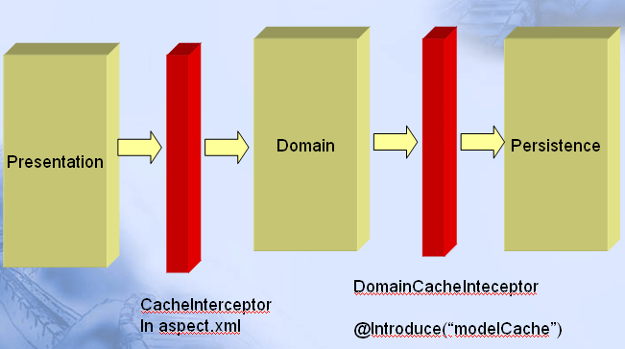

The technical components
The technical components mainly involves the technical function components,these components are marked with the @Component annotation.
The technical component's lifecycles management is also important,Jdonframework use the IOC container to manage the lifecycles of technical components,at the same time,the IOC container is also holded in the context container such as the ServeltContext.

As mentioned above,Jdonframework divides the application structure into two parts:Domain models and the technical components ,the domain models lives in the cache ,and the technical components lives in the IOC container,Jdonframework uses the interceptors to inject the technical components into the domain models.Using the Jdonframework,it will drive you to develop your application with the OO style,what's more,in this style,The domain models drive the components to finish the business operations,so do you smell the flavor of DDD ?

Domain Events support
As the DDD framework,it is essential to solve the interaction between the domain model and the technical component,Jdonframework apply the domain event pattern to make the domain models less coupling with technical components.the core architecture diagram as the followed here:

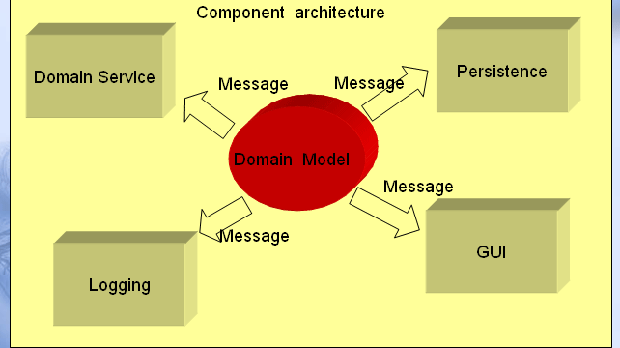

As the above diagram description,when domain models trigger some domain events,the domain event will generate proper domain message,at last the messageListener will treat with the event,and assist with the business logic.
If you want to use Domain event ,you just need to use three Annotations,@Introduce,@Inject and @Send.for example,we have a model class named MyModel,and a domain event named MyDomainEvent ,the code is as here:

@Model
public class MyModel {

private Long id;
private String name;

@Inject
private MyModelDomainEvent myModelDomainEvent;

@Inject
private MyModelService myModelServiceCommand;

public Long getId() {
return id;
}

public void setId(Long id) {
this.id = id;
}

public String getName() {
if (this.name == null) {
EventMessage message = myModelDomainEvent.asyncFindName(this);
this.name = (String) message.getEventResult();
}
return name;
}

public void setName(String name) {

this.name = name;
}

……
}

@Introduce("message")
public class MyModelDomainEvent {

@Send(value="MyModel.findName",asyn=true)
public DomainMessage asyncFindName(MyModel myModel) {
return new DomainMessage(myModel);
}

}

When you retrieve MyModel from service or repository,the CacheInterceptor and the DomainCacheInterceptor will inject the MyModelDomainEvent and MyModelService into MyModel,when injecting the MyModelDomainEvent,@Introduce("message") will lead MyModelDomainEvent to be enhanced with MessageInterceptor,when myModel.getName() is invoked, the MessageListenner will intercept the invocation,it will choose proper means to drive the MessageListner to response this event request.

Aop support
Using the DDD,It is the domain models drive the technical components to finish the business logics,and in this design style,the components are just the assistants,which assist the domain models to complete the business operations.So how the domain models gain the needed components,Jdonframework use the @Inject and @Component to inject components and the domain events into models.
As the followed diagram illustrates ,when client invoke the getA("a"),if Model A with a Introduce,the A will be enhanced,and the technical component C will also be injected into the A ,at the same time,when inject the B,the B will also be enhanced for the @Introduce.

