1. **Aritmatika**
2. **Code**

clc; clear; close all;

gambar1=imread('a.jpg');

gambar2=imread('b.jpg');

A=double(gambar1);

B=double(gambar2);

[x1, y1]=size(A);

[x2, y2]=size(B);

%pengurangan

if(x1 == x2) && (y1 == y2)

for l=1:x1

for m=1:x2

C(l,m)=A(l,m)-B(l,m);

end

end

end

subplot(4,3,1); imshow(gambar1);title('Gambar 1');

subplot(4,3,2); imshow(gambar2);title('Gambar 2');

subplot(4,3,3); imshow(C);title('Gambar Hasil Pengurangan CITRA');

%perkalian

for l=1:x1

for m=1:x1

F(l,m)=gambar1(l,m)*2;

end

end

subplot(4,3,4); imshow(gambar1); title('Gambar sebelum Perkalian');

subplot(4,3,6); imshow(F); title('Gambar setelah Perkalian');

%pembagian

for l=1:x1

for m=1:x1

G(l,m)=gambar1(l,m)/4;

end

end

subplot(4,3,7); imshow(gambar1); title('Gambar sebelum Pembagian');

subplot(4,3,9); imshow(G); title('Gambar setelah Pembagian');

1. **Hasil**

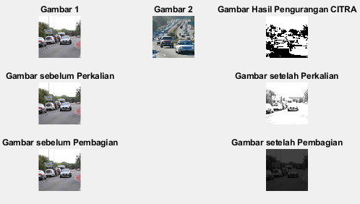

1. **Logika**
2. **Code**

a = imread('a.jpg');

b = imread('b.jpg');

Abw = im2bw(a);

subplot (4,3,1), imshow(Abw);

title('Citra a');

Bbw = im2bw(b);

subplot (4,3,3), imshow(Bbw);

title('Citra b');

c = and(Abw,Bbw);

subplot (4,3,5), imshow(c);

title('AND');

d = and(Abw,Bbw);

subplot (4,3,8), imshow(d);

title('OR');

e = and(Abw,Bbw);

subplot (4,3,11), imshow(e);

title('XOR');

1. **Hasil**

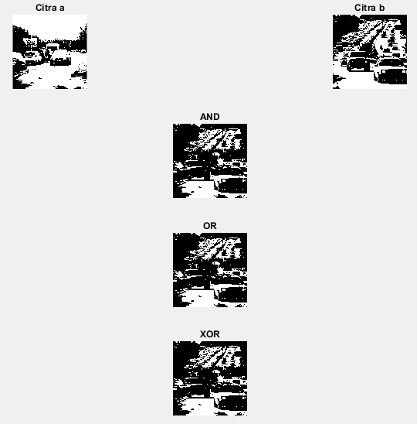

1. **Histogram Equalization**
2. **Code**

i = imread('a.JPG');

figure;

subplot(2,2,1); imshow(imh);title('streched');

subplot(2,2,2); imhist(imh);

subplot(2,2,3); imshow(imh1);title('hist eq');

subplot(2,2,4); imhist(imh1);

1. **Hasil**

