Subject | Physics
Question English
Question_hindi
Question image | 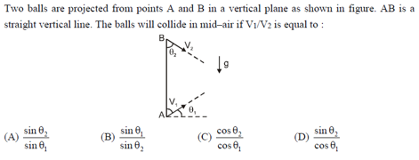
Question Type | single_choice
Option1 English
Option1 hindi
Option2 English
Option 2 Hindi
Option3 English
Option 3 Hindi
Option4 English
Option4 Hindi
Solution English
Solution Hindi
Correct Marks | 3
Incorrect Marks | 1
Correct Answer | D
Assertion English
Assertion Hindi
Solution English
Solution Hindi

Subject | Physics
Question English
Question_hindi
Question image | 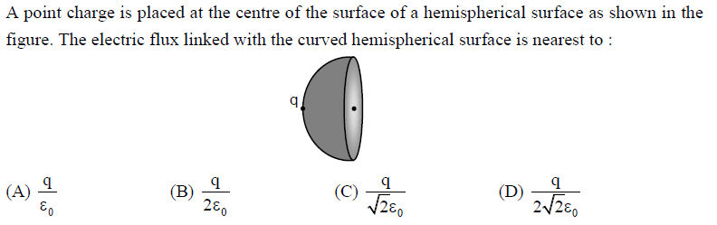
Question Type | single_choice
Option1 English
Option1 hindi
Option2 English
Option 2 Hindi
Option3 English
Option 3 Hindi
Option4 English
Option4 Hindi
Solution English
Solution Hindi
Correct Marks | 3
Incorrect Marks | 1
Correct Answer | D
Assertion English
Assertion Hindi
Solution English
Solution Hindi

Subject | Physics
Question English
Question_hindi
Question image | 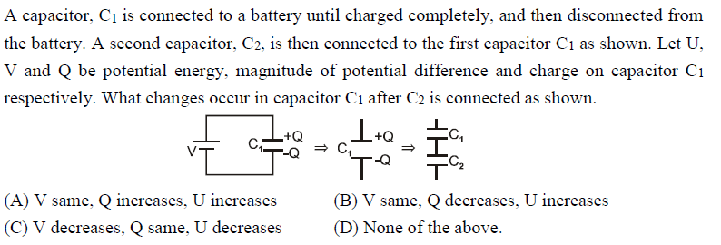
Question Type | single_choice
Option1 English
Option1 hindi
Option2 English
Option 2 Hindi
Option3 English
Option 3 Hindi
Option4 English
Option4 Hindi
Solution English
Solution Hindi
Correct Marks | 3
Incorrect Marks | 1
Correct Answer | D
Assertion English
Assertion Hindi
Solution English
Solution Hindi

Subject | Physics
Question English
Question_hindi
Question image | 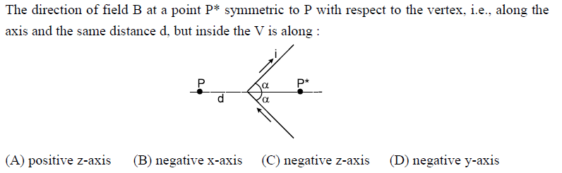
Question Type | single_choice
Option1 English
Option1 hindi
Option2 English
Option 2 Hindi
Option3 English
Option 3 Hindi
Option4 English
Option4 Hindi
Solution English
Solution Hindi
Correct Marks | 3
Incorrect Marks | 1
Correct Answer | C
Assertion English
Assertion Hindi
Solution English
Solution Hindi

Subject | Physics
Question English
Question_hindi
Question image | 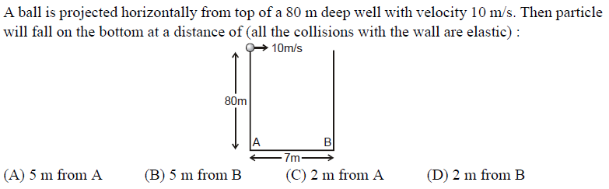
Question Type | multiple_choice
Option1 English
Option1 hindi
Option2 English
Option 2 Hindi
Option3 English
Option 3 Hindi
Option4 English
Option4 Hindi
Solution English
Solution Hindi
Correct Marks | 4
Incorrect Marks | 2
Correct Answer | B, C
Assertion English
Assertion Hindi
Solution English
Solution Hindi

Subject | Physics
Question English
Question_hindi
Question image | 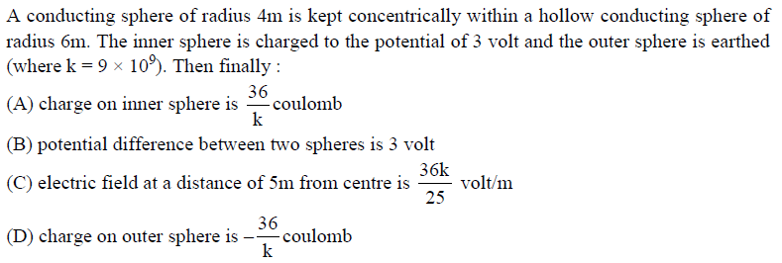
Question Type | multiple_choice
Option1 English
Option1 hindi
Option2 English
Option 2 Hindi
Option3 English
Option 3 Hindi
Option4 English
Option4 Hindi
Solution English
Solution Hindi
Correct Marks | 3
Incorrect Marks | 1
Correct Answer | A, B, C, D
Assertion English
Assertion Hindi
Solution English
Solution Hindi

Subject | Physics
Question English
Question_hindi
Question image | 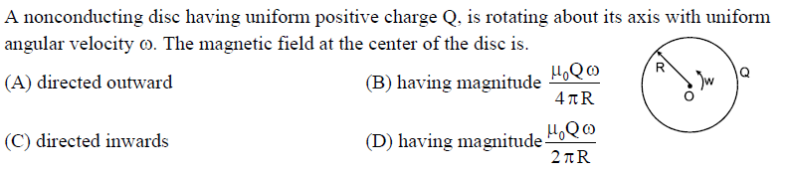
Question Type | multiple_choice
Option1 English
Option1 hindi
Option2 English
Option 2 Hindi
Option3 English
Option 3 Hindi
Option4 English
Option4 Hindi
Solution English
Solution Hindi
Correct Marks | 4
Incorrect Marks | 2
Correct Answer | A, D
Assertion English
Assertion Hindi
Solution English
Solution Hindi

Subject | Physics
Question English
Question_hindi
Question image | 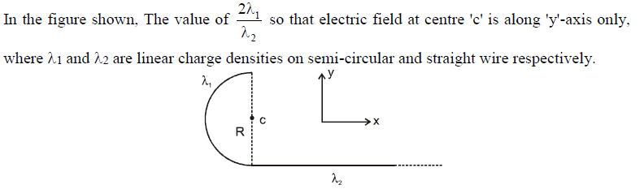
Question Type | integer
Option1 English
Option1 hindi
Option2 English
Option 2 Hindi
Option3 English
Option 3 Hindi
Option4 English
Option4 Hindi
Solution English
Solution Hindi
Correct Marks | 3
Incorrect Marks | 1
Correct Answer | 1
Assertion English
Assertion Hindi
Solution English
Solution Hindi

Subject | Physics
Question English
Question_hindi
Question image | 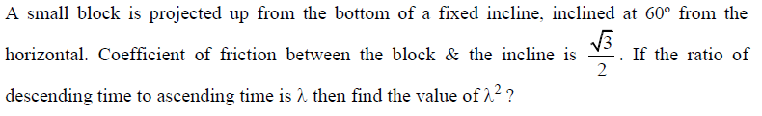
Question Type | integer
Option1 English
Option1 hindi
Option2 English
Option 2 Hindi
Option3 English
Option 3 Hindi
Option4 English
Option4 Hindi
Solution English
Solution Hindi
Correct Marks | 3
Incorrect Marks | 1
Correct Answer | 3
Assertion English
Assertion Hindi
Solution English
Solution Hindi

Subject | Physics
Question English
Question_hindi
Question image | 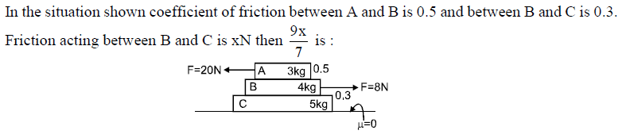
Question Type | integer
Option1 English
Option1 hindi
Option2 English
Option 2 Hindi
Option3 English
Option 3 Hindi
Option4 English
Option4 Hindi
Solution English
Solution Hindi
Correct Marks | 3
Incorrect Marks | 1
Correct Answer | 5
Assertion English
Assertion Hindi
Solution English
Solution Hindi

