Session-1:

Activities

Terminal

Enter Name:vinay

ex4.sh: 5: [: vinay: unexpected operator

Thank You

vbansal@vbansal:-/shellscript$ Sathya Sathya: command not found

vbansal@vbansal:-/shellscrtpt$ sh ex4.sh Enter Name: Sathya

ex4.sh: 5: [: Sathya: unexpected operator Thank You

vbansal@vbansal:-/shellscript$ gedit ex4.sh vbansal@vbansal:-/shellscripts sh ex4.sh

Enter Name:vinay Thank You

vbansal@vbansal:-/shellscript$ sh ex4.sh

Enter Name:Sathya

Hit Sathya, How r you

vbansal@vbansal:-/shellscript$ sh ex4.sh Enter Name:Vinay bansal

ex4.sh: 5: [: Vinay: unexpected operator

Thank You vbansal@vbansal:-/shellscripts gedit exs.sh

?

vbansal@vbansal:-/shellscript$ sh exs.sh ex5.sh: 4: [: 10: unexpected operator Not Equal vbansal@vbansal:-/shellscripts gedit ex5.sh

vbansalgybansal:-/shellscripts sh ex5.sh

Not Equal

vbansal@vbansal:-/shellscript$ gedit exs.sh vbansal@vbansal:-/shellscripts sh ex5.sh Enter a no.4

Enter another no.5

Not Equal

vbansal@vbansal:-/shellscript$ sh ex5.sh Enter a no.5

Enter another no.5

Equal

vbansal@vbansal:-/shellscripts sh ex5.sh

Enter a no.6

Enter another no.7-1 Not Equal

vbansal@vbansal:-/shellscripts sh ex5.sh

Enter a no.8

Enter another no.7+1 Not Equal

vbansalavbansal:-/shellscripts sh ex5.sh

Enter a no.8

Enter another no.9 Equal

Thank You

vbansal@vbansal:-/shellscript$ gedit ex4.sh

vbansal@vbansal:-/shellscript$ sh ex4.sh Hit Sathya! How r you

Enter Name: Sathya

vbansal@vbansal:-/shellscrtpts sh ex4.sh

Enter Name:Vinay Hit Sathyal How r you

vbansal@vbansal:-/shellscript$ gedit ex4.sh

vbansal@vbansal:-/shellscript$ sh ex4.sh

Enter Name: vinay Hti Sathya! How r you

vbansal@vbansal:-/shellscripts sh ex4.sh

Enter Name:Sathya

HLL Sathya! How r you

vbansalavbansal:-/shellscripts gedit ex4.sh vbansal@vbansal:-/shellscript$ sh ex4.sh.

Enter Name:vinay

Hit Sathya! How r you vbansal@vbansal:-/shellscripts gedit ex4.sh

vbansal@vbansal:-/shellscrtpt$ sh ex4.sh

?

Enter Name:vinay

Hit Sathya! How r you

vbansal@vbansal:-/shellscript$ Sathya Sathya: command not found

vbansal@vbansal:-/shellscripts gedit ex4.sh

vbansal@vbansal:-/shellscripts sh ex4.sh Enter Name:vinay

ex4.sh: 5: [: vinay: unexpected operator

Thank You

vbansal@vbansal:-/shellscripts Sathya Sathya: command not found

vbansalavbansal:-/shellscripts sh ex4.sh

Enter Name:Sathya ex4.sh: 5: [: Sathya: unexpected operator

Thank You

vbansal@vbansal:-/shellscripts gedit ex4.sh vbansalgybansal:-/shellscripts sh ex4.sh

Enter Nane:vinay

Thank You

vbansal@vbansal:-/shellscript$ sh ex4.sh

Enter Name:Sathya HLL Sathya, How you

vbansal@vbansal:-/shell scripts sh ex4.sh

Enter Nane:Vinay bansal

ex4.sh: 5: [: Vinay: unexpected operator Thank You vbansal@vbansal:-/shellscripts

Activities

Terminal

Thank You

vbansal@vbansal:-/shellscript$ gedit ex4.sh

vbansal@vbansal:-/shellscript$ sh ex4.sh Hit Sathya! How r you

Enter Name: Sathya

vbansal@vbansal:-/shellscrtpts sh ex4.sh

Enter Name:Vinay Hit Sathyal How r you

vbansal@vbansal:-/shellscript$ gedit ex4.sh

vbansal@vbansal:-/shellscript$ sh ex4.sh

Enter Name: vinay Hti Sathya! How r you

vbansal@vbansal:-/shellscripts sh ex4.sh

Enter Name:Sathya

HLL Sathya! How r you

vbansalavbansal:-/shellscripts gedit ex4.sh vbansal@vbansal:-/shellscript$ sh ex4.sh.

Enter Name:vinay

Hit Sathya! How r you vbansal@vbansal:-/shellscripts gedit ex4.sh

vbansal@vbansal:-/shellscrtpt$ sh ex4.sh

?

Enter Name:vinay

Hit Sathya! How r you

vbansal@vbansal:-/shellscript$ Sathya Sathya: command not found

vbansal@vbansal:-/shellscripts gedit ex4.sh

vbansal@vbansal:-/shellscripts sh ex4.sh Enter Name:vinay

ex4.sh: 5: [: vinay: unexpected operator

Thank You

vbansal@vbansal:-/shellscripts Sathya Sathya: command not found

vbansalavbansal:-/shellscripts sh ex4.sh

Enter Name:Sathya ex4.sh: 5: [: Sathya: unexpected operator

Thank You

vbansal@vbansal:-/shellscripts gedit ex4.sh vbansalgybansal:-/shellscripts sh ex4.sh

Enter Nane:vinay

Thank You

vbansal@vbansal:-/shellscript$ sh ex4.sh

Enter Name:Sathya HLL Sathya, How you

vbansal@vbansal:-/shell scripts sh ex4.sh

Enter Nane:Vinay bansal

ex4.sh: 5: [: Vinay: unexpected operator Thank You vbansal@vbansal:-/

Activities

Terminal

Thank You

vbansal@vbansal:-/shellscript$ gedit ex4.sh

vbansal@vbansal:-/shellscript$ sh ex4.sh Hit Sathya! How r you

Enter Name: Sathya

vbansal@vbansal:-/shellscrtpts sh ex4.sh

Enter Name:Vinay Hit Sathyal How r you

vbansal@vbansal:-/shellscript$ gedit ex4.sh

vbansal@vbansal:-/shellscript$ sh ex4.sh

Enter Name: vinay Hti Sathya! How r you

vbansal@vbansal:-/shellscripts sh ex4.sh

Enter Name:Sathya

HLL Sathya! How r you

vbansalavbansal:-/shellscripts gedit ex4.sh vbansal@vbansal:-/shellscript$ sh ex4.sh.

Enter Name:vinay

Hit Sathya! How r you vbansal@vbansal:-/shellscripts gedit ex4.sh

vbansal@vbansal:-/shellscrtpt$ sh ex4.sh

?

Enter Name:vinay

Hit Sathya! How r you

vbansal@vbansal:-/shellscript$ Sathya Sathya: command not found

vbansal@vbansal:-/shellscripts gedit ex4.sh

vbansal@vbansal:-/shellscripts sh ex4.sh Enter Name:vinay

ex4.sh: 5: [: vinay: unexpected operator

Thank You

vbansal@vbansal:-/shellscripts Sathya Sathya: command not found

vbansalavbansal:-/shellscripts sh ex4.sh

Enter Name:Sathya ex4.sh: 5: [: Sathya: unexpected operator

Thank You

vbansal@vbansal:-/shellscripts gedit ex4.sh vbansalgybansal:-/shellscripts sh ex4.sh

Enter Nane:vinay

Thank You

vbansal@vbansal:-/shellscript$ sh ex4.sh

Enter Name:Sathya HLL Sathya, How you

vbansal@vbansal:-/shell scripts sh ex4.sh

Enter Nane:Vinay bansal

ex4.sh: 5: [: Vinay: unexpected

vbansalavbansal:-/shellscrtpt$ ls -1 total 4

-rw-rw-r-- 1 vbansal vbansal 32 Feb 18 14:23 ex1.sh -rwxrw-r-- 1 vbansal vbansal 8 Feb 18 14:24

ex2.sh

vbansal@vbansal:-/shellscript$ gedit emp.txt vbansal@vbansal:-/shellscript$ gedit enp.txt vbansal@vbansal:-/shellscript$ rm emp.txt

rm: cannot remove 'enp.txt': No such file or directory

vbansal@vbansal:-/shellscripts gedit ex3.sh

vbansal@vbansal:-/shellscrlpt$ sh ex3.sh

Employee name:nameex3.sh: 1: read: arg count

Employee emp_idEmp_idex3.sh: 2: read: arg count

Employee deptdeptex3.sh: 3: read: arg count

name=

Employee_id=

Dept

vbansal@vbansal:-/shellscripts gedit ex3.sh vbansal@vbansal:-/shellscripts sh ex3.sh Employee name:naneex3.sh: 1; read: arg count

name=

Employee emp_idEmp_idex3.sh: 4: read: arg count Employee_id=

Employee deptdeptex3.sh: 7: read: arg count Dept= vbansal@vbansal:-/shellscripts gedit ex3.sh

vbansal@vbansal:-/shellscript$ sh ex3.sh Employee name:nameex3.sh: 3: read: arg count name

Employee enp_tdEmp_tdex3.sh: 6: read: arg count

Employee_id=

Employee deptdeptex3.sh: 9: read: arg count Dept

vbansalevbansal:-/shellscript$ gedit ex3.sh vbansal@vbansal:-/shellscripts sh ex3.sh Employee name;naneex3.sh: 3: read: arg count

name=

Employee Employee_id=

emp_id: Enp_1dex3.sh: 6: read: arg count

Employee dept:deptex3.sh: 9: read: arg count vbansalgybansal:-/shellscripts gedit ex3.sh

Dept

vbansal@vbansal:-/shellscript$ sh ex3.sh

Employee nane;naneex3.sh: 3: read: arg count

name= Employee enp_id:Enp_idex3.sh: 6: read: arg count

Employee Ide

Employee dept:deptex3.sh: 9: read: arg count

Terminal

F

vbansal@vbansal:-$ mkdir shellscript vbansalgybansal:-$ cd shellscript

vbansalgybansal:-/shellscripts gedit exi.sh vbansal@vbansal:-/shellscript$ sh ex1.sh

Hello Vinay

vbansal@vbansal:-/shellscrtpt$ gedit ex2.sh

vbansal@vbansal:-/shellscript$ ./ex2.sh bash: /ex2.sh: Permission dented

vbansal@vbansal:-/shellscrtpts chmod u+x ex2.sh vbansal@vbansal:-/shellscripts chal

O

Command

'chsl' not found, did you mean:

command 'chsh from deb passwd (1:4.8.1-1ubuntus.20.04.1)

Try: sudo apt install <deb

name>

vbansalgybansal:-/shellscript$

cat /etc/shells

# /etc/shells: valid login shells

/bin/sh /bin/bash

/usr/bin/bash

/bin/rbash

/usr/bin/rbash

/bin/dash

/usr/bin/dash

vbansalgybansal:-/shellscripts chsl

Command 'chsl' not found, did you mean:

command 'chsh' from deb passwd (1:4.8.1-1ubuntu5.20.04.1)

Try: sudo apt install <deb name>

vbansalgybansal:-/shellscrtpts chsh

Password:

Changing the login shell for vbansal Enter the new value, or press ENTER for the default

Login Shell [/bin/bash]: vbansal@vbensalt-/shellscripts pwd

/home/vbansal/s vbansal@vbanscripts Is ex1.sh ex2.sh

vbansalgybansal:-/shellscripts

ls

-1

total 4

-rw-rw-r-- 1 vbansal vbansal 32 Feb 10 14:23 ex1.sh -rwxrw-r-- 1 vbansal vbansal 6 Feb 10 14:24 ex2.sh

Terminal

coproc [NAME] command [redirections> shopt [-pasu] [-o] [optname ...] [-p] [name[=> source filename [arguments] suspend [-f]

declare [-aAfFgllnrtux] dirs [-clpv] [+N] [-N]

disown [-h] [-ar] [jobspec... | pid> test [expr] time [-p] pipeline times

echo [-neE] [arg...]

enable [-a] [-dnps] [-f filename] [n> eval [arg...]

trap [-1p] [[arg] signal_spec ...]

exec [-cl] [-a name] [command [argum> true exit [n]

type [-afptP] name [name ...] typeset [-aAfFgilnrtux] [-p] name[=>

export [-fn] [name[=value]...] or e>

false

ultntt [-SHabcdeftklmnpqrstuvxPT] [>

fc [-e ename] [-Inr] [first] [Last]> umask [-P] [-S] [mode] unalias [-a] name [name ...]

fg [job_spec] for NAME [in WORDS...];

do COMMAN> unset [-f] [-v] [-n] [name ...] for ((exp1; exp2; exp3 )); do COMMA> until COMMANDS; do COMMANDS; done

function name ( COMMANDS;) or name> vartables Names and meanings of s> watt [-fn] [1d...]

getopts optstring name [arg] hash [-tr] [-p pathname] [-dt] [name> while COMMANDS; do COMMANDS; done

help [-dns] [pattern ...]

[ COMMANDS ; }

vbansalavbansal:-/Folderis hello

?

Command 'hello' not found, but can be installed with:

sudo apt install hello

# version 2.10-2ubuntu2, or

sudo apt install hello-traditional # version 2.10-5

vbansalavbansal:-/Folderi$ ls file1.txt file2.txt file3.txt vbansalgybansal:-/Folderi$ cd --

vbansal@vbansal:-$ cd /home/vbansal/Folder1

vbansalevbansal:-/Folder15 cd

/home/vbansal

vbansalavbansal:-$ ls Desktop Downloads Music

Public Documents Folderi Pictures Templates Videos

text2

vbansalavbansal:-$ pwd

/hone/vbansal

vbansal@vbansal:-5 cp

cp: nissing file operand Try 'cp --help' for more information.

vbansalgybansal:-$ mv

ny: nissing file operand Try 'mv --help' for more information.

vbansalgybansals-5 mv Folder 2 v: nissing destination file operand after 'Folder2' Try 'mv --help' for more information.

vbansalavbansal1-$

vbansal@vbansal:-$ mkdir Folder1 vbansal@vbansal:-$ cd Folder1

vbansal@vbansal:-/Folderi$ touch file1.txt file2.txt file3.txt

vbansal@vbansal:-/Folderi$ ls

file1.txt file2.txt file3.txt

vbansal@vbansal:-/Folderi$ gedit file1.txt

vbansal@vbansal:-/Folderi$ gedit file1.sh

vbansal@vbansal:-/Folderi$ rm file1.sh

vbansalavbansal:-/Folderi$ ls

file1.txt file2.txt file3.txt vbansal@vbansal:-/Folderi$ cd -

/home/vbansal vbansal@vbansal:~$ ls

Desktop Documents

Downloads Music Folderi Pictures

Public text2 Templates Videos

vbansal@vbansal:-$ cd Folder1

vbansal@vbansal:-/Folderi$ ls file1.txt file2.txt file3.txt

vbansal@vbansal:-/Folderi$

cal

February 2022 Su Mo Tu We Th Fr Sa

1 2 3 4 5

6 7 8 9 10 11 12

13 14 15 16 17 18 19

20 21 22 23 24 25 26

27 28

vbansalgybansal:-/Folderi$ 8 cal

8: command not found vbansalevbansal:-/Folder1$ date

Thursday 10 February 2022 01:36:38 PM IST

vbansal@vbansal:-/Folder1$ help GNU bash, version 5.0.17(1)-release (x86_64-pc-linux-gnu)

These shell commands are defined internally. Type 'help' to see this list. Type 'help name' to find out more about the function 'name'. Use info bash' to find out more about the shell in general. Use 'man-k' or 'info' to find out more about commands not in this list.

A star (*) next to a name means that the command is disabled.

job_spec [8]

(( expression )) .filename [arguments]

[ arg... ]

[[ expression ]] altas [-p] [name[-value]... ]

bg job spec...

history [-c] [-d offset] [n] or his> if COMMANDS; then COMMANDS; [ elif > jobs [-Inprs] [jobspec...] or jobs>

kill [-s sigspec | -n signum | -stg> let arg [arg...]

local [option] name[-value] ... logout [n] mapfile [-d deltm] [-n count] [-0 o>

vbansal@vbansal:-/Folderi$ touch file1.txt file2.txt file3.txt

vbansalavbansal:-/Folderi$ ls

file1.txt file2.txt file3.txt vbansal@vbansal:-/Folderi$ gedit file1.txt

vbansal@vbansal:-/Folder1$ gedit file1.sh

vbansal@vbansal:-/Folder1$ rm file1.sh

vbansal@vbansal:-/Folder1$ ls

file1.txt file2.txt file3.txt vbansal@vbansal:-/Folderi$ cd -

/home/vbansal vbansal@vbansal:-$ ls

Desktop

Downloads

Music Public Documents Folder1 Pictures Templates

text2 Videos

vbansal@vbansal:-$ cd Folder1 vbansal@vbansal:-/Folder1$ ls

file1.txt file2.txt file3.txt

vbansal@vbansal:-/Folderi$ cal

February 2022 Su Mo Tu We Th Fr Sa

1 2 3 4 5

6 7 8 9 10 11 12 13 14 15 16 17 18 19

20 21 22 23 24 25 26

27 28

vbansal@vbansal:-/Folderi$ 8 cal 8: command not found

vbansal@vbansal:-/Folderi$ date

Thursday 18 February 2022 01:36:38 PM IST vbansalavbansal:-/Folderis help

GNU bash, version 5.0.17(1)-release (x86_64-pc-linux-gnu)

These shell commands are defined internally. Type 'help' to see this list. Type 'help name' to find out more about the function 'name'.

Use info bash' to find out more about the shell in general.

Use 'man -k' or 'info' to find out more about commands not in this list. A star (*) next to a name means that the command is disabled.

job_spec [8] ((expression ))

.filename [arguments]

[arg... ]

[[ expression 1] alias [-p] [name[value] ... ]

bg job spec...

history [-c] [-d offset] [n] or his> if COMMANDS; then COMMANDS; [ elif >

jobs [-Inprs] [jobspec...] or jobs>> kill [-s stgspec | -n signum | -stg>

let arg [arg...]

local [option] name[-value] ...

Logout [n] mapfile [-d delin] [-n count] [-0 o

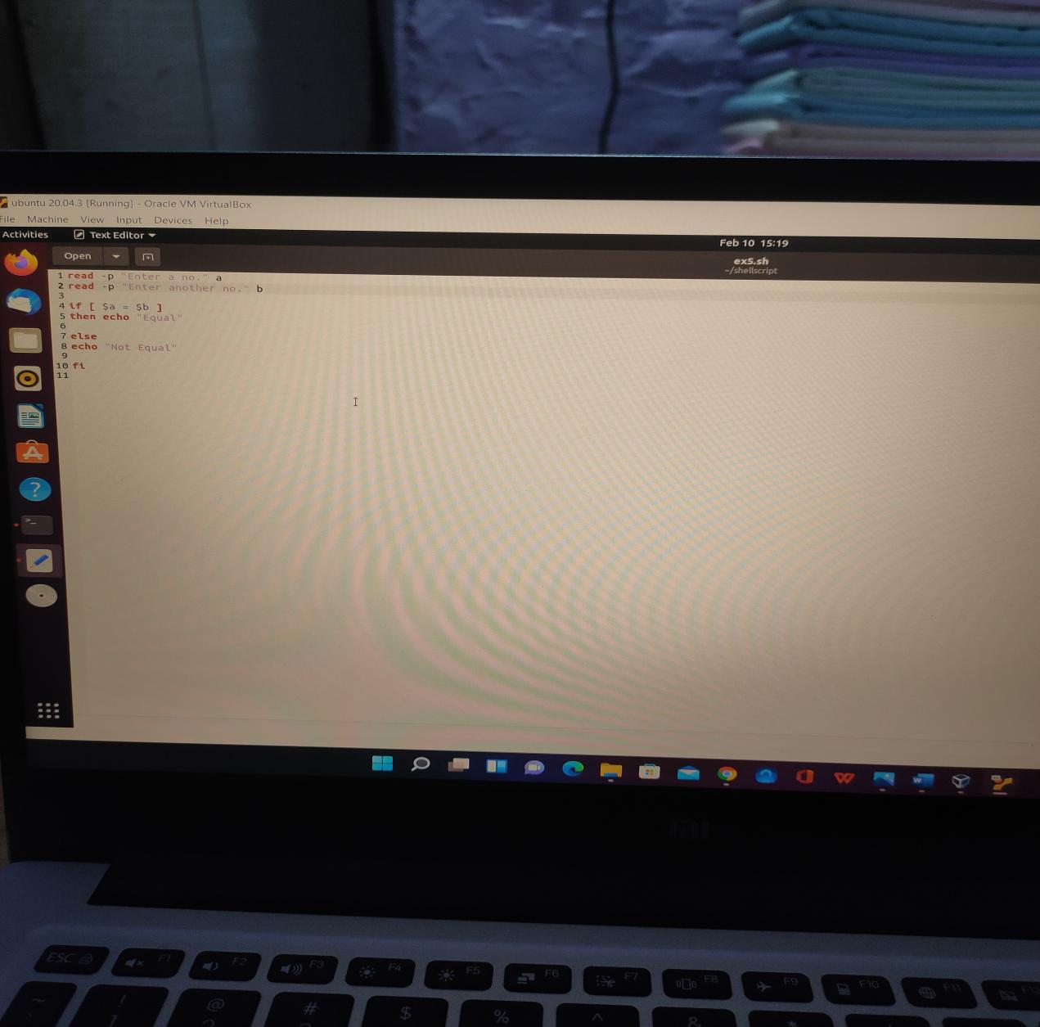

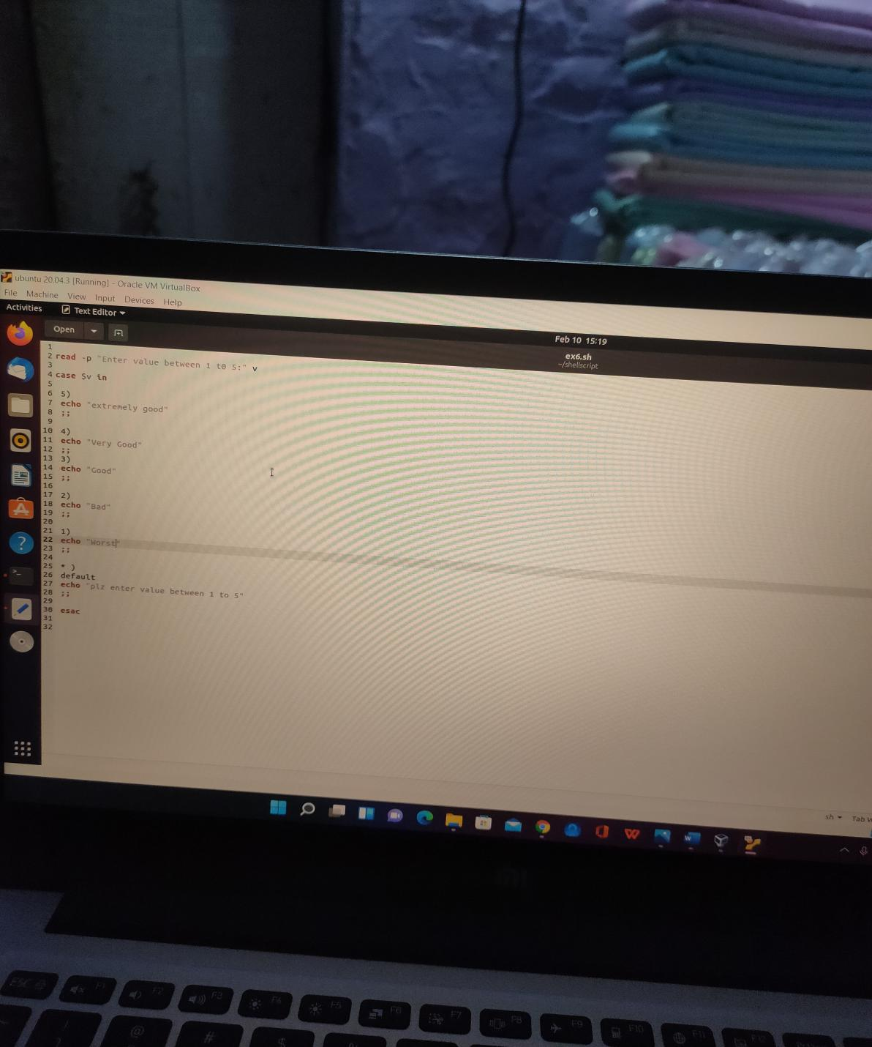

Session-2:

VINAY@DESKTOP-T2ESEI2 MINGW64 ~

$ cd E:

VINAY@DESKTOP-T2ESEI2 MINGW64 /e

$ cd trainig

bash: cd: trainig: No such file or directory

VINAY@DESKTOP-T2ESEI2 MINGW64 /e

$ cd training

VINAY@DESKTOP-T2ESEI2 MINGW64 /e/training

$ cd gitsession

VINAY@DESKTOP-T2ESEI2 MINGW64 /e/training/gitsession (book)

$ mkdir assign

VINAY@DESKTOP-T2ESEI2 MINGW64 /e/training/gitsession (book)

$ git checkout -b master

Switched to a new branch 'master'

VINAY@DESKTOP-T2ESEI2 MINGW64 /e/training/gitsession (master)

$ cd assign

VINAY@DESKTOP-T2ESEI2 MINGW64 /e/training/gitsession/assign (master)

$ git init

Initialized empty Git repository in E:/Training/gitsession/assign/.git/

VINAY@DESKTOP-T2ESEI2 MINGW64 /e/training/gitsession/assign (master)

$ touch aaa.sh

VINAY@DESKTOP-T2ESEI2 MINGW64 /e/training/gitsession/assign (master)

$ rm aaa.sh

VINAY@DESKTOP-T2ESEI2 MINGW64 /e/training/gitsession/assign (master)

$ ls

VINAY@DESKTOP-T2ESEI2 MINGW64 /e/training/gitsession/assign (master)

$ aaa.txt

bash: aaa.txt: command not found

VINAY@DESKTOP-T2ESEI2 MINGW64 /e/training/gitsession/assign (master)

$ touch aaa.txt

VINAY@DESKTOP-T2ESEI2 MINGW64 /e/training/gitsession/assign (master)

$ cat >> aaa.txt

hello, busy in doing assignments

VINAY@DESKTOP-T2ESEI2 MINGW64 /e/training/gitsession/assign (master)

$ cat aaa.txt

hello, busy in doing assignments

VINAY@DESKTOP-T2ESEI2 MINGW64 /e/training/gitsession/assign (master)

$ git status

On branch master

No commits yet

Untracked files:

(use "git add <file>..." to include in what will be committed)

aaa.txt

nothing added to commit but untracked files present (use "git add" to track)

VINAY@DESKTOP-T2ESEI2 MINGW64 /e/training/gitsession/assign (master)

$ cat >> aaa.txt

now doing 2nd ques

VINAY@DESKTOP-T2ESEI2 MINGW64 /e/training/gitsession/assign (master)

$ git commit -m "adding a line"

On branch master

Initial commit

Untracked files:

(use "git add <file>..." to include in what will be committed)

aaa.txt

nothing added to commit but untracked files present (use "git add" to track)

VINAY@DESKTOP-T2ESEI2 MINGW64 /e/training/gitsession/assign (master)

$ git add -all

error: did you mean `--all` (with two dashes)?

VINAY@DESKTOP-T2ESEI2 MINGW64 /e/training/gitsession/assign (master)

$ git add --all

warning: LF will be replaced by CRLF in aaa.txt.

The file will have its original line endings in your working directory

VINAY@DESKTOP-T2ESEI2 MINGW64 /e/training/gitsession/assign (master)

$ git status

On branch master

No commits yet

Changes to be committed:

(use "git rm --cached <file>..." to unstage)

new file: aaa.txt

VINAY@DESKTOP-T2ESEI2 MINGW64 /e/training/gitsession/assign (master)

$ git status --short

A aaa.txt

VINAY@DESKTOP-T2ESEI2 MINGW64 /e/training/gitsession/assign (master)

$ cat aaa.txt

hello, busy in doing assignments

now doing 2nd ques

VINAY@DESKTOP-T2ESEI2 MINGW64 /e/training/gitsession/assign (master)

$ cat >> aaa.txt

now good evening

VINAY@DESKTOP-T2ESEI2 MINGW64 /e/training/gitsession/assign (master)

$ git commit -a -m "adding more lines"

warning: LF will be replaced by CRLF in aaa.txt.

The file will have its original line endings in your working directory

[master (root-commit) 8631b8e] adding more lines

1 file changed, 3 insertions(+)

create mode 100644 aaa.txt

VINAY@DESKTOP-T2ESEI2 MINGW64 /e/training/gitsession/assign (master)

$ git log

commit 8631b8ec6073f49474a2932c470ba5f766e264b8 (HEAD -> master)

Author: VINAY <VINAYmehta973@gmail.com>

Date: Mon Jan 31 19:24:56 2022 +0530

adding more lines

VINAY@DESKTOP-T2ESEI2 MINGW64 /e/training/gitsession/assign (master)

$ git status

On branch master

nothing to commit, working tree clean

VINAY@DESKTOP-T2ESEI2 MINGW64 /e/training/gitsession/assign (master)

$ git checkout -b even

Switched to a new branch 'even'

VINAY@DESKTOP-T2ESEI2 MINGW64 /e/training/gitsession/assign (even)

$ git branch weme

VINAY@DESKTOP-T2ESEI2 MINGW64 /e/training/gitsession/assign (even)

$ git branch

* even

master

weme

VINAY@DESKTOP-T2ESEI2 MINGW64 /e/training/gitsession/assign (even)

$ git checkout weme

Switched to branch 'weme'

VINAY@DESKTOP-T2ESEI2 MINGW64 /e/training/gitsession/assign (weme)

$ git checkout master

Switched to branch 'master'

VINAY@DESKTOP-T2ESEI2 MINGW64 /e/training/gitsession/assign (master)

$ git merge weme

Already up to date.

VINAY@DESKTOP-T2ESEI2 MINGW64 /e/training/gitsession/assign (master)

$ git checkout weme

Switched to branch 'weme'

VINAY@DESKTOP-T2ESEI2 MINGW64 /e/training/gitsession/assign (weme)

$ git merge master

Already up to date.

VINAY@DESKTOP-T2ESEI2 MINGW64 /e/training/gitsession/assign (weme)

$ git checkout master

Switched to branch 'master'

VINAY@DESKTOP-T2ESEI2 MINGW64 /e/training/gitsession/assign (master)

$ git merge weme

Already up to date.