**EXPERIMENT 5**

**SOFTWARE REQUIREMENT SPECIFICATION DOCUMENT**

1. **Introduction**

This document aims at defining the overall software requirements for ‘Food Delivery Management System’. Efforts have been made to define the requirements exhaustively and accurately. The final product will be having only features/ functionalities mentioned in this document and assumptions for any additional functionality/ feature should not be made by any of the parties involved in developing/ testing/ implementing/ using this product. In case it is required to have some additional features, a formal change request will need to be raised and subsequently a new release of this document and/ or product will be produced.

* 1. **Purpose**

This specification document describes the capabilities that will be provided by the software application ‘Food Delivery Management System’. It also states the various required constraints by which the system will abide. The intended audience for this document are the development team, testing team and end users of the product.

* 1. **Scope**

The software product ‘Food Delivery Management System’ will be used for ordering food items from restaurants through an online portal. A unique user id and password will be used to uniquely identify each user. The users can view details of all the restaurants along with their menus. Restaurants can be searched on through their location or their name. The users can get their food delivered at their home by ordering from a restaurant and paying online. Bill for each order will be generated and delivered to the user. Users can also avail promo codes generated by the DBA.

The application will greatly simplify and speed up the food ordering process.

* 1. **Definitions, Acronyms, and Abbreviations**

Following abbreviations have been used throughout this document:

DBA: Database Administrator

* 1. **References**
  2. IEEE Recommended Practice for Software Requirements Specifications-IEEE Std 830-1993
  3. **Overview**

This is the Software Requirements Specification for Food Delivery Management System.

* Section 1.0 of the document introduces the purpose of the document, presents terminology and references that will be used in the project documentation, and also defines the scope of the project.
* Section 2.0 of the document describes the various software and hardware interfaces, project’s target audience, dependencies and constraints associated with the project.
* Section 3.0 of the document describes the technical requirements of the project. Requirements, as well as functional and performance requirements are described in this section.

1. **Overall Description**

The Food Delivery Management System uniquely identifies a user based on unique identification id and password possessed by the user. The system will allow the user to choose suitable language interface and order food from restaurants. The system also generates promo-codes based on user past preferences. The Food Delivery Management System will have the capability to maintain credentials and previous orders of all the users of the system. The system allows the user and administrator to view previous orders. The system automatically generates transaction receipt after each successful order made by the user containing information such as transaction id, user-id, amount, date and time and restaurant name.

* 1. **Product Perspective**
     1. **System Interfaces**

None

* + 1. **User Interfaces**

The application will have a user friendly and menu based interface. Following screens will be provided:

1. New user registration screen

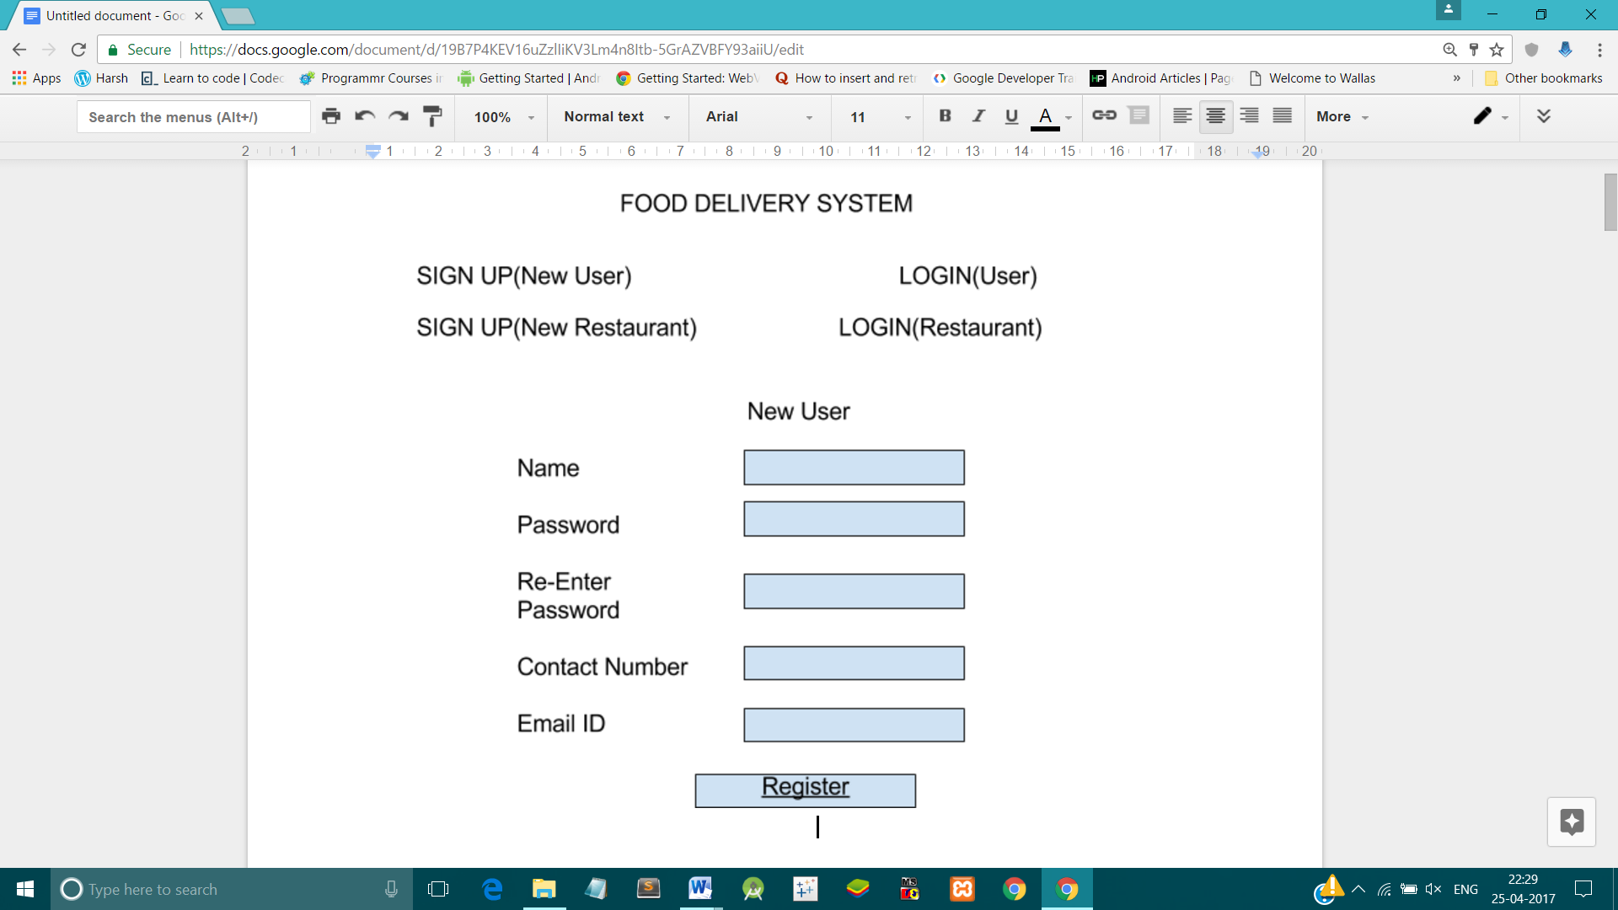

1. New restaurant registration screen

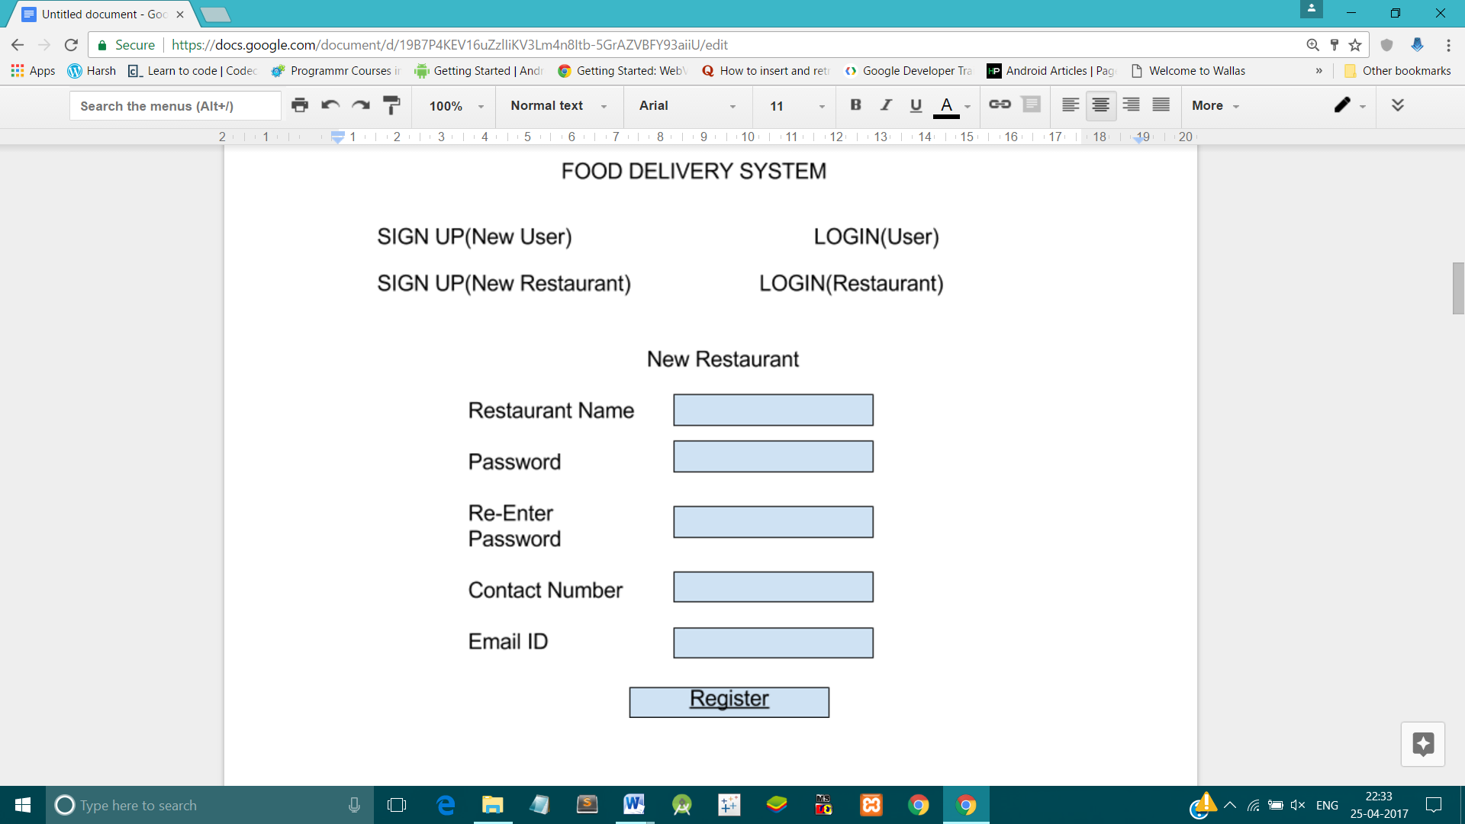

1. Restaurant login screen

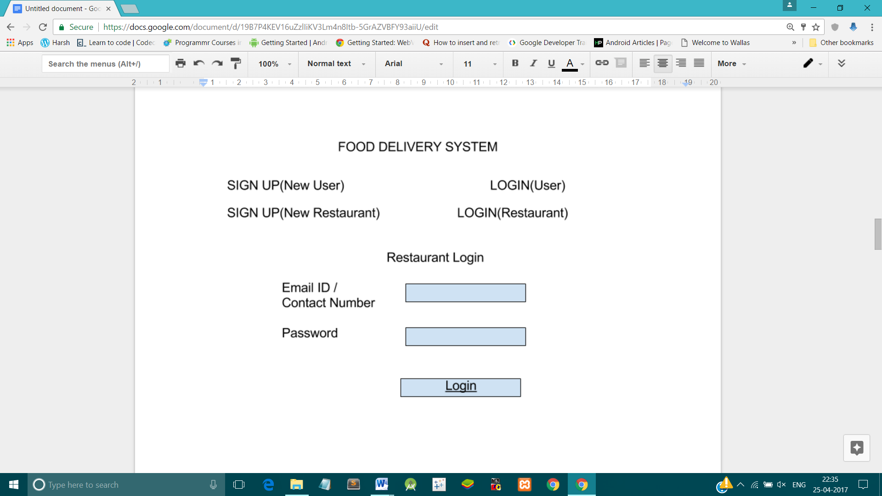

1. User login screen

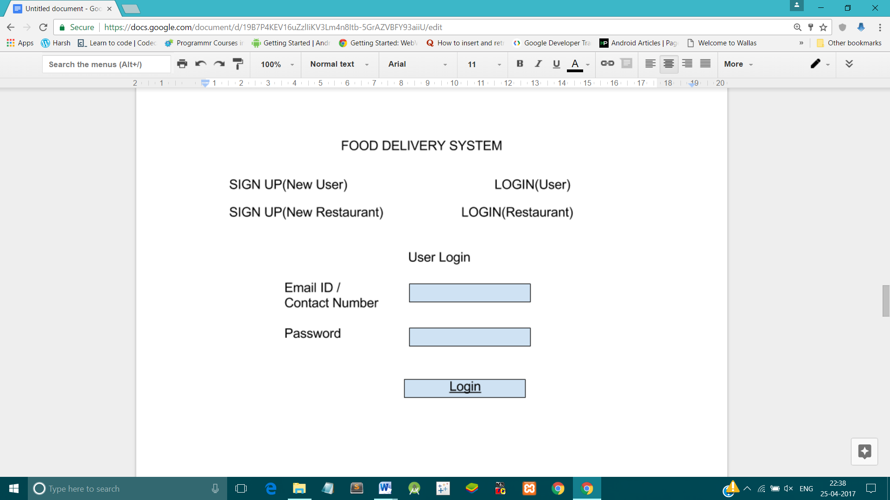

1. Search restaurant screen which will allow the users to search restaurants on the basis of their names or location.

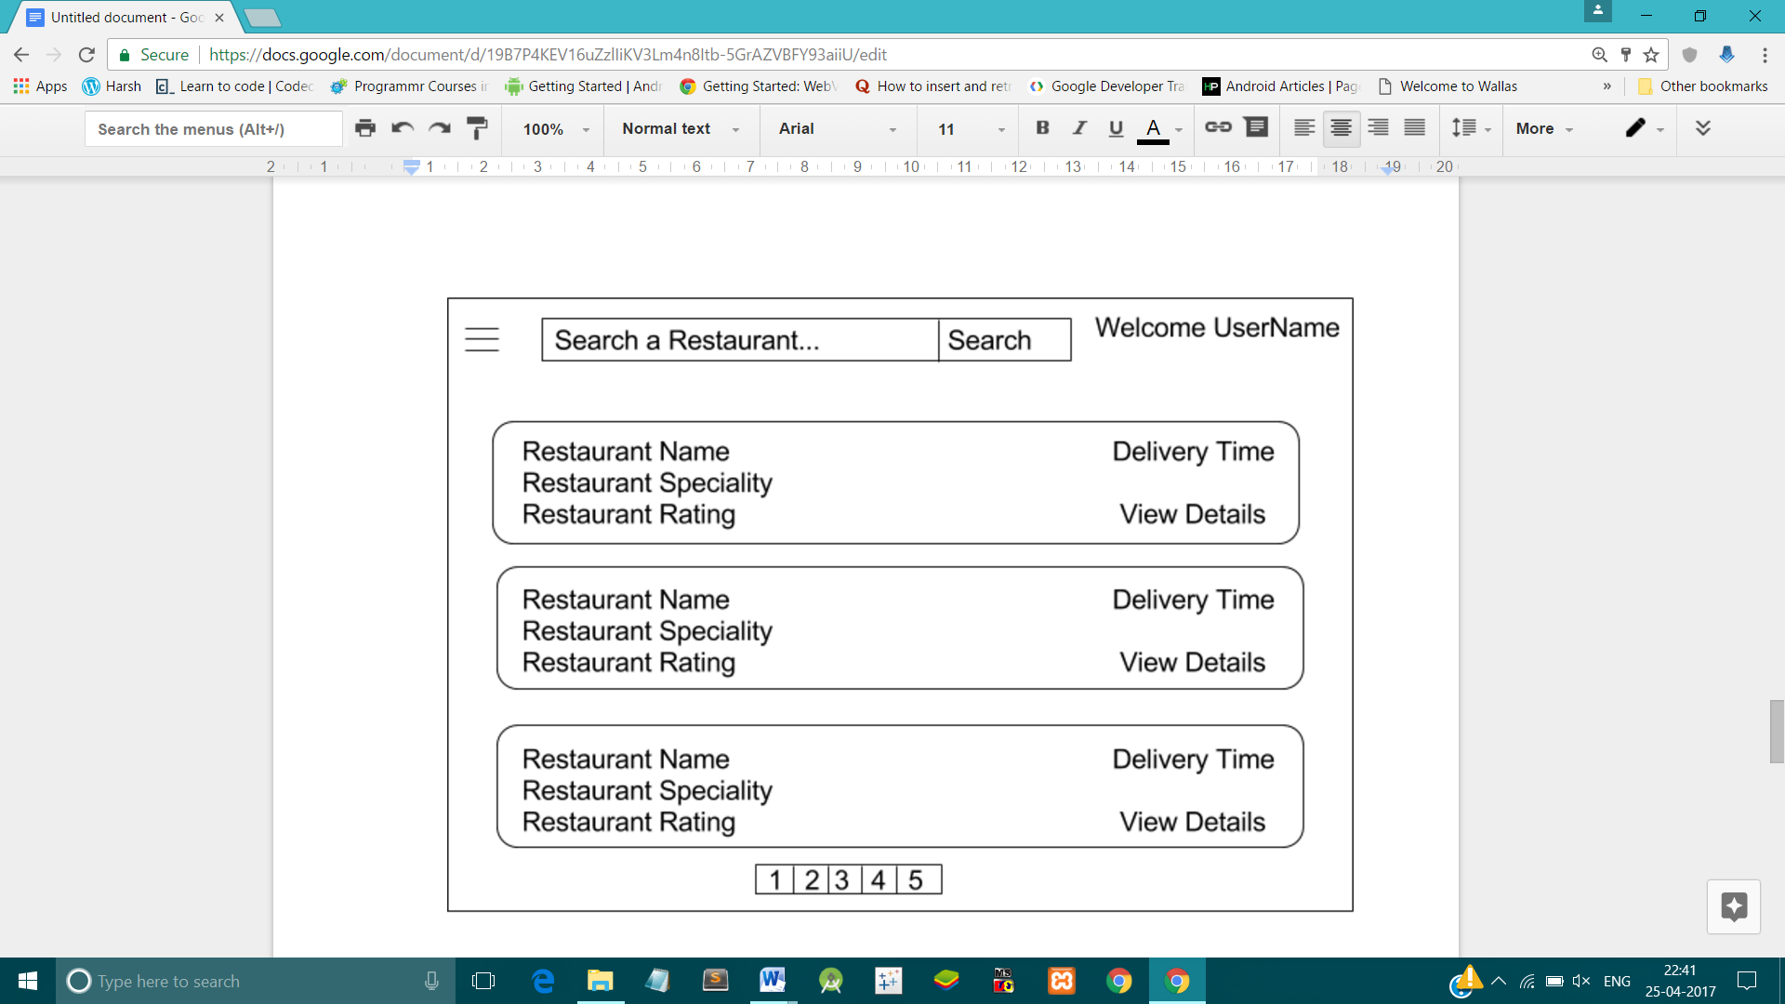

1. My cart screen which lists all the items ordered by the users along with their quantities and prices.

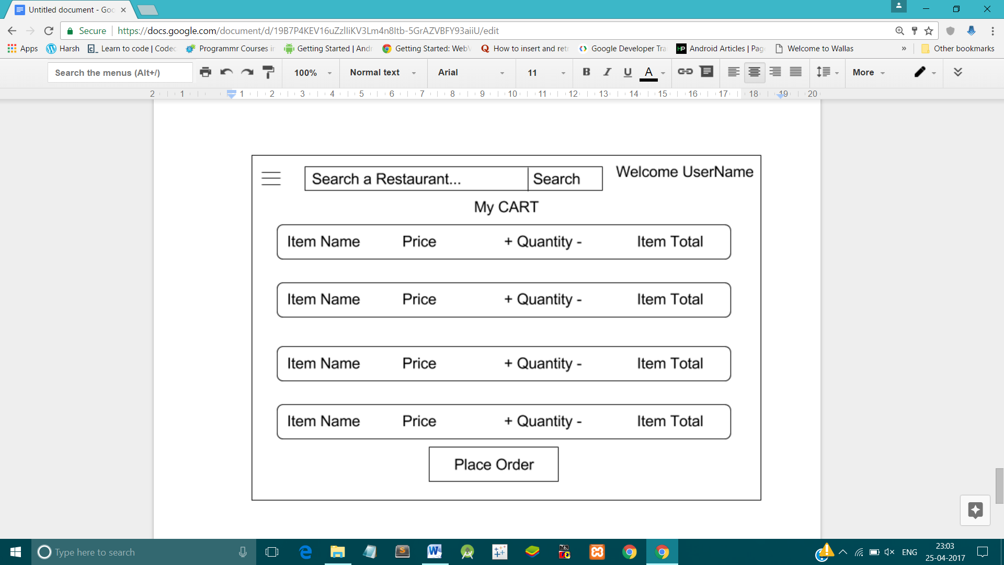

* + 1. **Hardware Interfaces**

1. Screen resolution of at least 500*500 is advised for proper and complete viewing of all the interfaces.
2. A RAM of 128 MB will be required for proper functioning of the software system.
3. Standalone system or network based- not a concern, as it will be possible to run the application on any of these.
4. Processor above P5 is advised for proper functioning.
   * 1. **Software Interfaces**
5. Any windows-based or dos-based operating system.
6. Oracle 10g database.
7. Adobe acrobat reader - for viewing receipts.
8. Codeblocks – for coding/developing the software.

Software mentioned in (ii) and (iv), will be required only for development of the application. The final application will be packaged as an independent setup program that will be delivered.

* + 1. **Communications Interfaces**

A 3D secured payment channel is required while updating wallet or making transactions for fund transfer.

* + 1. **Memory Constraints**

At least 128 MB RAM and 1 GB space on hard disk will be required for running the application and a CPU with clock cycle of at least 1.4 GHz.

* + 1. **Operations**

The product release will not cover any automated housekeeping aspects of the database. The DBA at the client site will be responsible for manually deleting old/non-required data. Database backup and recovery will also have to be handled by the DBA.

* + 1. **Site Adaptation Requirements**

The terminals at the client side will have to support the hardware and software interfaces specified in above sections.

* 1. **Product Functions**

The system will allow access only to registered users, database administrator and system engineer. Depending on the authorization grant provided by the DBA only specific modules of the system can be accessed by a user.

A summary of major functions that the software will perform:

1. A Login facility for enabling only authorised access to the system.
2. User will be able to edit details of his/her account.
3. Users will be able to search restaurants on the basis of their name or location.
4. Users will be able to place/ cancel order at any moment of time.
5. Users will be able to view orders placed previously through the system.
6. Users will be able to give reviews, feedbacks to the orders placed and also to the restaurants from which they ordered the food.
7. System generates automated bills once the order is placed.
8. Restaurant owners will be able to change menu of their restaurants.
9. DBA will be able to generate promo codes, offers to be used by the users.
10. DBA will be able to send notifications to the users.
    1. **User Characteristics**

* Should be comfortable with English language.
* Should have a registered credit/debit/master card and in case of net banking user must have net-banking id and password.
* Should have a functional email-id.
* Should be comfortable using general purpose applications on a computer.
  1. **Constraints**
* The system may become slow with increase in number of records being stored.
  1. **Assumptions and Dependencies**
* Each user would have only one username and password. In other words a user is not allowed to have multiple ids.
  1. **Apportioning of Requirements**

Not required.

1. **Specific Requirements**

This section contains the Software Requirements to a level of detail sufficient to enable designers to design the system and testers to test the system.

* 1. **External Interface Requirements**
     1. **System Interfaces:**

The system will have interface with the following two systems:

* A payment processing system: The system will access the payment processing system via its web services API.
* The Food Delivery Management database: The system will interact with the inventory database via an ODBC connection.
  + 1. **User Interfaces:**
* A login screen asking registered user for entering username and password. Also the language selection option will be provided.
* An interface will be provided for searching the restaurants based on their name and the user’s location.
* An interface will be provided for viewing a particular restaurant and placing an order from that restaurant.
* A screen will be there for editing their respective account details.

For User: Name, Address, Contact Number, and Email Id

For Restaurant Owner: Name, Restaurant Name, Menu, and Location.

* An interface will be provided for viewing all the valid promo codes available to a user for future orders.
* A screen will be there that will allow the user to view all the previous orders made by the user. The order id , amount , date, restaurant details of each order will be shown
* A screen will be there with authorization privileges only to the database administrator and system engineer providing information about all the user registered in the system and order details of all the users after providing username of the user.
  + 1. **Hardware Interfaces:**

There are no special hardware interface requirements.

* + 1. **Software Interfaces:**

There are no special software interface requirements.

* + 1. **Communication Interfaces:**

There are no special communication interfaces requirements

* 1. **Functional Requirements**
     1. **Stimulus: Click "Register" Button: Account Registration**
* The system shall allow a non-registered user to create a secure account.
* The system shall require following information from the user: Name, Address, Email Id, and Contact Number.
* The system shall ask the user for a username and password.
* The system shall confirm the username and password are acceptable.
* The system shall store the information in the database.
  + 1. **Stimulus: Click "Login" Button: Account Login**
* The system shall allow a registered user to log-in to their account.
* The system shall ask whether the user is a restaurant owner or a customer.
* The system shall require a username and password from the user and role also in case the user is a restaurant owner.
* The system will verify the username and password, and the user will be considered “logged-in”.
  + 1. **Stimulus: Click "Search" Button: Search**
* The system shall allow a user to search for restaurants by their name.
* The search results will include a picture of the restaurant, along with the name, rating and location.
  + 1. **Stimulus: Click “View Restaurant” Button: View Restaurant**
* The system allows the user to add the menu items in the cart by clicking on the particular item and selecting its quantity and then clicking on the ‘Update Cart’ option.
* The system then forwards the user to the ‘Update Cart’ Page.
  + 1. **Stimulus: Click “Update Cart” Button: Update the Cart**
* The system will allow the user to update the order cart after making the necessary changes in the order cart.
  + The system then forwards the user to the ‘Pay Bill’ Page.
    1. **Stimulus: Click "Pay Bill" Button: Pay Bill**
* After the selection of the board, the user is redirected to the payment gateway.
  + 1. **Stimulus: Click "Edit Account Details" Button: Profile**
  + The system shall allow a user to update the information in their account.
  + The user shall be allowed to view and change their name, mailing address, contact- no or email-id.
  + The restaurant owner or user shall be able to change their password by entering the old one once, and a new one twice.
  + The restaurant owner shall be allowed to view and change their name, restaurant name, menu or location.
    1. **Stimulus: Click "View Orders History" Button: History**
* The user will be given a summarized history of all the orders placed till date.
  + 1. **Stimulus: Click "Logout" Button: Account Logout**
* The system shall allow the registered and logged-in user to exit his/her account, so that access to operations requiring a user to be logged in are now disabled..
  + 1. **Stimulus: Click “View Promo codes ” Button: Promocodes**
* The user is given a list of promo codes which he is entitled to and he can use it to get cashbacks or discounts on bill clearances.
* The user can click on one of the items in the list and the system will display the code and its details such as cashback amount and expiration date, the user can apply the code to a future order.
  1. **Performance Requirements**

The performance requirements are as follows:

* System login/logout shall take less than 5 seconds.
* Searches shall return results within 7 seconds.
* Orders shall be processed within 10 seconds.
* System shall support 10,000 users simultaneously.
  1. **Design Constraints**

The Food Delivery Management System shall confirm to the following design constraints:

• Able to support Mobile Platforms.

* 1. **Software System Attributes**
     1. **Reliability**

The average time to failure shall be 30 days. In the event that a server does crash, a backup server will be up and running within the hour.

* + 1. **Availability**

The service shall be available to users 24 hours a day, 7 days a week, with the exception of being down for maintenance no more than one hour a week. If the system crashes, it should be back up within one hour.

* + 1. **Security**

Users will be able to access only their own personal information and not that of other users. Transactions will be handled through a secure payment server to ensure the protection of user’s credit card and personal information.

* + 1. **Maintainability**

Any updates or defect fixes shall be able to be made on server-side computers only, without any patches required by the user.

* + 1. **Portability**

Nothing required.

* 1. **Logical Structure of the Data**

The section below shows the different types of information used by various functions and the overall data model.

1. CUSTOMER:

* Customer ID
* Customer Name
* Telephone No
* Address

1. BILL:

* Bill ID
* Price

1. RESTAURANT:

* Restaurant ID
* Restaurant Name
* Restaurant Menu
* Telephone No
* Address

1. ORDER:

* Order ID
* No. of items
* Date and Time

1. ITEM:

* Item ID
* Item Name
* Item Details
* Item Price
* Quantity
  1. **Other Requirements**

None.