**MALVIYA NATIONAL INSTITUTE OF TECHNOLOGY JAIPUR**

**DEPARTMENT OF COMPUTER SCIENCE AND ENGINEERING**



**DATABASE MANAGEMENT PROJECT REPORT**

**Online Shopping System**

**Course - CSP313: DBMS LAB**

**Submitted By**

**Divy Bansal (2017UCP1720)**

**Lavish Nagar (2017UCP1762)**

**Submission Date: 18 November 2019**

**OBJECTIVE**

This Project is developed to serve as a platform for buyers and sellers to buy/sell commodities online.

If you have a physical store, you are limited by the geographical area that you can service. With an online website, the whole world is your playground.

Physical retail is driven by branding and relationships. In addition to these two drivers, online retail is also driven by traffic from search engines. It is not unusual for customers to follow a link in search engine results and land on an e-commerce website that they have never heard of. This additional source of traffic can be the tipping point for some small businesses.

E-commerce facilitates comparison shopping. There are several online services that allow customers to browse multiple e-commerce merchants and find the best prices.

Buyers and sellers of niche products can find it difficult to locate each other in the physical world. Online, it is only a matter of the customer searching for the product in a search engine. One example could be the purchase of obsolete parts. Instead of trashing older equipment for lack of spares, today we can locate parts online with great ease.

**PROJECT DESCRIPTION**

* This project is designed to serve as a platform for sellers and customers to Sell/Buy Items.
* Customers can place orders of the items that are listed on the platform by various sellers
* Customers can choose items and add them to cart before placing orders.
* Sellers can add items for sale on the platform.
* Sellers can update the status of the order placed by customer
* Customers Can Track The Status Of Previous Orders Placed

**Tools/Platform Used**

* Front End
  + HTML
  + CSS (BOOTSTRAP)
  + JAVASCRIPT
* Back End
  + PhP
  + MySQL DATABSE

**ER DIAGRAM**

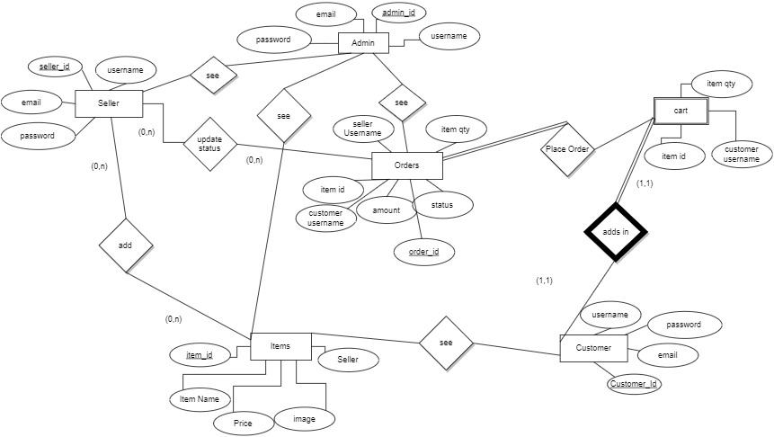

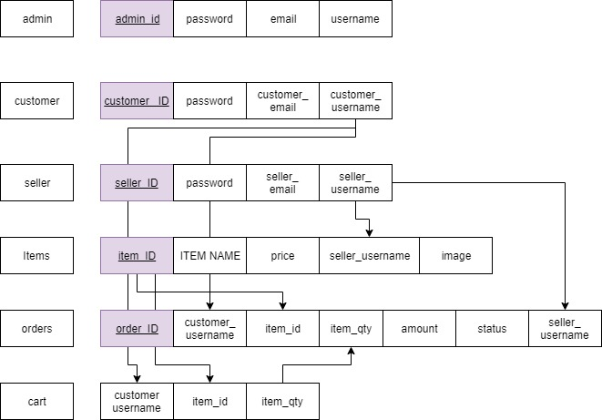**SCHEMA**

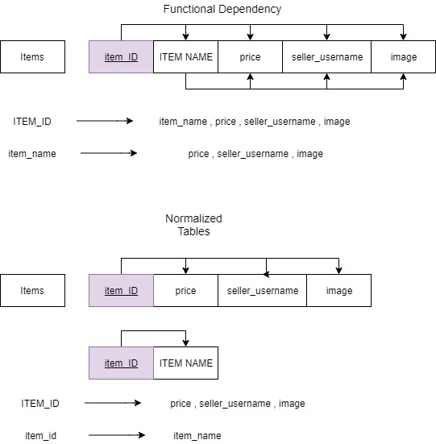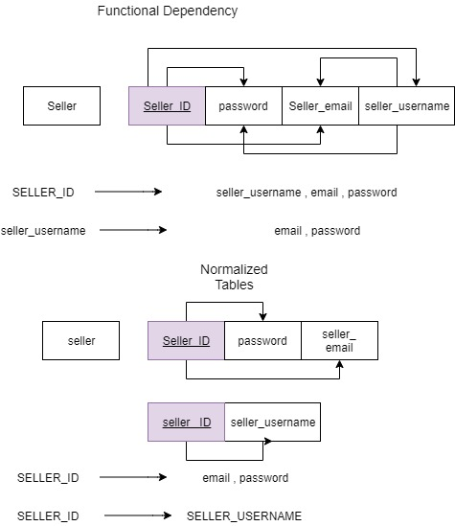

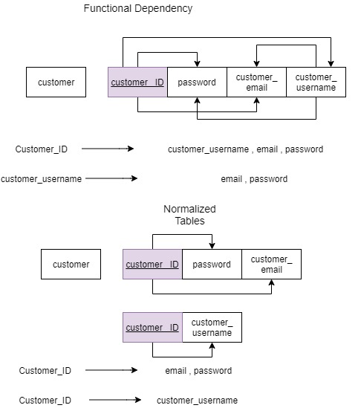

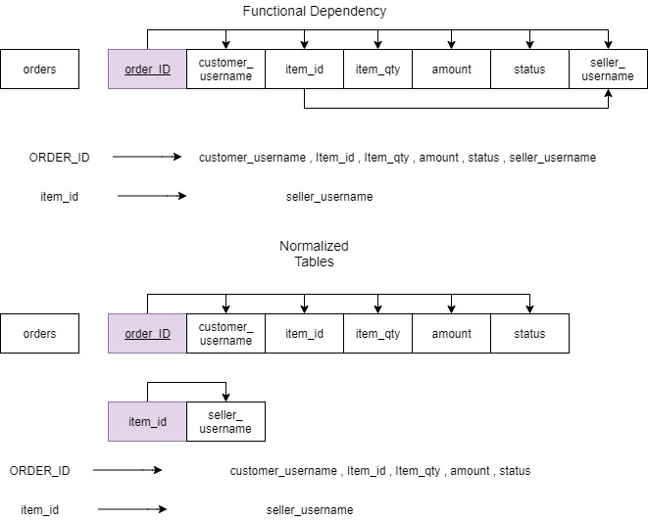

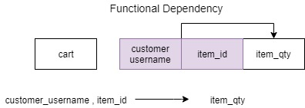

**REFERENCES**

**Some Of The Websites Refereed During The Development of The Project**

1. **W3SCHOOLS**
2. **STACK OVERFLOW**
3. **MATERIALIZE CSS**
4. **Google Images**
5. **WikiPedia**