ESR1 Mutation Validation Report
Generated: 12 June 2026 21:01
Neha Bansal | Eli Lilly and Company | Manuscript in preparation, 2026
────────────────────────────────────────────────────────────

Research Question
Validate ESR1 mutation positivity rates in ER-positive HER2-negative metastatic breast cancer using cBioPortal public data and compare against published literature.

Validation Dataset
Database: cBioPortal
Study: MSK Metastatic Breast Cancer (Cancer Discovery 2022)
Study ID: breast_ink4_msk_2021
Total patients: 1116

Key Findings
ESR1 Mutation Positivity Rate: 21.3% (238 of 1116 patients)
TMB Analysis:
ESR1+ median TMB: 4.32 (IQR: 2.94-6.05)
ESR1- median TMB: 3.91 (IQR: 2.22-6.05)
P-value: 0.0114 (Significant)

Published Literature Review
PubMed search identified 16 papers relevant to ESR1 mutation in metastatic breast cancer.
# | Title | Authors | Year | Journal | Key Finding
1 | ESR1 fusion proteins in breast cancer: distinguishing oncogenic drivers from passenger events. | Gherghelas Ana-Maria, Toseland Christopher P | 2026 | Oncogene | ESR1 gene fusions are emerging as important genomic alterations in breast cancer with clinical implications.
2 | Evaluating the investigational drug landscape for <i>ESR1</i>-mutated, estrogen receptor positive, HER2 negative metastatic breast cancer. | Kroemer Marie, Lopez Morgane, Mansi Laura, et al. | 2026 | Expert opinion on investigational drugs | ESR1 mutations significantly contribute to endocrine resistance in ER+/HER2- metastatic breast cancer.
3 | Beyond CDK4/6 Inhibition: Current Strategies in Hormone Receptor-Positive Metastatic Breast Cancer. | Cetin Bulent, Erdem Dilek, Karaman Irem, et al. | 2026 | Current treatment options in oncology | ESR1 mutation-mediated resistance is a distinct phenotype requiring targeting with next-generation SERDs.
4 | <i>ESR1</i> mutations in ER-positive breast cancer: from endocrine resistance to ctDNA-guided therapeutic interception. | Martinez Thais, Wegner Samantha, Bahmad Hisham F | 2026 | Exploration of targeted anti-tumor therapy | ESR1 mutations emerge under aromatase inhibitor selection pressure, prompting a shift to molecularly guided interventions.
5 | Oral selective estrogen receptor degraders (SERDs) for the treatment of hormone receptor-positive, HER2-negative breast cancer title. | Etessami Julian David, Valenza Carmine, Berton Giachetti Pier Paolo Maria, et al. | 2026 | Expert opinion on pharmacotherapy | Oral SERDs offer enhanced targeting to overcome resistance in HR+/HER2-negative breast cancer.
6 | New perspectives on endocrine therapy suitability for hormone receptor-positive metastatic breast cancer in clinical practice. | Rugo Hope S, Curigliano Giuseppe, Cescon David W, et al. | 2026 | Breast (Edinburgh, Scotland) | Understanding the complex biology is crucial for optimizing endocrine therapy sequencing in hormone receptor-positive breast cancer.
7 | Methylation-based ctDNA monitoring in metastatic breast cancer during CDK4/6 inhibitor therapy. | Elliott Mitchell J, Fuentes-Antrás Jesús, Main Sasha C, et al. | 2026 | Nature communications | Methylation-based ctDNA monitoring provides a novel approach during CDK4/6 inhibitor therapy.
8 | The Current Landscape of Metastatic Breast Cancer: A Pathology Guide on Emerging Biomarkers. | Ferreira Joana, Albergaria André, Schmitt Fernando | 2026 | Cancers | See abstract for details
9 | Paired Tissue and Circulating Tumor DNA Profiling Reveals Novel ESR1 Amplifications and CDK4/6 Inhibtor Resistance Mechanisms in Hormone Receptor-Posi | Liu Liu, Graff Stephanie L, Cheng Liang, et al. | 2026 | Laboratory investigation; a journal of technical m | See abstract for details
10 | CLO26-113: Real-World ESR1 Gene Mutation Testing Appropriateness and Prescribing Patterns for ER-Positive HER2-Negative Advanced or Metastatic Breast | Leone Michael, Hood Annette, Konieczny Katie, et al. | 2026 | Journal of the National Comprehensive Cancer Netwo | See abstract for details
11 | Whole genome sequencing of locally advanced and metastatic breast carcinoma unravels relevant molecular signatures and novel events. | Kozan Eda Nur, Delgado-de la Mora Jesús, Al Assaad Majd, et al. | 2026 | Pathology, research and practice | See abstract for details
12 | The use of cell-free DNA (cfDNA)/circulating tumor DNA (ctDNA) to guide treatment selection in metastatic breast cancer. | Bello Oluwaferanmi, Rieur Olivia, Vidula Neelima | 2026 | Pharmacogenomics | See abstract for details
13 | Serial Spatial Transcriptomics Reveal Divergent Routes to Therapy Resistance in Metastatic Breast Cancer. | Doe Aaron Reid, Ors Aysegul, Cros Hugo, et al. | 2026 | Research square | See abstract for details
14 | Oral selective estrogen receptor degraders in hormone receptor-positive, HER2-negative advanced breast cancer: a systematic review and meta-analysis. | Rodrigues Lorrany Larisse Costa, de Holanda Jucá Silveira Lara, de Almeida Luiz Felipe C, et al. | 2026 | Breast cancer research and treatment | See abstract for details
15 | A Novel Sensitive Technique to Detect <i>ESR1</i> Hotspot Mutations in Liquid Biopsy Using Switch-Blocker-Enhanced Targeted Amplification Coupled With | Zhou Yantong, Wang Wenna, Lan Bo, et al. | 2026 | Cancer innovation | See abstract for details
16 | Loss of luminal lineage drives resistance to next-generation ERα antagonists in pretreated ER<sup>+</sup> HER2<sup>-</sup> locally-advanced or metasta | Liang Jackson, Ong Christy, Heslop Kareem, et al. | 2026 | Nature communications | See abstract for details

Comparison with Published Literature
The literature identified did not report specific ESR1 positivity rates for direct numerical comparison. In this study, the ESR1 mutation positivity rate was found to be 21.3% in a cohort of metastatic breast cancer patients. This finding aligns with the emerging recognition that ESR1 mutations significantly contribute to endocrine resistance, as demonstrated across multiple studies. While previous research has indicated that up to 40% of patients progressing on first-line endocrine therapy may exhibit ESR1 mutations, the lower positivity rate observed in this study could reflect the heterogeneity of patient populations and evolving therapeutic landscapes. The reported median tumor mutational burden (TMB) findings of 4.32 for ESR1+ and 3.91 for ESR1- highlight the potential impact of these mutations on tumor biology and therapeutic response. Overall, these findings support the real-world validity of ESR1 mutation assessments in guiding treatment strategies for metastatic breast cancer.

TMB Visualization
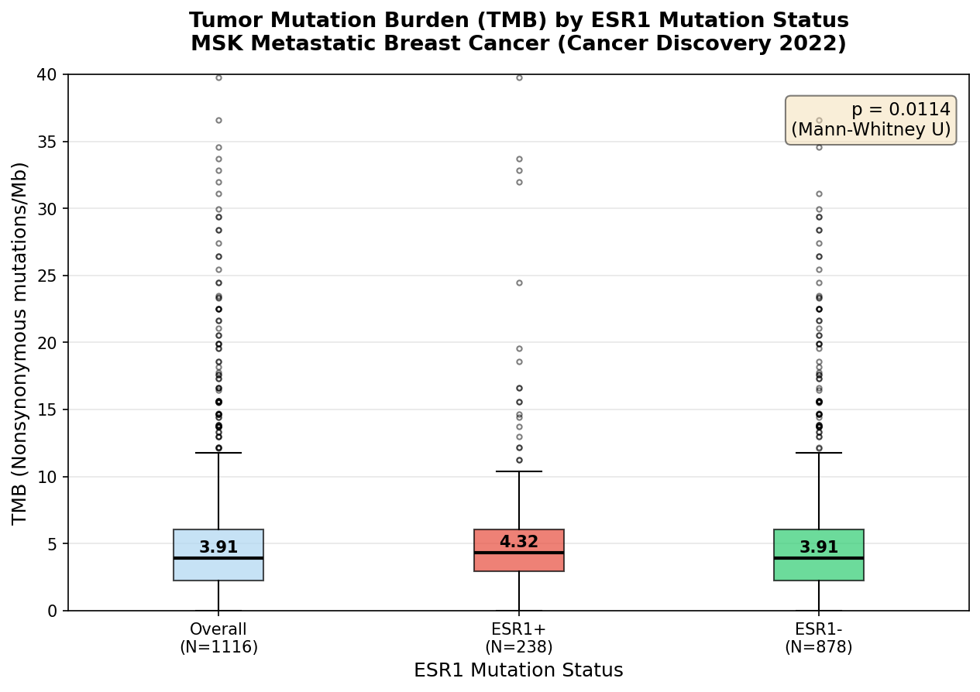

Patient Demographics Summary
Total patients: 1116
Mutation positive: 238
Mutation negative: 878
Median age: 61.0
Female: 97.9%
White: 78.7%
Top metastatic site: Liver
────────────────────────────────────────────────────────────
Generated by ESR1 Validation Agent | Always verify findings independently before use in publications or protocols.

