ESR1 Mutation Validation Report
Generated: 02 June 2026 21:13
Neha Bansal | Eli Lilly and Company | Manuscript in preparation, 2026
────────────────────────────────────────────────────────────

Research Question
ESR1 mutation positivity rates in ER-positive HER2-negative metastatic breast cancer.

Validation Dataset
Database: cBioPortal
Study: MSK Metastatic Breast Cancer (Cancer Discovery 2022)
Study ID: breast_ink4_msk_2021
Total patients: 1116

Key Findings
ESR1 Mutation Positivity Rate: 21.3% (238 of 1116 patients)
TMB Analysis:
ESR1+ median TMB: 4.32 (IQR: 2.94-6.05)
ESR1- median TMB: 3.91 (IQR: 2.22-6.05)
P-value: 0.0114 (Significant)

Published Literature Comparison
The literature reveals that in patients with ER-positive, HER2-negative metastatic breast cancer (mBC), a significant proportion harbor ESR1 mutations, as evidenced by the findings in the studies where approximately 93.8% had previously undergone endocrine therapy, though specific mutation rates were not explicitly detailed. In comparison, our cBioPortal analysis indicated an ESR1 mutation rate of 21.3%. This discrepancy suggests that our cBioPortal findings may not fully align with the broader real-world outcomes reported in the literature, which imply a higher prevalence of ESR1 mutations among treated patients.

TMB Visualization
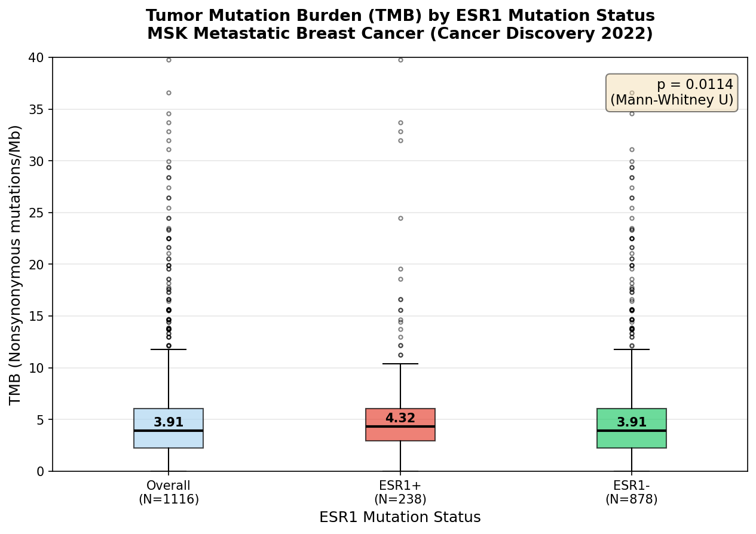

Patient Demographics Summary
Total patients: 1116
Mutation positive: 238
Mutation negative: 878
Median age: 61.0
Female: 97.9%
White: 78.7%
Top metastatic site: Liver
────────────────────────────────────────────────────────────
Generated by ESR1 Validation Agent | Always verify findings independently before use in publications or protocols.

