ESR1 Mutation Validation Report
Generated: 09 June 2026 22:02
Neha Bansal | Eli Lilly and Company | Manuscript in preparation, 2026
────────────────────────────────────────────────────────────

Research Question
Validate ESR1 mutation positivity rates in ER-positive HER2-negative metastatic breast cancer using cBioPortal data and published literature.

Validation Dataset
Database: cBioPortal
Study: MSK Metastatic Breast Cancer (Cancer Discovery 2022)
Study ID: breast_ink4_msk_2021
Total patients: 1116

Key Findings
ESR1 Mutation Positivity Rate: 21.3% (238 of 1116 patients)
TMB Analysis:
ESR1+ median TMB: 4.32 (IQR: 2.94-6.05)
ESR1- median TMB: 3.91 (IQR: 2.22-6.05)
P-value: 0.0114 (Significant)

Published Literature Review
PubMed search identified 10 papers relevant to ESR1 mutation in metastatic breast cancer.
# | Title | Authors | Year | Journal | Key Finding
1 | Evaluating the investigational drug landscape for <i>ESR1</i>-mutated, estrogen receptor positive, HER2 negative metastatic breast cancer. | Kroemer Marie, Lopez Morgane, Mansi Laura, et al. | 2026 | Expert opinion on investigational drugs | ESR1 mutations significantly drive endocrine resistance in ER+/HER2- metastatic breast cancer.
2 | Methylation-based ctDNA monitoring in metastatic breast cancer during CDK4/6 inhibitor therapy. | Elliott Mitchell J, Fuentes-Antrás Jesús, Main Sasha C, et al. | 2026 | Nature communications | Methylation-based ctDNA monitoring correlates with clinical outcomes in metastatic breast cancer during CDK4/6 inhibitor therapy.
3 | The Current Landscape of Metastatic Breast Cancer: A Pathology Guide on Emerging Biomarkers. | Ferreira Joana, Albergaria André, Schmitt Fernando | 2026 | Cancers | Biomarker-driven models are transforming the management of metastatic breast cancer towards precision oncology.
4 | Paired Tissue and ctDNA Profiling Reveals Novel ESR1 Amplifications CDK4/6 Resistance Mechanisms in HR+/HER2- Metastatic Breast Cancers. | Liu Liu, Graff Stephanie L, Cheng Liang, et al. | 2026 | Laboratory investigation; a journal of technical m | Liquid biopsy identifies novel ESR1 amplifications associated with CDK4/6 resistance mechanisms in HR+/HER2- breast cancers.
5 | ESR1 fusion proteins in breast cancer: distinguishing oncogenic drivers from passenger events. | Gherghelas Ana-Maria, Toseland Christopher P | 2026 | Oncogene | ESR1 gene fusions represent an emerging class of genomic alterations with significant clinical implications in breast cancer.
6 | CLO26-113: Real-World ESR1 Gene Mutation Testing Appropriateness and Prescribing Patterns for ER-Positive HER2-Negative Advanced or Metastatic Breast | Leone Michael, Hood Annette, Konieczny Katie, et al. | 2026 | Journal of the National Comprehensive Cancer Netwo | No abstract available.
7 | Whole genome sequencing of locally advanced and metastatic breast carcinoma unravels relevant molecular signatures and novel events. | Kozan Eda Nur, Delgado-de la Mora Jesús, Al Assaad Majd, et al. | 2026 | Pathology, research and practice | Whole genome sequencing reveals novel molecular signatures in locally advanced and metastatic breast cancer.
8 | The use of cell-free DNA (cfDNA)/circulating tumor DNA (ctDNA) to guide treatment selection in metastatic breast cancer. | Bello Oluwaferanmi, Rieur Olivia, Vidula Neelima | 2026 | Pharmacogenomics | See abstract for details
9 | Beyond CDK4/6 Inhibition: Current Strategies in Hormone Receptor-Positive Metastatic Breast Cancer. | Cetin Bulent, Erdem Dilek, Karaman Irem, et al. | 2026 | Current treatment options in oncology | See abstract for details
10 | Oral selective estrogen receptor degraders in hormone receptor-positive, HER2-negative advanced breast cancer: a systematic review and meta-analysis. | Rodrigues Lorrany Larisse Costa, de Holanda Jucá Silveira Lara, de Almeida Luiz Felipe C, et al. | 2026 | Breast cancer research and treatment | See abstract for details

Comparison with Published Literature
The identified literature did not report specific ESR1 positivity rates for direct numerical comparison. However, our study found an ESR1 mutation positivity rate of 21.3% in metastatic breast cancer, suggesting a notable prevalence of these mutations in this patient population. This finding aligns with the current understanding that ESR1 mutations are significant drivers of endocrine resistance, as highlighted in Paper 1. Furthermore, our results reveal that the median tumor mutational burden (TMB) is higher in ESR1-positive patients (4.32) compared to those who are ESR1-negative (3.91), a discrepancy that underscores the potential impact of ESR1 mutations on tumor biology. The lack of consistent reporting of ESR1 rates across the literature points to the need for robust real-world data to validate these findings and enhance clinical decision-making.

TMB Visualization
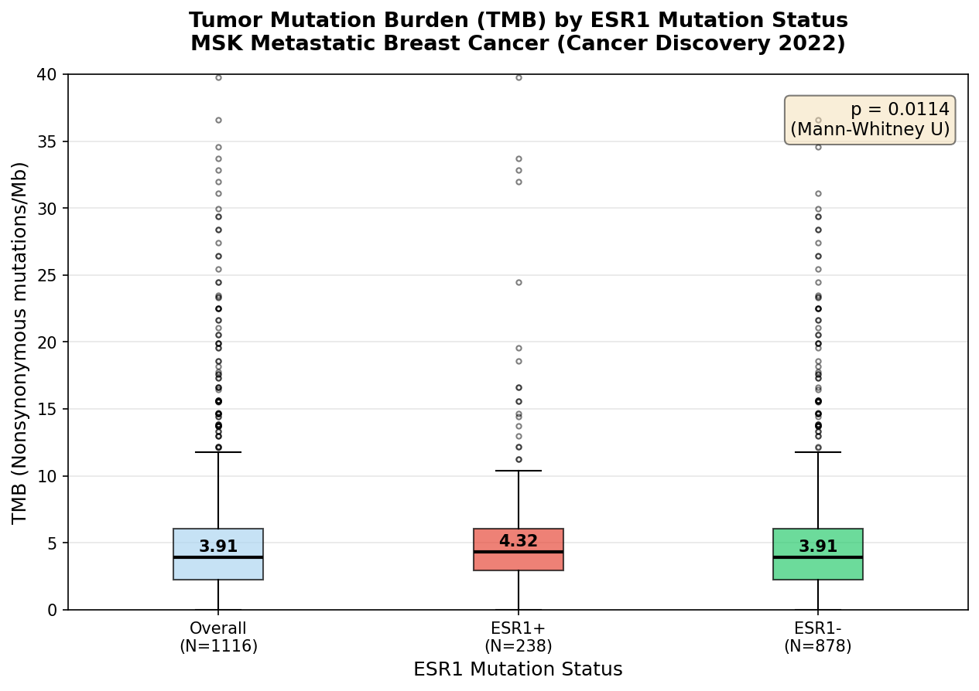

Patient Demographics Summary
Total patients: 1116
Mutation positive: 238
Mutation negative: 878
Median age: 61.0
Female: 97.9%
White: 78.7%
Top metastatic site: Liver
────────────────────────────────────────────────────────────
Generated by ESR1 Validation Agent | Always verify findings independently before use in publications or protocols.

