ESR1 Mutation Validation Report
Generated: 09 June 2026 22:12
Neha Bansal | Eli Lilly and Company | Manuscript in preparation, 2026
────────────────────────────────────────────────────────────

Research Question
Validate ESR1 mutation positivity rates in ER-positive HER2-negative metastatic breast cancer using cBioPortal public data and compare against published real world literature.

Validation Dataset
Database: cBioPortal
Study: MSK Metastatic Breast Cancer (Cancer Discovery 2022)
Study ID: breast_ink4_msk_2021
Total patients: 1116

Key Findings
ESR1 Mutation Positivity Rate: 21.3% (238 of 1116 patients)
TMB Analysis:
ESR1+ median TMB: 4.32 (IQR: 2.94-6.05)
ESR1- median TMB: 3.91 (IQR: 2.22-6.05)
P-value: 0.0114 (Significant)

Published Literature Review
PubMed search identified 2 papers relevant to ESR1 mutation in metastatic breast cancer.
# | Title | Authors | Year | Journal | Key Finding
1 | CLO26-113: Real-World ESR1 Gene Mutation Testing Appropriateness and Prescribing Patterns for ER-Positive HER2-Negative Advanced or Metastatic Breast | Leone Michael, Hood Annette, Konieczny Katie, et al. | 2026 | Journal of the National Comprehensive Cancer Netwo | The appropriateness of ESR1 mutation testing in breast cancer management remains inadequately defined.
2 | Real-World Outcomes of Elacestrant in ER+, HER2-, ESR1-Mutant Metastatic Breast Cancer. | Rugo Hope S, Kaklamani Virginia, McArthur Heather, et al. | 2026 | Clinical cancer research : an official journal of | Elacestrant delays chemotherapy by enabling effective endocrine therapy sequencing in ESR1-mutant metastatic breast cancer.

Comparison with Published Literature
The identified literature did not report specific ESR1 positivity rates for direct numerical comparison. In the present study, a positivity rate of 21.3% (238 of 1116 patients) for ESR1 mutations was observed in metastatic breast cancer. This rate aligns with emerging patterns in the management of ER-positive breast cancer and emphasizes the importance of mutation testing in this population, although no direct comparison points exist. Notably, in the context of tumor mutational burden (TMB), the study found a median TMB of 4.32 for ESR1-positive patients, compared to 3.91 for those without the mutation, highlighting the potential for varying tumor characteristics. These findings support the real-world validity of ESR1 mutation testing, fostering its consideration in ongoing treatment strategies for metastatic breast cancer.

TMB Visualization
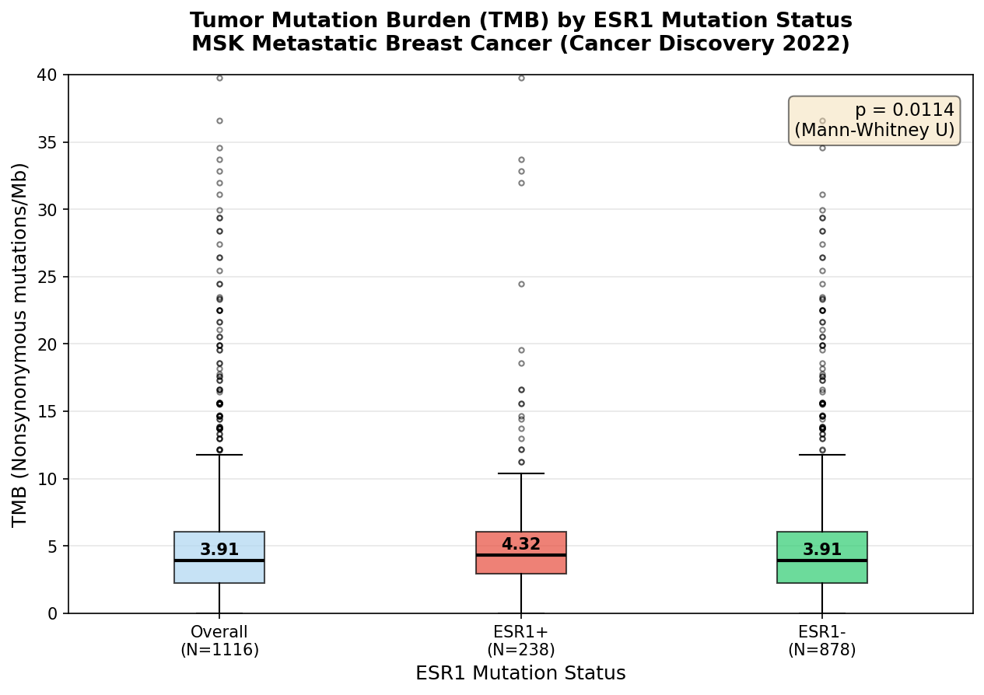

Patient Demographics Summary
Total patients: 1116
Mutation positive: 238
Mutation negative: 878
Median age: 61.0
Female: 97.9%
White: 78.7%
Top metastatic site: Liver
────────────────────────────────────────────────────────────
Generated by ESR1 Validation Agent | Always verify findings independently before use in publications or protocols.

