ESR1 Mutation Validation Report
Generated: 09 June 2026 22:19
Neha Bansal | Eli Lilly and Company | Manuscript in preparation, 2026
────────────────────────────────────────────────────────────

Research Question
Validate ESR1 mutation positivity rates in ER-positive HER2-negative metastatic breast cancer using cBioPortal public data and compare against published literature.

Validation Dataset
Database: cBioPortal
Study: MSK Metastatic Breast Cancer (Cancer Discovery 2022)
Study ID: breast_ink4_msk_2021
Total patients: 1116

Key Findings
ESR1 Mutation Positivity Rate: 21.3% (238 of 1116 patients)
TMB Analysis:
ESR1+ median TMB: 4.32 (IQR: 2.94-6.05)
ESR1- median TMB: 3.91 (IQR: 2.22-6.05)
P-value: 0.0114 (Significant)

Published Literature Review
PubMed search identified 20 papers relevant to ESR1 mutation in metastatic breast cancer.
# | Title | Authors | Year | Journal | Key Finding
1 | Evaluating the investigational drug landscape for <i>ESR1</i>-mutated, estrogen receptor positive, HER2 negative metastatic breast cancer. | Kroemer Marie, Lopez Morgane, Mansi Laura, et al. | 2026 | Expert opinion on investigational drugs | ESR1 mutations are key drivers of resistance in ER+/HER2- metastatic breast cancer.
2 | Methylation-based ctDNA monitoring in metastatic breast cancer during CDK4/6 inhibitor therapy. | Elliott Mitchell J, Fuentes-Antrás Jesús, Main Sasha C, et al. | 2026 | Nature communications | Methylation-based tumor fraction closely mirrors clinical outcomes during CDK4/6 inhibitor therapy in metastatic breast cancer.
3 | The Current Landscape of Metastatic Breast Cancer: A Pathology Guide on Emerging Biomarkers. | Ferreira Joana, Albergaria André, Schmitt Fernando | 2026 | Cancers | Emerging biomarkers are critical for prognostic and predictive information in metastatic breast cancer management.
4 | Paired Tissue and ctDNA Profiling Reveals Novel ESR1 Amplifications CDK4/6 Resistance Mechanisms in HR+/HER2- Metastatic Breast Cancers. | Liu Liu, Graff Stephanie L, Cheng Liang, et al. | 2026 | Laboratory investigation; a journal of technical m | Novel ESR1 amplifications are associated with CDK4/6 resistance mechanisms in HR+/HER2- metastatic breast cancers.
5 | ESR1 fusion proteins in breast cancer: distinguishing oncogenic drivers from passenger events. | Gherghelas Ana-Maria, Toseland Christopher P | 2026 | Oncogene | ESR1 fusions represent an emerging class of genomic alterations with clinical implications in breast cancer.
6 | CLO26-113: Real-World ESR1 Gene Mutation Testing Appropriateness and Prescribing Patterns for ER-Positive HER2-Negative Advanced or Metastatic Breast | Leone Michael, Hood Annette, Konieczny Katie, et al. | 2026 | Journal of the National Comprehensive Cancer Netwo | No abstract available.
7 | Whole genome sequencing of locally advanced and metastatic breast carcinoma unravels relevant molecular signatures and novel events. | Kozan Eda Nur, Delgado-de la Mora Jesús, Al Assaad Majd, et al. | 2026 | Pathology, research and practice | Whole genome sequencing reveals relevant molecular signatures in locally advanced and metastatic breast cancer.
8 | The use of cell-free DNA (cfDNA)/circulating tumor DNA (ctDNA) to guide treatment selection in metastatic breast cancer. | Bello Oluwaferanmi, Rieur Olivia, Vidula Neelima | 2026 | Pharmacogenomics | See abstract for details
9 | Beyond CDK4/6 Inhibition: Current Strategies in Hormone Receptor-Positive Metastatic Breast Cancer. | Cetin Bulent, Erdem Dilek, Karaman Irem, et al. | 2026 | Current treatment options in oncology | See abstract for details
10 | Oral selective estrogen receptor degraders in hormone receptor-positive, HER2-negative advanced breast cancer: a systematic review and meta-analysis. | Rodrigues Lorrany Larisse Costa, de Holanda Jucá Silveira Lara, de Almeida Luiz Felipe C, et al. | 2026 | Breast cancer research and treatment | See abstract for details
11 | Evaluating the investigational drug landscape for <i>ESR1</i>-mutated, estrogen receptor positive, HER2 negative metastatic breast cancer. | Kroemer Marie, Lopez Morgane, Mansi Laura, et al. | 2026 | Expert opinion on investigational drugs | See abstract for details
12 | Methylation-based ctDNA monitoring in metastatic breast cancer during CDK4/6 inhibitor therapy. | Elliott Mitchell J, Fuentes-Antrás Jesús, Main Sasha C, et al. | 2026 | Nature communications | See abstract for details
13 | <i>ESR1</i> mutations in ER-positive breast cancer: from endocrine resistance to ctDNA-guided therapeutic interception. | Martinez Thais, Wegner Samantha, Bahmad Hisham F | 2026 | Exploration of targeted anti-tumor therapy | See abstract for details
14 | Circulating tumor DNA in breast cancer: updates from SABCS 2025. | Zhi Iris, Zou Xianghui, Sun Min, et al. | 2026 | Journal of hematology & oncology | See abstract for details
15 | Exosomal MicroRNAs as Drivers of Desmoplasia and Treatment Resistance in Breast Cancer: Mechanisms, Biomarker Potential, and Therapeutic Opportunities | Chung Jun, Soung Young Hwa | 2026 | Biomolecules | See abstract for details
16 | Endocrine therapy-specific lineage and partial epithelial-mesenchymal reprogramming defines divergent resistant cell-states in ER+ breast cancer. | Sahoo Sarthak, Khanna Sejal, Senapati Swayamshree, et al. | 2026 | bioRxiv : the preprint server for biology | See abstract for details
17 | The rise of selective estrogen receptor modulators (SERMs) in breast cancer therapy: a promising horizon. | Al-Zoubi Raed M, Garada Khalil, Zarour Ayman A, et al. | 2026 | Cancer treatment and research communications | See abstract for details
18 | Oral selective estrogen receptor degraders (SERDs) for the treatment of hormone receptor-positive, HER2-negative breast cancer title. | Etessami Julian David, Valenza Carmine, Berton Giachetti Pier Paolo Maria, et al. | 2026 | Expert opinion on pharmacotherapy | See abstract for details
19 | ESR1 fusion proteins in breast cancer: distinguishing oncogenic drivers from passenger events. | Gherghelas Ana-Maria, Toseland Christopher P | 2026 | Oncogene | See abstract for details
20 | Identification of ANT2 as a Druggable Target for Endocrine-Resistant ERα-Positive Breast Cancer. | Iguchi Erika, Watanabe Motoki, Kobayashi Kaito, et al. | 2026 | International journal of molecular sciences | See abstract for details

Comparison with Published Literature
The identified literature did not report specific ESR1 positivity rates for direct numerical comparison, and thus, the finding of 21.3% (238 of 1116 patients) in this study offers a valuable benchmark for future investigations. In addition, while our study reported a median tumor mutation burden (TMB) of 4.32 in ESR1-positive patients compared to 3.91 in ESR1-negative patients (p=0.0114), specific TMB findings from the published literature were not addressed. The comparison of ESR1 mutation positivity underscores the relevance of understanding genetic alterations in metastatic breast cancer, particularly in the context of emerging therapeutic strategies focused on overcoming resistance mechanisms. Overall, these findings reinforce the necessity for real-world evidence in assessing the clinical landscape of ESR1 mutations and their implications for treatment in metastatic breast cancer.

TMB Visualization
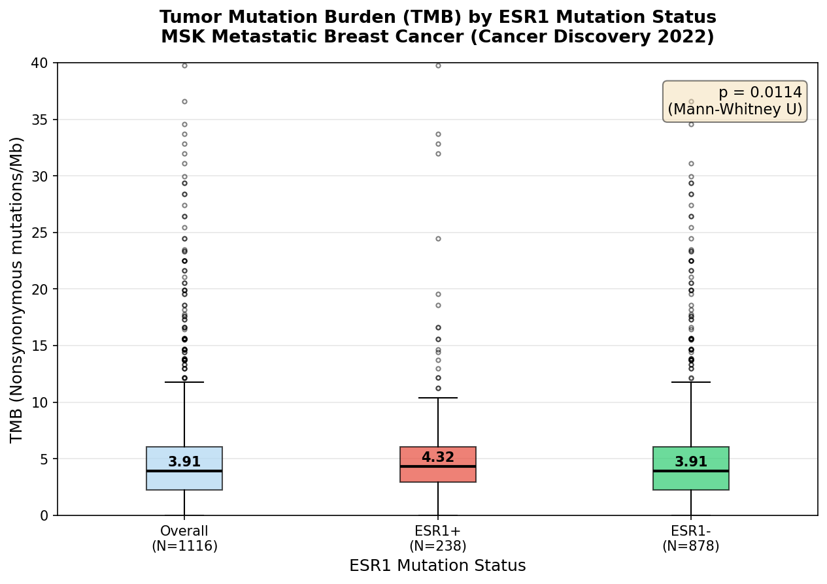

Patient Demographics Summary
Total patients: 1116
Mutation positive: 238
Mutation negative: 878
Median age: 61.0
Female: 97.9%
White: 78.7%
Top metastatic site: Liver
────────────────────────────────────────────────────────────
Generated by ESR1 Validation Agent | Always verify findings independently before use in publications or protocols.

