ESR1 Mutation Validation Report
Generated: 11 June 2026 21:01
Neha Bansal | Eli Lilly and Company | Manuscript in preparation, 2026
────────────────────────────────────────────────────────────

Research Question
Validate ESR1 mutation positivity rates in ER-positive HER2-negative metastatic breast cancer using cBioPortal data and compare against published literature.

Validation Dataset
Database: cBioPortal
Study: MSK Metastatic Breast Cancer (Cancer Discovery 2022)
Study ID: breast_ink4_msk_2021
Total patients: 1116

Key Findings
ESR1 Mutation Positivity Rate: 21.3% (238 of 1116 patients)
TMB Analysis:
ESR1+ median TMB: 4.32 (IQR: 2.94-6.05)
ESR1- median TMB: 3.91 (IQR: 2.22-6.05)
P-value: 0.0114 (Significant)

Published Literature Review
PubMed search identified 17 papers relevant to ESR1 mutation in metastatic breast cancer.
# | Title | Authors | Year | Journal | Key Finding
1 | New perspectives on endocrine therapy suitability for hormone receptor-positive metastatic breast cancer in clinical practice. | Rugo Hope S, Curigliano Giuseppe, Cescon David W, et al. | 2026 | Breast (Edinburgh, Scotland) | Endocrine therapy and CDK4/6 inhibitors are the standard first-line treatment for hormone receptor-positive metastatic breast cancer.
2 | Evaluating the investigational drug landscape for <i>ESR1</i>-mutated, estrogen receptor positive, HER2 negative metastatic breast cancer. | Kroemer Marie, Lopez Morgane, Mansi Laura, et al. | 2026 | Expert opinion on investigational drugs | ESR1 mutations are significant drivers of endocrine resistance in estrogen receptor-positive metastatic breast cancer.
3 | Methylation-based ctDNA monitoring in metastatic breast cancer during CDK4/6 inhibitor therapy. | Elliott Mitchell J, Fuentes-Antrás Jesús, Main Sasha C, et al. | 2026 | Nature communications | Methylation-based ctDNA monitoring correlates with radiographic response and outcomes in patients receiving CDK4/6 inhibitors.
4 | The Current Landscape of Metastatic Breast Cancer: A Pathology Guide on Emerging Biomarkers. | Ferreira Joana, Albergaria André, Schmitt Fernando | 2026 | Cancers | Biomarker-driven models are becoming essential in managing metastatic breast cancer for better prognostic and predictive insights.
5 | Paired Tissue and Circulating Tumor DNA Profiling Reveals Novel ESR1 Amplifications and CDK4/6 Inhibtor Resistance Mechanisms in Hormone Receptor-Posi | Liu Liu, Graff Stephanie L, Cheng Liang, et al. | 2026 | Laboratory investigation; a journal of technical m | Identifying biomarkers linked to CDK4/6 inhibitor resistance is critical in treating hormone receptor-positive metastatic breast cancers.
6 | ESR1 fusion proteins in breast cancer: distinguishing oncogenic drivers from passenger events. | Gherghelas Ana-Maria, Toseland Christopher P | 2026 | Oncogene | ESR1 fusions represent an emerging class of genomic alterations with significant clinical implications in breast cancer.
7 | CLO26-113: Real-World ESR1 Gene Mutation Testing Appropriateness and Prescribing Patterns for ER-Positive HER2-Negative Advanced or Metastatic Breast | Leone Michael, Hood Annette, Konieczny Katie, et al. | 2026 | Journal of the National Comprehensive Cancer Netwo | Appropriateness of ESR1 mutation testing impacts prescribing patterns for ER-positive HER2-negative breast cancer.
8 | Whole genome sequencing of locally advanced and metastatic breast carcinoma unravels relevant molecular signatures and novel events. | Kozan Eda Nur, Delgado-de la Mora Jesús, Al Assaad Majd, et al. | 2026 | Pathology, research and practice | See abstract for details
9 | The use of cell-free DNA (cfDNA)/circulating tumor DNA (ctDNA) to guide treatment selection in metastatic breast cancer. | Bello Oluwaferanmi, Rieur Olivia, Vidula Neelima | 2026 | Pharmacogenomics | See abstract for details
10 | Beyond CDK4/6 Inhibition: Current Strategies in Hormone Receptor-Positive Metastatic Breast Cancer. | Cetin Bulent, Erdem Dilek, Karaman Irem, et al. | 2026 | Current treatment options in oncology | See abstract for details
11 | Targeting drug resistance in breast cancer: a dual-perspective landscape analysis of PROTACs from bench to bedside. | Yang Yinlong, Lin Yihao | 2026 | Breast cancer research : BCR | See abstract for details
12 | <i>ESR1</i> mutations in ER-positive breast cancer: from endocrine resistance to ctDNA-guided therapeutic interception. | Martinez Thais, Wegner Samantha, Bahmad Hisham F | 2026 | Exploration of targeted anti-tumor therapy | See abstract for details
13 | Circulating tumor DNA in breast cancer: updates from SABCS 2025. | Zhi Iris, Zou Xianghui, Sun Min, et al. | 2026 | Journal of hematology & oncology | See abstract for details
14 | Exosomal MicroRNAs as Drivers of Desmoplasia and Treatment Resistance in Breast Cancer: Mechanisms, Biomarker Potential, and Therapeutic Opportunities | Chung Jun, Soung Young Hwa | 2026 | Biomolecules | See abstract for details
15 | Endocrine therapy-specific lineage and partial epithelial-mesenchymal reprogramming defines divergent resistant cell-states in ER+ breast cancer. | Sahoo Sarthak, Khanna Sejal, Senapati Swayamshree, et al. | 2026 | bioRxiv : the preprint server for biology | See abstract for details
16 | The rise of selective estrogen receptor modulators (SERMs) in breast cancer therapy: a promising horizon. | Al-Zoubi Raed M, Garada Khalil, Zarour Ayman A, et al. | 2026 | Cancer treatment and research communications | See abstract for details
17 | Oral selective estrogen receptor degraders (SERDs) for the treatment of hormone receptor-positive, HER2-negative breast cancer title. | Etessami Julian David, Valenza Carmine, Berton Giachetti Pier Paolo Maria, et al. | 2026 | Expert opinion on pharmacotherapy | See abstract for details

Comparison with Published Literature
The identified literature did not report specific ESR1 positivity rates for direct numerical comparison. However, the study found an ESR1 mutation positivity rate of 21.3% (238 of 1116 patients) in metastatic breast cancer, indicating a notable prevalence of these mutations in the studied cohort. This finding suggests a potential alignment with previous research highlighting ESR1 mutations as significant drivers of endocrine resistance in estrogen receptor-positive metastatic breast cancer. Our study also reported a median tumor mutational burden (TMB) of 4.32 for ESR1-positive patients compared to 3.91 for ESR1-negative patients (p=0.0114), adding to the existing discourse on the genomic landscape of this malignancy. Overall, these results underscore the importance of identifying biomarkers, such as ESR1 mutations, to enhance therapeutic strategies and support real-world applicability in clinical settings.

TMB Visualization
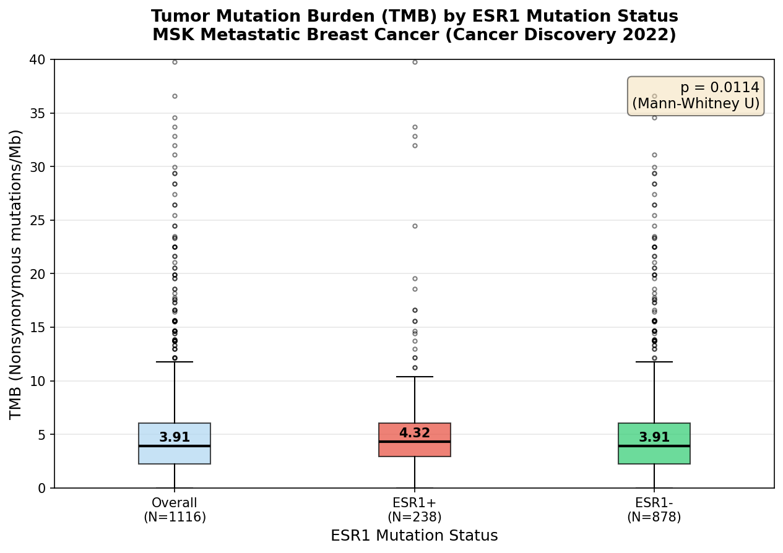

Patient Demographics Summary
Total patients: 1116
Mutation positive: 238
Mutation negative: 878
Median age: 61.0
Female: 97.9%
White: 78.7%
Top metastatic site: Liver
────────────────────────────────────────────────────────────
Generated by ESR1 Validation Agent | Always verify findings independently before use in publications or protocols.

