mOBILEMYLAB

uSER MANUAL





This document is the property of the Miranda House.

It may not be reproduced or communicated without the author's prior agreement.

|  |  |  |
| --- | --- | --- |
|  |  |  |
|  |  |  |

Contents

|  |  |  |
| --- | --- | --- |
| **No.** | **Topic** | **Page number** |
| 1. | Starting application | 3 |
| 2. | Registration | 4-5 |
| 3. | Logging into application | 6-7 |
| 4. | Accelerometer | 8-10 |
| 5. | RGB value | 11-13 |
| 6. | Light sensor | 14-15 |
| 7. | Barometer | 16-18 |
| 8. | Magnetometer | 19-21 |

# Starting Application

*To start the MobileMyLab application follow the steps given below:*

*1. Click on MobileMyLab icon on application menu.*

*2. On clicking the MobileMyLab icon, the application starts and display Login page. TheLogin page contains the Google+ Login Option.*



# Registration

To register with the Miranda House MobileMyLab application, follow the steps given below:

1. Start the Miranda House MobileMyLab application.

2. On starting the application the Google+ Login page is displayed.

3. Click the Register link on the Login Page.

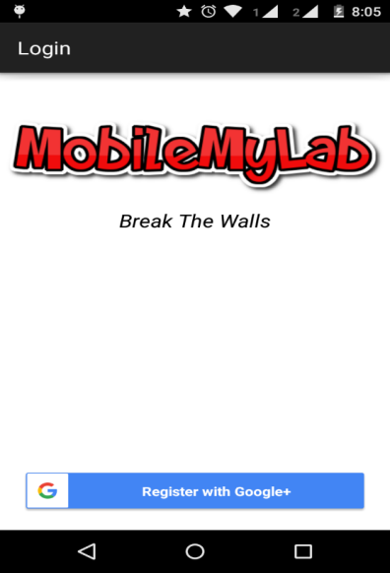

4. On clicking the Register link, the registration page is displayed.

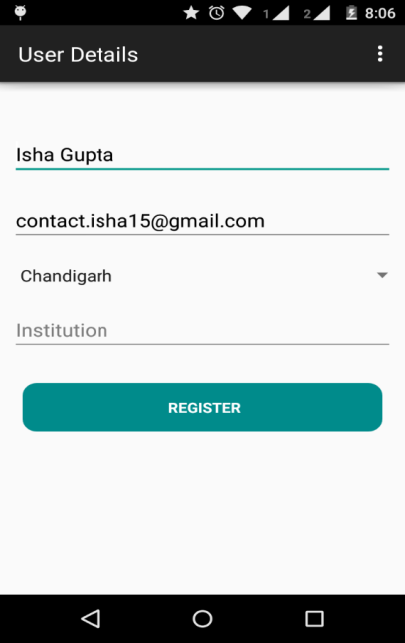

5. This page has the following input fields, where the information needs to be added for

registration:

a. Name

b. Email id

c. Location

d. Institution

6. After filling the above details, click on the Register button.

7. The Application validates the information and user gets registered.

# Logging in to the Application

1. After successful registration, registered user gets redirected to the dashboard every time it

opens the application.

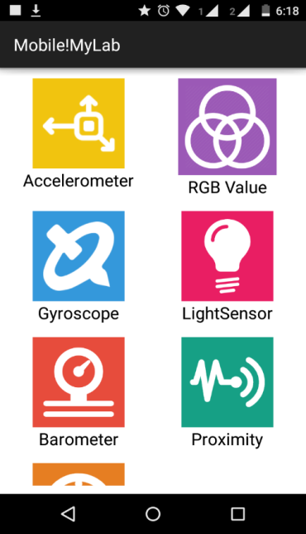

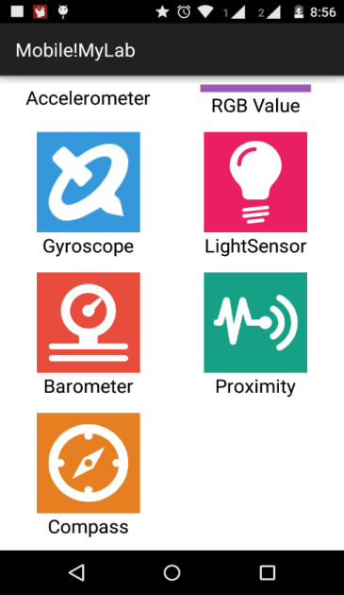

5. The dashboard contains the following icons. Each of these icon is a link to the respective section:

a. Accelerometer

b. RGB Value

c. Gyroscope

d. Light Sensor

e. Barometer

f. Proximity

g. Compass

# 4.Accelerometer

Accelerometer sensor is available in the android phones as hardware sensor for motion detection (shake ,tilt,etc.)

It measures the acceleration of device in m/s $²$ that is applied to the device in all the three axes –x axis, y axis and z axis(including the force of gravity).

## 4.1 Experiment Details

On Clicking the Accelerometer icon, Experiment Details Page is displayed.

After filling the details, Click on Begin.

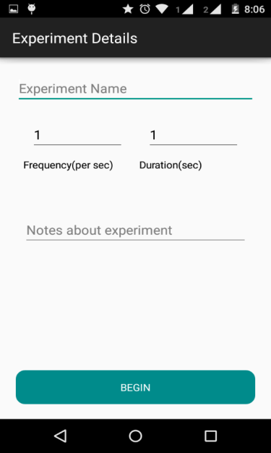

## 4.2 Begin

Click on **Begin**  to begin taking the readings of Sensor.

Experiment will begin and you will see a screen with dynamic graph. You will see the values of the x , y and z axis changing as you move your phone because that will change the acceleration of the phone in all the axes. The acceleration along x axis is shown with color ,

along y axis shown with and along z axis with color.

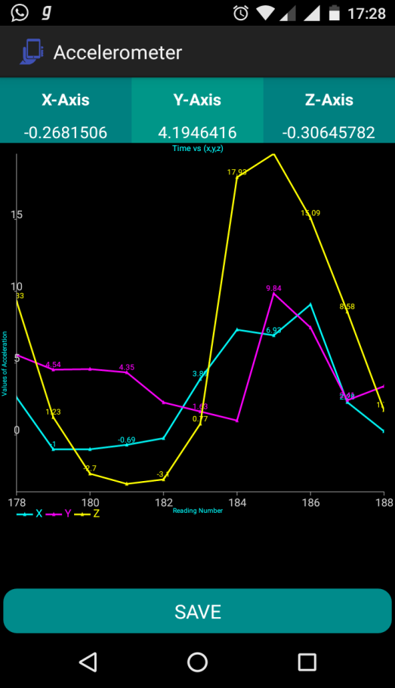

## 4.3 SAVE

*After some time (depends on the duration you mentioned in the Experiment details screen), the graph will stop changing. You can now save the readings of the experiment. You can do so by clicking on SAVE button. It will take you to your Gmail application from there you can mail the readings of experiment(in .csv format) and analyse it later.*

*To perform another experiment , click on the back button of your phone and follow the above steps again.*

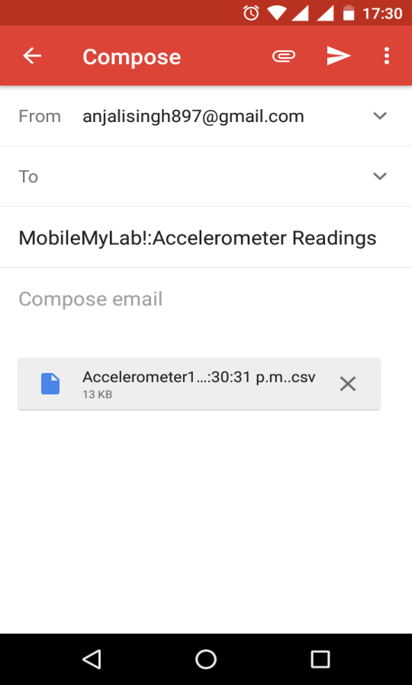

# 5.RGB VALUE

A color's **RGB value** indicates its red, green, and blue intensity. Each intensity **value** is on a scale of 0 to 255, or in hexadecimal from 00 to FF.

RGB Value is designed to analyze color groups in your image based on the visible

spectrum

1. You can take a picture from internal camera.
2. The RGB Value of the center point of the image will be shown along with the image

5.1 Experiment details :

On Clicking the RGB Value icon, Experiment Detail Page is displayed.

After filling the details, Click on Begin.

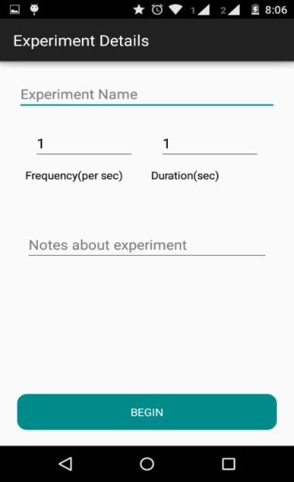

## 5.2 Begin

To start the experiment, follow the following steps:

1. Click on the camera icon in the action bar to capture the image.
2. RGB Values of the color groups in the image will be displayed after the image is captured.
3. More images can be clicked by repeating the step 1.

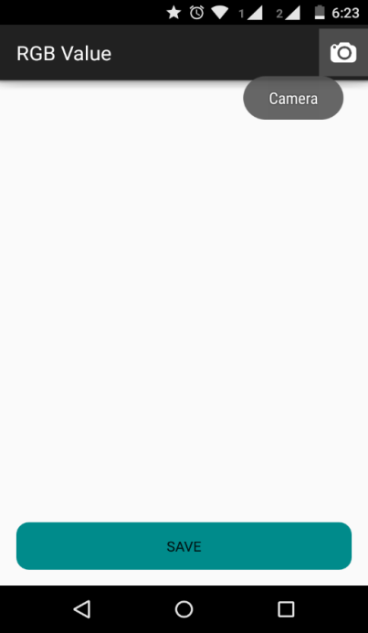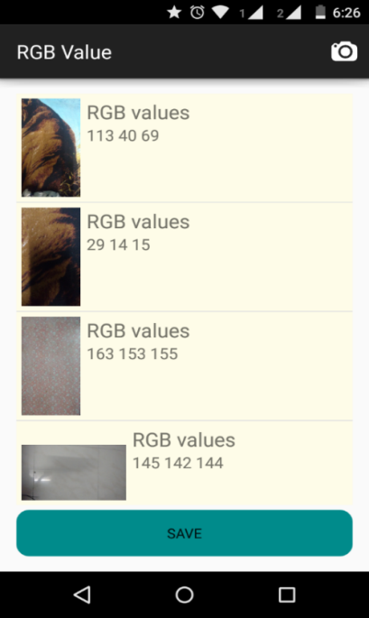

## 5.3.SAVE

* After you are done with the number of required RGB Values, click on “Save”.
* You will be redirected to your Gmail Account.

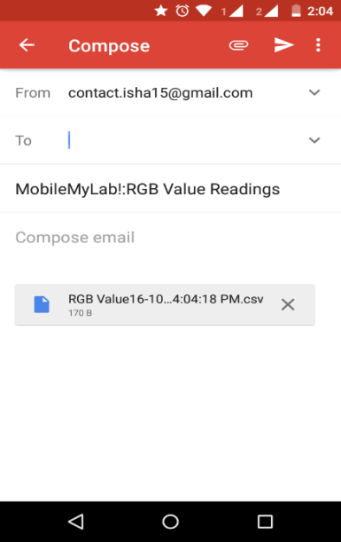

* You can mail the readings of the experiment(in .csv file) and analyze them later .
* To perform another experiment click on back button of your phone and follow steps above.

# 6.Light sensor

* Light sensor is available in the android phones as hardware sensor .
* It measures the ambient light level( in lux units ).
* Common uses include controlling screen brightness.

## 6.1 Experiment Details

On Clicking the Light sensor icon, Experiment Detail Page is displayed.

After filling the details, Click on Begin.

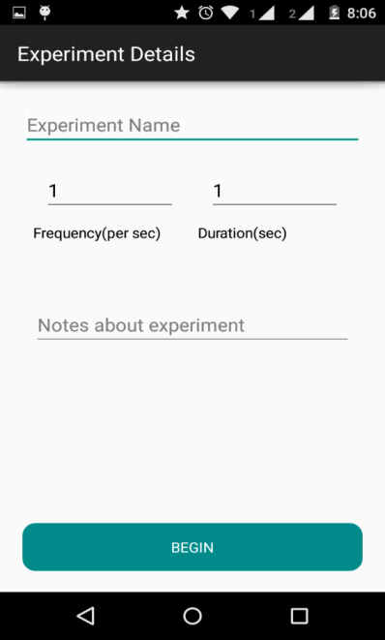

## 6.2 BEGIN

*In Samsung Galaxy S6 the light sensor is available in the front of the phone (at the top).*

*But you can always Google search for the availability of sensor in the particular phone.*

*Usually it is available in the front of the phone.*

*Click on Begin for beginning the experiment and focus the sensor on the part that you want to find the intensity for.*

*You will see a graph with x axis showing the reading number and y axis showing the respective intensity value of light in lux.*

*The value shown at the top of the graph is the last intensity value changed.*

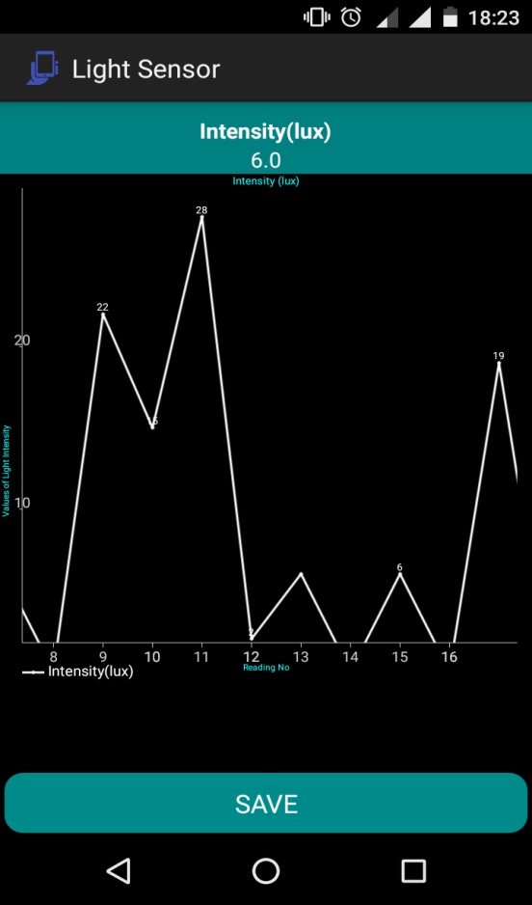

## 6.3 SAVE

*After some time (depends on the duration you mentioned in the Experiment details screen), the graph will stop changing. You can now save the readings of the experiment. You can do so by clicking on SAVE button. It will take you to your Gmail application, from there you can mail the readings of experiment(in .csv format) and analyze it later.*

*To perform another experiment , click on the back button of your phone and follow the above steps again.*

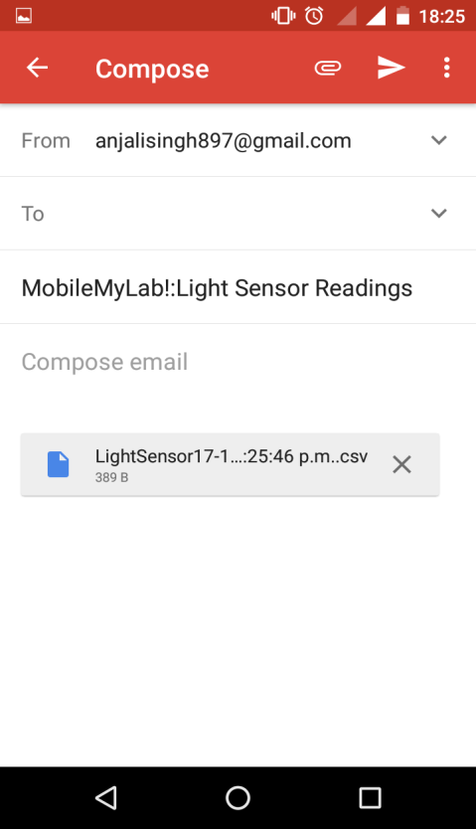

# BAROMETER

Barometers measure atmospheric pressure, so you can get a general sense of what’s going to happen by whether a barometer rises or falls. If the barometer goes up, then that means the weather is going to be fair. If it goes down, then it’s probably going to rain, snow, or indicate some other type of inclement weather.

It gives **atmospheric pressure in hPa (millibar**)

## 7.1Experiment Detail

On Clicking the barometer icon, Experiment Detail Page is displayed.

After filling the details, Click on Begin.

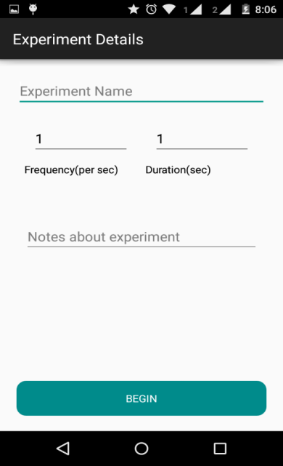

7.3 BEGIN EXPERIMENT

Experiment will begin and you will see a screen with dynamic graph. You willsee the

values of the pressure changing as per the conditions.

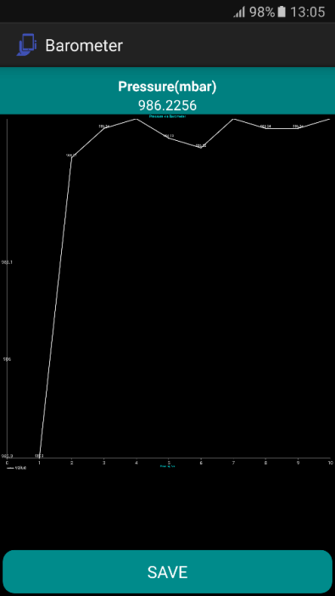

## Save

* After the experiment finishes (depends on the duration you mentioned in the experiment details screen),click on “Save”.
* You will be directed to your Gmail account .
* You can mail the readings of the experiment(in .csv file) and analyze them later .
* To perform another experiment click on back button of your phone and follows steps above.

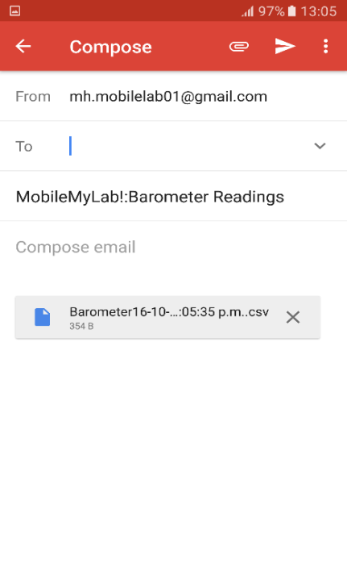

# MAGNETOMETER

* The digital magnetometer is usually based on a sensor called magnetometer provides mobile phones with a simple orientation in relation to the Earth's magneticfield.
* Displays x, y, and z component of magneticfield.
* All values are in micro-Tesla (uT) and measure the ambient magneticfield in the X, Y and Z axis

## 8.1 Experiment Detail

On Clicking the Compass icon, Experiment Detail Page is displayed. After filling the details, Click on Begin.

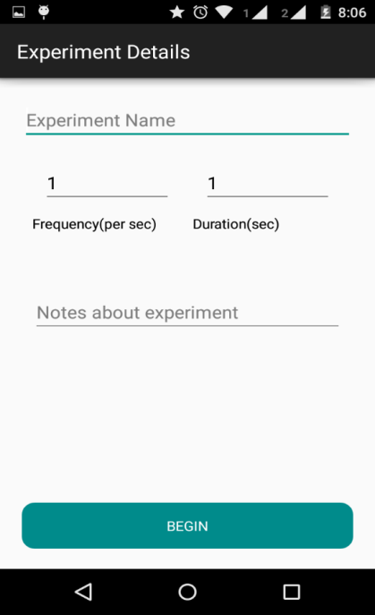

## Begin Experiment

Click on **Begin**  to begin taking the readings of Sensor.Experiment will begin and you will see a screen with dynamic graph. You will see the values of the x , y and z axis changing as you move your phone. The x axis is shown with color ,y axis shown with and z axis with

.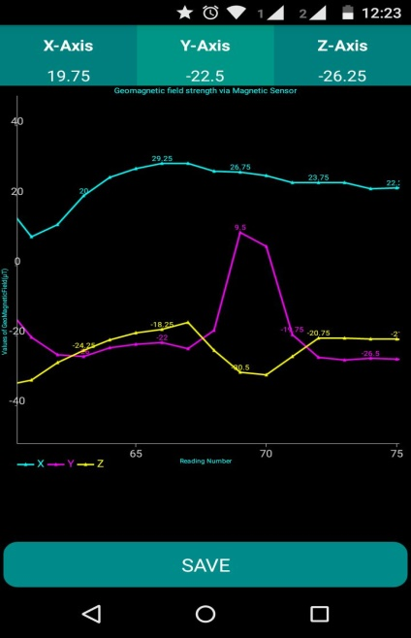.

## Save

* After the experiment finishes (depends on the duration you mentioned in the experiment details screen),click on “Save”.
* You will be directed to your Gmail account .

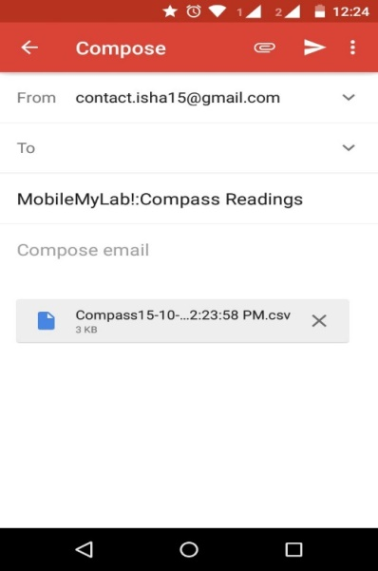

* You can mail the readings of the experiment(in .csv file) and analyze them later .
* To perform another experiment click on back button of your phone and follows steps above.