Wireframes

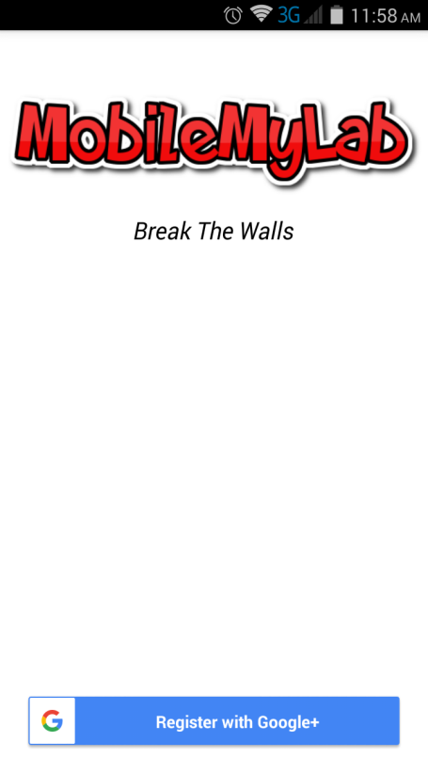

Click this button for registering with Google+

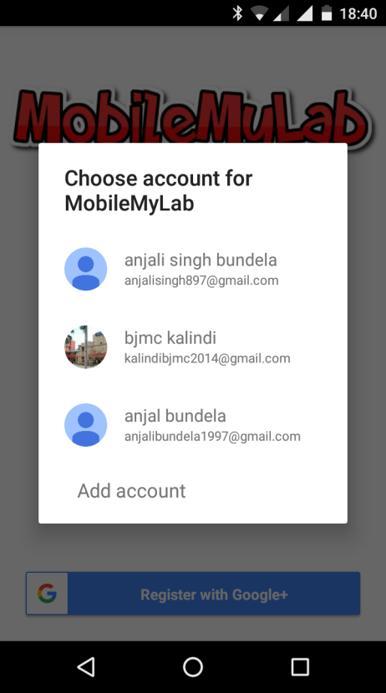

One of the multiple accounts can be used for the registration .

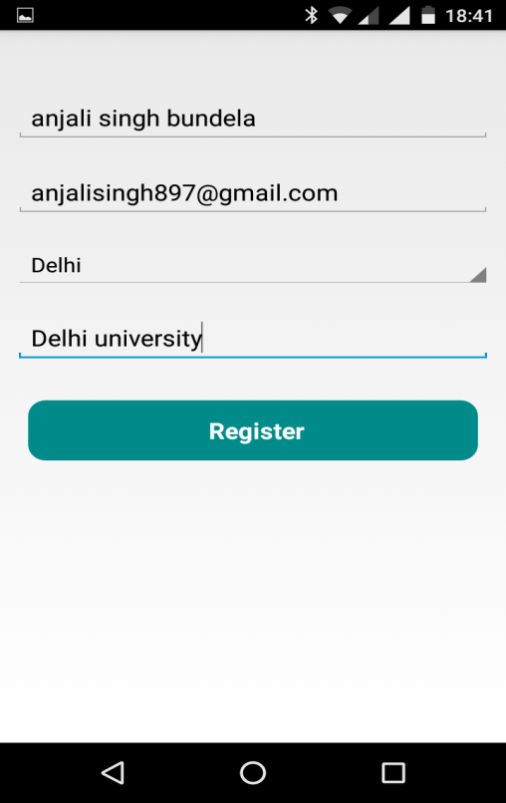

Click on this button to register yourself with the application. Your information is recorded.

Text boxes for entering user details

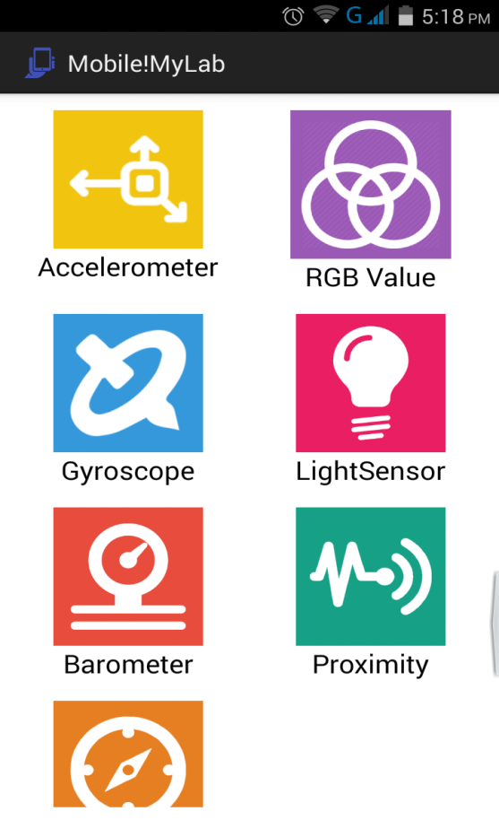

Gyroscope sensor

Tap on the particular icon for starting the experiment

Proximity sensor

Accelerometer sensor

Tap on this for calculating RGB value using camera

Scroll view showing all the sensors available for the experiment

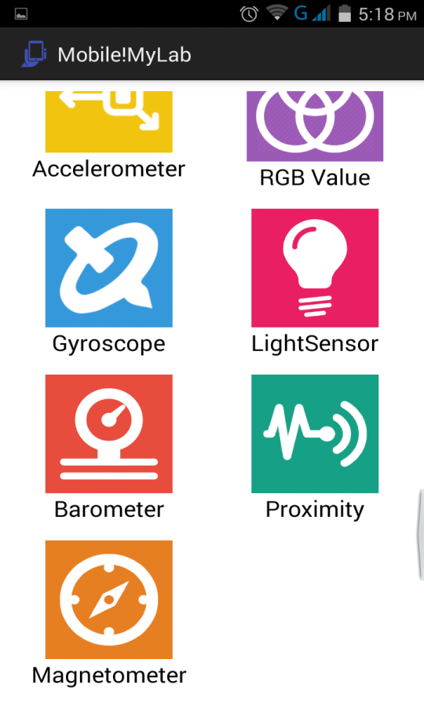

Barometer sensor

Magnetometer

Light sensor

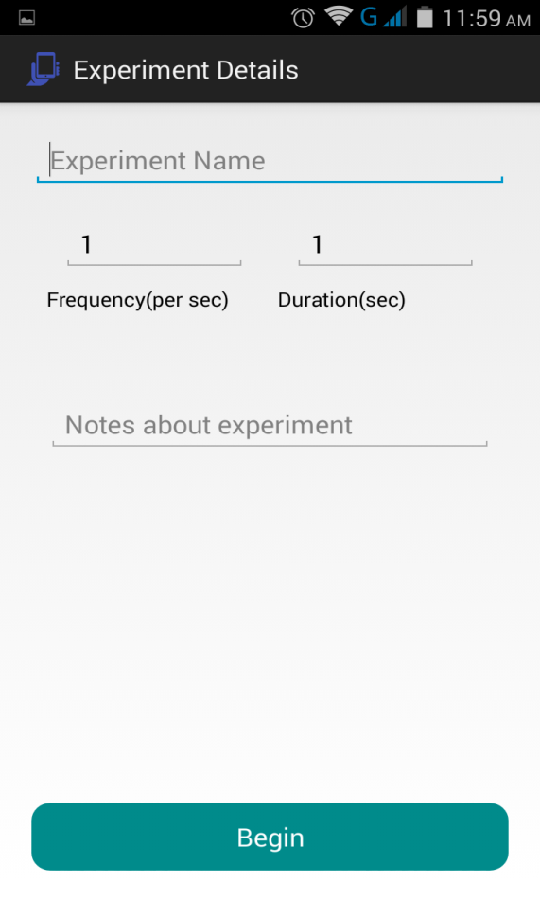

Tap to begin taking the readings of the sensor .

Put the notes for the future reference of the experiment.

Type the experiment name in the auto complete text box.

Type in frequency and duration in the text boxes as per the requirements.

Experiment details screen of the particular sensor .

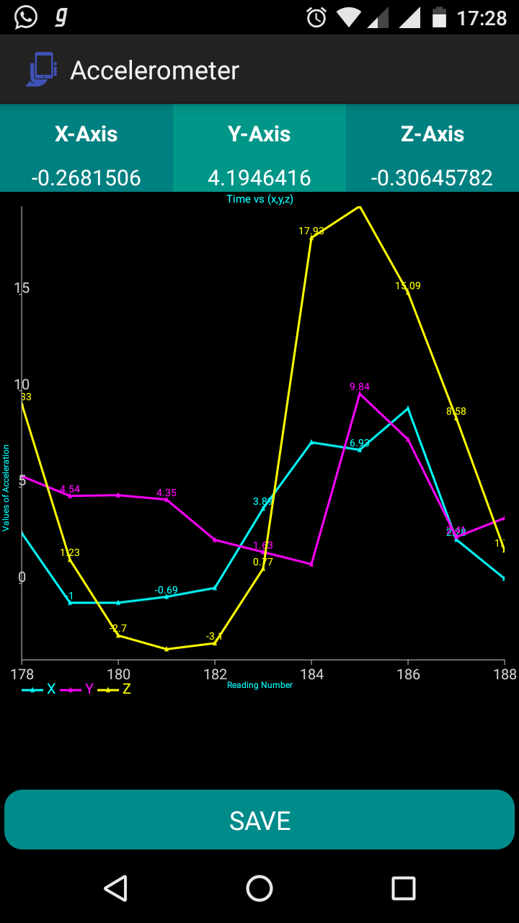

Tap to save the readings of the sensor. Readings are exported to the database .

Z axis acceleration

Y axis acceleration

X axis acceleration

Instantaneous values of the sensor.

Screen showing the sensor readings of the accelerometer in the x ,y and z axes as phone is moved.

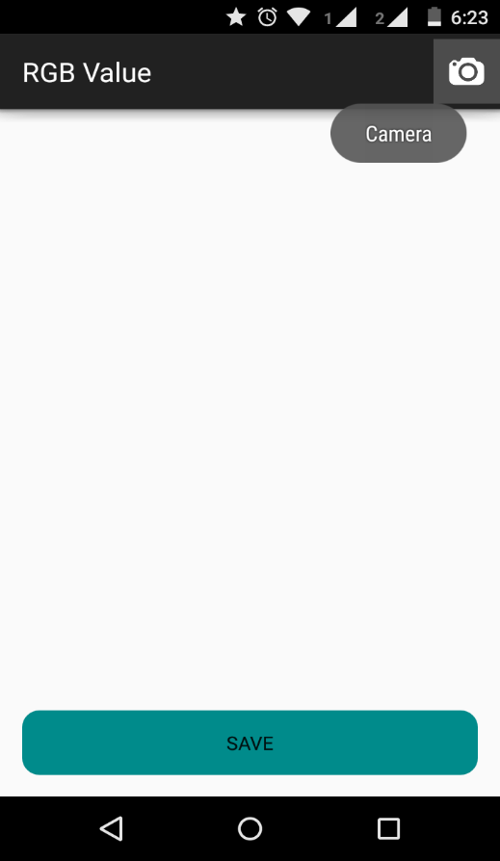

Tap to start clicking the picture for finding RGB value of the centre point of the picture.

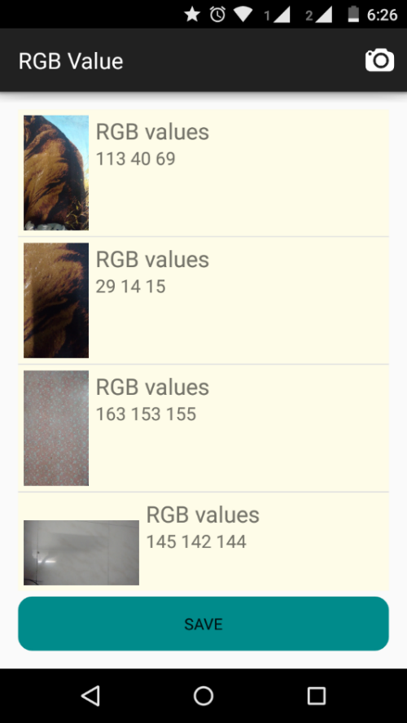

Tap to save the readings of the sensor. Readings are exported to the database .

RGB values of the picture

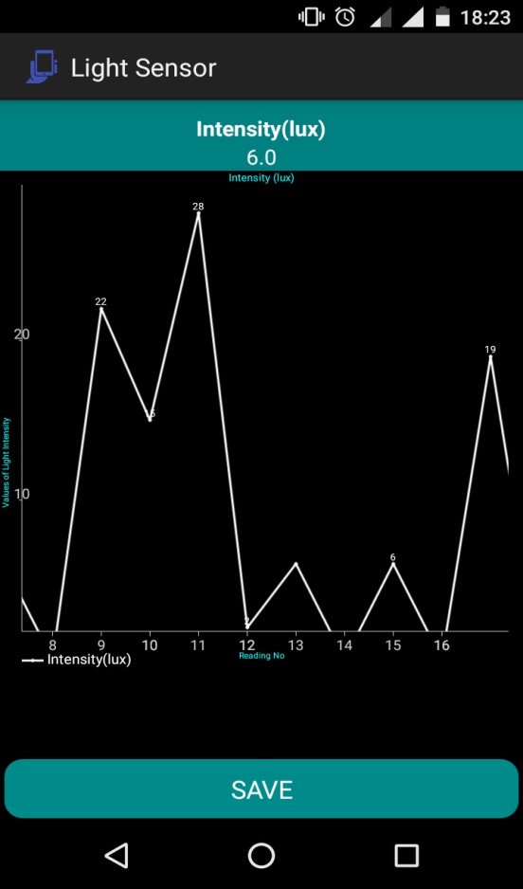

Tap to save the readings of the sensor. Readings are exported to the database .

Reading no vs intensity (lux) graph

Instantaneous value of the

sensor.

Screen showing the readings of the light sensor .

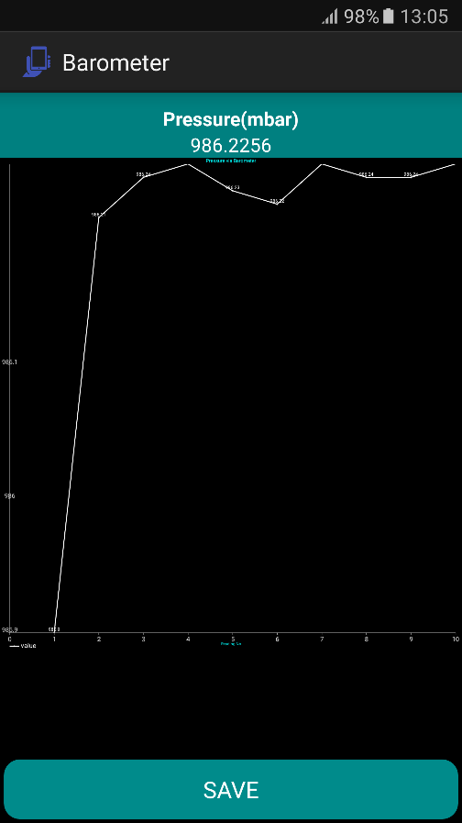

Tap to save the readings of the sensor. Readings are exported to the database .

Graph showing the barometer values (pressure) in mbar

Screen showing the barometer readings

Instantaneous value along x ,y and z axes in micro tesla

Screen showing the magnetometer (compass) values .

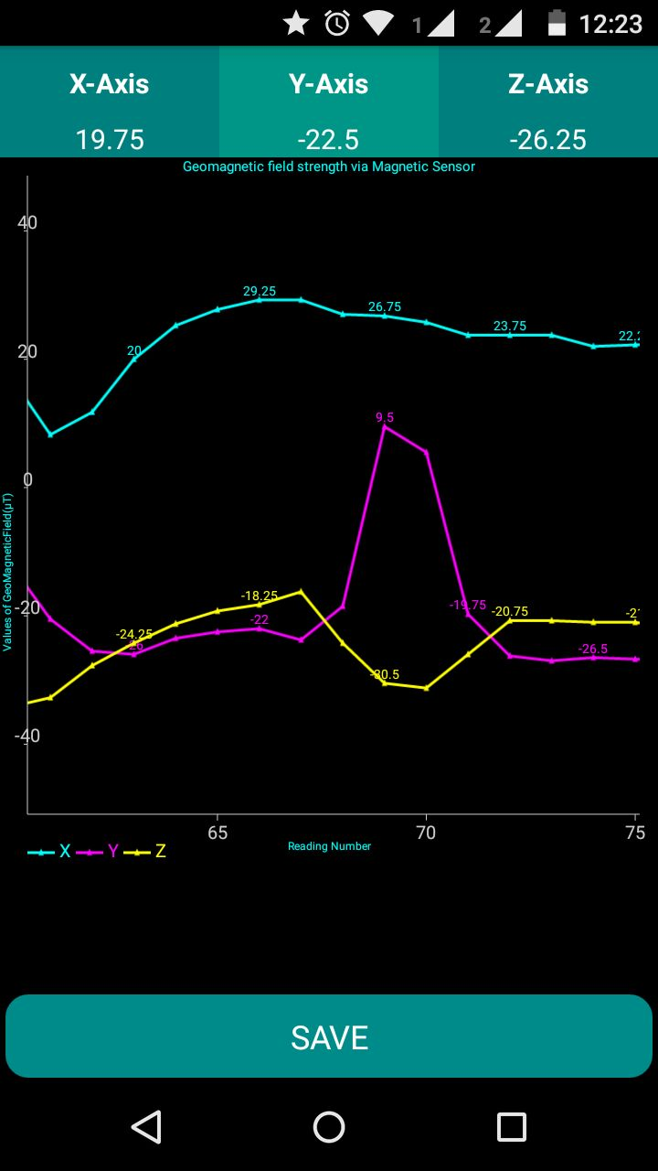

X axis

Y axis

Z axis value

Tap to save the readings of the sensor. Readings are exported to the database .

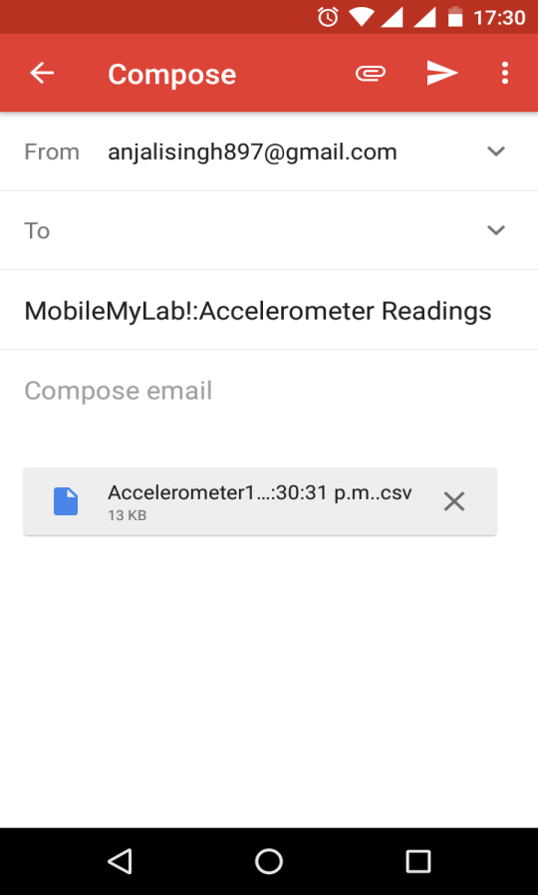

Tap on back button to perform another experiment.

Tap to mail the readings and analyze later.

Readings of the experiment in the .csv format