Problem 1 (Employee Names)

Write a query that prints a list of employee names (i.e.: the name attribute) from the ****Employee**** table in alphabetical order.

****Input Format****

The ****Employee**** table containing employee data for a company is described as follows:

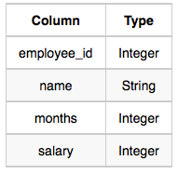

where employee_id is an employee's ID number, name is their name, months is the total number of months they've been working for the company, and salary is their monthly salary.

****Sample Input****

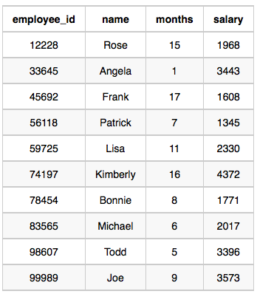

****Sample Output****

Angela

Bonnie

Frank

Joe

Kimberly

Lisa

Michael

Patrick

Rose

Todd

Problem 2 (Revising the select query 1)

Query all columns for all American cities in the ****CITY**** table with populations larger than 100000. The ****CountryCode**** for America is USA.

The ****CITY**** table is described as follows:

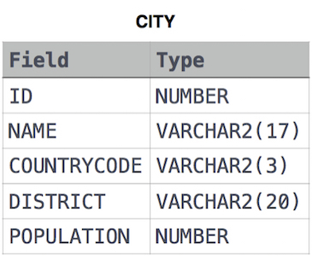

Problem 3 (Revising the select query 2)

Query the ****NAME**** field for all American cities in the ****CITY**** table with populations larger than 120000. The CountryCode for America is USA.

The ****CITY**** table is described as follows:  


Problem 4 (Select All)

Query all columns (attributes) for every row in the ****CITY**** table.

The ****CITY**** table is described as follows:  


Problem 5 (Select By Id)

Query all columns for a city in ****CITY**** with the ID 1661.

The ****CITY**** table is described as follows:  


Problem 6 (Japanese Cities’ Attributes)

Query all attributes of every Japanese city in the ****CITY**** table. The ****COUNTRYCODE**** for Japan is JPN.

The ****CITY**** table is described as follows:  


Problem 7 (Japanese Cities’ Names)

Query the names of all the Japanese cities in the ****CITY**** table. The ****COUNTRYCODE**** for Japan is JPN.  
The ****CITY**** table is described as follows:  


Problem 8 (Weather Observation Station 1)

Query a list of ****CITY**** and ****STATE**** from the ****STATION**** table.  
The ****STATION**** table is described as follows:  
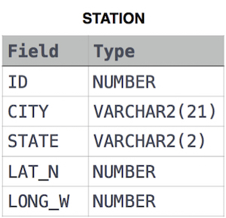

where ****LAT_N**** is the northern latitude and ****LONG_W**** is the western longitude.