az iot hub device-identity show --device-id testingsul --hub-name mi2 --resource-group sulabh123

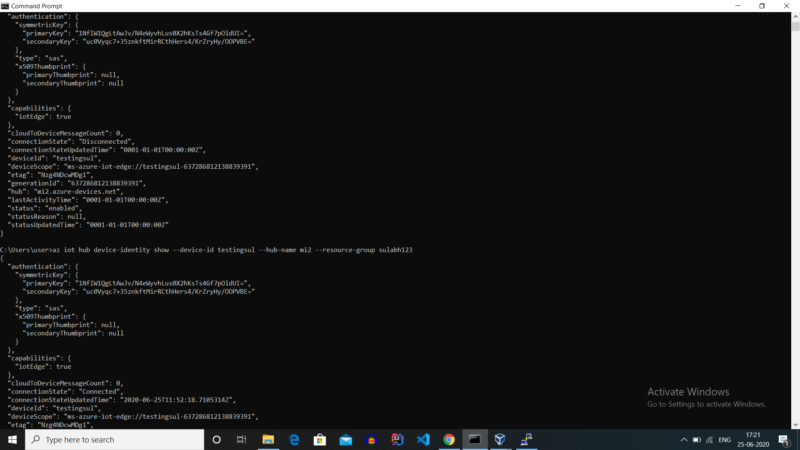

By this command we can fetch the status from azure cloud.

1. If our iot edge deployment is not successful then “connectionState” will show “Disconnected” otherwise it will show “connected”.
2. After getting status connected we can deploy our modules.

