Snapshots: Labor Market Analysis Using Tableau

1. Population Distribution Over Different Provinces : Areas Like Ontario and Quebec are Heavily populated while provinces as New Brunswick have few inhabitants.

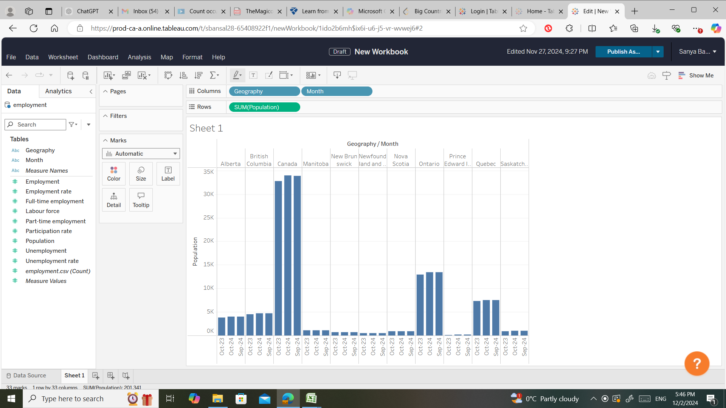

2. Employment Rate Over Provinces: Provinces like British Columbia and Ontario likely showcase strong employment rates based on Canada’s economic landscape. While, Regions like Newfoundland and Labrador might have lower employment due to smaller labor markets or industry focus.

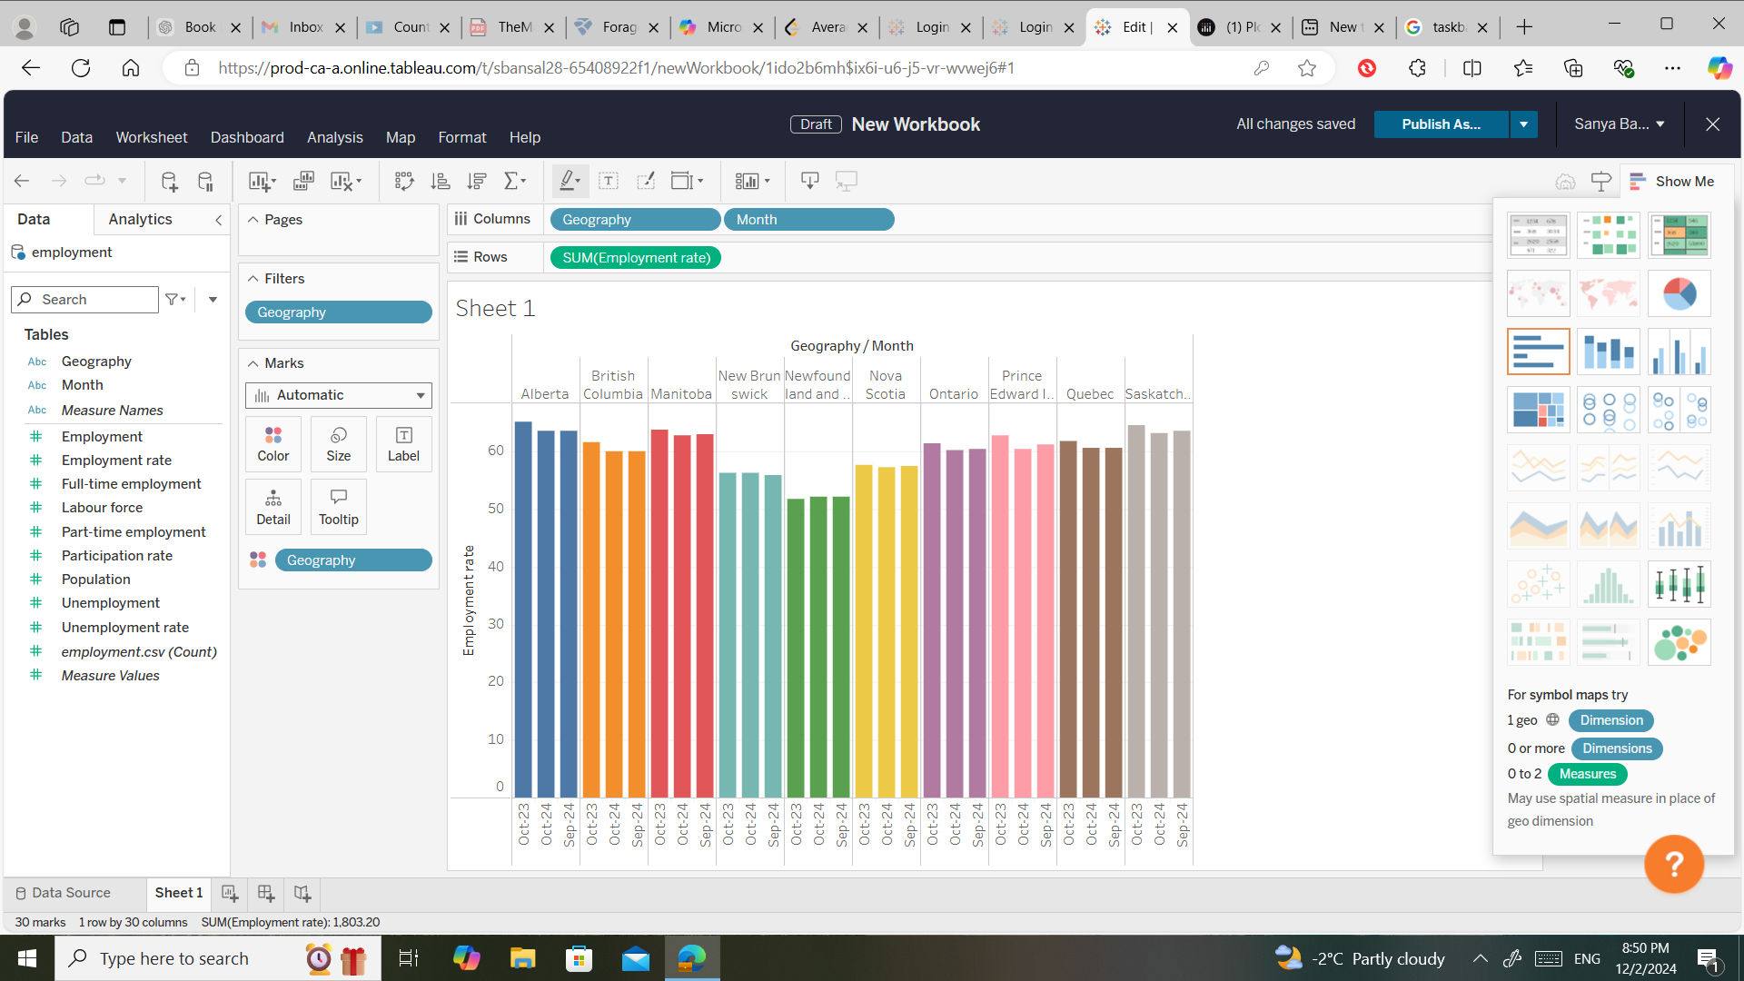

3. Average Employment Rate for the months considered : Alberta has the highest average employment rate due to Alberta being a resource-heavy region while Newfoundland has the lowest which suggests that there are significant labour challenges in the province.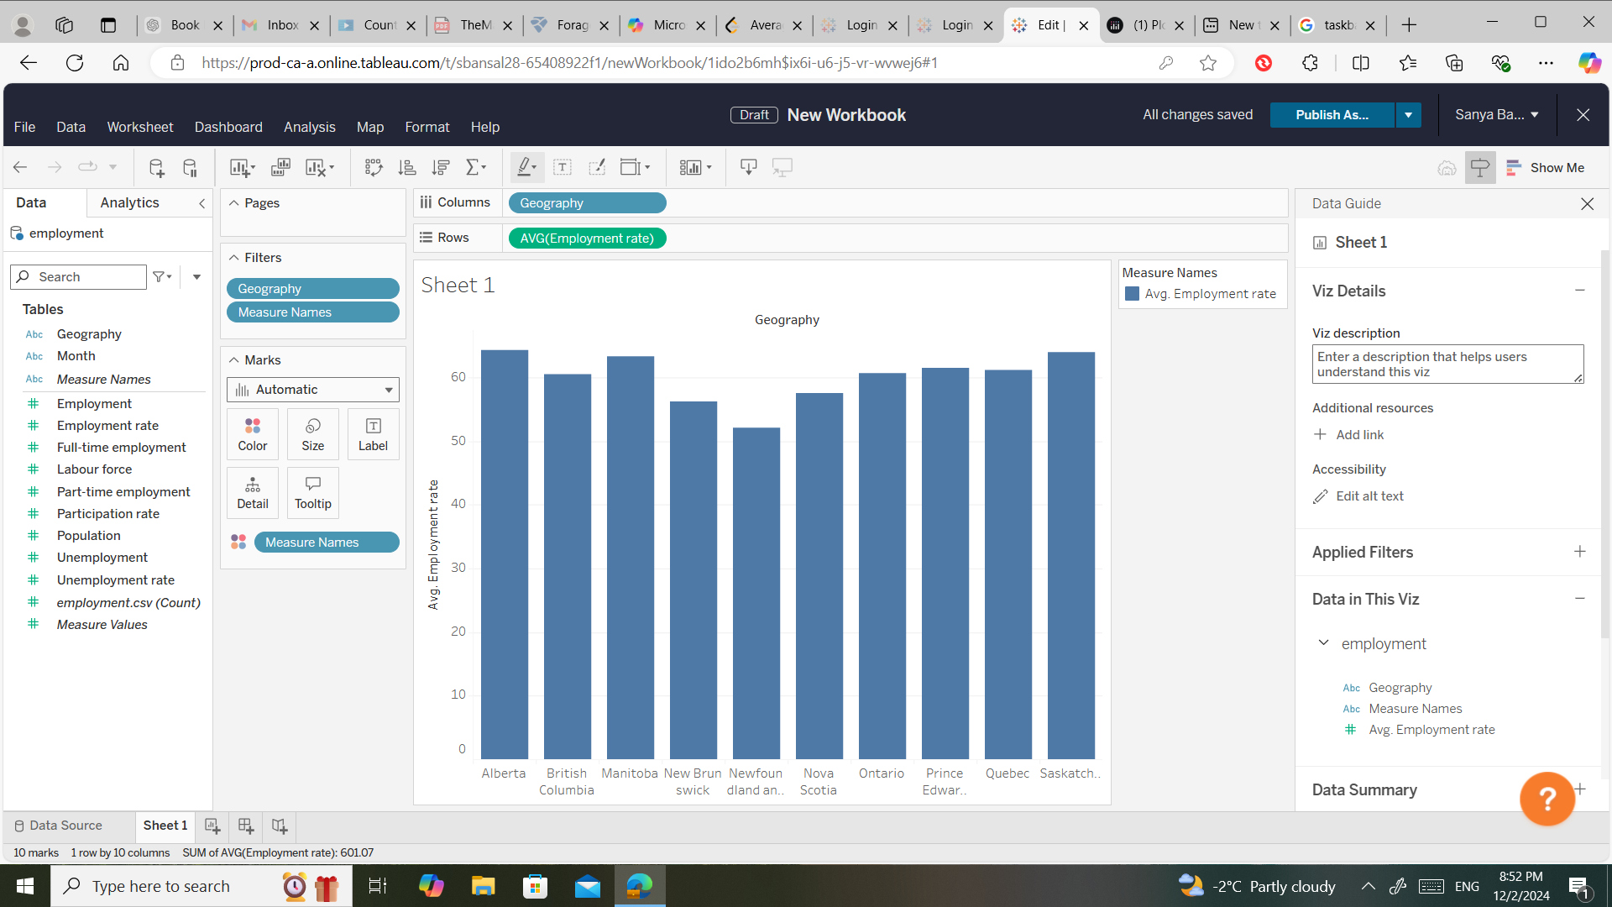

4. Comparison of Average Employment, Unemployment and Part-Time Employment Rates: Part-time employment could be significant in urban areas (Ontario, Quebec) due to student and gig work prevalence. Full-time employment might dominate resource-heavy regions like Alberta (oil and gas sectors).