|  |  |
| --- | --- |
| Test Case ID | C39563, C39564, C39565, C39566 |
| Test Case Summary | CKM Admin |
| Jira | CKM-376 |
| Build | 1.2 |
| Environment | Chrome, Windows 10 |

Test Steps:

1. Home page

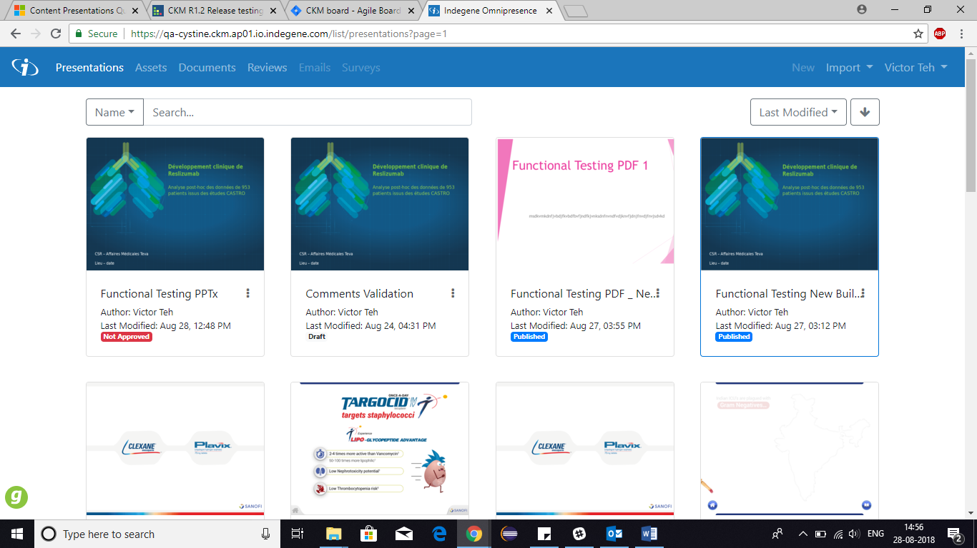

1. Setting Section (All roles are visible) for Admin

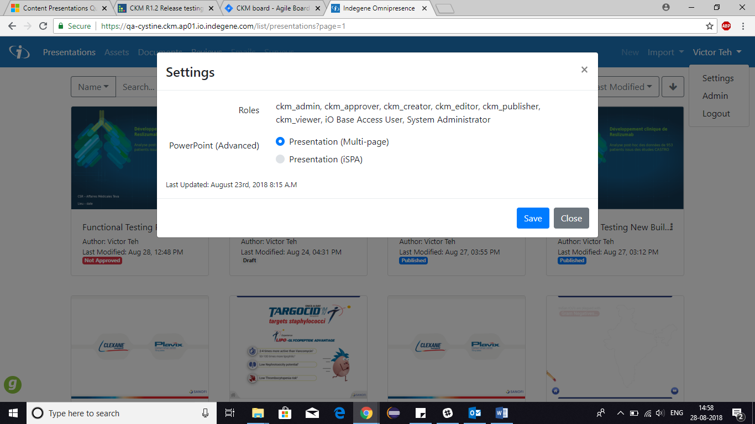

1. Can View Someone else presentation



1. Admin can force publish a presentation

