ABSTRACT

In spite of the improvement of communication link and despite all progress in advanced communication technologies, there are still very few functioning commercial wireless monitoring systems, which are most off-line, and there are still a number of issues to deal with.
Therefore, there is a strong need for investigating the possibility of design and implementation of an interactive real-time wireless communication system. In our project, a generic real-time wireless communication system was designed and developed for short and long term remote patient-monitoring applying wireless protocol. The primary function of this system is to monitor the temperature and Heart Beat of the Patient and the Data collected by the sensors are sent to the Microcontroller. The Microcontroller transmits the data over the air. Here we are using the GSM modem in order to transmit the information.

From the transmitter the recordings are sent as an SMS to the care taker or the expert which have been given as the recipient. Not only we send the information through GSM module as SMS we also display the readings in the PC where we can record them and also keep a track on his/her previous history. And when the conditions go abnormal then we sense those values and then alarm the people around by blowing the alarm and also sending by sending as urgency SMS.

INDEX
1.Introduction 5
2.Block Diagram 6
2.1 Block Diagram Description 6
2.2 Schematic Diagram 7
2.3 Schematic Description 8
2.3.1 Latch Connections to Micro controller 8
2.3.2 MAX-232 connections to microcontroller 8
2.3.3 LCD connections to Micro controller 8
3. Hardware Components 9
3.1 Micro Controller 89S52 9
3.1.1 Introduction 9
3.1.2 The Major Features 9
3.1.3 AT89S52 Microcontroller Architecture 10
3.1.4 Types of memory 11
3.1.5 Pin Description 13
3.1.6 Oscillator Characteristics 16
3.1.8 SFRs (Special Function Registers) 17
3.1.9 8051 Register Banks and Stack 20
3.1.10 Program counter 24
3.1.11 TIMERS 24
3.1.12 Serial Communication 27
3.1.13 RS232 Standards 28
3.1.14 8051 connection to RS232 30
3.1.15 INTERRUPTS 31
3.2 GLOBAL SYSTEM FOR MOBILE COMMUNICATIONS 34
3.2.1 Definition 34
3.2.2 Description 34
3.2.3 GSM Modems 35
3.2.4 SMART MODEM (GSM/GPRS) 36
3.2.5 Connecting Modem to external devices 39
3.2.6 AT commands features 41
3.2.7 Services provided by GSM 42
3.2.8 Architecture of the GSM network 43
3.3 PULSE SENSOR(LM358) 47
3.4 Temperature Sensor 51
3.4.1 The LM35 51
3.5 Power supply 54
3.5.1 Transformer 54
3.5.2 RECTIFIER 56
3.5.3 Filter 58
3.5.4 Regulator 60
3.6LCD 61
3.7 ADC 62
4 Circuit Description 64
5.Software Used 66
5.1 Introduction to Embedded ‘C’ 66
5.1.1 Data Types 66
5.1.2I/O PROGRAMMING IN EMBEDDED “C” 68
5.1.3 DATA CONVERSION PROGRAMS IN EMBEDDED C 69
5.2 ABOUT SOFTWARE 72

6.Flow Chart 85
7.Conclusion and Future Scope 87
8.Bibliography 88

LIST OF FIGURES

Figure 1 Block Diagram 6
Figure 2 Schematic 7
Figure 3Functional block diagram of Microcontroller 11
Figure 4Pin Diagram of AT89s52 13
Figure 5Oscillator Connections Figure 5.1External Clock Drive Configuration 17
Figure 6Memory Organization of RAM 20
Figure 7Interfacing of MAX-232 to Controller 31
Figure 8 Structure Of a GSM Network 35
Figure 9 GSM Smart Modem 36
Figure 10 Block Diagram of Modem with key connections 37
Figure 11Internal Diagram of GSM Modem 38
Figure 12 Inserting/Removing the sim card into the modem 38
Figure 13 General architecture of a GSM network 44
Figure 14 Circuit diagram of LM35 53
Figure 15 LM 35 wired on a circuit board 53
Figure 16 Functional Block Diagram of Power supply 54
Figure 17 An Electrical Transformer 55
Figure 18 Full Wave Bridge Rectifier 57
Figure 19 Operation During Positive Cycle 58
Figure 20 Operation During Negative Cycle 58
Figure 21 A Three Terminal Voltage Regulator 60
Figure 22 LCD 61
Figure 23 LCD Pin Description 62
Figure 24 ADC 63

1.Introduction

As the goal of this project, we see a device that can detect ailments in a patient and inform them to the concerned medical personnel, without the intervention of even the patient himself. This process is done with the help of GSM technology. The GSM technology is used for reading and sending SMS to the concerned person.
.

Global system for mobile communication (GSM) is a globally accepted standard for digital cellular communication. GSM is the name of a standardization group established in 1982 to create a common European mobile telephone standard that would formulate specifications for a pan-European mobile cellular radio system operating at 900 MHz. It is estimated that many countries outside of Europe will join the GSM partnership.

2.Block Diagram

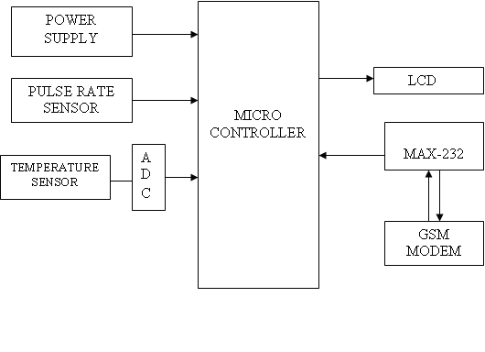
Figure 1 Block Diagram

2.1 Block Diagram Description
In this block diagram, there is a micro controller, a heart beat sensor (Electrodes) circuitry, a GSM MODEM and a LCD Display.

The heart beat circuitry consists of a Quad Op-amp IC and three electrodes. These electrodes are placed to the patient who is suffering with high B.P as well as heart problems. The output of this circuitry is considered into logic levels and this output is given to one of the pin of the micro controller.
The GSM Modem is used for sending and receiving messages from the patient to a doctor and vice versa. Whenever the heart beat rate or the B.P. exceeds the threshold value. The micro controller will automatically send the signals to the GSM Modem. Through the GSM Modem, the message will gives to the concerned person or a doctor.
The LCD display is used to display the status of the GSM modem and as well as the heart beat rate continuously.
For the circuitry operation, it requires the +5V DC power supply.

2.2 Schematic Diagram

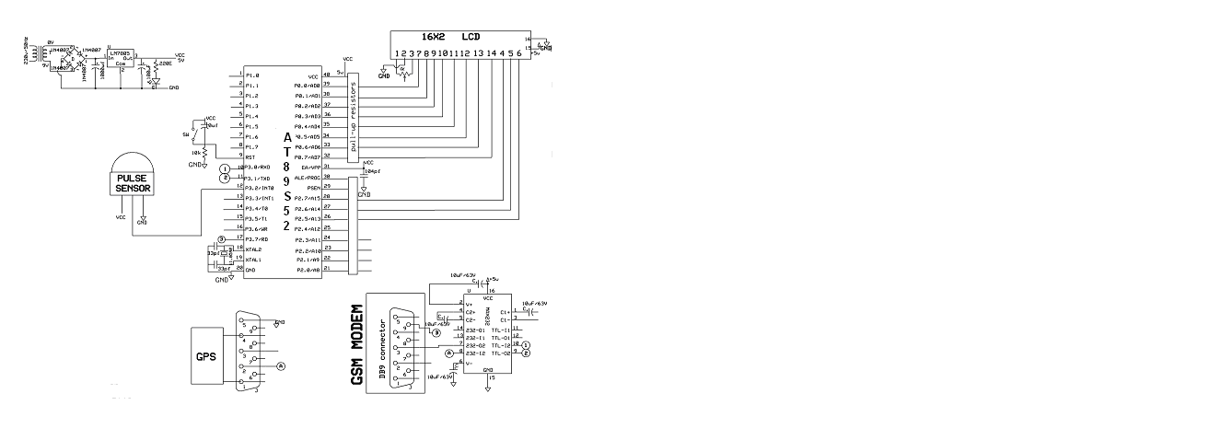
Figure 2 Schematic

2.3 Schematic Description

2.3.1 Latch Connections to Micro controller
Pins Connections
9, 16 P3.0
2, 13 P3.1
19 P3.6
1 P3.7
10 GND
20 VCC

2.3.2 MAX-232 connections to microcontroller
Pins connections
11 This pin is connected to P3.1 (TXD) of the Micro controller
12 This pin is connected to P3.0 (RXD) of the Micro controller
13 This pin is connected to 3rd pin (TXD) of DB-9 connector
14 This pin is connected to 2nd pin (RXD) of DB-9 connector
15 Ground
16 Vcc (+5v)

2.3.3 LCD connections to Micro controller
Pins Connections
1 VSS (ground)
2 VCC (+5V)
3 10k pot
4 RS, this pin is connected to P2.7 of the micro controller
5 R/w, this pin is connected to P2.6 of the micro controller
6 EN, this pin is connected to P2.5 of the micro controller
7-14 (D0-D7) these pins are connected to the port (P0) of the micro controller

The heart beat sensor (Electrodes) circuitry is connected to the P3.2 of the micro controller.

3. Hardware Components

3.1 Micro Controller 89S52

3.1.1 Introduction
A Micro controller consists of a powerful CPU tightly coupled with memory, various I/O interfaces such as serial port, parallel port timer or counter, interrupt controller, data acquisition interfaces-Analog to Digital converter, Digital to Analog converter, integrated on to a single silicon chip
.
If a system is developed with a microprocessor, the designer has to go for external memory such as RAM, ROM, EPROM and peripherals. But controller is provided all these facilities on a single chip. Development of a Micro controller reduces PCB size and cost of design.

One of the major differences between a Microprocessor and a Micro controller is that a controller often deals with bits not bytes as in the real world application.

Intel has introduced a family of Micro controllers called the MCS-51.

3.1.2 The Major Features
- Compatible with MCS-51 products
- 4k Bytes of in-system Reprogrammable flash memory
- Fully static operation: 0HZ to 24MHZ
- Three level programmable clock
- 128 * 8 –bit timer/counters
- Six interrupt sources
- Programmable serial channel
- Low power idle power-down modes

AT89C52 is 8-bit micro controller, which has 4 KB on chip flash memory, which is just sufficient for our application. The on-chip Flash ROM allows the program memory to be reprogrammed in system or by conventional non-volatile memory Programmer. Moreover ATMEL is the leader in flash technology in today’s market place and hence using AT 89C52 is the optimal solution.

3.1.3 AT89S52 Microcontroller Architecture
The 89C52 architecture consists of these specific features:
- Eight –bit CPU with registers A (the accumulator) and B
- Sixteen-bit program counter (PC) and data pointer (DPTR)
- Eight- bit stack pointer (PSW)
- Eight-bit stack pointer (Sp)
- Internal ROM or EPROM (8751) of 0(8031) to 4K (89C51)
- Internal RAM of 128 bytes:
- Thirty –two input/output pins arranged as four 8-bit ports:p0-p3
- Two 16-bit timer/counters: T0 and T1
- Full duplex serial data receiver/transmitter: SBUF
- Control registers: TCON, TMOD, SCON, PCON, IP, and IE
- Two external and three internal interrupts sources.
- Oscillator and clock circuits.

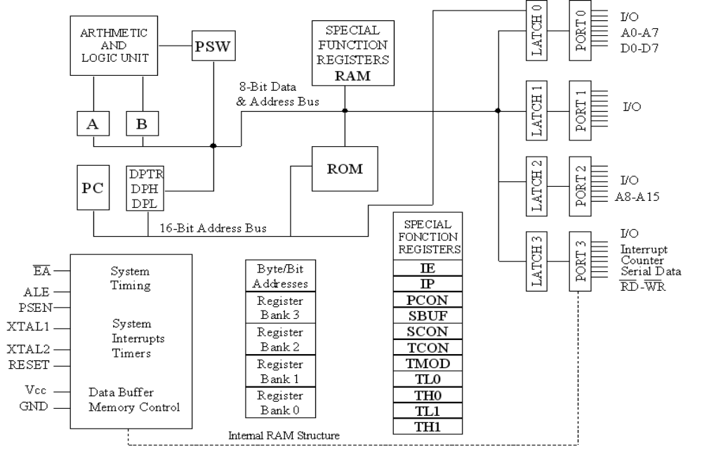
Figure 3Functional block diagram of Microcontroller

3.1.4 Types of memory
The 89C51 have three general types of memory. They are on-chip memory, external Code memory and external Ram. On-Chip memory refers to physically existing memory on the micro controller itself. External code memory is the code memory that resides off chip. This is often in the form of an external EPROM. External RAM is the Ram that resides off chip. This often is in the form of standard static RAM or flash RAM.

Code memory
Code memory is the memory that holds the actual 89C51 programs that is to be run. This memory is limited to 64K. Code memory may be found on-chip or off-chip. It is possible to have 4K of code memory on-chip and 60K off chip memory simultaneously. If only off-chip memory is available then there can be 64K of off chip ROM. This is controlled by pin provided as EA.

Internal RAM
The 89C51 have a bank of 128 of internal RAM. The internal RAM is found on-chip. So it is the fastest Ram available. And also it is most flexible in terms of reading and writing. Internal Ram is volatile, so when 89C51 is reset, this memory is cleared. 128 bytes of internal memory are subdivided. The first 32 bytes are divided into 4 register banks. Each bank contains 8 registers. Internal RAM also contains 128 bits, which are addressed from 20h to 2Fh. These bits are bit addressed i.e. each individual bit of a byte can be addressed by the user. They are numbered 00h to 7Fh. The user may make use of these variables with commands such as SETB and CLR.

Flash memory is a nonvolatile memory using NOR technology, which allows the user to electrically program and erase information. Flash memory is used in digital cellular phones, digital cameras, LAN switches, PC Cards for notebook computers, digital set-up boxes, embedded controllers, and other devices.
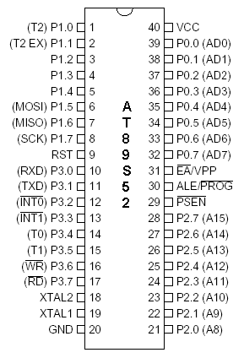
Figure 4Pin Diagram of AT89s52

3.1.5 Pin Description
VCC: Supply voltage.
GND: Ground.

Port 0
Port 0 is an 8-bit open-drain bi-directional I/O port. As an output port, each pin can sink eight TTL inputs. When 1sare written to port 0 pins, the pins can be used as high impedance inputs. Port 0 may also be configured to be the multiplexed low order address/data bus during accesses to external program and data memory. In this mode P0 has internal pull-ups. Port 0 also receives the code bytes during Flash programming, and outputs the code bytes during program verification. External pull-ups are required during program verification.

Port 1
Port 1 is an 8-bit bi-directional I/O port with internal pull-ups. The Port 1 output buffers can sink/source four TTL inputs. When 1s are written to Port 1 pins they are pulled high by the internal pull-ups and can be used as inputs. As inputs, Port 1 pins that are externally being pulled low will source current (IIL) because of the internal pull-ups. Port 1 also receives the low-order address bytes during Flash programming and verification.

Port 2
Port 2 is an 8-bit bi-directional I/O port with internal pull-ups. The Port 2 output buffers can sink/source four TTL inputs. When 1s are written to Port 2 pins they are pulled high by the internal pull-ups and can be used as inputs. As inputs, Port 2 pins that are externally being pulled low will source current (IIL) because of the internal pull-ups.

Port 3
Port 3 is an 8-bit bi-directional I/O port with internal pull-ups. The Port 3 output buffers can sink/source four TTL inputs. When 1s are written to Port 3 pins they are pulled high by the internal pull-ups and can be used as inputs. As inputs, Port 3 pins that are externally being pulled low will source current (IIL) because of the pull-ups.
Port 3 also serves the functions of various special features of the AT89C51 as listed below:
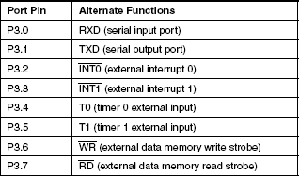
Table 1Port pins and their alternate functions

RST
Reset input. A high on this pin for two machine cycles while the oscillator is running resets the device.

ALE/PROG
Address Latch Enable output pulse for latching the low byte of the address during accesses to external memory. This pin is also the program pulse input (PROG) during Flash programming. In normal operation ALE is emitted at a constant rate of 1/6the oscillator frequency, and may be used for external timing or clocking purposes. Note, however, that one ALE pulse is skipped during each access to external Data Memory.
If desired, ALE operation can be disabled by setting bit 0 of SFR location 8EH. With the bit set, ALE is active only during a MOVX or MOVC instruction. Otherwise, the pin is weakly pulled high. Setting the ALE-disable bit has no effect if the micro controller is in external execution mode.

PSEN
Program Store Enable is the read strobe to external program memory. When the AT89C51 is executing code from external program memory, PSEN is activated twice each machine cycle, except that two PSEN activations are skipped during each access to external data memory.

EA/VPP
External Access Enable. EA must be strapped to GND in order to enable the device to fetch code from external program memory locations starting at 0000H up to FFFFH.
Note, however, that if lock bit 1 is programmed, EA will be internally latched on reset. EA should be strapped to VCC for internal program executions. This pin also receives the 12-volt programming enable voltage (VPP) during Flash programming, for parts that require 12-volt VPP.

XTAL1
Input to the inverting oscillator amplifier and input to the internal clock operating circuit.

XTAL2
Output from the inverting oscillator amplifier.

3.1.6 Oscillator Characteristics
XTAL1 and XTAL2 are the input and output, respectively, of an inverting amplifier, which can be configured for use as an on-chip oscillator, as shown in Figs 6.1 Either a quartz crystal or ceramic resonator may be used. To drive the device from an external clock source, XTAL2 should be left unconnected while XTAL1 is driven as shown in Figure 6.2. There are no requirements on the duty cycle of the external clock signal, since the input to the internal clocking circuitry is through a divide-by-two flip-flop, but minimum and maximum voltage high and low time specifications must be observed.
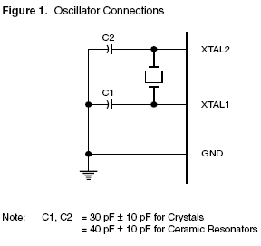
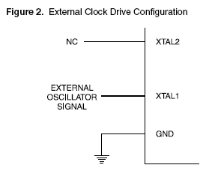

Figure 5Oscillator Connections Figure 5.1External Clock Drive Configuration

3.1.7 REGISTERS
In the CPU, registers are used to store information temporarily. That information could be a byte of data to be processed, or an address pointing to the data to be fetched. The vast majority of 8051 registers are 8–bit registers.
D7 | D6 | D5 | D4 | D3 | D2 | D1 | D0
The most widely used registers of the 8051 are A(accumulator), B, R0, R1, R2, R3, R4, R5, R6, R7, DPTR(data pointer), and PC(program counter). All of the above registers are 8-bits, except DPTR and the program counter. The accumulator, register A, is used for all arithmetic and logic instructions.

3.1.8 SFRs (Special Function Registers)
In the 8051, registers A, B, PSW and DPTR are part of the group of registers commonly referred to as SFR (special function registers). The SFR can be accessed by the names (which is much easier) or by their addresses. For example, register A has address E0h, and register B has been ignited the address F0H, as shown in table.
The following two points should note about the SFR addresses.
- The Special function registers have addresses between 80H and FFH. These addresses are above 80H, since the addresses 00 to 7FH are addresses of RAM memory inside the 8051.
- Not all the address space of 80H to FFH is used by the SFR. The unused locations 80H to FFH are reserved and must not be used by the 8051 programmer.
Symbol | Name | Address
ACC | Accumulator | 0E0H
B | B register | 0F0H
PSW | Program status word | 0D0H
SP | Stack pointer | 81H
DPTR | Data pointer 2 bytes
DPL | Low byte | 82H
DPH | High byte | 83H
P0 | Port0 | 80H
P1 | Port1 | 90H
P2 | Port2 | 0A0H
P3 | Port3 | 0B0H
IP | Interrupt priority control | 0B8H
IE | Interrupt enable control | 0A8H
TMOD | Timer/counter mode control | 89H
TCON | Timer/counter control | 88H
T2CON | Timer/counter 2 control | 0C8H
T2MOD | Timer/counter mode2 control | 0C9H
TH0 | Timer/counter 0high byte | 8CH
TL0 | Timer/counter 0 low byte | 8AH
TH1 | Timer/counter 1 high byte | 8DH
TL1 | Timer/counter 1 low byte | 8BH
TH2 | Timer/counter 2 high byte | 0CDH
TL2 | Timer/counter 2 low byte | 0CCH
RCAP2H | T/C 2 capture register high byte | 0CBH
RCAP2L | T/C 2 capture register low byte | 0CAH
SCON | Serial control | 98H
SBUF | Serial data buffer | 99H
PCON | Power control | 87H
Table 3.2 : 8051 Special function register Address

A Register (Accumulator)
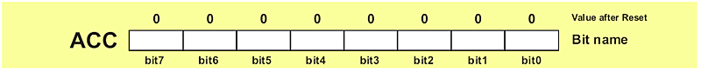

This is a general-purpose register, which serves for storing intermediate results during operating. A number (an operand) should be added to the accumulator prior to execute an instruction upon it. Once an arithmetical operation is preformed by the ALU, the result is placed into the accumulator

B Register
B register is used during multiply and divide operations which can be performed only upon numbers stored in the A and B registers. All other instructions in the program can use this register as a spare accumulator (A).

Registers (R0-R7)
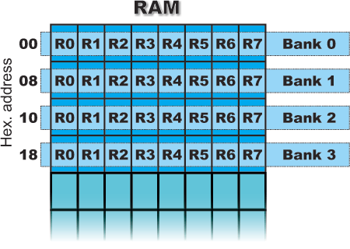
Figure 6Memory Organization of RAM

This is a common name for the total 8 general purpose registers (R0, R1, R2 ...R7). Even they are not true SFRs, they deserve to be discussed here because of their purpose. The bank is active when the R registers it includes are in use. Similar to the accumulator, they are used for temporary storing variables and intermediate results. Which of the banks will be active depends on two bits included in the PSW Register. These registers are stored in four banks in the scope of RAM.

3.1.9 8051 Register Banks and Stack

RAM memory space allocation in the 8051
There are 128 bytes of RAM in the 8051. The 128 bytes of RAM inside the 8051 are assigned addresses 00 to7FH. These 128 bytes are divided into three different groups as follows:
- A total of 32 bytes from locations 00 to 1FH hex are set aside for register banks and the stack.
- A total of 16 bytes from locations 20 to 2FH hex are set aside for bit-addressable read/write memory.
- A total of 80 bytes from locations 30H to 7FH are used for read and write storage, or what is normally called Scratch pad. These 80 locations of RAM are widely used for the purpose of storing data and parameters nu 8051 programmers.

Default register bank
Register bank 0; that is, RAM locations 0, 1,2,3,4,5,6, and 7 are accessed with the names R0, R1, R2, R3, R4, R5, R6, and R7 when programming the 8051.
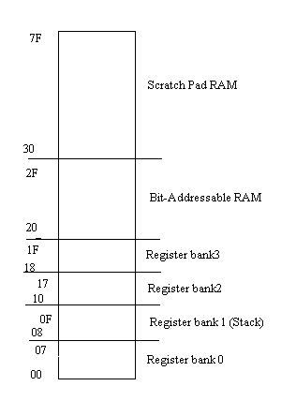
FIG 3.6 RAM Allocation in the 8051

PSW Register (Program Status Word)
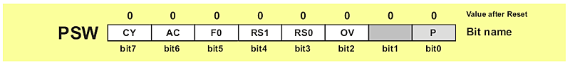

This is one of the most important SFRs. The Program Status Word (PSW) contains several status bits that reflect the current state of the CPU. This register contains: Carry bit, Auxiliary Carry, two register bank select bits, Overflow flag, parity bit, and user-definable status flag. The ALU automatically changes some of register’s bits, which is usually used in regulation of the program performing.
P - Parity bit. If a number in accumulator is even then this bit will be automatically set (1), otherwise it will be cleared (0). It is mainly used during data transmission and receiving via serial communication.
OV Overflow occurs when the result of arithmetical operation is greater than 255 (decimal), so that it cannot be stored in one register. In that case, this bit will be set (1). If there is no overflow, this bit will be cleared (0).
RS0, RS1 - Register bank select bits. These two bits are used to select one of the four register banks in RAM. By writing zeroes and ones to these bits, a group of registers R0-R7 is stored in one of four banks in RAM. This is a general-purpose bit available to the user.
RS1 | RS2 | Space in RAM
0 | 0 | Bank0 00h-07h
0 | 1 | Bank1 08h-0Fh
1 | 0 | Bank2 10h-17h
1 | 1 | Bank3 18h-1Fh
Table 3.3: Register bank select

AC - Auxiliary Carry Flag is used for BCD operations only.
CY - Carry Flag is the (ninth) auxiliary bit used for all arithmetical operations and shift instructions.

DPTR Register (Data Pointer)
These registers are not true ones because they do not physically exist. They consist of two separate registers: DPH (Data Pointer High) and (Data Pointer Low). Their 16 bits are used for external memory addressing. They may be handled as a 16-bit register or as two independent 8-bit registers. Besides, the DPTR Register is usually used for storing data and intermediate results, which have nothing to do with memory locations.
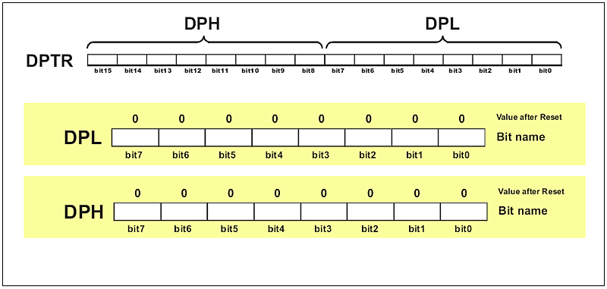

SP Register (Stack Pointer) 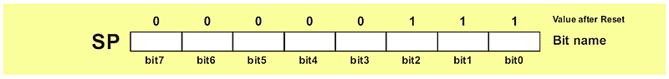
The stack is a section of RAM used by the CPU to store information temporily. This information could be data or an address. The CPU needs this storage area since there are only a limited number of registers.

How stacks are accessed in the 8051
If the stack is a section of RAM, there must be registers inside the CPU to point to it. The register used to access the stack is called the SP (Stack point) Register. The stack pointer in the 8051 is only 8 bits wide; which means that it can take values of 00 to FFH. When the 8051 is powered up, the SP register contains value 07. This means that RAM location 08 is the first location used for the stack by the 8051. The storing of a CPU register in the stack is called a PUSH, and pulling the contents off the stack back into a CPU register is called a POP. In other words, a register is pushed onto the stack to save it and popped off the stack to retrieve it. The job of the SP is very critical when push and pop actions are performed.

3.1.10 Program counter
The important register in the 8051 is the PC (Program counter). The program counter points to the address of the next instruction to be executed. As the CPU fetches the opcode from the program ROM, the program counter is incremented to point to the next instruction. The program counter in the 8051 is 16bits wide. This means that the 8051 can access program addresses 0000 to FFFFH, a total of 64k bytes of code. However, not all members of the 8051 have the entire 64K bytes of on-chip ROM installed, as we will see soon.

3.1.11 TIMERS
On-chip timing/counting facility has proved the capabilities of the micro controller for implementing the real time application. These includes pulse counting, frequency measurement, pulse width measurement, baud rate generation, etc,. Having sufficient number of timer/counters may be a need in a certain design application. The 8051 has two timers/counters. They can be used either as timers to generate a time delay or as counters to count events happening outside the micro controller.

TIMER 0 REGISTERS
The 16-bit register of Timer 0 is accessed as low byte and high byte. the low byte register is called TL0(Timer 0 low byte)and the high byte register is referred to as TH0(Timer 0 high byte).These register can be accessed like any other register, such as A,B,R0,R1,R2,etc.

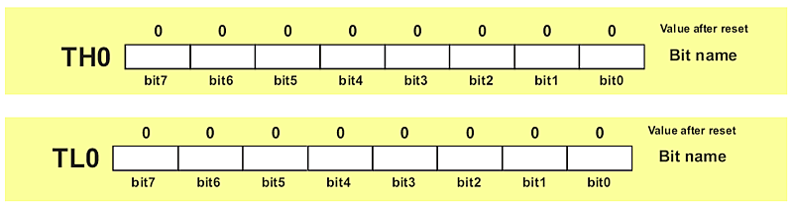

TIMER 1 REGISTERS
Timer 1 is also 16-bit register is split into two bytes, referred to as TL1 (Timer 1 low byte) and TH1 (Timer 1 high byte). These registers are accessible n the same way as the register of Timer 0.

TMOD (timer mode) REGISTER
Both timers 0 and 1 use the same register, called TMOD, to set the various timer operation modes. TMOD is an 8-bit register in which the lower 4 bits are set aside for Timer 0 and the upper 4 bits for Timer 1.in each case; the lower 2 bits are used to set the timer mode and the upper 2 bits to specify the operation.

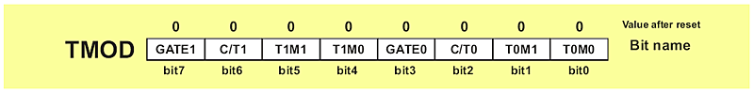

GATE Gate control when set. The timer/counter is enabled only
while the INTx pin is high and the TRx control pin is set. When cleared, the timer is enabled.
C/T Timer or counter selected cleared for timer operation
(Input from internal system clock).set for counter
operation (input TX input pin).

M1 M0 MODE Operating Mode

0 0 0 13-bit timer mode
8-bit timer/counter THx with TLx as
5-bit prescaler.
0 1 1 16-bit timer mode
16-bit timer/counters THx with TLx are
cascaded; there is no prescaler
1 0 2 8-bit auto reload
8-bit auto reload timer/counter;THx
Holds a value that is to be reloaded into TLx each time it overflows.
1 1 3 Split timer mode.

Table: 3.4:TMOD Selection

C/T (clock/timer)
This bit in the TMOD register is used to decide whether the timer is used as a delay generator or an event counter. If C/T=0, it is used as a timer for time delay generation. The clock source for the time delay is the crystal frequency of the 8051.this section is concerned with this choice. The timer’s use as an event counter is discussed in the next section.

3.1.12 Serial Communication
Serial data communication uses two methods, asynchronous and synchronous. The synchronous method transfers a block of data at a time, while the asynchronous method transfers a single byte at a time.
In data transmission if the data can be transmitted and received, it is a duplex transmission. This is in contrast to simplex transmissions such as with printers, in which the computer only sends data. Duplex transmissions can be half or full duplex, depending on whether or not the data transfer can be simultaneous. If data is transmitted one way at a time, it is referred to as half duplex. If the data can go both ways at the same time, it is full duplex. Of course, full duplex requires two wire conductors for the data lines, one for transmission and one for reception, in order to transfer and receive data simultaneously.

Asynchronous serial communication and data framing
The data coming in at the receiving end of the data line in a serial data transfer is all 0s and 1s; it is difficult to make sense of the data unless the sender and receiver agree on a set of rules, a protocol, on how the data is packed, how many bits constitute a character, and when the data begins and ends.

Start and stop bits
Asynchronous serial data communication is widely used for character-oriented transmissions, while block-oriented data transfers use the synchronous method. In the asynchronous method, each character is placed between start and stop bits. This is called framing. In the data framing for asynchronous communications, the data, such as ASCII characters, are packed between a start bit and a stop bit. The start bit is always one bit, but the stop bit can be one or two bits. The start bit is always a 0 (low) and the stop bit (s) is 1 (high).

Data transfer rate
The rate of data transfer in serial data communication is stated in bps (bits per second). Another widely used terminology for bps is baud rate. However, the baud and bps rates are not necessarily equal. This is due to the fact that baud rate is the modem terminology and is defined as the number of signal changes per second. In modems a single change of signal, sometimes transfers several bits of data. As far as the conductor wire is concerned, the baud rate and bps are the same, and for this reason we use the bps and baud interchangeably.

3.1.13 RS232 Standards
To allow compatibility among data communication equipment made by various manufacturers, an interfacing standard called RS232 was set by the Electronics Industries Association (EIA) in 1960. In 1963 it was modified and called RS232A. RS232B AND RS232C were issued in 1965 and 1969, respectively. Today, RS232 is the most widely used serial I/O interfacing standard. This standard is used in PCs and numerous types of equipment. However, since the standard was set long before the advert of the TTL logic family, its input and output voltage levels are not TTL compatible. In RS232, a 1 is represented by -3 to -25V, while a 0 bit is +3 to +25V, making -3 to +3 undefined. For this reason, to connect any RS232 to a micro controller system we must use voltage converters such as MAX232 to convert the TTL logic levels to the RS232 voltage levels, and vice versa. MAX232 IC chips are commonly referred to as line drivers.

RS232 pins
RS232 cable, commonly referred to as the DB-25 connector. In labeling, DB-25P refers to the plug connector (male) and DB-25S is for the socket connector (female). Since not all the pins are used in PC cables, IBM introduced the DB-9 Version of the serial I/O standard, which uses 9 pins only, as shown in table.
DB-9 pin connector

1 2 3 4 5
6 7 8 9

Fig3.7 DB-9 pin connector

Pin Functions
Pin | Description
1 | Data carrier detect (DCD)
2 | Received data (RXD)
3 | Transmitted data (TXD)
4 | Data terminal ready(DTR)
5 | Signal ground (GND)
6 | Data set ready (DSR)
7 | Request to send (RTS)
8 | Clear to send (CTS)
9 | Ring indicator (RI)

Table 3.5 : DB9 Pin Functions
Note: DCD, DSR, RTS and CTS are active low pins.

The method used by RS-232 for communication allows for a simple connection of three lines: Tx, Rx, and Ground. The three essential signals for 2-way RS-232

Communications are these
TXD: carries data from DTE to the DCE.
RXD: carries data from DCE to the DTE
SG: signal ground

3.1.14 8051 connection to RS232
The RS232 standard is not TTL compatible; therefore, it requires a line driver such as the MAX232 chip to convert RS232 voltage levels to TTL levels, and vice versa. The interfacing of 8051 with RS232 connectors via the MAX232 chip is the main topic.

The 8051 has two pins that are used specifically for transferring and receiving data serially. These two pins are called TXD and RXD and a part of the port 3 group (P3.0 and P3.1). pin 11 of the 8051 is assigned to TXD and pin 10 is designated as RXD. These pins are TTL compatible; therefore, they require a line driver to make them RS232 compatible. One such line driver is the MAX232 chip.

Since the RS232 is not compatible with today’s microprocessors and microcontrollers, we need a line driver (voltage converter) to convert the RS232’s signals to TTL voltage levels that will be acceptable to the 8051’s TXD and RXD pins. One example of such a converter is MAX232 from Maxim Corp. The MAX232 converts from RS232 voltage levels to TTL voltage levels, and vice versa.

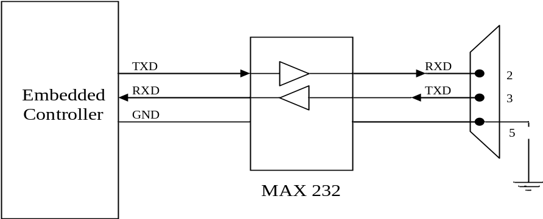
Figure 7Interfacing of MAX-232 to Controller

3.1.15 INTERRUPTS
A single micro controller can serve several devices. There are two ways to do that: INTERRUPTS or POLLING.

INTERRUPTS vs POLLING
The advantage of interrupts is that the micro controller can serve many devices (not all the same time, of course); each device can get the attention of the micro controller based on the priority assigned to it. The polling method cannot assign priority since it checks all devices in round-robin fashion. More importantly, in the interrupt method the micro controller can also ignore (mask) a device request for service. This is again not possible with the polling method. The most important reason that the interrupt method is preferable is that the polling method wastes much of the micro controller’s time by polling devices that do not need service. So, in order to avoid tying down the micro controller, interrupts are used.

INTERRUPT SERVICE ROUTINE
For every interrupt, there must be an interrupt service routine (ISR), or interrupt handler. When an interrupt is invoked, the micro controller runs the interrupts service routine. For every interrupt, there is a fixed location in memory that holds the address of its ISR. The group of memory location set aside to hold the addresses of ISRs is called the interrupt vector table. Shown below:

INTERRUPT ROM
LOCATION (HEX) PIN FLAG CLEARING

Reset 0000 9 Auto
External hardware
Interrupt 0 0003 P3.2 (12) Auto
Timers 0 interrupt (TF0) 000B Auto
External hardware 0013 P3.3 (13) Auto
Interrupt 1(INT1)
Timers 1 interrupt (TF1) 001B Auto
Serial COM (RI and TI) 0023 Programmer
Clears it
Table 3.6: Interrupt Vector Table for the 8051

Six Interrupts in the 8051
In reality, only five interrupts are available to the user in the 8051, but many manufacturers’ data sheets state that there are six interrupts since they include reset .the six interrupts in the 8051 are allocated as above.
- Reset. When the reset pin is activated, the 8051 jumps to address location 0000.this is the power-up reset.
- Two interrupts are set aside for the timers: one for Timer 0 and one for Timer 1.Memory location 000BH and 001BH in the interrupt vector table belong to Timer 0 and Timer 1, respectively.
- Two interrupts are set aside for hardware external harder interrupts. Pin number 12(P3.2) and 13(P3.3) in port 3 is for the external hardware interrupts INT0 and INT1, respectively. These external interrupts are also referred to as EX1 and EX2.Memory location 0003H and 0013H in the interrupt vector table are assigned to INT0 and INT1, respectively.
- Serial communication has a single interrupt that belongs to both receive and transmit. The interrupt vector table location 0023H belongs to this interrupt.

Interrupt Enable Register
D7 D6 D5 D4 D3 D2 D1 D0
EA -- ET2 ES ET1 EX1 ET0 EX0

EA IE.7 disables all interrupts. If EA=0, no interrupts is acknowledged.
If EA=1, each interrupt source is individually enabled disabled
By setting or clearing its enable bit.
-- IE.6 Not implemented, reserved for future use.*
ET2 IE.5 Enables or disables Timer 2 overflow or capture interrupt (8052 Only).
ES IE.4 Enables or disables the serial ports interrupt.
ET1 IE.3 Enables or disables Timers 1 overflow interrupt
EX1 IE.2 Enables or disables external interrupt 1.
ET0 IE.1 Enables or disables Timer 0 overflow interrupt.
EX0 IE.0 Enables or disables external interrupt 0.

3.2 GLOBAL SYSTEM FOR MOBILE COMMUNICATIONS

3.2.1 Definition
Global system for mobile communication (GSM) is a globally accepted standard for digital cellular communication. GSM is the name of a standardization group established in 1982 to create a common European mobile telephone standard that would formulate specifications for a pan-European mobile cellular radio system operating at 900 MHz. It is estimated that many countries outside of Europe will join the GSM partnership.

3.2.2 Description
GSM, the Global System for Mobile communications, is a digital cellular communications system, which has rapidly gained acceptance and market share worldwide, although it was initially developed in a European context. In addition to digital transmission, GSM incorporates many advanced services and features, including ISDN compatibility and worldwide roaming in other GSM networks. The advanced services and architecture of GSM have made it a model for future third-generation cellular systems, such as UMTS. This paper will give an overview of the services offered by GSM, the system architecture, the radio transmission
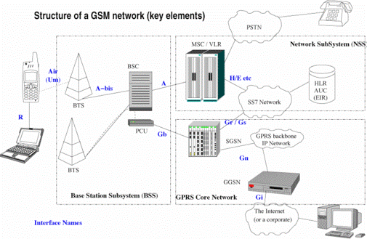
Figure 8 Structure Of a GSM Network

3.2.3 GSM Modems
A GSM modem can be an external modem device, such as the Wavecom FASTRACK Modem. Insert a GSM SIM card into this modem, and connect the modem to an available serial port on your computer.
A GSM modem can be a PC Card installed in a notebook computer, such as the Nokia Card Phone.
A GSM modem could also be a standard GSM mobile phone with the appropriate cable and software driver to connect to a serial port on your computer. Phones such as the Nokia 7110 with a DLR-3 cable, or various Ericsson phones, are often used for this purpose.
A dedicated GSM modem (external or PC Card) is usually preferable to a GSM mobile phone. This is because of some compatibility issues that can exist with mobile phones. For example, if you wish to be able to receive inbound MMS messages with your gateway, and you are using a mobile phone as your modem, you must utilize a mobile phone that does not support WAP push or MMS. This is because the mobile phone automatically processes these messages, without forwarding them via the modem interface. Similarly some mobile phones will not allow you to correctly receive SMS text messages longer than 160 bytes (known as “concatenated SMS” or “long SMS”). This is because these long messages are actually sent as separate SMS messages, and the phone attempts to reassemble the message before forwarding via the modem interface. (We’ve observed this latter problem utilizing the Ericsson R380, while it does not appear to be a problem with many other Ericsson models.)

When you install your GSM modem, or connect your GSM mobile phone to the computer, be sure to install the appropriate Windows modem driver from the device manufacturer. To simplify configuration, the Now SMS/MMS Gateway will communicate with the device via this driver. An additional benefit of utilizing this driver is that you can use Windows diagnostics to ensure that the modem is communicating properly with the computer.
The Now SMS/MMS gateway can simultaneously support multiple modems, provided that your computer hardware has the available communications port resources.

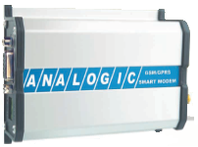
Figure 9 GSM Smart Modem

3.2.4 SMART MODEM (GSM/GPRS)
INTRODUCTION
Analogic’s GSM Smart Modem is a multi-functional, ready to use, rugged and versatile modem that can be embedded or plugged into any application. The Smart Modem can be customized to various applications by using the standard AT commands. The modem is fully type-approved and can directly be integrated into your projects with any or all the features of Voice, Data, Fax, SMS, and Internet etc.
Smart Modem kit contain the following items:
Analogic’s GSM/GPRS Smart Modem
SMPS based power supply adapter.
3 dBi antenna with cable (optional: other types)
Data cable (RS232)
User Manual

PRODUCT DESCRIPTION

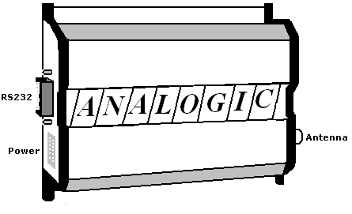
Figure 10 Block Diagram of Modem with key connections

Dimensions | 100 x 78 x 32 mm (excluding connectors)
Weight | 125 grams
Housing | Aluminum Profiled
Table 3.10 Physical Characteristics

Temperature Range
Operating temperature: from -20⁰C to +55⁰C
Storage temperature: from -25⁰C to +70⁰C
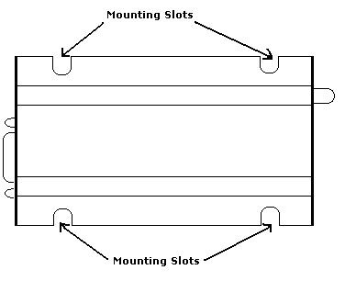
Figure 11Internal Diagram of GSM Modem

Installing the modem
To install the modem, plug the device on to the supplied SMPS Adapter. For Automotive applications fix the modem permanently using the mounting slots (optional as per your requirement dimensions).

Inserting/ Removing the SIM Card
To insert or Remove the SIM Card, it is necessary to press the SIM holder ejector button with Sharp edged object like a pen or a needle. With this, the SIM holder comes out a little, then pulls it out and insert or remove the SIM Card

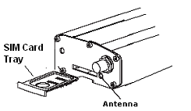
Figure 12 Inserting/Removing the sim card into the modem

Make sure that the ejector is pushed out completely before accessing the SIM Card holder do not remove the SIM card holder by force or tamper it (it may permanently damage). Place the SIM Card Properly as per the direction of the installation. It is very important that the SIM is placed in the right direction for its proper working condition

Connecting External Antenna
Connect GSM Smart Modem to the external antenna with cable end with SMA male. The Frequency of the antenna may be GSM 900/1800 MHz. The antenna may be ( 0 dbi, 3 dbi or short length L-type antenna) as per the field conditions and signal conditions.

DC Supply Connection
The Modem will automatically turn ON when connection is given to it. The following is the Power Supply Requirement:
Parameters | MIN | Avg | Max
Supply Voltage | 5 V | 9 V | 12 V
Peak Current at 5 V supply |  |  | 1.8 A (during transmission)
Average Current at 5 V supply in idle Mode |  |  | 35 mA
Average Current at 5 V supply in idle Mode and RS232 Power Saving Activated |  |  | 13 mA

Table 3.11:Power Supply Requirement

3.2.5 Connecting Modem to external devices
RS232 can be used to connect to the external device through the D-SUB/ USB (for USB model only) device that is provided in the modem.
Connector | Function
SMA | RF Antenna connector
15 pin or 9 pin D-SUB USB (optional) | RS232 link Audio link (only for 15 D-SUB) Reset (only for 15 D-SUB) USB communication port (optional)
2 pin Phoenix ^{tm} | Power Supply Connector
SIM Connector | SIM Card Connection
RJ11 (For 9 D-SUB and USB only) | Audio link Simple hand set connection (4 wire) 2 wire desktop phone connection
Table3.11:Connector Functions

Description of the interfaces
The modem comprises several interfaces:
LED Function including operating Status
External antenna (via SMA)
Serial and control link
Power Supply (Via 2 pin Phoenix ^{tm} contact)
SIM card holder

LED Status Indicator
The LED will indicate different status of the modem:
OFF Modem Switched off
ON Modem is connecting to the network
Flashing Slowly Modem is in idle mode
Flashing rapidly Modem is in transmission/communication (GSM only)

9 – PIN D-SUB Female Connector
PIN | NAME | Designation | Type
1 | X None | NC | NC
2 | Tx | Transmit Data | Input
3 | Rx | Receive Data | Output
4 | DSR | Data Set Ready | Output
5 | GND | Ground | Ground
6 | DTR | Data Terminal Ready | Input
7 | CTS | Clear to send | Output
8 | RTS | Request to send | Input
9 | X None | NC | NC
Table 3.12:DB9 Female Connector

Protecting Modem
Do not expose to the modem to extreme conditions such as High temperatures, direct sunlight, High Humidity, Rain, Chemicals, Water, Dust etc. For these details see the specifications given.
Do not drop, Shake or hit the Modem. (Warranty may void)
The Modem should not be used in extreme vibrating conditions
Handle the Antenna and cable with care.

3.2.6 AT commands features
Line settings
A serial link handler is set with the following default values
Autobaud, 8 bits data, 1 stop bit, no parity, flow control.
Command line
Commands always start with AT (which means attention) and finish with a <CR> character.
Information responses and result codes
Responses start and end with <CR><LF>,.
If command syntax is incorrect, an ERROR string is returned.
If command syntax is correct but with some incorrect parameters, the +CME ERROR: <Err> or +CMS ERROR: <SmsErr> strings are returned with different error codes.
If the command line has been performed successfully, an OK string is returned.
In some cases, such as “AT+CPIN?” or (unsolicited) incoming events, the product does not return the OK string as a response.

3.2.7 Services provided by GSM
GSM was designed having interoperability with ISDN in mind, and the services provided by GSM are a subset of the standard ISDN services. Speech is the most basic, and most important, teleservice provided by GSM.
In addition, various data services are supported, with user bit rates up to 9600 bps. Specially equipped GSM terminals can connect with PSTN, ISDN, Packet Switched and Circuit Switched Public Data Networks, through several possible methods, using synchronous or asynchronous transmission. Also supported are Group 3 facsimile service, videotex, and teletex. Other GSM services include a cell broadcast service, where messages such as traffic reports, are broadcast to users in particular cells.
A service unique to GSM, the Short Message Service, allows users to send and receive point-to-point alphanumeric messages up to a few tens of bytes. It is similar to paging services, but much more comprehensive, allowing bi-directional messages, store-and-forward delivery, and acknowledgement of successful delivery.
Supplementary services enhance the set of basic teleservices. In the Phase I specifications, supplementary services include variations of call forwarding and call barring, such as Call Forward on Busy or Barring of Outgoing International Calls. Many more supplementary services, including multiparty calls, advice of charge, call waiting, and calling line identification presentation will be offered in the Phase 2 specifications.

3.2.8 Architecture of the GSM network
A GSM network is composed of several functional entities, whose functions and interfaces are specified. Figure 1 shows the layout of a generic GSM network. The GSM network can be divided into three broad parts. The Mobile Station is carried by the subscriber. The Base Station Subsystem controls the radio link with the Mobile Station. The Network Subsystem, the main part of which is the Mobile services Switching Center (MSC), performs the switching of calls between the mobile users, and between mobile and fixed network users. The MSC also handles the mobility management operations. Not shown is the Operations

A GSM network is composed of several functional entities, whose functions and interfaces are specified. Figure 1 shows the layout of a generic GSM network. The GSM network can be divided into three broad parts. Subscriber carries the Mobile Station. The Base Station Subsystem controls the radio link with the Mobile Station. The Network Subsystem, the main part of which is the Mobile services Switching Center (MSC), performs the switching of calls between the mobile users, and between mobile and fixed network users. The MSC also handles the mobility management operations. Not shown is the Operations intendance Center, which oversees the proper operation and setup of the network. The Mobile Station and the Base Station Subsystem communicate across the Um interface, also known as the air interface or radio link. The Base Station Subsystem communicates with the Mobile services Switching Center across the A interface. 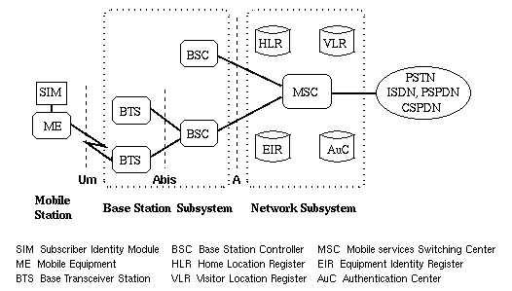
Figure 13 General architecture of a GSM network

Mobile Station
The mobile station (MS) consists of the mobile equipment (the terminal) and a smart card called the Subscriber Identity Module (SIM). The SIM provides personal mobility, so that the user can have access to subscribed services irrespective of a specific terminal. By inserting the SIM card into another GSM terminal, the user is able to receive calls at that terminal, make calls from that terminal, and receive other subscribed services.

The mobile equipment is uniquely identified by the International Mobile Equipment Identity (IMEI). The SIM card contains the International Mobile Subscriber Identity (IMSI) used to identify the subscriber to the system, a secret key for authentication, and other information. The IMEI and the IMSI are independent, thereby allowing personal mobility. The SIM card may be protected against unauthorized use by a password or personal identity number.

Base Station Subsystem
The Base Station Subsystem is composed of two parts, the Base Transceiver Station (BTS) and the Base Station Controller (BSC). These communicate across the standardized Abis interface, allowing (as in the rest of the system) operation between components made by different suppliers.

The Base Transceiver Station houses the radio transceivers that define a cell and handles the radio-link protocols with the Mobile Station. In a large urban area, there will potentially be a large number of BTSs deployed, thus the requirements for a BTS are ruggedness, reliability, portability, and minimum cost.

The Base Station Controller manages the radio resources for one or more BTSs. It handles radio-channel setup, frequency hopping, and handovers, as described below. The BSC is the connection between the mobile station and the Mobile service Switching Center (MSC).

Network Subsystem
The central component of the Network Subsystem is the Mobile services Switching Center (MSC). It acts like a normal switching node of the PSTN or ISDN, and additionally provides all the functionality needed to handle a mobile subscriber, such as registration, authentication, location updating, handovers, and call routing to a roaming subscriber. These services are provided in conjunction with several functional entities, which together form the Network Subsystem. The MSC provides the connection to the fixed networks (such as the PSTN or ISDN). Signalling between functional entities in the Network Subsystem uses Signalling System Number 7 (SS7), used for trunk signalling in ISDN and widely used in current public networks.

The Home Location Register (HLR) and Visitor Location Register (VLR), together with the MSC, provide the call-routing and roaming capabilities of GSM. The HLR contains all the administrative information of each subscriber registered in the corresponding GSM network, along with the current location of the mobile. The location of the mobile is typically in the form of the signalling address of the VLR associated with the mobile as a distributed database. station. The actual routing procedure will be described later. There is logically one HLR per GSM network, although it may be implemented

The Visitor Location Register (VLR) contains selected administrative information from the HLR, necessary for call control and provision of the subscribed services, for each mobile currently located in the geographical area controlled by the VLR. Although each functional entity can be implemented as an independent unit, all manufacturers of switching equipment to date implement the VLR together with the MSC, so that the geographical area controlled by the MSC corresponds to that controlled by the VLR, thus simplifying the signalling required. Note that the MSC contains no information about particular mobile stations --- this information is stored in the location registers.

The other two registers are used for authentication and security purposes. The Equipment Identity Register (EIR) is a database that contains a list of all valid mobile equipment on the network, where each mobile station is identified by its International Mobile Equipment Identity (IMEI). An IMEI is marked as invalid if it has been reported stolen or is not type approved. The Authentication Center (AuC) is a protected database that stores a copy of the secret key stored in each subscriber's SIM card, which is used for authentication and encryption over the radio channel

3.3 PULSE SENSOR(LM358)
Unique Characteristics
- In the linear mode the input common-mode voltage
range includes ground and the output voltage can also
swing to ground, even though operated from only a single
power supply voltage.

- The unity gain cross frequency is temperature
compensated.

- The input bias current is also temperature compensated.

Advantages
- Two internally compensated op amps in a single
package
- Eliminates need for dual supplies
- Allows directly sensing near GND and VOUT also goes
to GND
- Compatible with all forms of logic
- Power drain suitable for battery operation
- Pin-out same as LM1558/LM1458 dual operational

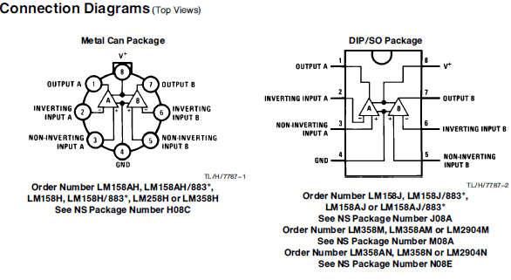

Features
- Internally frequency compensated for unity gain
- Large dc voltage gain 100 dB
- Wide bandwidth (unity gain) 1 MHz
(temperature compensated)
- Wide power supply range:
- Single supply 3V to 32V
or dual supplies g1.5V to g16V
- Very low supply current drain (500 mA)Ðessentially independent
of supply voltage
- Low input offset voltage 2 mV
- Input common-mode voltage range includes ground
- Differential input voltage range equal to the power supply
voltage
- Large output voltage swing 0V to Va b 1.5V
CAUTION: Stresses above those listed in “Absolute Maximum Ratings” may cause permanent damage to the device. This is a stress only rating and operation of the
device at these or any other conditions above those indicated in the operational sections of this specification is not implied.
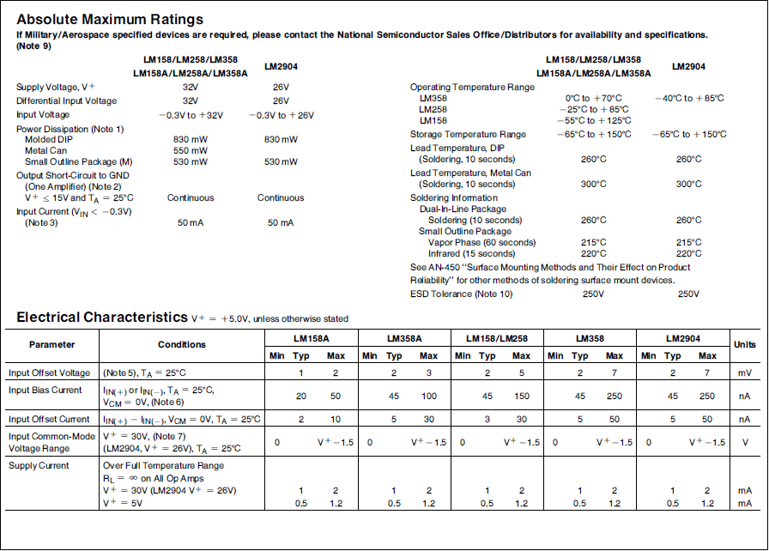

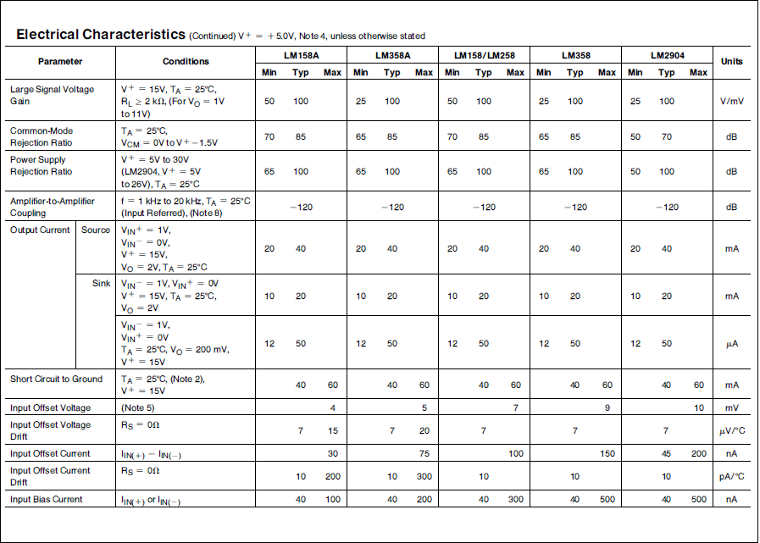
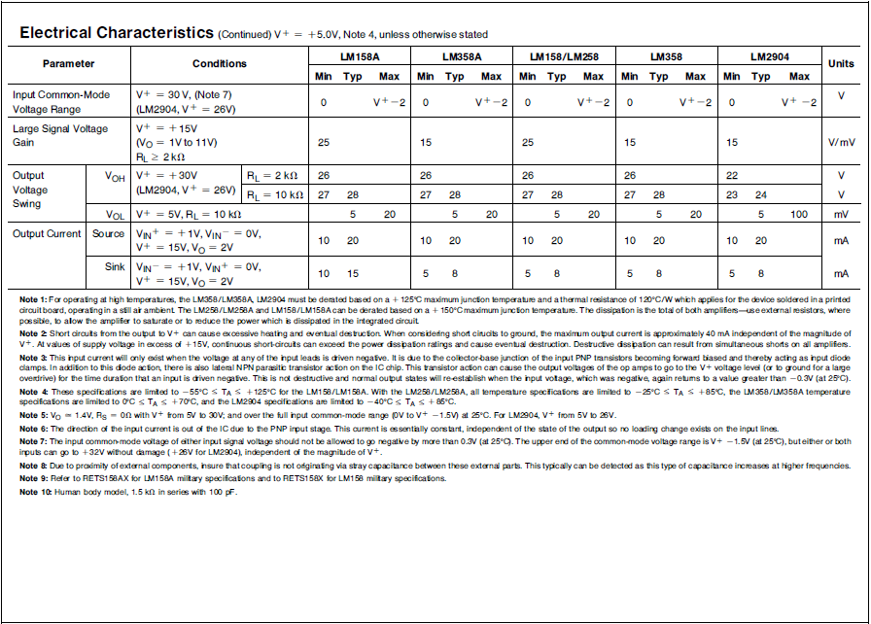

3.4 Temperature Sensor

3.4.1 The LM35
The LM35 is an integrated circuit sensor that can be used to measure temperature with an electrical output proportional to the temperature (in ºC)
The LM35 - An Integrated Circuit Temperature Sensor
  - You can measure temperature more accurately than a using a thermistor.
  - The sensor circuitry is sealed and not subject to oxidation, etc.
  - The LM35 generates a higher output voltage than thermocouples and may not require that the output voltage be amplified.

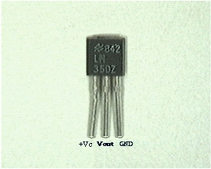
Fig 3.22 Temperature Sensor

Working of LM35
  - It has an output voltage that is proportional to the Celsius temperature.
  - The scale factor is .01V/ºC
  - The LM35 does not require any external calibration or trimming and maintains an accuracy of +/-0.4 ºC at room temperature and +/- 0.8 ºC over a range of 0 ºC to +100 ºC.
  - Another important characteristic of the LM35DZ is that it draws only 60 micro amps from its supply and possesses a low self-heating capability. The sensor self-heating causes less than 0.1 ºC temperature rise in still air.
The LM35 comes in many different packages, including the following.
- TO-92 plastic transistor-like package,
- T0-46 metal can transistor-like package
- 8-lead surface mount SO-8 small outline package
- TO-202 package. (Shown in the picture above)

CIRCUIT CONNECTION
Here is a commonly used circuit. For connections refer to the picture above.
  - In this circuit, parameter values commonly used are:
    - V_{c} = 4 to 30v
    - 5v or 12 v are typical values used.
    - R_{a} = V_{c} /10⁻⁶
    - Actually, it can range from 80 K to 600 K , but most just use 80 K.
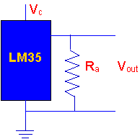
Figure 14 Circuit diagram of LM35

  - Here is a photo of the LM 35 wired on a circuit board.
    - The white wire in the photo goes to the power supply.
    - Both the resistor and the black wire go to ground.
    - The output voltage is measured from the middle pin to ground.l
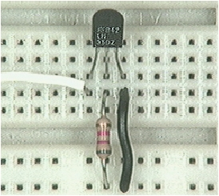
Figure 15 LM 35 wired on a circuit board

3.5 Power supply
The power supply are designed to convert high voltage AC mains electricity to a suitable low voltage supply for electronics circuits and other devices. A power supply can by broken down into a series of blocks, each of which performs a particular function. A d.c power supply which maintains the output voltage constant irrespective of a.c mains fluctuations or load variations is known as “Regulated D.C Power Supply”
For example a 5V regulated power supply system as shown below:
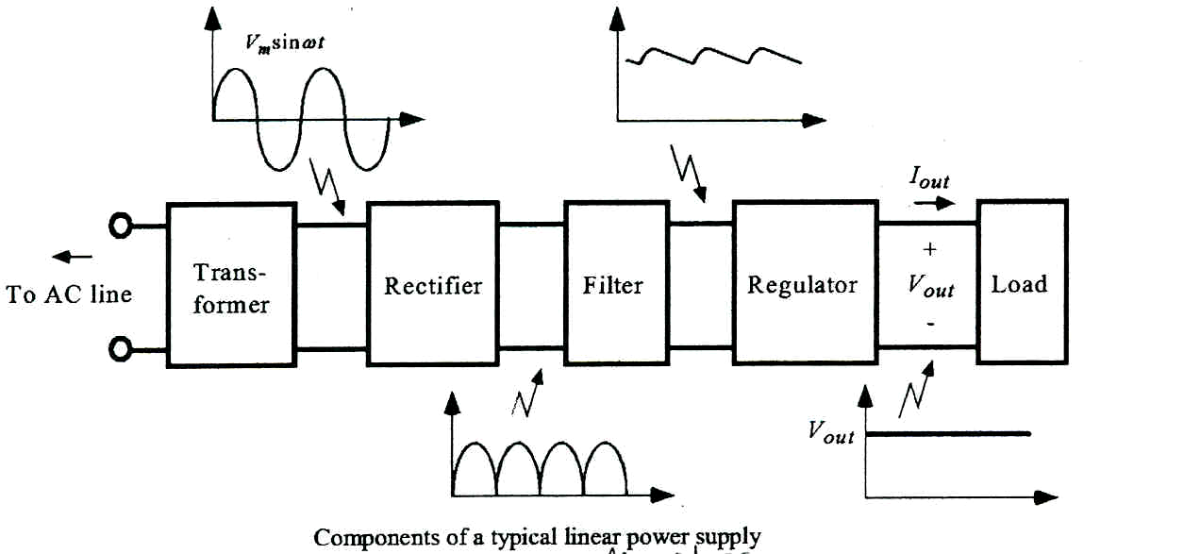
Figure 16 Functional Block Diagram of Power supply

3.5.1 Transformer
A transformer is an electrical device which is used to convert electrical power from one electrical circuit to another without change in frequency.

Transformers convert AC electricity from one voltage to another with little loss of power. Transformers work only with AC and this is one of the reasons why mains electricity is AC. Step-up transformers increase in output voltage, step-down transformers decrease in output voltage. Most power supplies use a step-down transformer to reduce the dangerously high mains voltage to a safer low voltage. The input coil is called the primary and the output coil is called the secondary. There is no electrical connection between the two coils; instead they are linked by an alternating magnetic field created in the soft-iron core of the transformer. The two lines in the middle of the circuit symbol represent the core. Transformers waste very little power so the power out is (almost) equal to the power in. Note that as voltage is stepped down current is stepped up. The ratio of the number of turns on each coil, called the turn’s ratio, determines the ratio of the voltages. A step-down transformer has a large number of turns on its primary (input) coil which is connected to the high voltage mains supply, and a small number of turns on its secondary (output) coil to give a low output voltage.

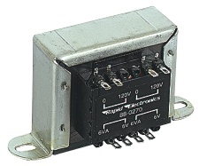
Figure 17 An Electrical Transformer

Turns ratio = Vp/ V_{S} = Np/N_{S}
Power Out= Power In
V_{S} X I_{S}=V_{P} X I_{P}
Vp = primary (input) voltage
Np = number of turns on primary coil
Ip = primary (input) current

3.5.2 RECTIFIER
A circuit, which is used to convert a.c to d.c, is known as RECTIFIER. The process of conversion a.c to d.c is called “rectification”

TYPES OF RECTIFIERS
- Half wave Rectifier
- Full wave rectifier
1. Center tap full wave rectifier.
2. Bridge type full bridge rectifier.

Comparison of rectifier circuits
Parameter | Type of Rectifier
Parameter | Half wave Full wave Bridge
Number of diodes | 1 | 2 | 4
PIV of diodes | Vm | 2Vm | Vm
D.C output voltage | Vm/ | 2Vm/ | 2Vm/
Vdc, at  no-load | 0.318Vm | 0.636Vm | 0.636Vm
Ripple factor | 1.21 | 0.482 | 0.482
Ripple  frequency | f | 2f | 2f
Rectification  efficiency | 0.406 | 0.812 | 0.812
Transformer  Utilization  Factor(TUF) | 0.287 | 0.693 | 0.812
RMS voltage Vrms | Vm/2 | Vm/√2 | Vm/√2
Table 3.18:Comparison of rectifier circuits
Full-wave Rectifier
From the above comparisons we came to know that full wave bridge rectifier as more advantages than the other two rectifiers. So, in our project we are using full wave bridge rectifier circuit.

Bridge Rectifier
A bridge rectifier makes use of four diodes in a bridge arrangement to achieve full-wave rectification. This is a widely used configuration, both with individual diodes wired as shown and with single component bridges where the diode bridge is wired internally.
A bridge rectifier makes use of four diodes in a bridge arrangement as shown in fig(a) to achieve full-wave rectification. This is a widely used configuration, both with individual diodes wired as shown and with single component bridges where the diode bridge is wired internally.
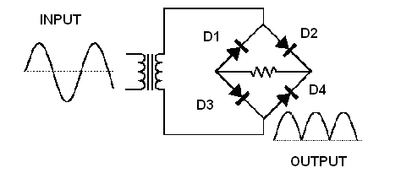
Figure 18 Full Wave Bridge Rectifier

Operation
During positive half cycle of secondary, the diodes D2 and D3 are in forward biased while D1 and D4 are in reverse biased as shown in the fig(b). The current flow direction is shown in the fig (b) with dotted arrows.
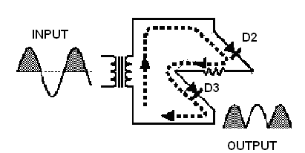
Figure 19 Operation During Positive Cycle
During negative half cycle of secondary voltage, the diodes D1 and D4 are in forward biased while D2 and D3 are in reverse biased as shown in the fig(c). The current flow direction is shown in the fig (c) with dotted arrows.
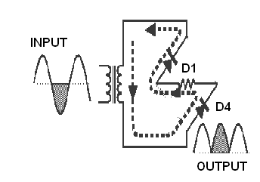
Figure 20 Operation During Negative Cycle

3.5.3 Filter
A Filter is a device, which removes the a.c component of rectifier output but allows the d.c component to reach the load

Capacitor Filter
We have seen that the ripple content in the rectified output of half wave rectifier is 121% or that of full-wave or bridge rectifier or bridge rectifier is 48% such high percentages of ripples is not acceptable for most of the applications. Ripples can be removed by one of the following methods of filtering:
(a) A capacitor, in parallel to the load, provides an easier by –pass for the ripples voltage though it due to low impedance. At ripple frequency and leave the d.c.to appears the load.

(b) An inductor, in series with the load, prevents the passage of the ripple current (due to high impedance at ripple frequency) while allowing the d.c (due to low resistance to d.c)

(c) various combinations of capacitor and inductor, such as L-section filter section filter, multiple section filter etc. which make use of both the properties mentioned in (a) and (b) above. Two cases of capacitor filter, one applied on half wave rectifier and another with full wave rectifier.

Filtering is performed by a large value electrolytic capacitor connected across the DC supply to act as a reservoir, supplying current to the output when the varying DC voltage from the rectifier is falling. The capacitor charges quickly near the peak of the varying DC, and then discharges as it supplies current to the output. Filtering significantly increases the average DC voltage to almost the peak value (1.4 × RMS value).
To calculate the value of capacitor(C),
C = ¼*√3*f*r*Rl
Where,
f = supply frequency,
r = ripple factor,
Rl = load resistance
Note: In our circuit we are using 1000microfarads.

3.5.4 Regulator
Voltage regulator ICs is available with fixed (typically 5, 12 and 15V) or variable output voltages. The maximum current they can pass also rates them. Negative voltage regulators are available, mainly for use in dual supplies. Most regulators include some automatic protection from excessive current ('overload protection') and overheating ('thermal protection'). Many of the fixed voltage regulator ICs have 3 leads and look like power transistors, such as the 7805 +5V 1A regulator shown on the right. The LM7805 is simple to use. You simply connect the positive lead of your unregulated DC power supply (anything from 9VDC to 24VDC) to the Input pin, connect the negative lead to the Common pin and then when you turn on the power, you get a 5 volt supply from the output pin.

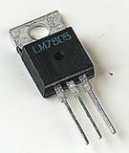
Figure 21 A Three Terminal Voltage Regulator

78XX
The Bay Linear LM78XX is integrated linear positive regulator with three terminals. The LM78XX offer several fixed output voltages making them useful in wide range of applications. When used as a zener diode/resistor combination replacement, the LM78XX usually results in an effective output impedance improvement of two orders of magnitude, lower quiescent current. The LM78XX is available in the TO-252, TO-220 & TO-263packages,

Features
• Output Current of 1.5A
• Output Voltage Tolerance of 5%
• Internal thermal overload protection
• Internal Short-Circuit Limited
• No External Component
• Output Voltage 5.0V, 6V, 8V, 9V, 10V, 12V, 15V, 18V, 24V
• Offer in plastic TO-252, TO-220 & TO-263
• Direct Replacement for LM78XX

3.6LCD
The most commonly used LCDs found in the market today are 1 Line, 2 Line or 4 Line LCDs which have only one controller and support at most 80 characters, whereas LCDs supporting more than 80 characters make use of 2 HD44780 controllers. Apart from displaying some simple static characters you can create animated text scripts and a lot more!
Most LCDs with 1 controller has 14 Pins and 16 Pins (two extra pins are for back-light LED connections). Pin description is shown in the table below. (We may also have 16 pins in 2 controllers, refer to the datasheet for exact details).
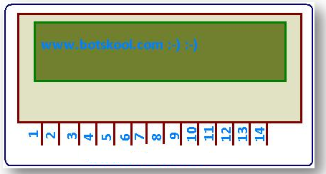
Figure 22 LCD
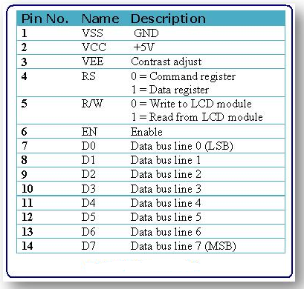
Figure 23 LCD Pin Description

3.7 ADC
Normally analogue-to-digital con-verter (ADC) needs interfacing through a microprocessor to convert analogue data into digital format. This requires hardware and necessary software, resulting in increased complexity and hence the total cost.

The circuit of A-to-D converter shown here is configured around ADC 0808, avoiding the use of a microprocessor. The ADC 0808 is an 8-bit A-to-D converter, having data lines D0-D7. It works on the principle of successive approximation. It has a total of eight analogue input channels, out of which any one can be selected using address lines A, B and C. Here, in this case, input channel IN0 is selected by grounding A, B and C address lines.
Usually the control signals EOC (end of conversion), SC (start conversion), ALE (address latch enable) and OE (output enable) are interfaced by means of a microprocessor. However, the circuit shown here is built to operate in its continuous mode without using any microprocessor. Therefore the input control signals ALE and OE, being active-high, are tied to Vcc (+5 volts). The input control signal SC, being active-low, initiates start of conversion at falling edge of the pulse, whereas the output signal EOC becomes high after completion of digitisation. This EOC output is coupled to SC input, where falling edge of EOC output acts as SC input to direct the ADC to start the conversion.
As the conversion starts, EOC signal goes high. At next clock pulse EOC output again goes low, and hence SC is enabled to start the next conversion. Thus, it provides continuous 8-bit digital output corresponding to instantaneous value of analogue input. The maximum level of analogue input voltage should be appropriately scaled down below positive reference (+5V) level.
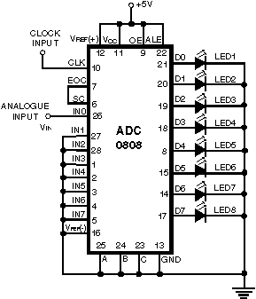
Figure 24 ADC

4 Circuit Description

In this project, the GSM and GPS are connected to the micro controller. The GSM is used for sending, receiving and reading the messages. The GPS is used for getting the location of the vehicle which sends the location name in the form of coordinates ie., latitudes, longitudes and altitudes. These GSM and GPS are both meant for serial communication. Both the GSM and GPS are RS voltage level compatible but the Micro controller is TTL compatible. To match the voltage levels we using the MAX-232 line driver to convert the RS voltage level to TTL voltage levels and vice versa.

The controller is having one serial port. It is impossible to interface to two serial communication devices and access both at a time. So that, through Latch these devices are connected to the MAX. The latch is acts to store the information temporarily. For accessing these devices, one is kept in sleep mode and the other activated and vice versa.

The Heart beat circuitry consists of electrodes and a 4-quad op-amp IC. There are three electrodes are present. These electrodes are placed to patient at the heart and patient pulse. The signals are given to the LM 324 IC, which quad op-amp IC. In that IC, the two signal frequencies are mixed up to generate a particular frequency there you can given to the input of the third op-amp. The reference signal is generated at the fourth op-amp with the help of the RC circuit. These signals such as reference signal and the output of the third op-amp signal is compares then given output through the transistor. The transistor converts the analog frequencies into our corresponding logic levels. These output digital values are given to the one of the pin of the micro controller.

The LCD display will acts as an output source in this project that will be helpful to display the location name on this display. The RS, R/W. and EN pins are the control pins which are used for controlling purpose. The RS pin is used to select either data mode or command mode. The R/W is used to indicate that the LCD will acts as a either read or write mode. The EN pin is used to enable the data. D0-D7 are data pins used to get the data from the micro controller. To operate the LCD display, which requires maximum of +5V DC power supply. In this project, the LCD is used to display the status of the GSM modem and also displays the heart beat rate and B.P.

The power supply is used drive all the hardware components, which are work at the maximum voltage of +5V DC. The 230V AC is a power supply which is used for operate our general home appliance. But our hardware components which requires just +5V DC voltage. A step-down transformer is used to step down the 230V AC to the required AC voltage and thereafter it is meant for filtering with the help of a capacitor. Thereby, the circuit is meant for the regulation to get the constant +5V DC. This output +5V DC power supply is getting at the load ie., may be a capacitor for rectification purpose, ie., any AC ripples should be minimized with the help of this capacitor at the load.

5.Software Used

5.1 Introduction to Embedded ‘C’

5.1.1 Data Types
U people have already come across the word “Data types” in C- Language. Here also the functionality and the meaning of the word is same except a small change in the prefix of their labels. Now we will discuss some of the widely used data types for embedded C- programming.

Data Types | Size in Bits | Data Range/Usage
unsigned char | 8-bit | 0-255
signed char | 8-bit | -128 to +127
unsigned int | 16-bit | 0 to 65535
signed int | 16-bit | -32,768 to +32,767
sbit | 1-bit | SFR bit addressable only
bit | 1-bit | RAM bit addressable only
sfr | 8-bit | RAM addresses 80-FFH only

Table 5.1:Data Types
Unsigned char
The unsigned char is an 8-bit data type that takes a value in the range of 0-255(00-FFH). It is used in many situations, such as setting a counter value, where there is no need for signed data we should use the unsigned char instead of the signed char. Remember that C compilers use the signed char as the default if we do not put the key word.

Signed char
The signed char is an 8-bit data type that uses the most significant bit (D7 of D7-D0) to represent the – or + values. As a result, we have only 7 bits for the magnitude of the signed number, giving us values from -128 to +127. In situations where + and – are needed to represent a given quantity such as temperature, the use of the signed char data type is a must.

Unsigned int
The unsigned int is a 16-bit data type that takes a value in the range of 0 to 65535 (0000-FFFFH).It is also used to set counter values of more than 256. We must use the int data type unless we have to. Since registers and memory are in 8-bit chunks, the misuse of int variables will result in a larger hex file. To overcome this we can use the unsigned char in place of unsigned int.

Signed int
Signed int is a 16-bit data type that uses the most significant bit (D15 of D15-D0) to represent the – or + value. As a result we have only 15 bits for the magnitude of the number or values from -32,768 to +32,767.

Sbit (single bit)
The sbit data type is widely used and designed specifically to access single bit addressable registers. It allows access to the single bits of the SFR registers.

5.1.2I/O PROGRAMMING IN EMBEDDED “C”
In this topic we look at C- programming of the I/O ports and also both byte and bit I/O programming.

Byte size I/O
As we know that ports P0-P3 are byte accessible, we use the P0-P3 labels as defined in the header file.

Bit – addressable I/O programming
The I/O ports of P0-P3 are bit- addressable, so we can access a single bit without disturbing the rest of the port.
We use the sbit data type to access a single bit of P0-P3.the format is Px^y where x is the port and y is the bit.

Accessing SFR addresses 80-FFH
Another way to access the SFR RAM space 80-FFH is to use the sfr data type. This is shown in the below example .Both the bit and byte addresses for the P0-P3 ports are given in the table. Notice in the given example that there is no #include<reg51.h> statement which allows us to access any byte of the SFR RAM space 80-FFH.

Single Bit Addresses of Ports
P0 | Addr | P1 | Addr | P2 | Addr | P3 | Addr | Ports Bit
P0.0 | 80H | P1.0 | 90H | P2.0 | A0H | P3.0 | B0H | D0
P0.1 | 81H | P1.1 | 91H | P2.1 | A1H | P3.1 | B1H | D1
P0.2 | 82H | P1.2 | 92H | P2.2 | A2H | P3.2 | B2H | D2
P0.3 | 83H | P1.3 | 93H | P2.3 | A3H | P3.3 | B3H | D3
P0.4 | 84H | P1.4 | 94H | P2.4 | A4H | P3.4 | B4H | D4
P0.5 | 85H | P1.5 | 95H | P2.5 | A5H | P3.5 | B5H | D5
P0.6 | 86H | P1.6 | 96H | P2.6 | A6H | P3.6 | B6H | D6
P0.7 | 87H | P1.7 | 97H | P2.7 | A7H | P3.7 | B7H | D7

Table 5.2: Single Bit Addresses of Ports

5.1.3 DATA CONVERSION PROGRAMS IN EMBEDDED C
Many micro-controllers have a real time clock (RTC) where the time and date are kept even when the power is off. These time and date are often in packed BCD by RTC. To display them they must be converted to ASCII. So, in this topic we are showing application of logic and instructions in the conversion of BCD and ASCII.

ASCII numbers
On ASCII key boards, when the key “0” is activated, “0110000” (30h) is provided to the system. Similarly 31h (0110001) is provided for the key “1”, and so on as shown in the table

Packed BCD to ASCII conversion
The RTC provides the time of day (hour, minutes, seconds) and the date (year, month, day) continuously, regardless of whether the power is ON or OFF. In the conversion procedure the packed BCD is first converted to unpacked BCD. Then it is tagged with 0110000 (30h).

ASCII code for Digits 0-9
Key | ASCII (hex) | Binary | BCD (unpacked)
0 | 30 | 011 0000 | 0000 0000
1 | 31 | 011 0001 | 0000 0001
2 | 32 | 011 0010 | 0000 0010
3 | 33 | 011 0011 | 0000 0011
4 | 34 | 011 0100 | 0000 0100
5 | 35 | 011 0101 | 0000 0101
6 | 36 | 011 0110 | 0000 0110
7 | 37 | 011 0111 | 0000 0111
8 | 38 | 011 1000 | 0000 1000
9 | 39 | 011 1001 | 0000 1001

Table 5.3: ASCII code for Digits 0-9

ASCII to packed BCD conversion
To convert ASCII to packed BCD it is first converted to unpacked and then combined to make packed BCD. For example 4 and 7 on the keyboard give 34h and 37h
respectively the goal is to produce 47h or “0100 0111” which is packed BCD.

Key ASCII unpacked BCD packed BCD

4 34 00000100
7 37 00000111 01000111 or 47h

Table 5.4: ASCII to packed BCD conversion

Checksum byte in ROM
To ensure the integrity of ROM contents, every system must perform the checksum calculation. The process of checksum will detect any corruption of the contents of ROM. One of the cause of the ROM corruption is current surge either when the system is turned on or during operation. To ensure data integrity in ROM the checksum process uses, what is a checksum byte. There is an extra byte that is tagged to the end of the series of data.

To calculate the checksum byte of a series of bytes of data, the following steps can be used
- Add the bytes together and drop the carries.
- Take the 2’s complement of the total sum. This is the checksum byte , which becomes the last byte of the series

Binary (hex) to decimal and ASCII conversion in embedded C
In C-language we use a function call “printf” which is standard IO library function doing the conversions of data from binary to decimal, or vice versa. But here we are using our own functions for conversions because it occupies much of memory.

One of the most commonly used is binary to decimal conversion. In devices such as ADC chips the data is provided to the controller in binary. In order to display binary data we need to convert it to decimal and then to ASCII. Since the hexadecimal format is a convenient way of representing binary data we refer to binary data as hex. The binary data 00-FFH converted to decimal will give us 000 to 255.
One way to do this is to divide it by 10 and keep the remainder, for example 11111101 or FDH is 253 in decimal. The following is one version of the algorithm for conversion of hex (binary) to decimal.
.

5.2 ABOUT SOFTWARE
Software’s used are:
*Keil software for C programming
*Express PCB for lay out design
*Express SCH for schematic design
What's New in µVision3?
µVision3 adds many new features to the Editor like Text Templates, Quick Function Navigation, and Syntax Coloring with brace high lighting Configuration Wizard for dialog based startup and debugger setup. µVision3 is fully compatible to µVision2 and can be used in parallel with µVision2.

What is µVision3?
µVision3 is an IDE (Integrated Development Environment) that helps you write, compile, and debug embedded programs. It encapsulates the following components:
- A project manager.
- A make facility.
- Tool configuration.
- Editor.
- A powerful debugger.
To help you get started, several example programs (located in the \C51\Examples, \C251\Examples, \C166\Examples, and \ARM\...\Examples) are provided.
- HELLO is a simple program that prints the string "Hello World" using the Serial Interface.
- MEASURE is a data acquisition system for analog and digital systems.
- TRAFFIC is a traffic light controller with the RTX Tiny operating system.
- SIEVE is the SIEVE Benchmark.
- DHRY is the Dhrystone Benchmark.
- WHETS is the Single-Precision Whetstone Benchmark.
Additional example programs not listed here are provided for each device architecture.

Building an Application in µVision2
To build (compile, assemble, and link) an application in µVision2, you must:
- Select Project -(forexample,166\EXAMPLES\HELLO\HELLO.UV2).
- Select Project - Rebuild all target files or Build target.
µVision2 compiles, assembles, and links the files in your project.

Creating Your Own Application in µVision2

To create a new project in µVision2, you must
- Select Project - New Project.
- Select a directory and enter the name of the project file.
- Select Project - Select Device and select an 8051, 251, or C16x/ST10 device from the Device Database™.
- Create source files to add to the project.
- Select Project - Targets, Groups, Files. Add/Files, select Source Group1, and add the source files to the project.
- Select Project - Options and set the tool options. Note when you select the target device from the Device Database™ all special options are set automatically. You typically only need to configure the memory map of your target hardware. Default memory model settings are optimal for most applications.
- Select Project - Rebuild all target files or Build target.

Debugging an Application in µVision2
To debug an application created using µVision2, you must:
- Select Debug - Start/Stop Debug Session.
- Use the Step toolbar buttons to single-step through your program. You may enter G, main in the Output Window to execute to the main C function.
- Open the Serial Window using the Serial #1 button on the toolbar.
Debug your program using standard options like Step, Go, Break, and so on.

Starting µVision2 and Creating a Project
µVision2 is a standard Windows application and started by clicking on the program icon. To create a new project file select from the µVision2 menu.
Project – New Project…. This opens a standard Windows dialog that asks you
for the new project file name.
We suggest that you use a separate folder for each project. You can simply use the icon Create New Folder in this dialog to get a new empty folder. Then select this folder and enter the file name for the new project, i.e. Project1. µVision2 creates a new project file with the name PROJECT1.UV2 which contains a default target and file group name. You can see these names in the Project.

Window – Files.
Now use from the menu Project – Select Device for Target and select a CPU for your project. The Select Device dialog box shows the µVision2 device database. Just select the micro controller you use. We are using for our examples the Philips 80C51RD+ CPU. This selection sets necessary tool options for the 80C51RD+ device and simplifies in this way the tool Configuration.

Building Projects and Creating a HEX Files
Typical, the tool settings under Options – Target are all you need to start a new application. You may translate all source files and line the application with a click on the Build Target toolbar icon. When you build an application with syntax errors, µVision2 will display errors and warning messages in the Output Window – Build page. A double click on a message line opens the source file on the correct location in a µVision2 editor window. Once you have successfully generated your application you can start debugging.
After you have tested your application, it is required to create an Intel HEX file to download the software into an EPROM programmer or simulator. µVision2 creates HEX files with each build process when Create HEX files under Options for Target – Output is enabled. You may start your PROM programming utility after the make process when you specify the program under the option Run User Program #1.

CPU Simulation
µVision2 simulates up to 16 Mbytes of memory from which areas can be mapped for read, write, or code execution access. The µVision2 simulator traps and reports illegal memory accesses.
In addition to memory mapping, the simulator also provides support for the integrated peripherals of the various 8051 derivatives. The on-chip peripherals of the CPU you have selected are configured from the Device.

Database selection
You have made when you create your project target. Refer to page 58 for more Information about selecting a device. You may select and display the on-chip peripheral components using the Debug menu. You can also change the aspects of each peripheral using the controls in the dialog boxes.

Start Debugging
You start the debug mode of µVision2 with the Debug – Start/Stop Debug Session command. Depending on the Options for Target – Debug Configuration, µVision2 will load the application program and run the startup code µVision2 saves the editor screen layout and restores the screen layout of the last debug session. If the program execution stops, µVision2 opens an editor window with the source text or shows CPU instructions in the disassembly window. The next executable statement is marked with a yellow arrow. During debugging, most editor features are still available.
For example, you can use the find command or correct program errors. Program source text of your application is shown in the same windows. The µVision2 debug mode differs from the edit mode in the following aspects:
_ The “Debug Menu and Debug Commands” described on page 28 are Available. The additional debug windows are discussed in the following.
_ the project structure or tool parameters cannot be modified. All build Commands are disabled.

Disassembly Window
The Disassembly window shows your target program as mixed source and assembly program or just assembly code. A trace history of previously executed instructions may be displayed with Debug – View Trace Records. To enable the trace history, set Debug – Enable/Disable Trace Recording.
If you select the Disassembly Window as the active window all program step commands work on CPU instruction level rather than program source lines. You can select a text line and set or modify code breakpoints using toolbar buttons or the context menu commands.
You may use the dialog Debug – Inline Assembly… to modify the CPU instructions. That allows you to correct mistakes or to make temporary changes to the target program you are debugging.

Steps for executing the Keil programs
- Click on the Keil uVision Icon on Desktop
- The following fig will appear
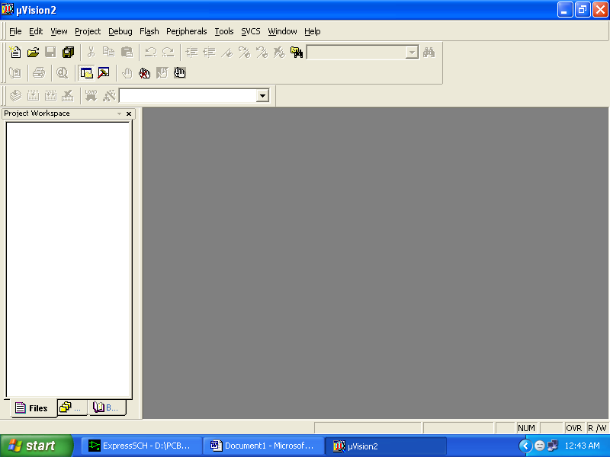
- Click on the Project menu from the title bar
- Then Click on New Project

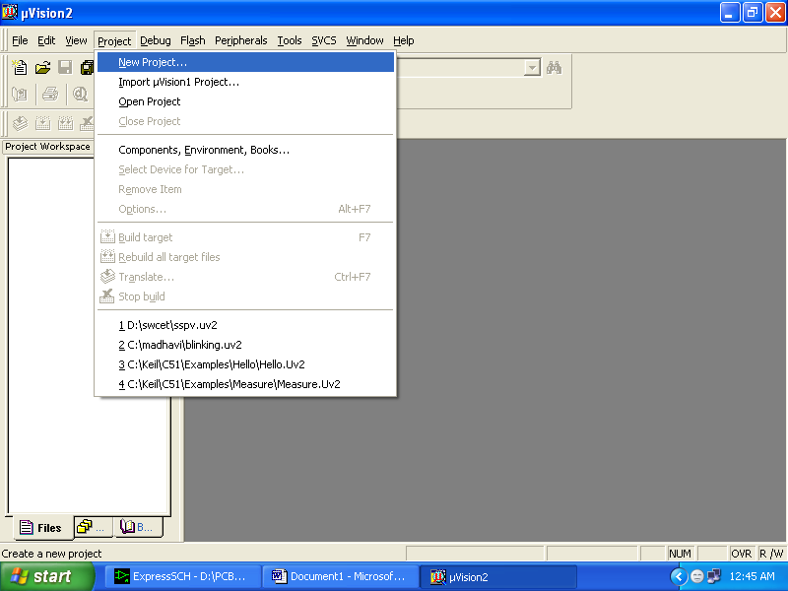
- Save the Project by typing suitable project name with no extension in u r own folder sited in either C:\ or D:\

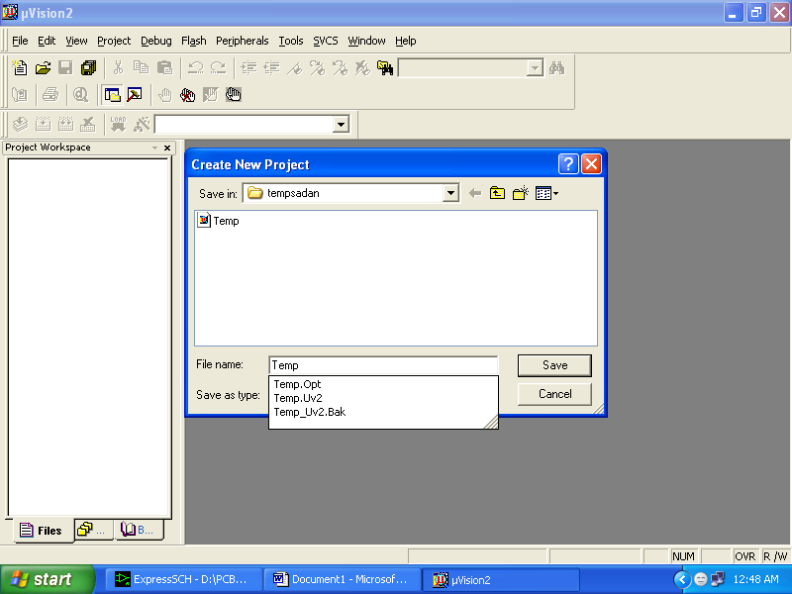

- Then Click on Save button above.
- Select the component for u r project. i.e. Atmel……
- Click on the + Symbol beside of Atmel

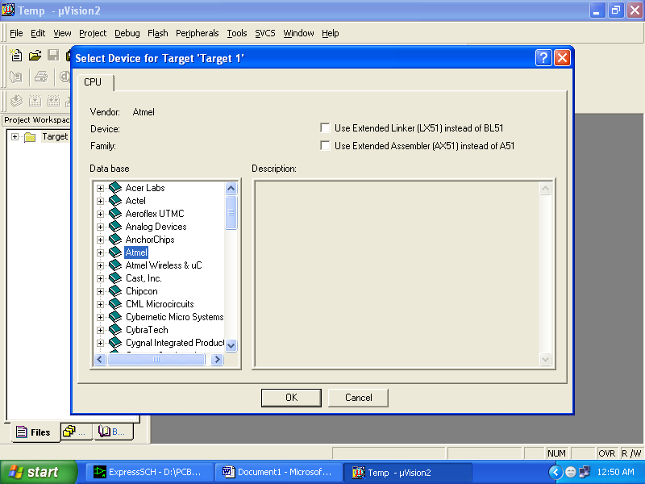
- Select AT89C51 as shown below
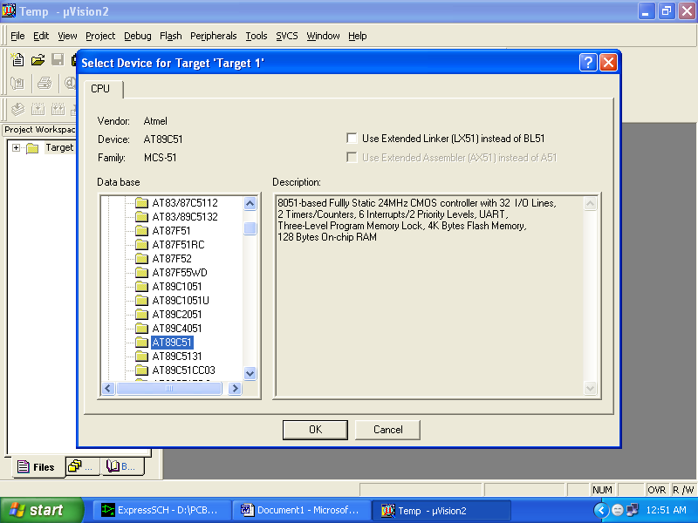

- Then Click on “OK”
- The Following fig will appear

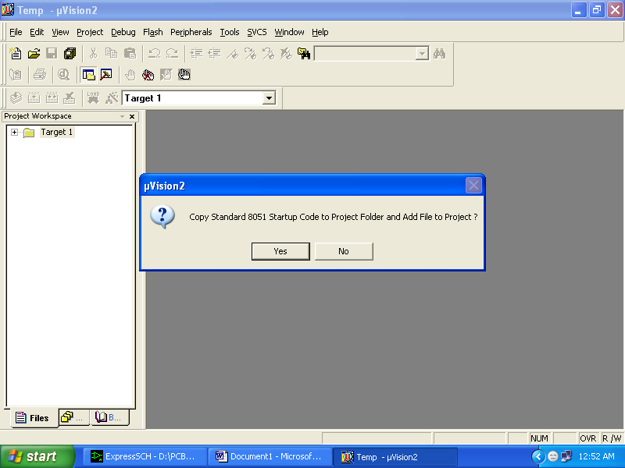

- Then Click either YES or NO………mostly “NO”
- Now your project is ready to USE
- Now double click on the Target1, you would get another option “Source group 1” as shown in next page.
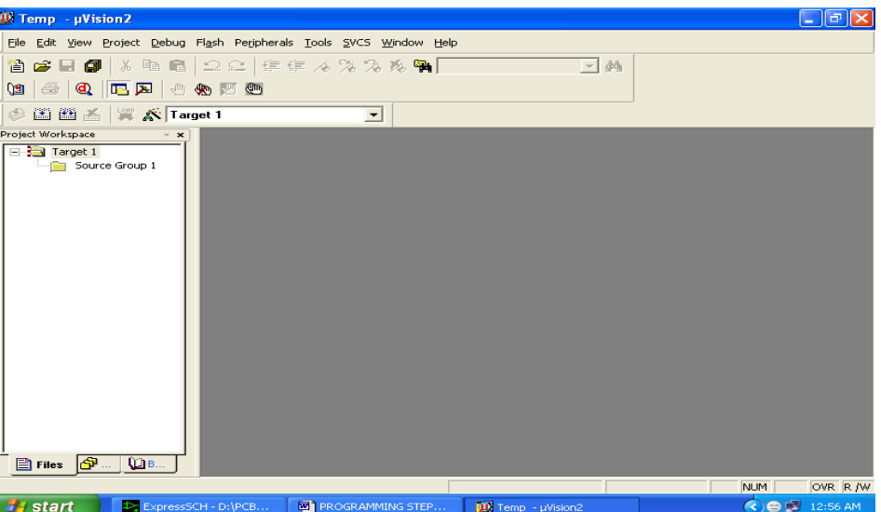

- Click on the file option from menu bar and select “new”

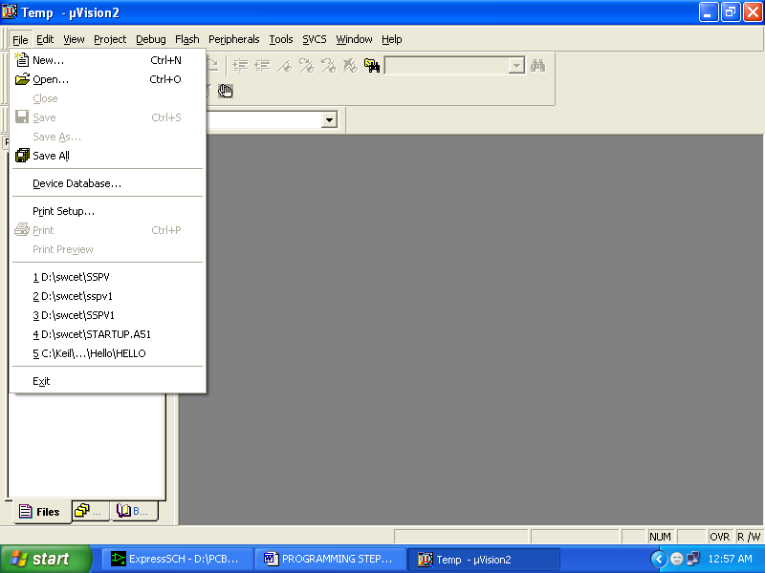

- The next screen will be as shown in next page, and just maximize it by double clicking on its blue boarder.
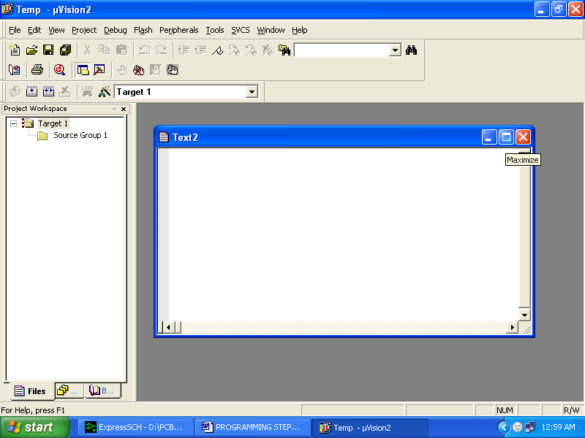

- Now start writing program in either in “C” or “ASM”
- For a program written in Assembly, then save it with extension “. asm” and for “C” based program save it with extension “ .C”

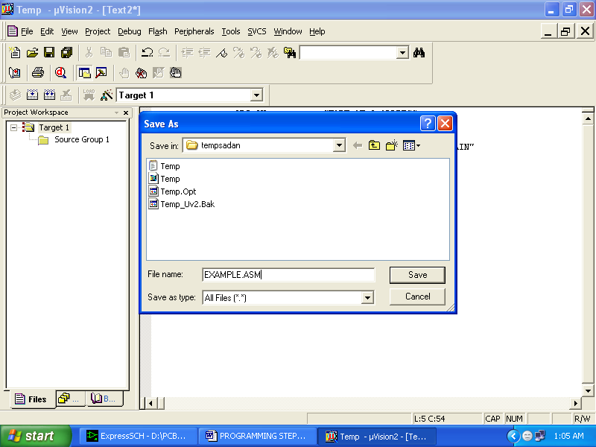

Now right click on Source group 1 and click on “Add files to Group Source”

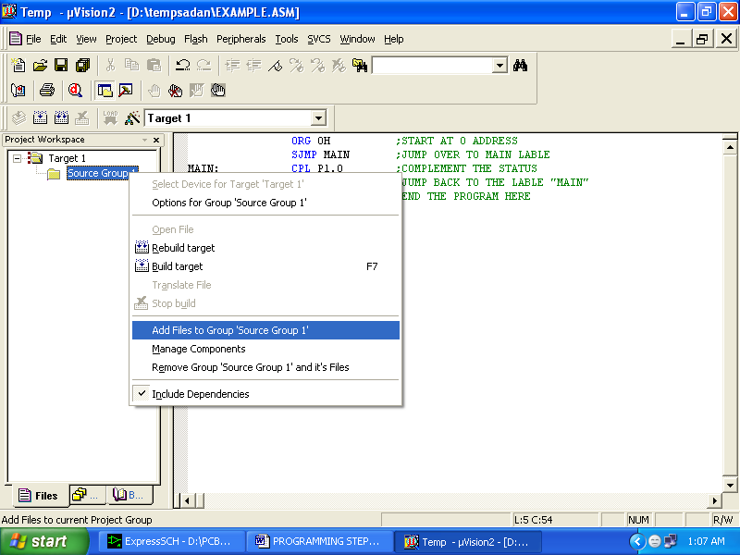

- Now you will get another window, on which by default “C” files will appear.

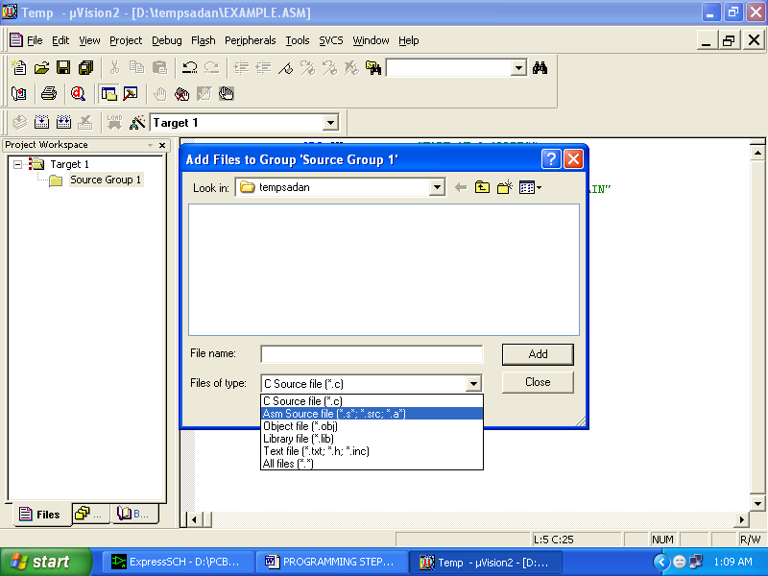

- Now select as per your file extension given while saving the file
- Click only one time on option “ADD”
- Now Press function key F7 to compile. Any error will appear if so happen.

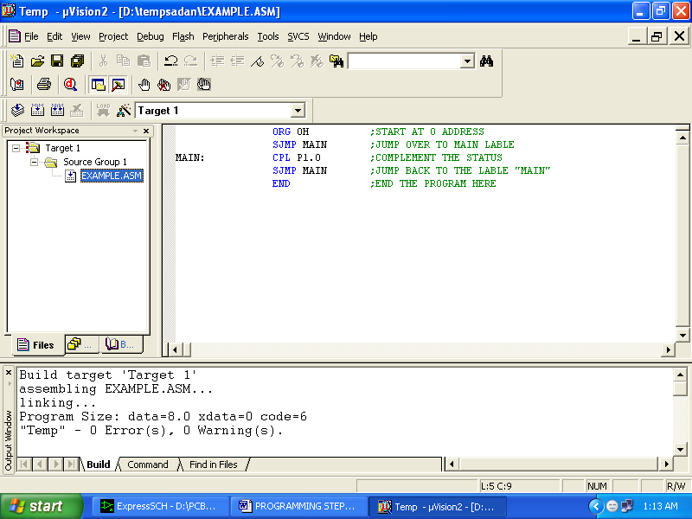

- If the file contains no error, then press Control+F5 simultaneously.
- The new window is as follows

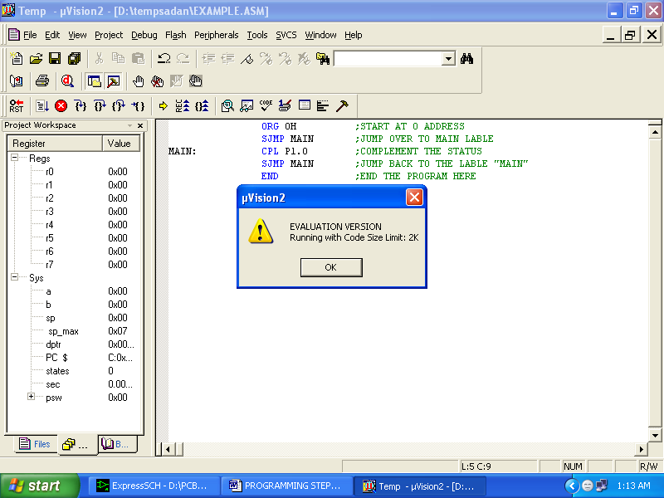

- Then Click “OK”
- Now Click on the Peripherals from menu bar, and check your required port as shown in fig below
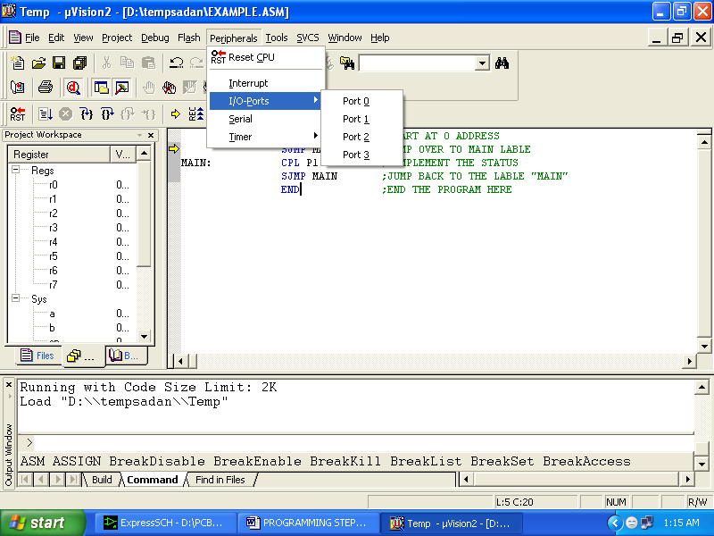

- Drag the port a side and click in the program file.

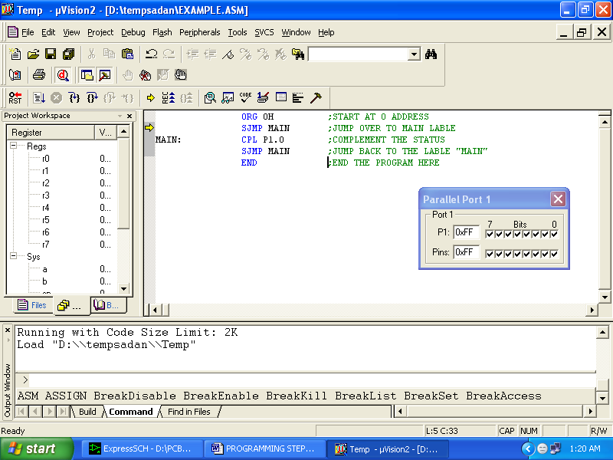

- Now keep Pressing function key “F11” slowly and observe.
- You are running your program successfully

6.Flow Chart

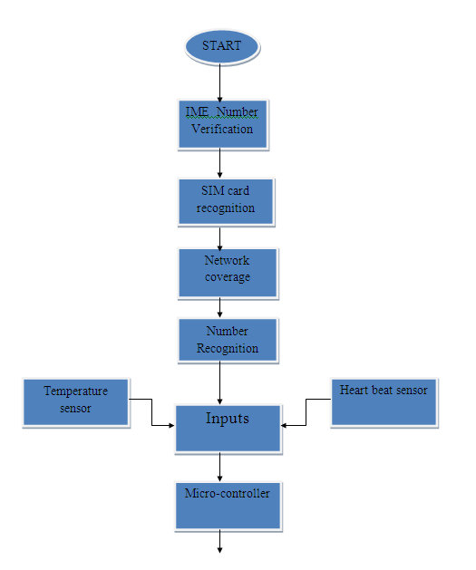
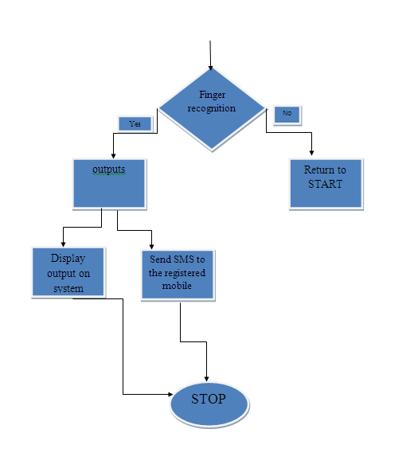

.

7.Conclusion and Future Scope

The project “Patient Monitoring System and Data Acquisition Through GSM ” has been successfully designed and tested

It has been developed by integrating features of all the hardware components used. Presence of every module has been reasoned out and placed carefully thus contributing to the best working of the unit.

Secondly, using highly advanced IC’s and with the help of growing technology the project has been successfully implemented.

The Whole health monitoring system,which we have proposed can be integrated into a small compact unit as small as a cell phone or a wrist watch.This will help the patients to easily carry this device with them wherever they go.The VLSI technologies will greatly come handy in this regard.

8.Bibliography

The 8051 Micro controller and Embedded Systems
- Janice Gillispie Mazidi
-Muhammad Ali Mazidi
The 8051 Micro controller Architecture, Programming & Applications
-Kenneth J.Ayala
Electronic Components
-D.V.Prasad
Fundamentals of Micro processors and Micro computers
-B.Ram
Micro processor Architecture, Programming & Applications
-Ramesh S.Gaonkar
Wireless Communications
-Theodore S. Rappaport
Mobile Tele Communications
-William C.Y. Lee

References on the Web:
[1]Analog Temperature Sensors. www.national.com
[2]89S52 Architecture. www.microsoftsearch.com
[3]modems. www.howstuffworks.com
[4].Current GSM Constellations http://tycho.usno.navy.mil/gsmcurr.html

