Name :vaghasiya Jasmin p.

Enrollment no :250203020053

Subject :environment science
Class :mca-sem2

Case Study: Urban Heat Island Effect in India

1. Introduction
ᴥ Urbanisation is one of the fastest-growing global trends, especially in developing countries like India.
ᴥ The Urban Heat Island (UHI) Effect refers to the phenomenon where urban regions experience higher temperatures than surrounding rural areas.
ᴥ This temperature difference arises due to replacement of natural vegetation with artificial structures such as buildings, roads, and parking areas.
ᴥ Rapid population growth, industrialisation, and increased energy consumption have intensified this effect.
ᴥ Indian cities such as Delhi, Mumbai, Ahmedabad, Chennai, and Hyderabad frequently experience severe heat waves.
ᴥ Climate change further amplifies the Urban Heat Island Effect by raising overall background temperatures.
ᴥ This case study explores scientific mechanisms, causes, case studies, impacts, mitigation strategies, policy frameworks, and future outlook.

2. Scientific Mechanism of Urban Heat Island
ᴥ Natural land surfaces cool the atmosphere through shading and evapotranspiration.
ᴥ Urban materials like asphalt and concrete have low albedo, meaning they absorb more sunlight instead of reflecting it.
ᴥ These materials store heat during the day and slowly release it at night, preventing cooling.
ᴥ Tall buildings create “urban canyons” that trap heat and reduce airflow.
ᴥ Vehicles and air conditioners release anthropogenic (human-generated) heat.
ᴥ Reduced vegetation decreases carbon dioxide absorption and oxygen production.
ᴥ Temperature differences between urban and rural areas typically range from 2°C to 8°C.

3. Major Causes of Urban Heat Island Effect

3.1 Deforestation and Loss of Green Spaces
Urban expansion reduces parks, forests, and wetlands that naturally cool the environment.

3.2 Impervious Surfaces
Concrete roads and pavements prevent water absorption and increase heat retention.

3.3 High Energy Consumption
Extensive use of air conditioning releases additional heat into the atmosphere.

3.4 Transportation Emissions
Large numbers of vehicles contribute to greenhouse gases and direct heat emission.

3.5 Industrial Activities
Factories release thermal energy and pollutants that trap heat.

3.6 Population Density
Dense population leads to higher electricity use and waste heat generation.

4. Case Example: Urban Heat in Ahmedabad
ᴥ Ahmedabad has experienced repeated extreme heat waves over the past decade.
ᴥ Temperatures have crossed 45°C during peak summer months.
ᴥ Rapid infrastructure development has reduced green cover significantly.
ᴥ Vulnerable communities such as outdoor laborers face severe health risks.
ᴥ In response, Ahmedabad Municipal Corporation launched India’s first Heat Action Plan in 2013.
ᴥ This plan includes early warning systems, public awareness campaigns, and emergency medical response.

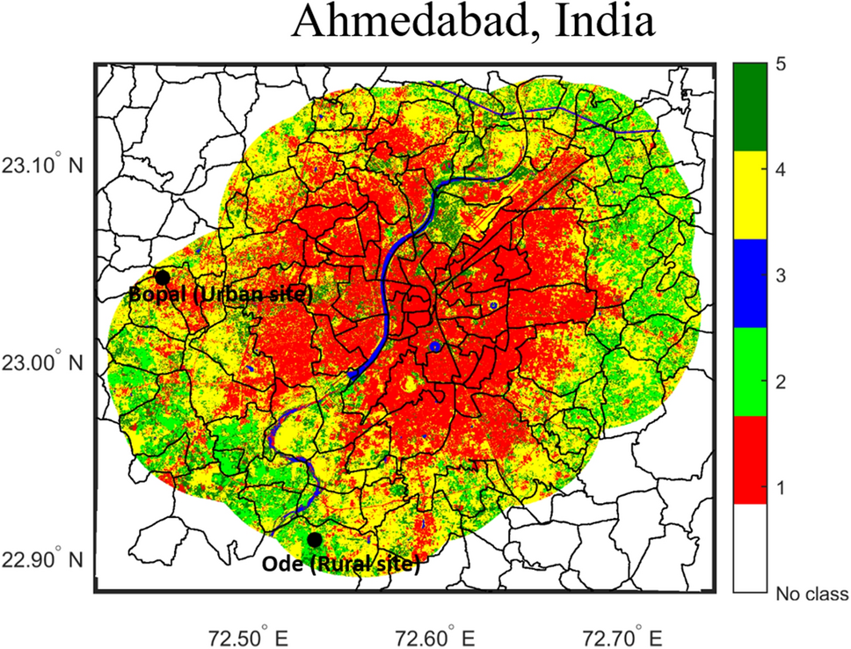

What the Map Shows

1.Color Scale (Right Side Legend)
The vertical color bar shows temperature intensity levels:
- Red (Class 1) → Very High Heat (Hot zones)
- Yellow (Class 4) → Moderate heat
- Green (Class 5) → Cooler areas
- Blue (Class 3) → Water bodies (very cool zones)
- No class → Outside study area
Red areas are the hottest parts of the city.
Green areas are cooler parts.

Heat Distribution Pattern

Central Ahmedabad (Urban Core)
- The middle part of the city is mostly red.
- This shows very high temperatures.
- These areas have:
  - Dense buildings
  - Concrete roads
  - Heavy traffic
  - Less green cover
This is the Urban Heat Island effect — city center is hotter than surrounding areas.

Outer Areas (Peripheral Zones)
- The outer areas are mostly green and yellow.
- These areas have:
  - More open land
  - Agricultural fields
  - Trees
  - Less construction
So they remain cooler.

Blue Curved Line (River)
The blue curved line in the middle represents the Sabarmati River.
Water bodies help:
- Reduce temperature
- Provide cooling effect
- Increase humidity
That’s why areas near the river are slightly cooler.

Marked Locations
- Bopal (Urban Site) → Represents developed urban region (hot zone).
- Ode (Rural Site) → Represents rural area (cooler zone).
This comparison clearly shows:
Urban area = Higher temperature
Rural area = Lower temperature

What This Image Proves
✔ Ahmedabad city center is significantly hotter than rural surroundings.
✔ Rapid urban development increases surface temperature.
✔ Lack of green spaces contributes to heat rise.
✔ Water bodies reduce temperature locally.

Conclusion from Image
This map clearly demonstrates the Urban Heat Island Effect in Ahmedabad:
- Dense built-up areas = High heat (Red zones)
- Vegetated & rural areas = Cooler (Green zones)
- River areas = Lowest temperature
It visually proves how urbanization increases city temperature compared to nearby rural regions.

1: Ahmedabad Earlier (Open Spaces & Vegetation)

2: Ahmedabad Now (Urban Expansion & Increased Heat)
ᴥ Satellite imagery shows a noticeable rise in land surface temperature over time.
ᴥ Electricity demand has increased due to heavy reliance on cooling systems.

5. Impacts of Urban Heat Island Effect

5.1 Health Impacts
Heat exhaustion and heat stroke.
Respiratory and cardiovascular stress.
Increased mortality during extreme heat waves.

5.2 Environmental Impacts
Increased ground-level ozone formation.
Stress on urban water bodies.
Loss of biodiversity.

5.3 Social Impacts
Low-income communities are disproportionately affected.
Increased inequality in access to cooling facilities.

5.4 Economic Impacts
Higher electricity consumption and bills.
Reduced outdoor labor productivity.
Infrastructure damage due to thermal expansion.

6. Government Initiatives
ᴥ National Disaster Management Authority issued national guidelines for heat wave management.
ᴥ Smart Cities Mission promotes sustainable urban development.
ᴥ Cool Roof programs in several Indian cities.
ᴥ Urban afforestation and green corridor development projects.

7. Technological and Urban Planning Strategies
ᴥ Use of reflective roofing materials.
ᴥ Development of vertical gardens and green walls.
ᴥ Adoption of permeable pavements.
ᴥ Integration of renewable energy sources.
ᴥ Climate-sensitive urban design and zoning regulations.

8. Challenges
ᴥ Rapid urban migration.
ᴥ Limited financial resources for green infrastructure.
ᴥ Weak enforcement of environmental planning norms.
ᴥ Increasing climate variability.
ᴥ Lack of long-term climate adaptation planning.

9. Comparative Analysis: Rural vs Urban Temperature
Factor | Rural Area | Urban Area
Vegetation | High | Low
Surface Material | Soil & plants | Concrete & asphalt
Night Cooling | Fast | Slow
Air Circulation | Better | Restricted
Temperature | Lower | Higher

10. Future Outlook
ᴥ Urban heat islands are expected to intensify with continued urban growth.
ᴥ Climate-resilient infrastructure will become essential.
ᴥ Cities may need heat-resistant building materials and smart temperature monitoring systems.
ᴥ Long-term sustainability planning will be critical for public health protection.

11. Conclusion
The Urban Heat Island Effect is a growing environmental challenge in India. Rapid urbanisation, loss of vegetation, and increased energy consumption have significantly raised urban temperatures.
Integrated urban planning, green infrastructure, public awareness, and climate adaptation policies are necessary to reduce heat stress and ensure sustainable city development.
Without immediate intervention, the Urban Heat Island Effect may worsen public health risks and environmental degradation in the coming decades.

