**Project – 2**

**Instagram User Analytics**

**Project Description**

The aim of this project is to analyze Instagram user engagement and take insights through which we will be able to take informed decisions about future directions of Instagram. By using MySQL workbench and SQL queries we will be able to handle tasks and answer key questions.

**Approach**

* First loaded the provided dataset into MySQL workbench.
* Then reviewed the table schema and the keys associated to it to understand the relationship between each table and columns.
* Further we analyzed the problem statement given and wrote SQL queries for each task and repeated the process of writing the SQL queries until we found an accurate answer.
* Verified accuracy of queries by validating results against expected patterns.

**Tech-Stack Used**

* Used MySQL workbench Version 8.0.41.0.
* Choose MySQL workbench as it can be used for database setup, querying, and performing commands for filtering, aggregating and joining data to have insights.

**Insights**

1. **Marketing Analysis:**
2. Loyal User Reward

We found 5 most loyal users by accessing users table and arranging them in ascending order and by printing the 5 users who have made account first from the given dataset.

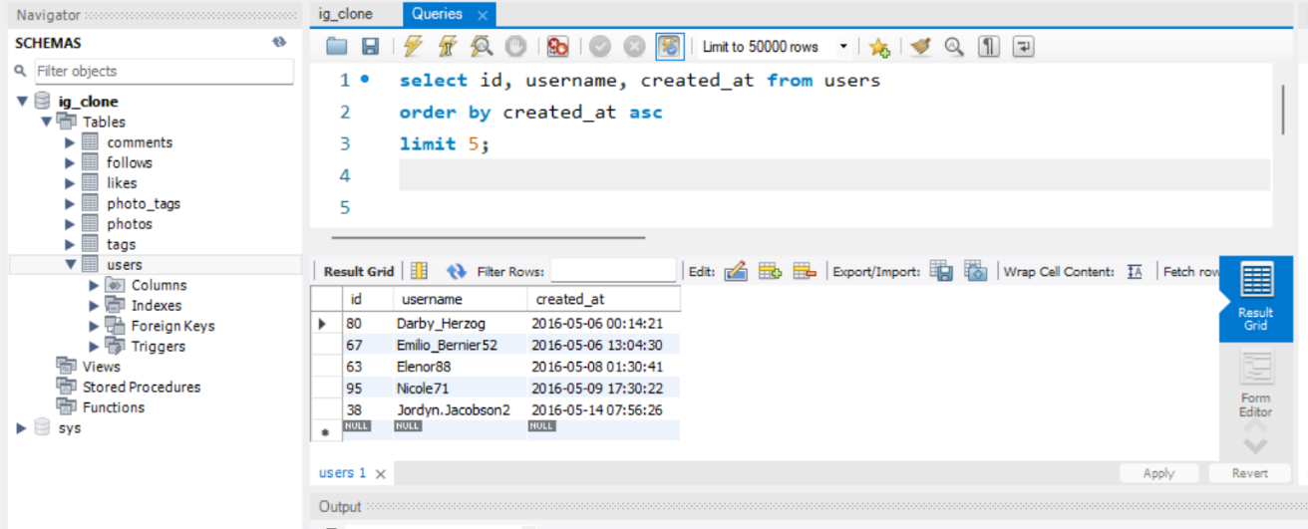

Insight- we found most loyal users by finding who has been using the Instagram for the longest time and found 5 oldest users on Instagram which are given above in output table.

1. Inactive User Engagement

We found inactive user by finding who have not posted any photo. We found it from photos table where we searched which user id was not present.

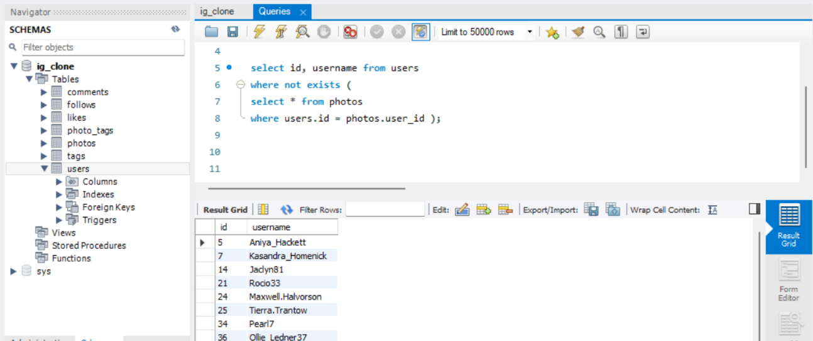

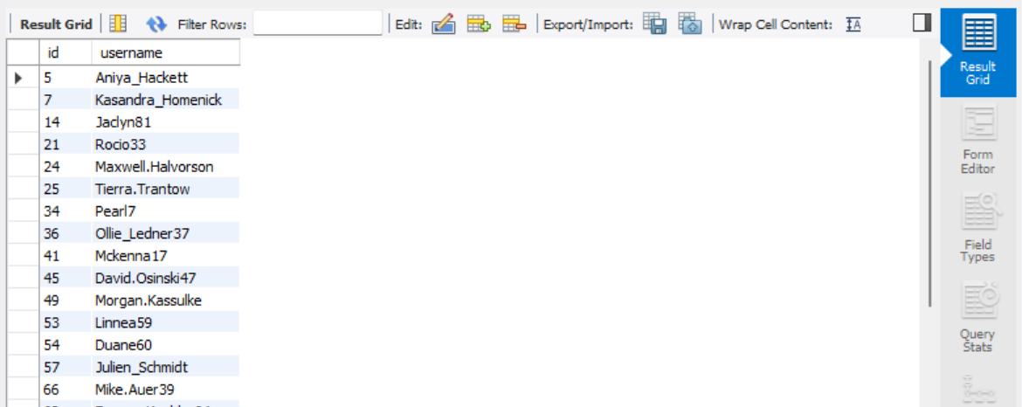

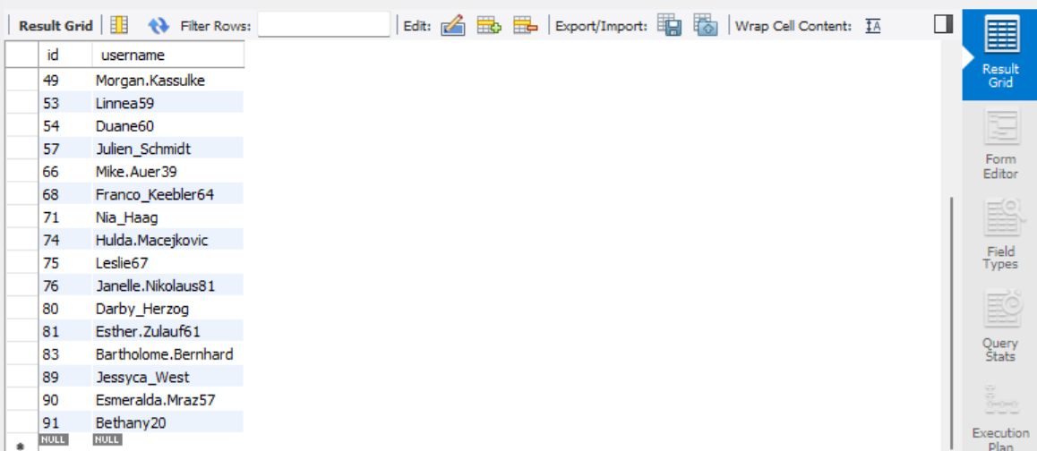

Insight - list of users who have never posted a single photo on Instagram this helps team to encourage inactive users to start engaging. The list is given above in the output table.

1. Contest Winner Declaration

We found contest winner by finding the most liked photo from likes table and joining it with photos table that gives as number of likes per photo and then we return the details of user with most liked photos from users table.

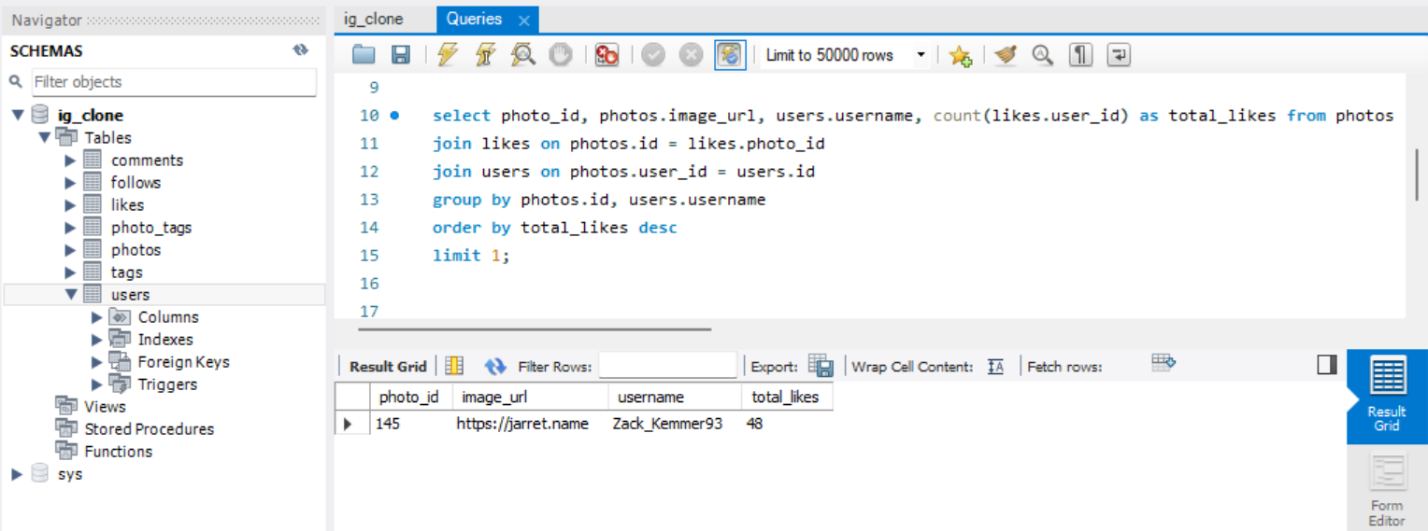

Insight - found the person who has most likes on the post and identified the details about them. The person is Zack having username Zack_Kemmer93 and he has 48 likes.

1. Hashtag Research

We found five most commonly used photo by accessing photo_tags table where we counted count tags by photo_id from photo_tags table and then ordering it in descending order and finding the top 5 hashtags.

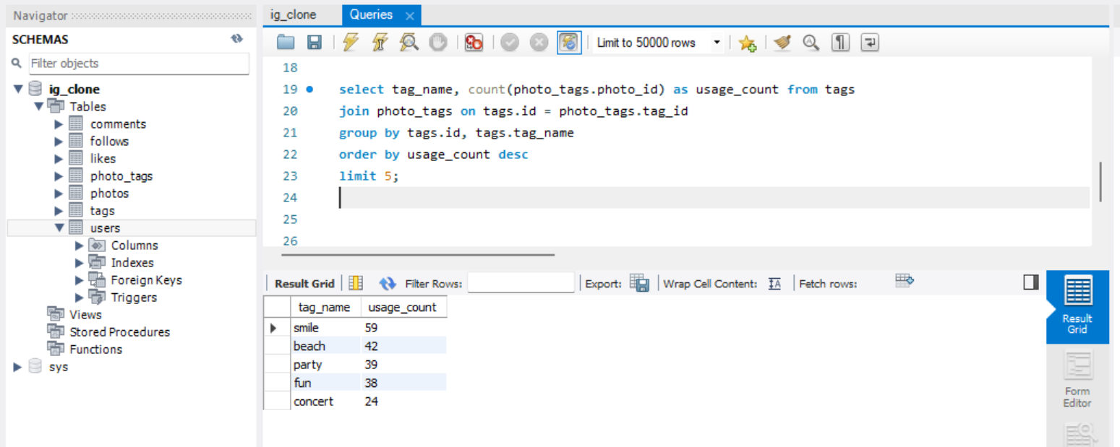

Insight - identified five most used hashtags. This will help the users to maximize their reach on post by using most used hashtags. The hashtags are smile, beach, party, fun and concert.

1. Ad Campaign Launch

We found most users registration from users table where we counted the created_at which is day at which a user created account and then arrange it in descending order and got two most registered days.

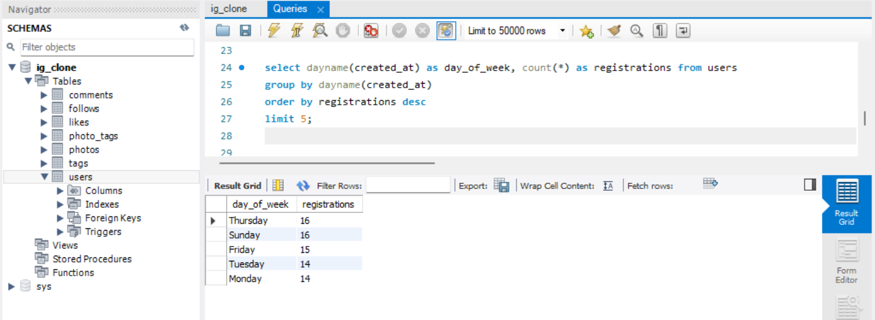

Insight - found the day on which the maximum registration was received which will help the team to schedule ad campaign. The days are Thursday and Sunday.

1. **Investor Metrics:**
2. User Engagement

We found average number of posts per user by finding the count of total photos divided by count of total number of users.

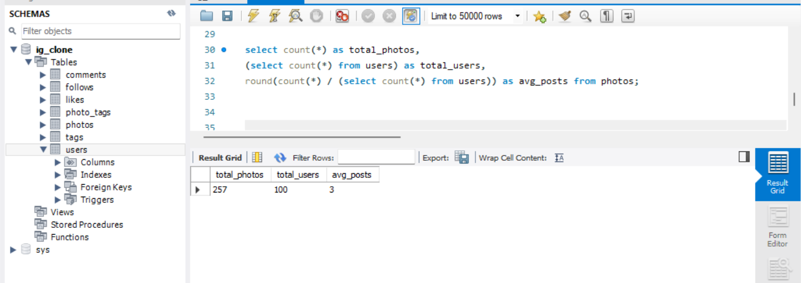

Insight –found average number of posts on Instagram which is 3.

1. Bots & Fake Accounts

We found dummy and fake accounts by finding out the user who has liked every single photo we did it by joining user and likes table and counted number of likes per user and compared it with total number of photos and the accounts which were equal are printed.

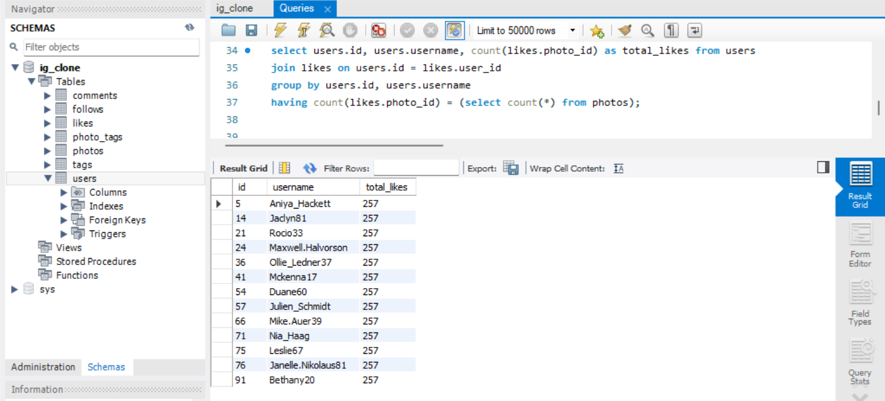

Insight – we found user who have liked every post on the site this helps us to understand that the platform is crowded with 13 fake and dummy accounts.

Conclusion Insight

Found that most users who have not posted photos are dummy and fake users.

**Result**

Through this project we discovered user engagement patterns and behavior which helped us to understand the marketing and investor goals for future Instagram growth. It helped to gain deeper knowledge to analyze the situation and gain more knowledge in SQL querying and relational database.