**Project – 3**

**Hiring Process Analytics**

**Project Description**

This project aims to analyse the hiring process within an organization. Here in this project we have analysed gender distribution, salary analyses, salary distribution understanding, department properties visualization and position tier distribution visualization. In conclusion we have gained insights into company’s salary structure and hiring trends using excel as data analytics tool.

**Approach**

* Dataset was downloaded and imported into Microsoft excel
* Ensured dataset was clean and free of missing values
* Then we started with analysis using pivot tables and its function.
* For gender distribution we used pivot tables to count and compare the number of females and males hired.
* For salary analysis we calculated average salary using pivot tables.
* Then for salary distribution we used if function to first form salary range column and then by using pivot table we calculated the salary distribution.
* Then we analysed proportion of employees in different departments using pivot graphs and we plot the pie chart to show the distribution.
* To show the position tier analysis we used pivot graph to the position across different tiers using bar graph.

**Tech-Stack Used**

Microsoft® Word 2019 MSO (Version 2501 Build 16.0.18429.20132) 64-bit for data analysis, pivot table creation and chart generation.

**Insights**

1. **Hiring Analysis**

Analysed proportion of males and females hired. Here 2675 female and 4085 males are hired revealing the gender imbalances.

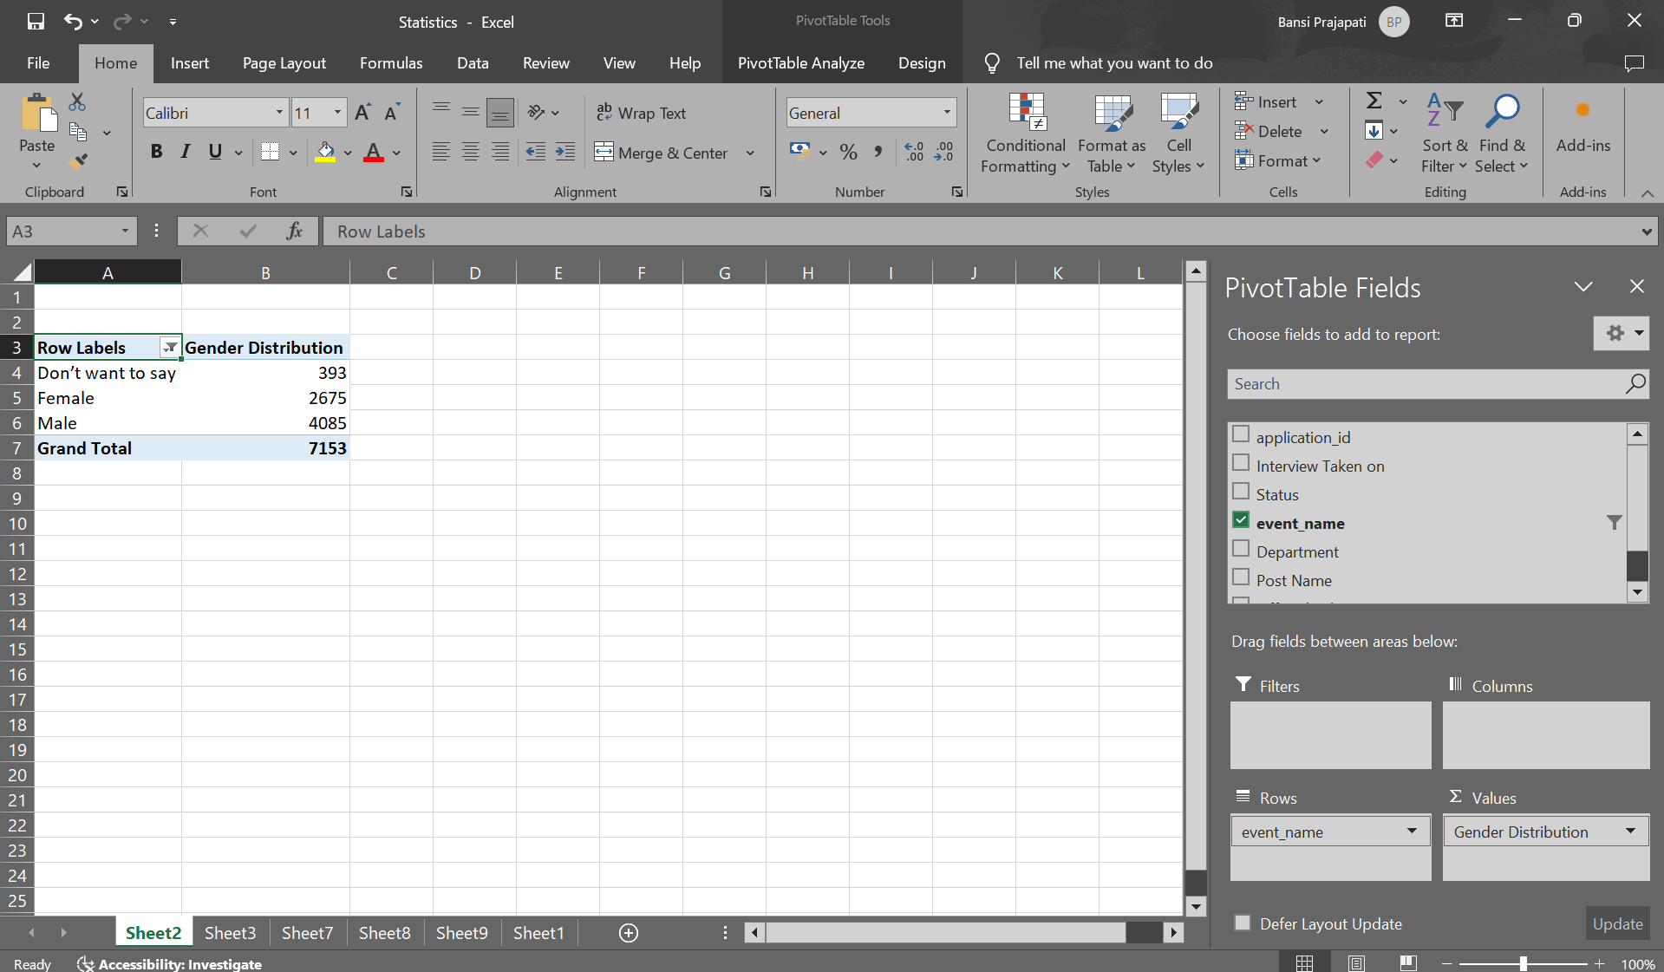

1. **Salary Analysis**

Average salary offered by the company is 49983/-.

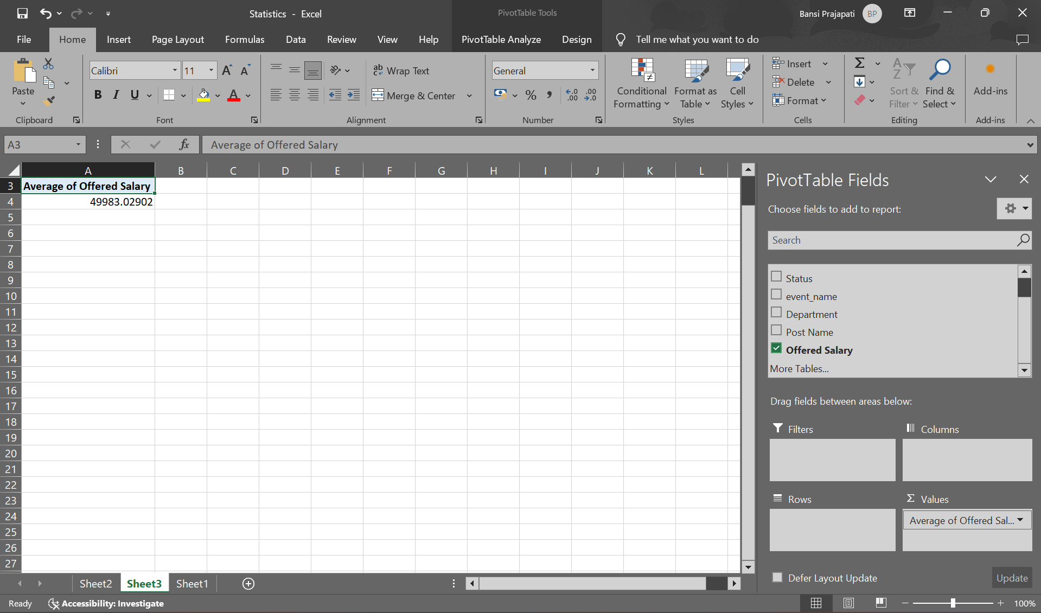

1. **Salary Distribution**

Visualized how salaries are distributed across different intervals. Here most people have salaries between 40,000-50,000. Which also tells that it is average salary among the company.

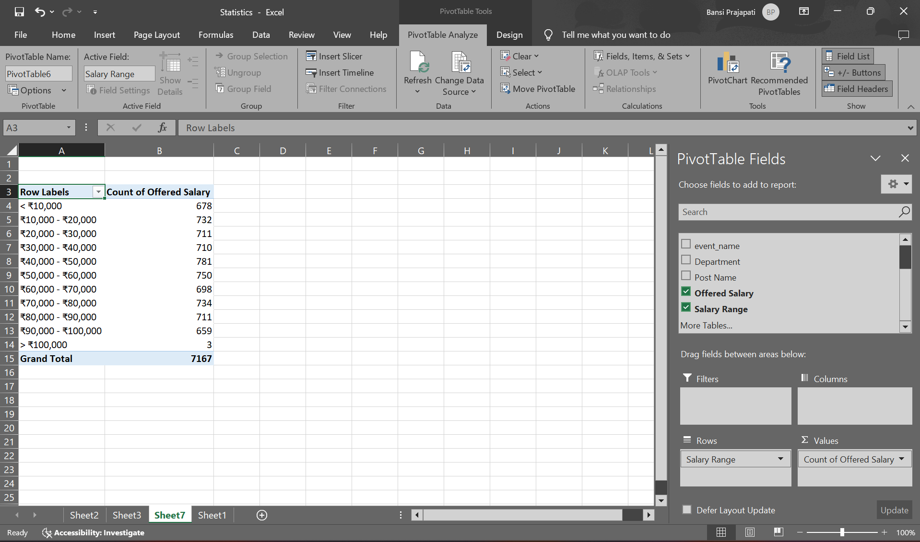

1. **Departmental Analysis**

Identified that operation department has most employees and human resource department has least number of employees.

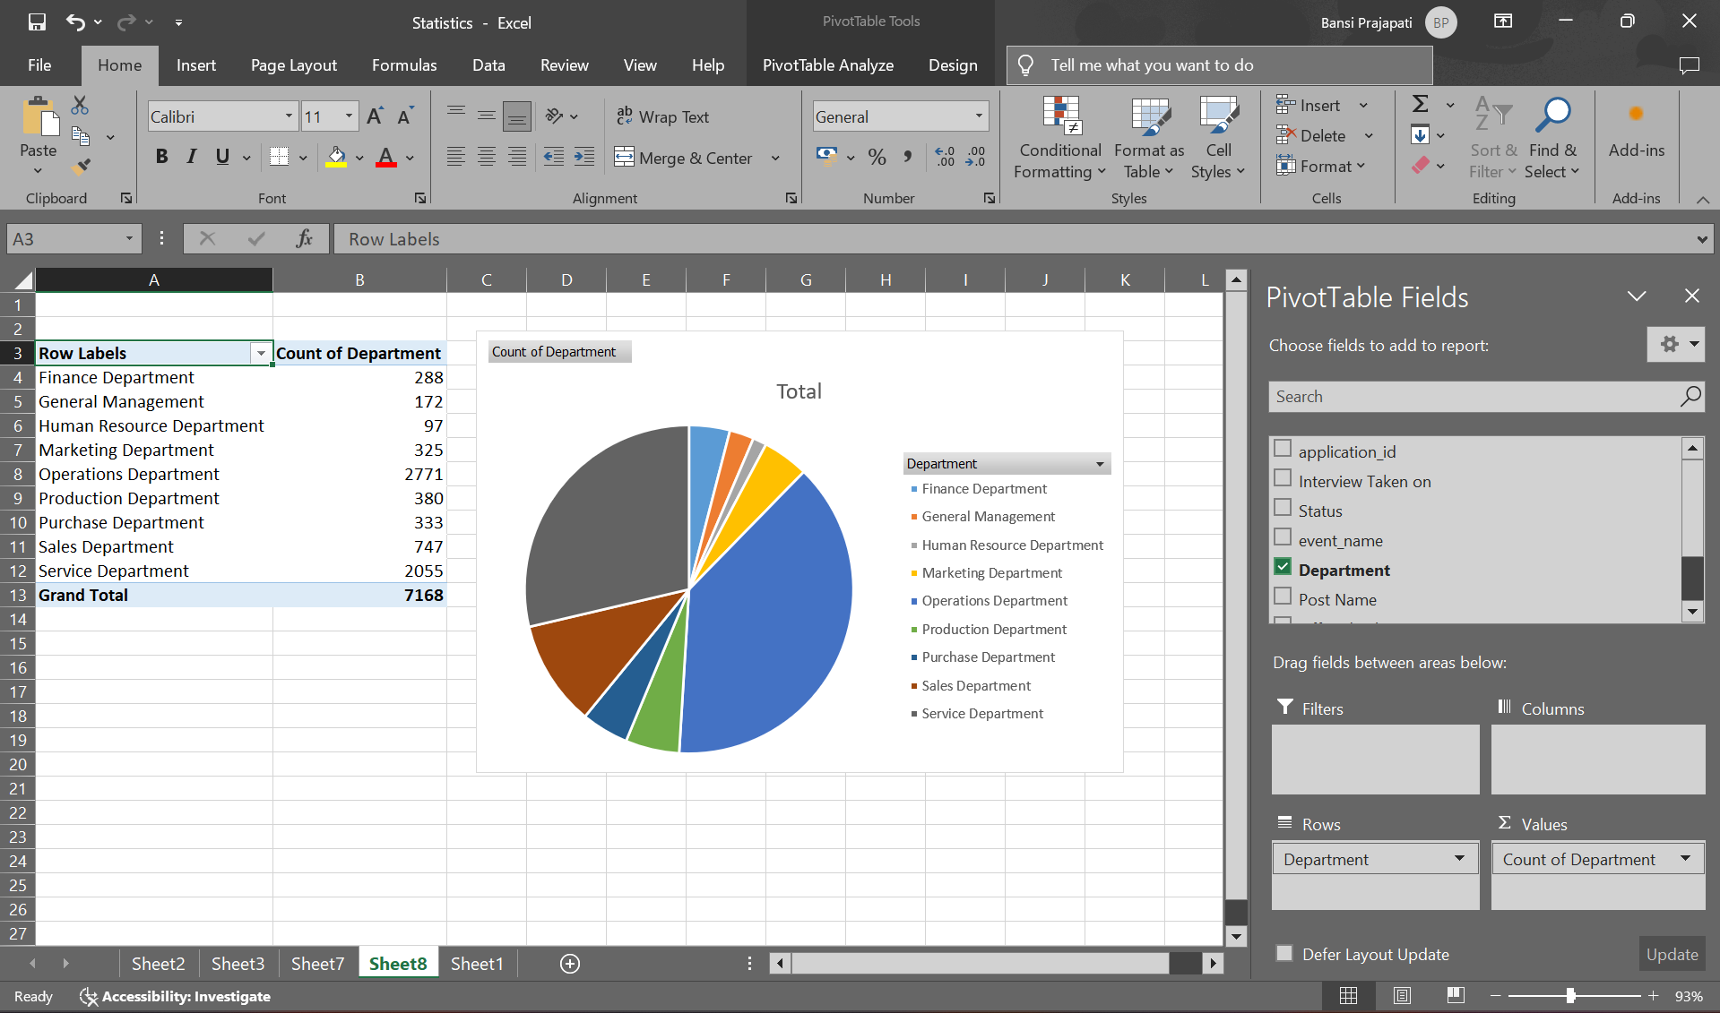

1. **Position Tier Analysis**

Examined distribution of positions among the various tiers and it shows that c9 has most positions in company’s hierarchical structure.

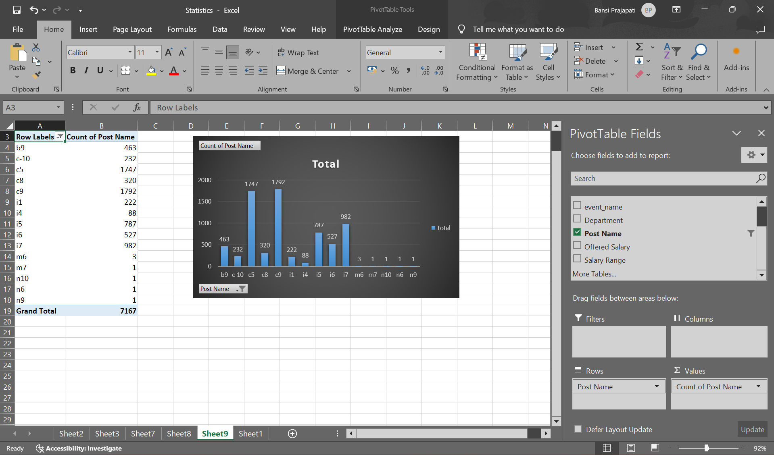

**Result**

In this project we were able to derive key trends and patterns in salary structure, gender distribution and departmental composition. This insights help HR and management team to take an informed decisions regarding the salary adjustments, hiring practices and departmental resource allocation. Hence project helps to provide comprehensive understanding of hiring process within organization.

**Drive link of Excel Sheet**

Refer sheet 2, 3, 7, 8, 9 for the answers.

[**https://docs.google.com/spreadsheets/d/17NBk8-FEd5TLBjCX0QkAX5PN4gKKA-jf/edit?usp=sharing&ouid=109001208060904860088&rtpof=true&sd=true**](https://docs.google.com/spreadsheets/d/17NBk8-FEd5TLBjCX0QkAX5PN4gKKA-jf/edit?usp=sharing&ouid=109001208060904860088&rtpof=true&sd=true)