**Project – 7**

**Analyzing the Impact of Car Features on Price and Profitability**

**Project Description**

This project aims to analyse the relationship between a car's features, market category, and pricing, and identifying which features and categories are most popular among consumers and most profitable for the manufacturer. By using data analysis techniques such as regression analysis and market segmentation, the manufacturer could develop a pricing strategy that balances consumer demand with profitability, and identify which product features to focus on in future product development efforts. This could help the manufacturer improve its competitiveness in the market and increase its profitability over time.

**Approach**

* First I have cleaned the data to ensure accurate results. I observed that columns having null values where Engine HP, Engine fuel type, Engine cylinders, Market Category and Number of doors.
* Engine fuel type had three blank cells so we filled it with ‘regular unleaded’.
* Then we removed the null value rows from Engine HP, Engine cylinders and Number of doors.
* Then for better visualization and understanding we converted MSRP into $ currency.
* Afterwards using pivot table, regression analysis and different types of charts such as bar chart, scatter chart, bubble chart, stacked bar chart, line chart and combo chart we have explored the relationships between different features.
* This helped us to build an interactive dashboard which shows the relationship between car features, market categories, popularity, fuel efficiency, manufacturers and engine power.

**Tech-Stack Used**

Microsoft® Word 2019 MSO (Version 2501 Build 16.0.18429.20132) 64-bit for data analysis, pivot table creation and chart generation.

**Insights**

**Tasks: Analysis**

**Insight Required:** How does the popularity of a car model vary across different market categories?

* **Task 1.A:** Create a pivot table that shows the number of car models in each market category and their corresponding popularity scores.

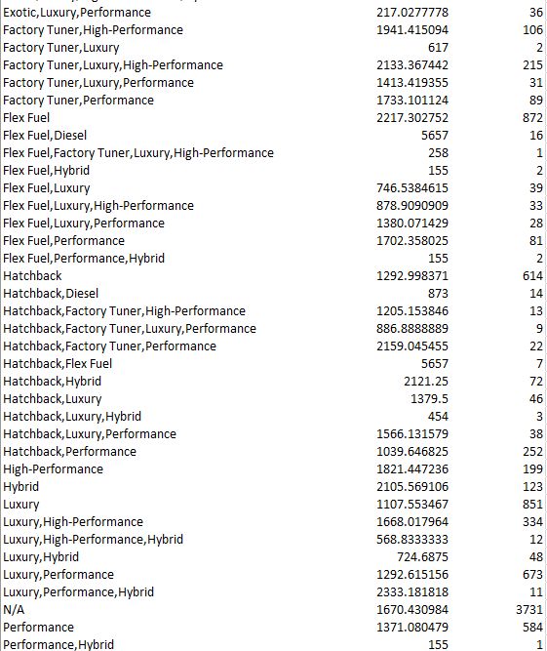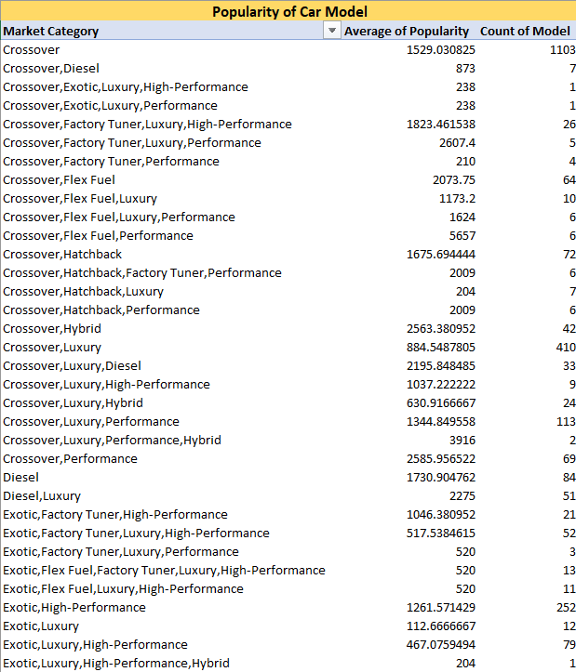

* 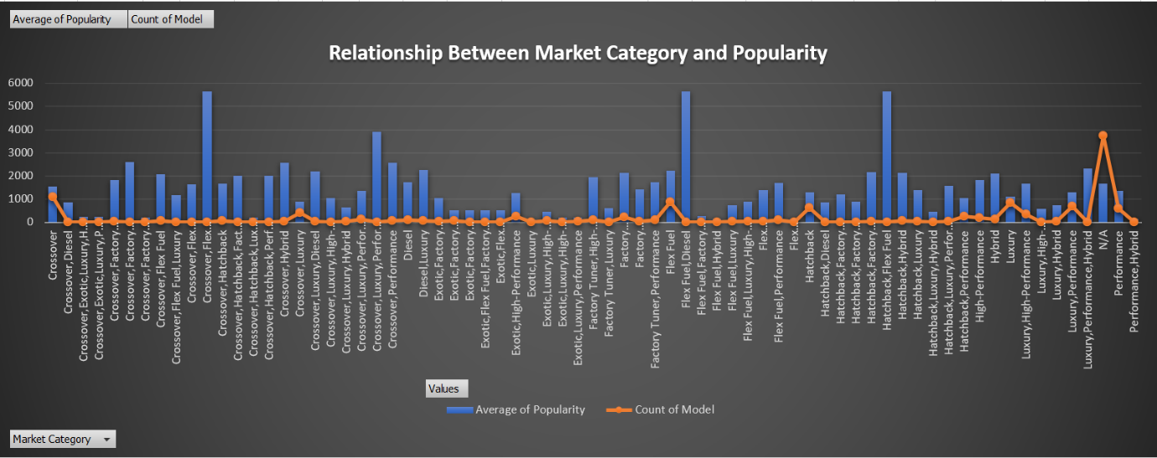**Task 1.B:** Create a combo chart that visualizes the relationship between market category and popularity.

**Insight:**

The popularity of car model varies across different market categories based on various factors. Here the most popular market categories for car models are Crossover, flex fuel, diesel, hatchback, and performance.

**Insight Required:** What is the relationship between a car's engine power and its price?

* **Task 2:** Create a scatter chart that plots engine power on the x-axis and price on the y-axis. Add a trendline to the chart to visualize the relationship between these variables.

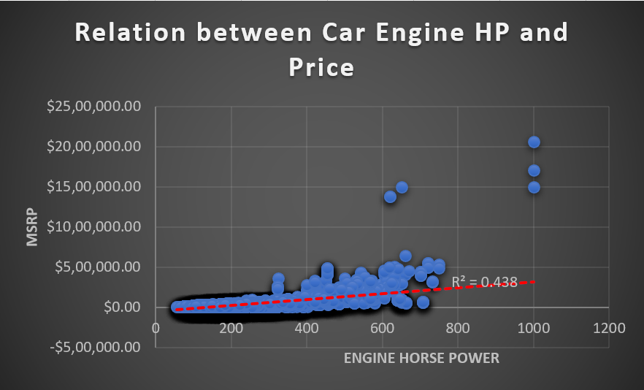

**Insight:**

We can observe the positive correlation between engine power and price, which means that as engine power increases the price of car tends to increase as well. This is because higher engine power requires more advanced technology and components which increases the cost of production.

**Insight Required:** Which car features are most important in determining a car's price?

* **Task 3:** Use regression analysis to identify the variables that have the strongest relationship with a car's price. Then create a bar chart that shows the coefficient values for each variable to visualize their relative importance.

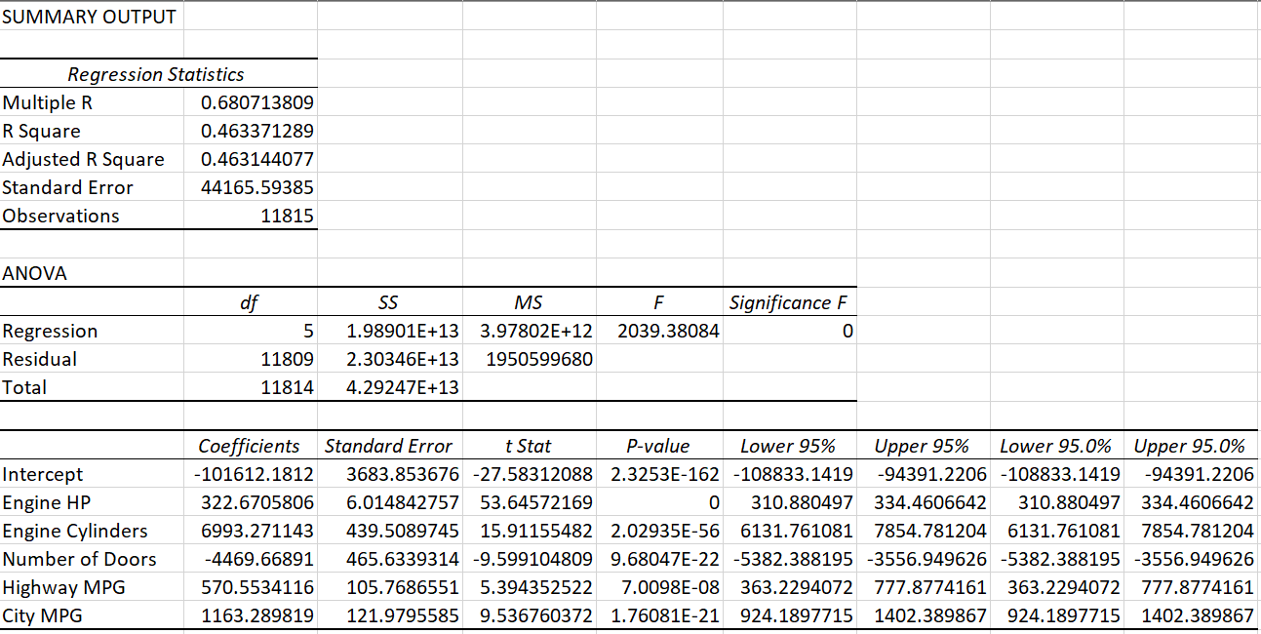

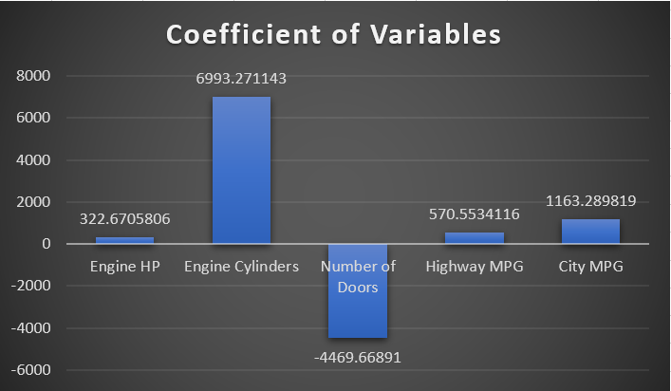

**Insight:**

We can observe that engine cylinders is the most important feature to determine the price of a car, then followed by City MPG and Highway MPG.

**Insight Required:** How does the average price of a car vary across different manufacturers?

* **Task 4.A:** Create a pivot table that shows the average price of cars for each manufacturer.

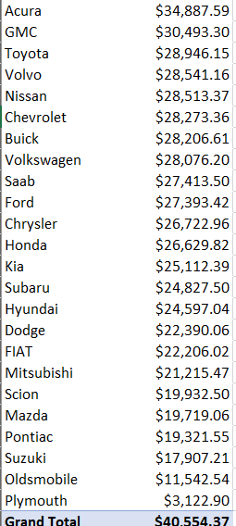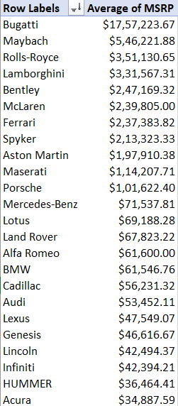

* **Task 4.B:** Create a bar chart or a horizontal stacked bar chart that visualizes the relationship between manufacturer and average price.

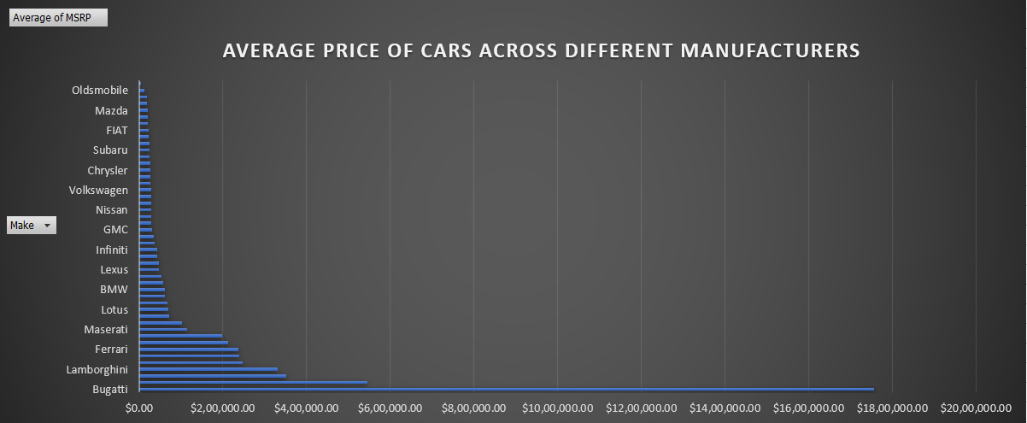

**Insight:**

Average price of a car depends on the manufacturers as they vary significantly, as each manufacturer has its own pricing strategy, market target, product offerings and brand positioning. Which contributes in variations in average prices. Here we can observe that Bugatti has highest average price and Oldsmobile has the lowest average price.

**Insight Required:** What is the relationship between fuel efficiency and the number of cylinders in a car's engine?

* **Task 5.A:** Create a scatter plot with the number of cylinders on the x-axis and highway MPG on the y-axis. Then create a trendline on the scatter plot to visually estimate the slope of the relationship and assess its significance.

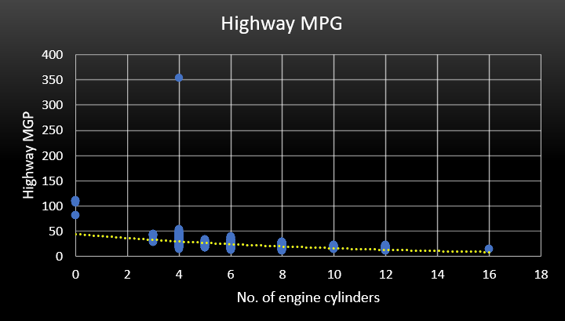

* **Task 5.B:** Calculate the correlation coefficient between the number of cylinders and highway MPG to quantify the strength and direction of the relationship.



=CORREL(A2:A11816,B2:B11816)

**Insight:**

It is observed that Number of Engine Cylinders increases and the Highway MPG decreases. So it shows that both of them have negative relationship.

The correlation coefficient between them is -0.62032 which also tells they have negative correlation which means as one will increase the other will decrease and vice versa.

**Building the Dashboard:**

**Task 1:** How does the distribution of car prices vary by brand and body style?

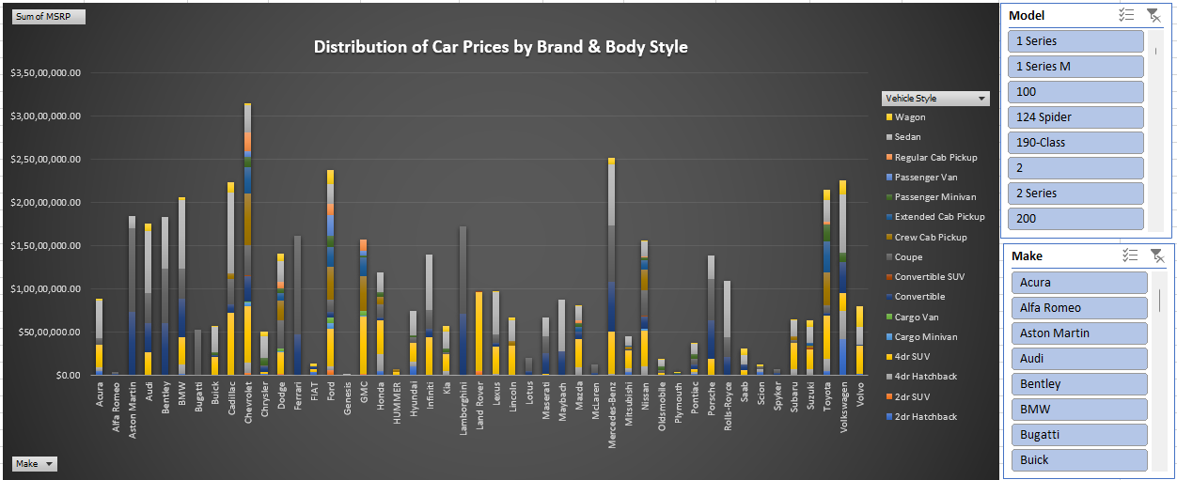

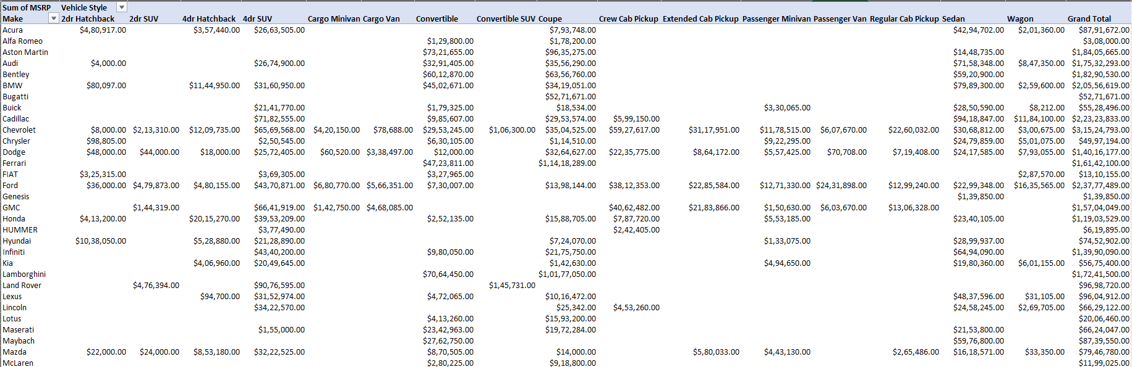

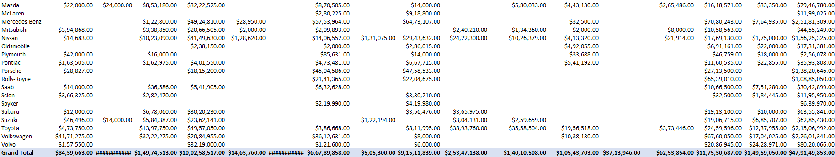

**Result:**

Chevrolet has the highest price distribution by body style. The price distribution of automobile by brand and body type depends on market trends such as:

* Pricing differs on the basis of target audience and brand positioning such as high end brands have premium feature and cutting edge technology which makes it higher at price point while cost effective brands focus on affordability.
* Pricing is also influenced and affected by the branding. The well known brands with reputation has quality products which are dependable due to which cost is higher.
* Body type of vehicle also influence the price point as the increased size and perceived prestige influence the prices at higher end.

**Task 2:** Which car brands have the highest and lowest average MSRPs, and how does this vary by body style?

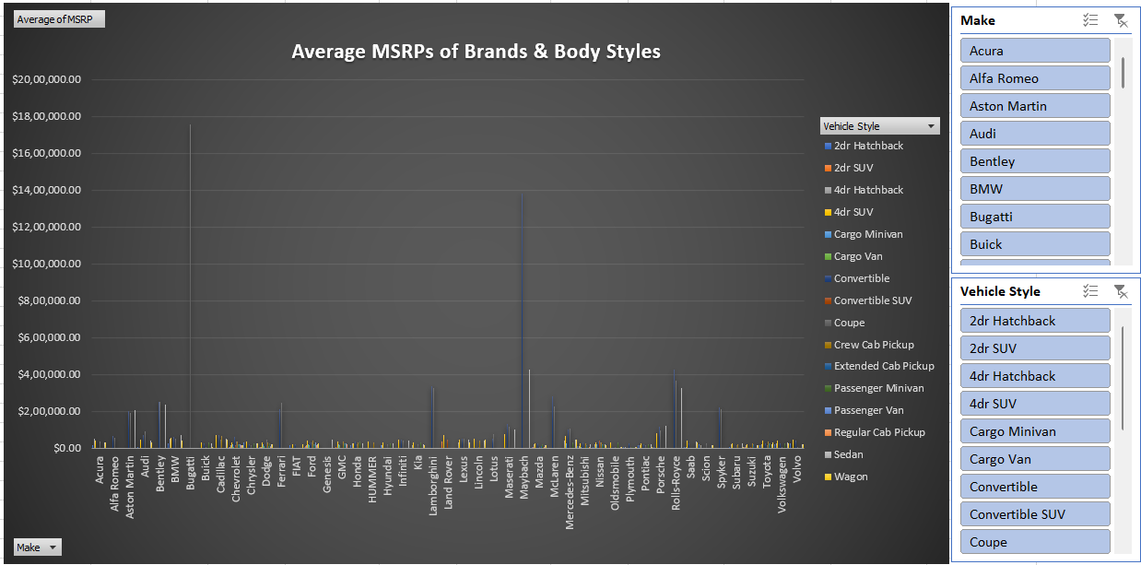

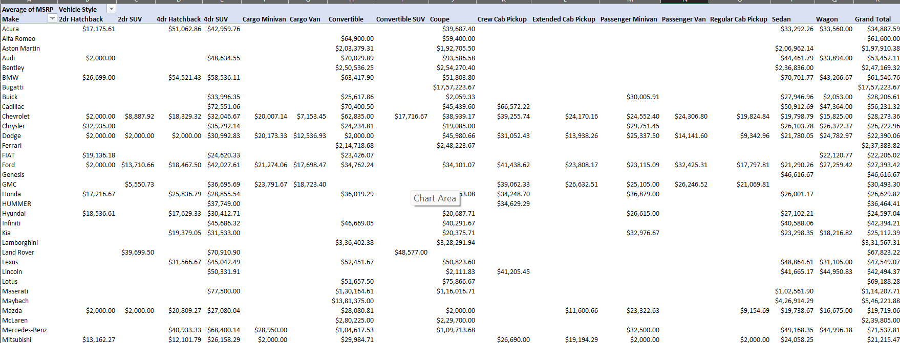

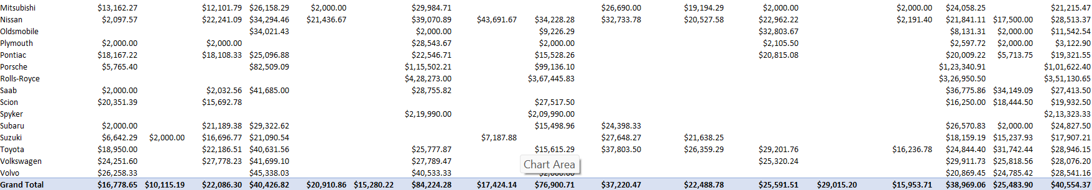

**Result:**

* Bugatti has highest average MSRP which suggests it as luxury brand. This luxury brands are known for its high end product with cutting edge technology.
* On the other hand Plymouth has lowest MSRP which tell it as a budget brand that offers reasonable prices depending on the model and body type.
* The tendencies of brand may be seen as which cars are frequently bought according to their model, material used, engine type and technology used.
* The mainstream companies provide variety of compact and midsize sedans and hatchbacks. This all cars seems to be more economical solution for daily use.

**Task 3:** How do the different feature such as transmission type affect the MSRP, and how does this vary by body style?

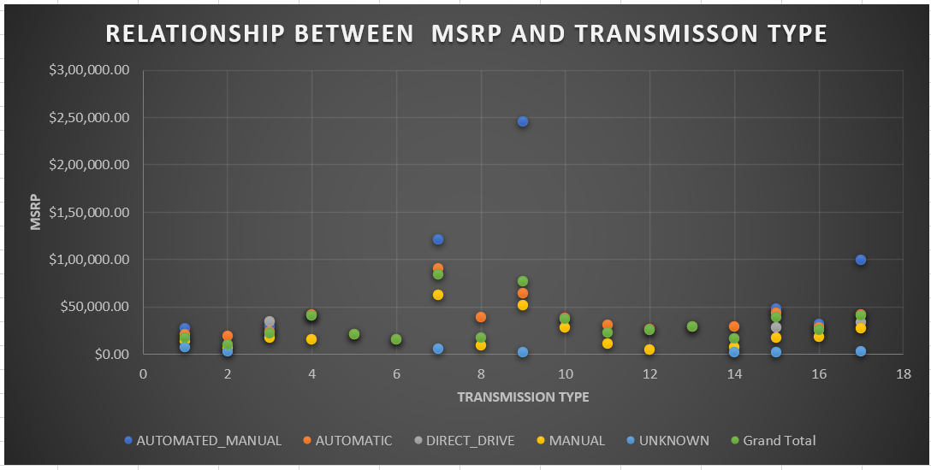

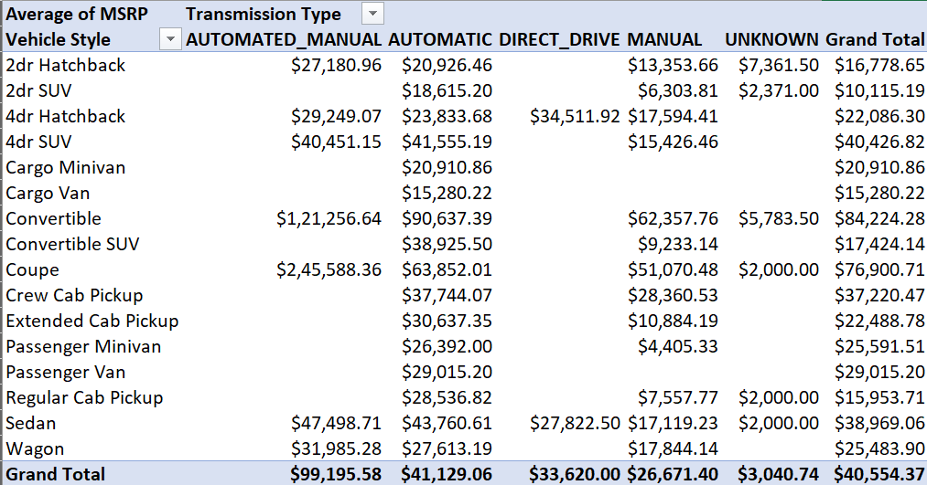

**Result:**

* The most expensive transmission is automated manual and also the automatic is one of the most popular transmission.
* The transmission type of a vehicle can vary also on body type of the vehicle such as for sedan cars they have higher trim levels and automatic transmission levels which generally offers comfortable driving options.
* Which suggests us that sedan having automatic transmission have expensive MSRP than equivalent model with manual transmissions.
* Generally the MSRP have an important feature which is transmission type. It varies according to the body style of a vehicle. As automated transmission provides more comfort and ease to use it has higher price than manual transmission.

**Task 4:** How does the fuel efficiency of cars vary across different body styles and model years?

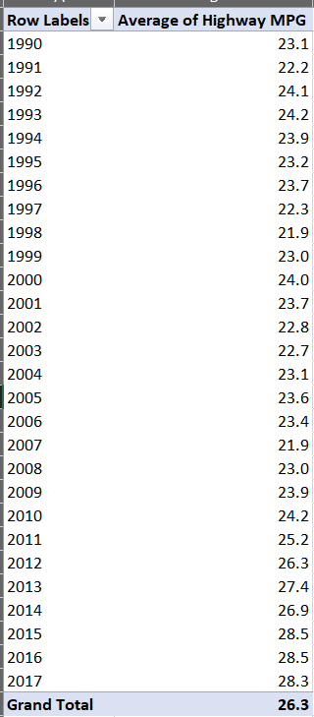

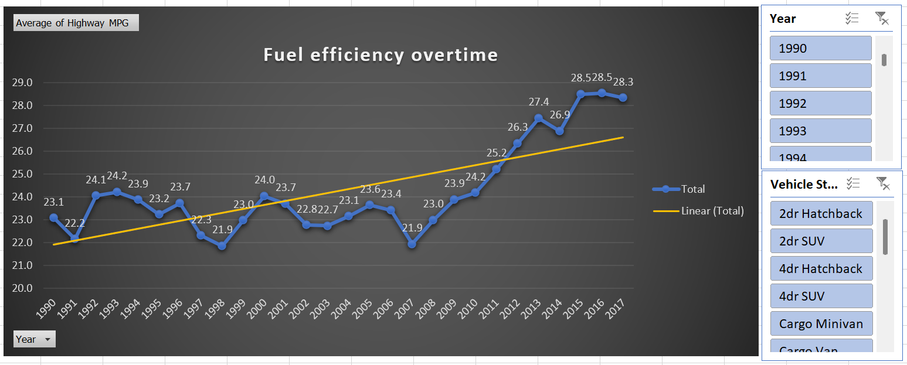

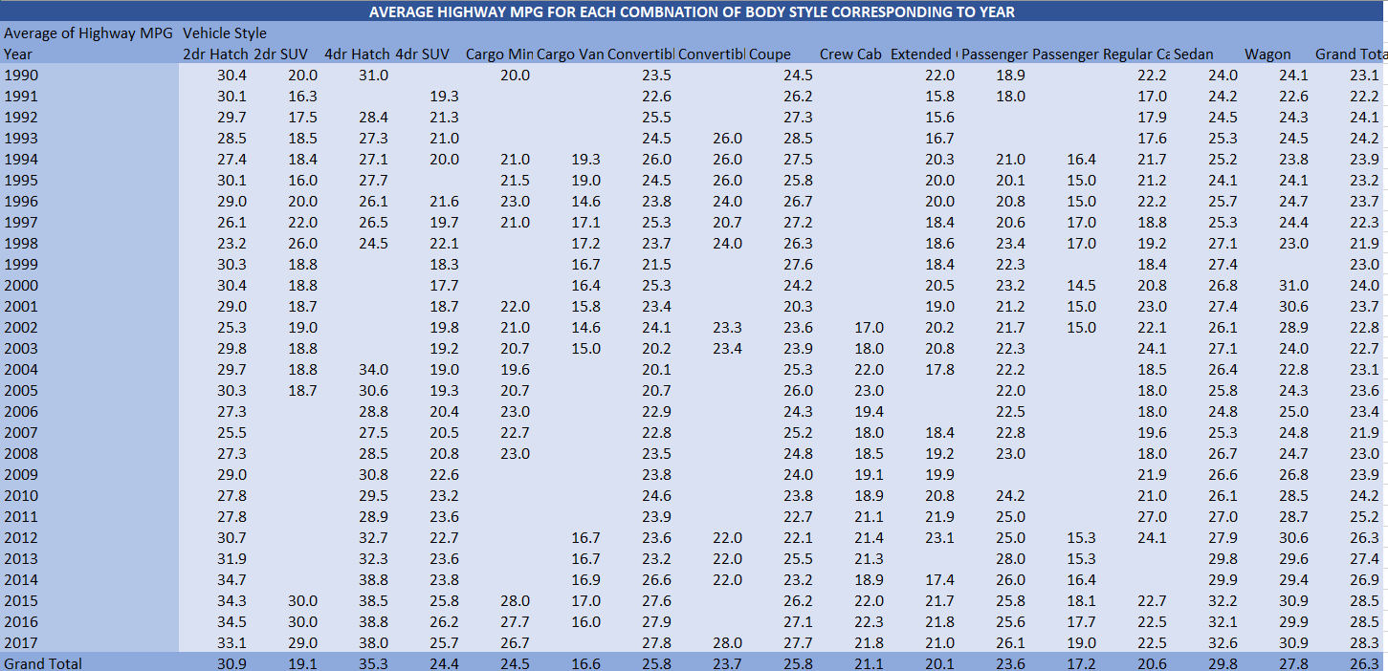

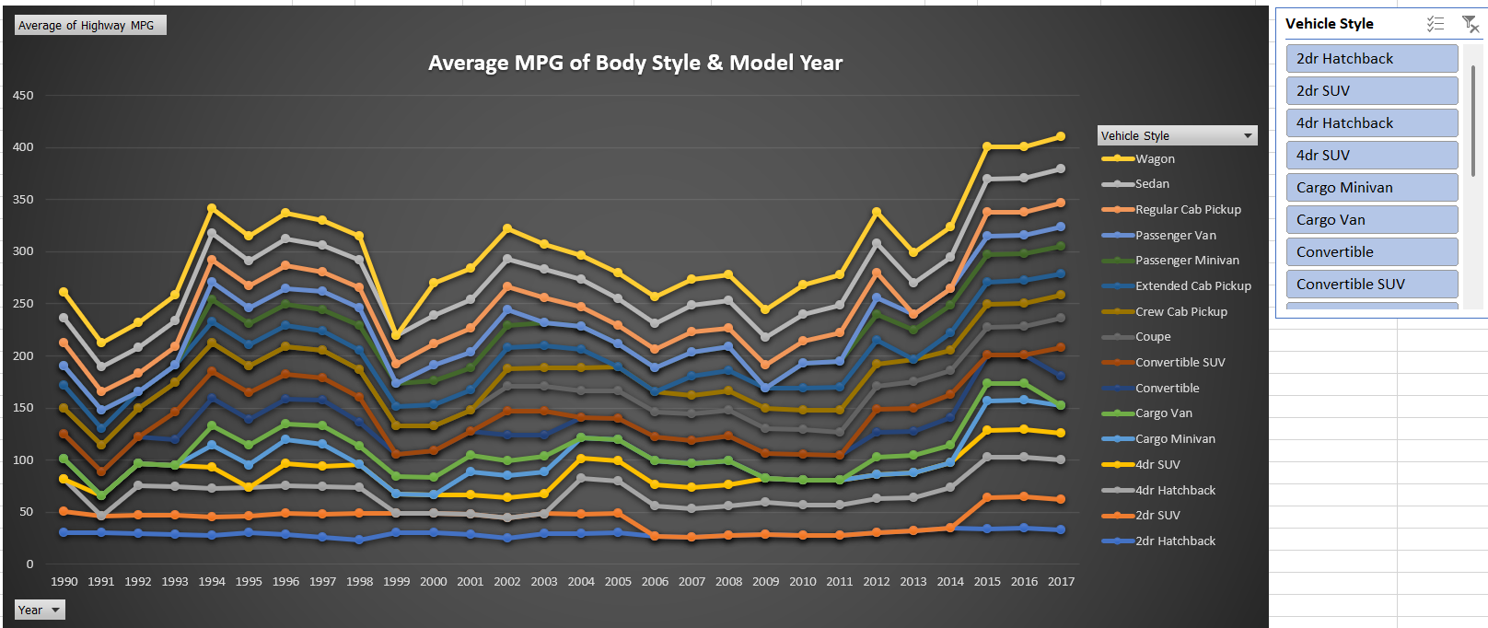

**Result:**

* Overall fuel efficiency has increased after 2007 at slower rate.
* Car’s fuel efficiency range as per the body type and model years. It can be seen that different body style have impact on fuel efficiency.
* As most efficient engines have been developed by automakers which later improves fuel economy.
* As the year passes the manufacturer improves their design and use of technology so it is observed that there is seen the increase in fuel economy after 2007.

**Task 5:** How does the car's horsepower, MPG, and price vary across different Brands?

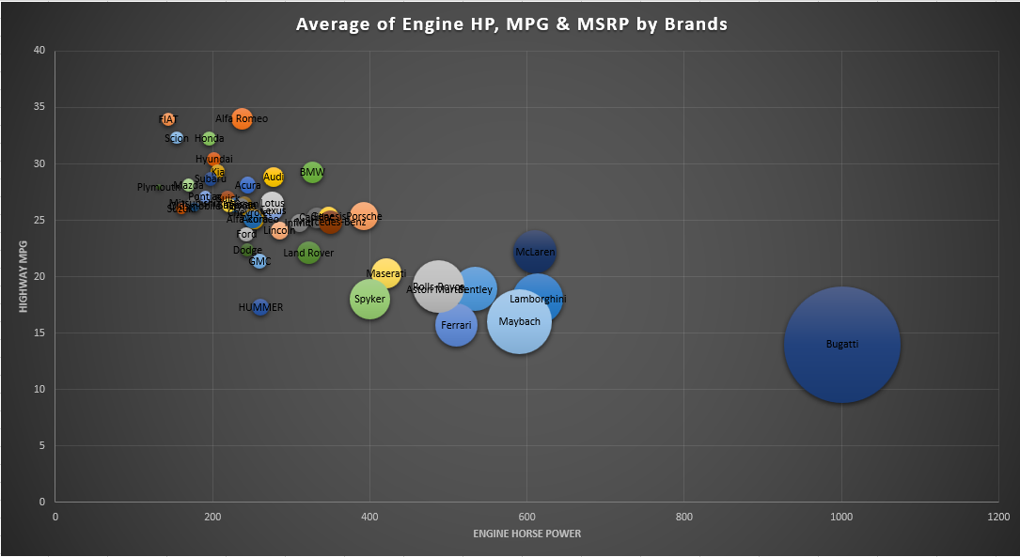

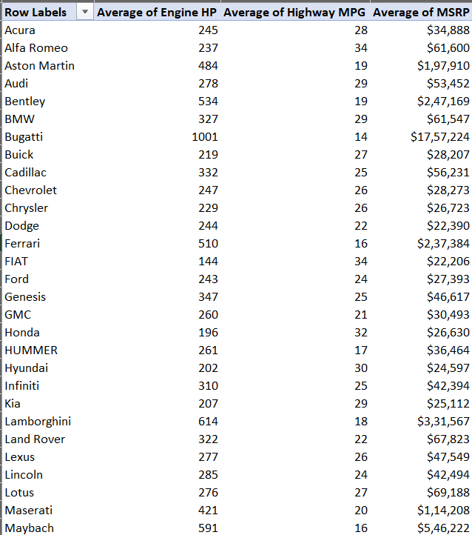

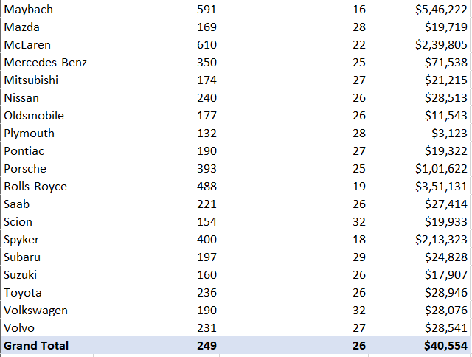

**Result:**

* It is observed as the engine horse power increases the highway MPG decreases and the price goes up.
* It helps us to see how different manufacturers design and price their vehicles.
* Such as Bugatti, Maybach, Lamborghini have high performance automobiles. This brands manufacturers mainly focuses on acceleration, speed and track performance. It provides varied horsepower numbers.
* On the other hand large amount of manufacturers focuses on mass market such as Toyota, Honda, and ford as they mainly focuses on utility and fuel economy.
* There are two types of automakers one is luxury which are like Rolls Royce, Bently, Bugatti and many more this focuses on creating expensive automobiles that have cutting edge technology.
* And the another one is mainstream brands which includes Toyota, Honda, Ford and many more this all provides affordable options and also offers higher end priced models with advanced features which offers varied price range.

**Dashboard**

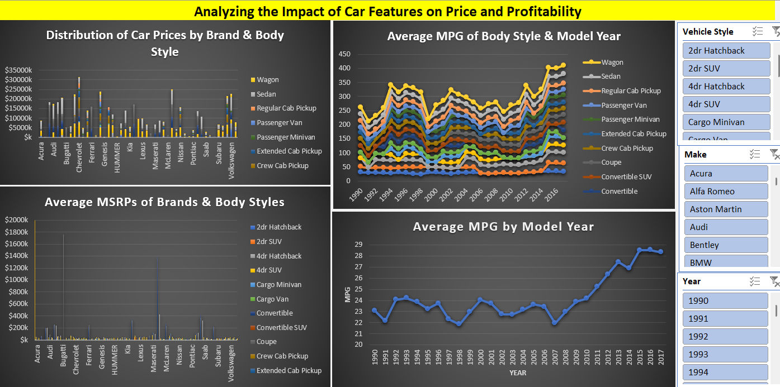

**Result:**

This interactive dashboard helps stakeholders to explore different aspects of dataset. It helps to visualize distribution of car prices by brand and body style, average MSRPs of brands and body styles, average MPG by model year and average MPG of body style and model year. This helps to understand the relationship between horsepower, MPG and price across different car brands. This information helps the manufacturers to make informed decisions of pricing, product development, marketing and competitiveness of market. Manufacturers by optimizing the factors as discussed can optimize maximum profitability while keeping in mind the needs of consumer demand.

**Drive Link**

[**https://docs.google.com/spreadsheets/d/184tjYBAI2fvyYnGquVBQgMvfo8xwjjnK/edit?usp=sharing&ouid=109001208060904860088&rtpof=true&sd=true**](https://docs.google.com/spreadsheets/d/184tjYBAI2fvyYnGquVBQgMvfo8xwjjnK/edit?usp=sharing&ouid=109001208060904860088&rtpof=true&sd=true)

**Loom Link**

[**https://www.loom.com/share/d6cf481072664eb09872f0d7243e3600**](https://www.loom.com/share/d6cf481072664eb09872f0d7243e3600)