**Project – 8**

**ABC Call Volume Trend Analysis**

**Project Description**

In this project we have done analysis of inbound call data for ABC Insurance Company, which focuses on optimizing call handling efficiency and improving customer service. The analysis is done by performing certain analysis which will give us useful insights. This begins by performing average call duration analysis which provides us insights into efficiency of call handling process throughout the day. Then using visualization call volume analysis is presented to show the trends in call over time. Then we have proposed a detailed manpower strategy which aims to reduce abandon rate to 10% this is done by calculating minimum number of agents required in each time bucket. Then at last we have address the issue of unanswered calls during night shifts, where also we have proposed manpower plan to make sure customer satisfactory experience. Overall this project highlights the assumptions, methodologies and recommendations, that provides actionable insights for ABC Insurance Company’s management team to optimize call centre operations and increase the customer satisfaction.

**Approach**

* We begin by importing and preprocessing the dataset.
* We then ensured that data is cleaned to have accurate outcomes and results.
* Then using descriptive statistics and visualization we have calculated the average call duration for each time bucket.
* For call volume analysis, using visualization through graphs we have plot the bar chart which shows the temporal distribution of call volume.
* Then after for we have plot the graph to display the phone number counts, ratio distribution and average call durations. This is done to present the manpower allocation plan for each time bucket which ensures adequate coverage to meet service level targets.
* Then we have analyzed the distribution of calls during night shift period. This helps to determine manpower requirements for calls to handle which maintains the abandon rate. This helps to propose manpower plan for night shift according to the availability and scheduling of the agents.

**Tech-Stack Used**

Microsoft® Word 2019 MSO (Version 2501 Build 16.0.18429.20132) 64-bit for data analysis, pivot table creation and chart generation.

**Insights**

1. **Average Call Duration**: Determine the average duration of all incoming calls received by agents. This should be calculated for each time bucket.

**Your Task**: What is the average duration of calls for each time bucket?

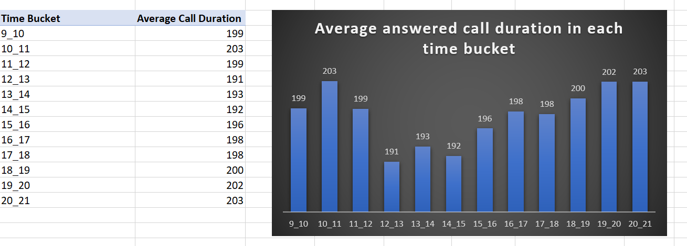

Highest Average Call Duration: 10_11

Lowest Average Call Duration: 12_13

1. **Call Volume Analysis:** Visualize the total number of calls received. This should be represented as a graph or chart showing the number of calls against time. Time should be represented in buckets (e.g., 1-2, 2-3, etc.).

**Your Task:** Can you create a chart or graph that shows the number of calls received in each time bucket?

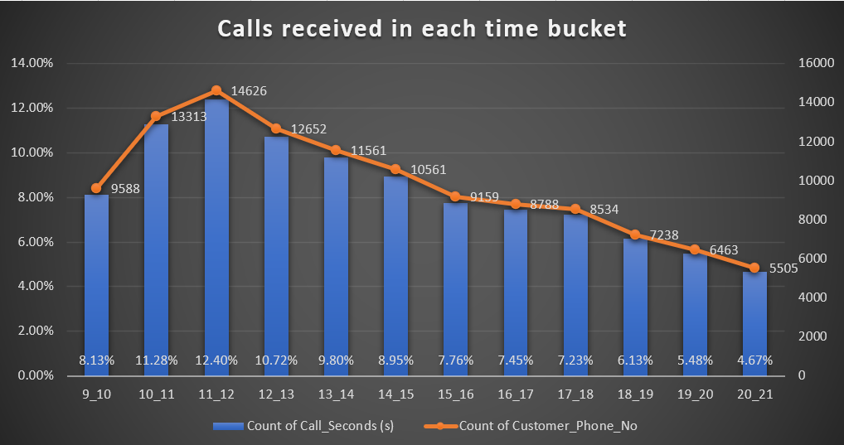

Max number of calls answered in duration: 11_12

Min number of calls answered in duration: 20_21

1. **Manpower Planning:** The current rate of abandoned calls is approximately 30%. Propose a plan for manpower allocation during each time bucket (from 9 am to 9 pm) to reduce the abandon rate to 10%. In other words, you need to calculate the minimum number of agents required in each time bucket to ensure that at least 90 out of 100 calls are answered.

**Your Task:** What is the minimum number of agents required in each time bucket to reduce the abandon rate to 10%?

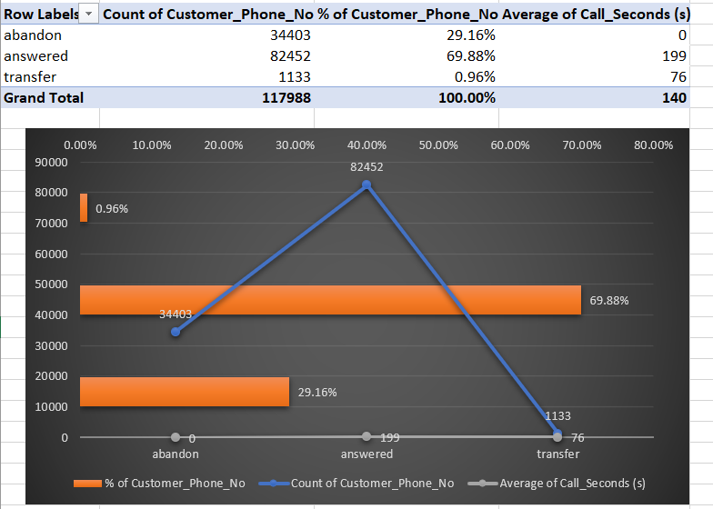

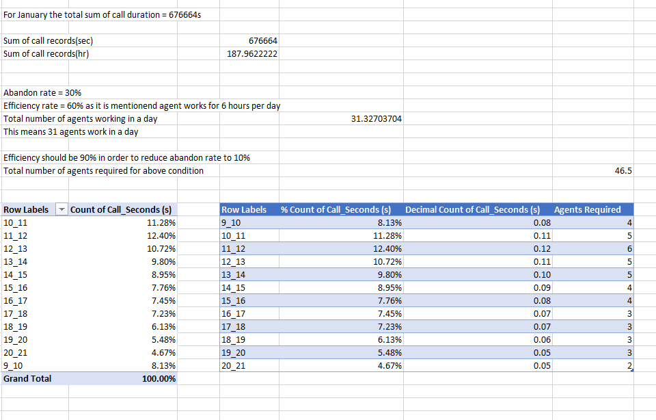

Total agents required to reduce the abandon rate to 10% is 47.

The distribution according to each hour is given in the table (agent required) column.

1. **Night Shift Manpower Planning:** Customers also call ABC Insurance Company at night but don't get an answer because there are no agents available. This creates a poor customer experience. Assume that for every 100 calls that customers make between 9 am and 9 pm, they also make 30 calls at night between 9 pm and 9 am. The distribution of these 30 calls is as follows:

**Your Task:** Propose a manpower plan for each time bucket throughout the day, keeping the maximum abandon rate at 10%.

**Assumptions:** An agent works for 6 days a week; On average, each agent takes 4 unplanned leaves per month; An agent's total working hours are 9 hours, out of which 1.5 hours are spent on lunch and snacks in the office. On average, an agent spends 60% of their total actual working hours (i.e., 60% of 7.5 hours) on calls with customers/users. The total number of days in a month is 30.



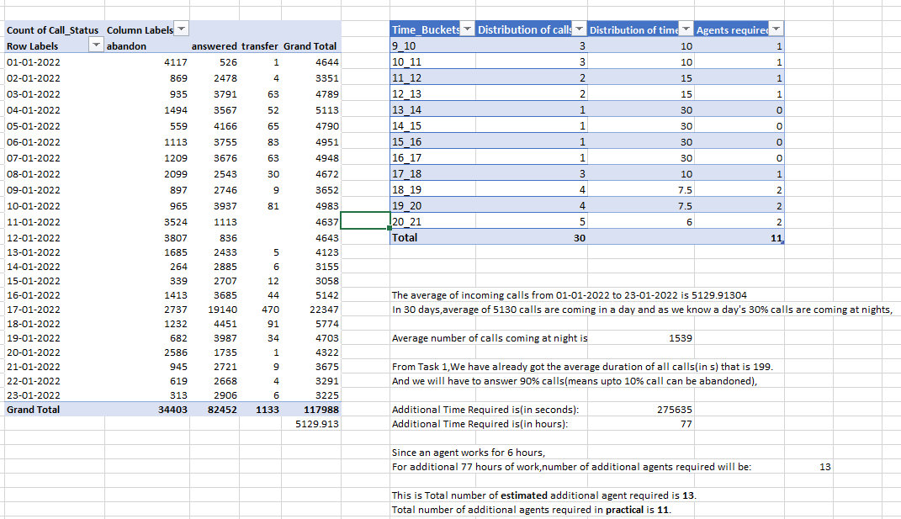

Total number of additional agents required is 11. Discrete number of agents required for each time interval from 9PM to 9AM is given in the table (agent required) column.

**Result**

In analyzing the inbound call data for ABC Insurance Company, we found that the average call duration varies across different time buckets throughout the day. Call volume follows a distinct pattern, with peaks and troughs corresponding to different hours. To reduce the abandon rate from 30% to 10%, we determined the minimum number of agents required during each time bucket, ensuring that at least 90 out of 100 calls are answered. Additionally, to address nighttime calls and provide a better customer experience, we proposed a manpower plan for each time bucket, maintaining the abandon rate at or below 10%. These solutions are based on specific calculations and assumptions regarding agent availability and call distribution patterns.

**Drive Link for Excel**

[**https://docs.google.com/spreadsheets/d/1WxiyxMxCuUH4O93kNWwY8RGBwE5aSdfU/edit?usp=sharing&ouid=109001208060904860088&rtpof=true&sd=true**](https://docs.google.com/spreadsheets/d/1WxiyxMxCuUH4O93kNWwY8RGBwE5aSdfU/edit?usp=sharing&ouid=109001208060904860088&rtpof=true&sd=true)

**Drive Link for Loom Video**

[**https://www.loom.com/share/b0048433361c4d148c21f1aef65ae9b6?sid=0dd2e282-f75f-40ff-8ebc-851bb75b75f2**](https://www.loom.com/share/b0048433361c4d148c21f1aef65ae9b6?sid=0dd2e282-f75f-40ff-8ebc-851bb75b75f2)