Agentic AI Engineering Handbook
From LLM Fundamentals to Production-Ready AI Agents
A practical engineering guide to designing, building, evaluating, governing and deploying production-grade AI agents.

Style note for import: `#` → Heading 1 (24pt), `##` → Heading 2 (18pt), `###` → Heading 3 (14pt), body text → Normal (11–12pt, Arial). Import via Google Docs → File → Open → Upload, or convert via the accompanying `.docx` build. Code fences render as monospace blocks.
Sourcing note: This handbook is original content written to cover the same concept areas as general agentic-AI engineering literature and newsletters (including works like "Agentic AI Design Patterns" and the ByteByteGo Newsletter). No text or images are reproduced from those or any other copyrighted, paywalled sources — see the Further Reading appendix (Part VI) to consult them directly. The recurring Invoice Explainability Agent case study is a fully original, generic teaching example, not a reproduction of any company's internal system.

Table of Contents
Part I — Foundations
- Introduction
- AI vs LLM vs Agent
- SLM vs LLM
- Evolution of Agentic AI
- Agent Anatomy
- Mental Models
Part II — The 13 Core Topics
- Prompting & Context Engineering
- Tool Use & Function Calling
- Agent Loop
- State & Memory
- Retrieval-Augmented Generation (RAG)
- Planning & Task Decomposition
- Multi-Agent Orchestration
- LangGraph & State Machines
- Guardrails & Hallucination Prevention
- Human-in-the-Loop & Human-on-the-Loop
- Evaluation & LLM-as-Judge
- Observability
- Deployment & Production Architecture
Part III — Production Engineering
APIs · FastAPI · Authentication · Authorization · Rate Limiting · Observability · Logging · Decision Logs · Auditability · Governance · Policy Engine · Human-in-the-Loop · Human-on-the-Loop · Evaluation · Deployment
Part IV — Case Study: Invoice Explainability Agent
V1 Prompt-only → V2 +Tools → V3 +Memory → V4 +RAG → V5 +Guardrails → V6 +Evaluation → V7 Production Deployment
Part V — Portfolio Projects
Flowise Agent · Tool-Calling Agent · RAG Agent · Uber-like Ride Agent · Paytm-like Payments Agent · LangGraph Agent · FastAPI Agent · Evaluation Pipeline · Guardrails Project · Production Architecture
Part VI — Interview Preparation & Appendix
Per-chapter interview banks (Senior/Staff/Architecture/Follow-ups) · Glossary · Further Reading

Part I — Foundations

Chapter 1 — Introduction

Why This Chapter Exists
Before writing a single line of agent code, you need a shared vocabulary and a shared reason to care. This chapter sets the frame: what problem class agentic AI actually solves, who this handbook is for, and how to read it so it compounds rather than overwhelms.

Learning Objectives
By the end of this chapter you should be able to:
- State, in one sentence, what an AI agent adds on top of a raw LLM call.
- Explain why "agentic AI" became viable now rather than five years ago.
- Describe how this handbook is organized and how to use it for teaching, interviews, and production work.

Fundamental Concepts
- The automation spectrum: from static rules → configurable workflows → ML-assisted decisions → autonomous agents. Agentic AI is the newest, most flexible, and most operationally demanding point on this spectrum.
- Why now: reliable structured function calling, long and cheap context windows, and mature orchestration frameworks converged to make agents production-viable rather than a research demo.
- The three audiences this handbook serves: the learner building foundational understanding, the engineer shipping a real system, and the candidate preparing for an interview — every chapter speaks to all three.

Architecture Diagram — The Automation Spectrum
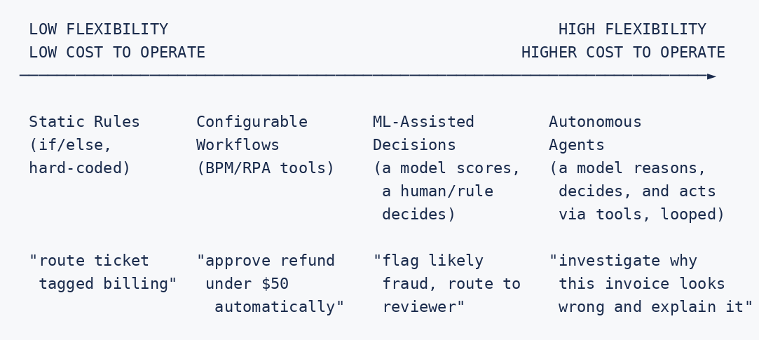

Example
A support team currently classifies incoming tickets with hand-written keyword rules ("contains 'refund' → billing queue"). This breaks constantly on phrasing the rules didn't anticipate. Moving one step right on the spectrum (an ML classifier) fixes classification accuracy but still can't investigate anything. Only an agent — one that can call a billing API, a trip API, and reason over both — can answer "why is this specific invoice wrong," because the number of possible root causes is too large to enumerate as rules or as a fixed classifier's label set.

Interview Questions
- In one sentence, what does an agent add on top of a plain LLM API call?
- Why did agentic AI become practically viable only in the last few years, and not the exact moment LLMs were first available?
- Give an example of a task you would not turn into an agent, and explain why a simpler solution is correct.
- Follow-up (Staff level): How would you convince a team building rule-based automation to invest in an agent instead — what evidence would you require before recommending that migration?

Hands-on Lab
#### No-Code Exercise (Flowise or Dify — both have free tiers)
- Build the fixed-rule baseline. In Flowise, build a simple 3-node flow: input → LLM node with a prompt hard-coded to classify into exactly two categories ("billing" or "other") → a Condition node routing each category to a different fixed text response. Test it against 5 sample support messages, including at least one that's clearly a third category (e.g., "I want to delete my account"). Record which ones get force-fit into the wrong bucket.
- Repeat in Dify. Recreate the same flow as a Dify "Workflow" app (free self-host or cloud sandbox plan). Note any differences in how each tool visualizes the fixed branching — this comparison is useful later when you pick a Tier-1 tool for your own projects.
#### Code Exercise (Python)
- Write a ~10-line Python function using a plain if/elif router that mimics the same fixed 2-category classification. Feed it the same 5 messages used above and confirm it fails on the same third-category message in the same way — proving the failure is structural (fixed branching), not tool-specific.

Summary
Agentic AI is the newest point on a long-running automation spectrum, justified specifically when the decision space is too large or dynamic for rules or a fixed classifier. This handbook is built to serve three simultaneous goals — teaching, production reference, and interview prep — and every chapter from here on reflects that in its structure.

Chapter 2 — AI vs LLM vs Agent

Why This Chapter Exists
These three terms get used interchangeably in casual conversation and incorrectly in interviews. Precision here prevents architecture mistakes later — e.g., reaching for "agent" complexity when you actually just need a well-prompted LLM call.

Learning Objectives
- Precisely define AI, LLM, and Agent as nested-but-distinct concepts.
- Identify, given a system description, which of the three it actually is.
- Explain the specific capability jump from "LLM" to "Agent."

Fundamental Concepts
Term | Definition | Analogy
AI | The broad field: any system that performs tasks normally requiring human intelligence (includes symbolic AI, classic ML, deep learning, LLMs). | The entire discipline of medicine.
LLM | A specific class of AI model: a large neural network trained on text (and often other modalities) to predict/generate language, used as a single-shot or per-turn reasoning engine. | A specialist doctor — deeply capable in their domain, but only when consulted.
Agent | A system built around one or more LLMs, adding a loop, tools, memory, and goal-directed control flow so it can act, not just respond. | A case manager who consults the specialist doctor repeatedly, orders tests (tools), keeps a patient file (memory), and drives the case to resolution.

The critical distinction: an LLM is stateless and reactive per call — it has no loop, no memory, and cannot act on the world by itself. An agent wraps an LLM (or several) in infrastructure — orchestration, tools, state — that the LLM itself does not provide.

Architecture Diagram
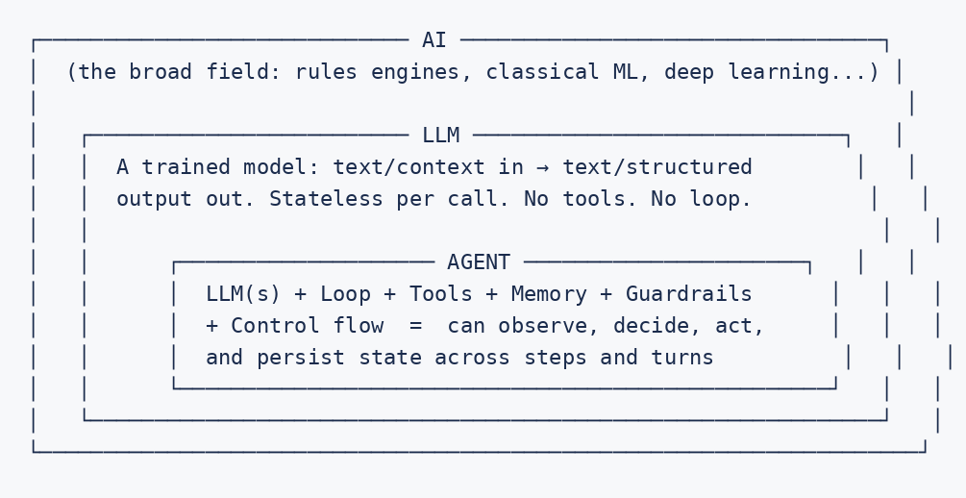

Example
- AI, not LLM, not agent: a decision tree that scores loan applications based on hand-engineered features.
- LLM, not agent: a single API call that summarizes a document — one shot, no memory, no tools, done.
- Agent: a system that reads the same document, decides it needs to cross-check a fact against a live database (tool call), remembers this conversation's prior corrections (memory), and iterates until confident (loop) before returning a final, cited summary.

Interview Questions
- Is a fine-tuned BERT classifier an "agent"? Justify your answer precisely.
- What specific capabilities does an agent add that a raw LLM call by definition cannot provide?
- Can a system be "AI" and explicitly not involve an LLM at all? Give an example.
- Follow-up (Architecture level): You're asked to add "agentic capabilities" to an existing LLM-powered chatbot. What is the minimum set of infrastructure additions required, and in what order would you add them?

Hands-on Lab
#### No-Code Exercise (Flowise or Dify)
- Bare LLM (no agent). In Dify, create a single-prompt "Chatbot" app (just one LLM node, no tools) and ask it to "look up and confirm today's exchange rate between USD and INR." Observe that it answers confidently without actually checking anything live — this is the LLM layer alone.
- Add the agent layer. In Flowise, build a "Tool Agent" node with one real Custom Tool (a web-search or HTTP-request node — Flowise's free tier includes a search-tool integration) and ask the identical question. Compare the two answers side by side and note exactly which capability (tool use + decision-to-act) closed the gap.
#### Code Exercise (Python)
- Implement both versions in ~20 lines of Python: (a) one bare llm.chat(question) call, and (b) the Chapter 1-style loop wrapping the same LLM with one tool (e.g., a mock or real exchange-rate lookup function). Log both outputs and write one sentence stating which layer (AI, LLM, or Agent) each version demonstrates.

Summary
AI is the field, LLM is a specific reactive model type within it, and an agent is a system built around one or more LLMs that adds looping, tool use, memory, and control flow. Confusing these three in an interview or an architecture review is one of the fastest ways to signal you haven't built one for real.

Chapter 3 — SLM vs LLM

Why This Chapter Exists
Not every node in an agent's graph needs the biggest, most expensive model. Understanding when a Small Language Model (SLM) is the better engineering choice — not just the cheaper one — is core to building cost-effective, low-latency production agents (this connects directly to Part II's cost/model-tiering material).

Learning Objectives
- Define SLM vs LLM along parameter count, deployment footprint, and capability trade-offs.
- Map agent sub-tasks to the model size that actually fits them.
- Explain the risk of both over-provisioning (cost/latency waste) and under-provisioning (accuracy loss) model size.

Fundamental Concepts
Dimension | SLM (Small Language Model) | LLM (Large Language Model)
Typical scale | Millions to a few billion parameters | Tens of billions to trillions of parameters
Deployment | Can run on-device, on modest hardware, or cheaply at high concurrency | Typically served via API or large GPU clusters
Latency | Very low | Higher, though provider-optimized
Cost per call | Low | Higher
Strength | Narrow, well-defined tasks: classification, extraction, short structured generation | Broad reasoning, nuanced synthesis, open-ended generation, complex multi-step inference
Weakness | Struggles with genuinely novel, ambiguous, multi-step reasoning | Costlier and slower for high-volume, simple sub-tasks

Architecture Diagram — Model Tiering Inside One Agent
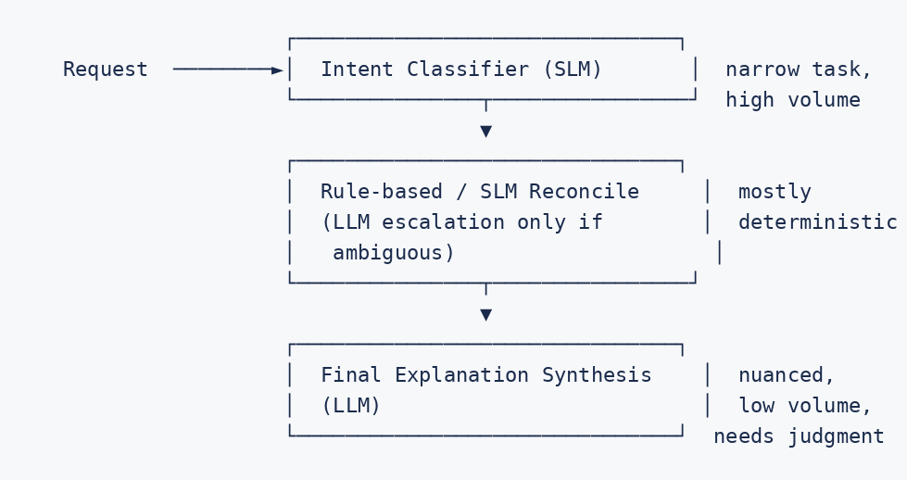

Example
In the Invoice Explainability Agent, classifying "is this a billing question, an account question, or something else?" is a narrow, high-volume, well-bounded task — a strong candidate for an SLM. Composing the final, empathetic, precisely-worded explanation of a nuanced discrepancy is exactly where an LLM's broader reasoning and language quality earn their cost.

Interview Questions
- Give two concrete sub-tasks inside a typical agent that are well-suited to an SLM, and explain why.
- What's the risk of using an SLM for every step "to save cost"? Give a concrete failure mode.
- How would you validate that an SLM swap for a given node doesn't regress accuracy?
- Follow-up (Senior level): A teammate proposes replacing your agent's final synthesis step with an SLM to cut cost by 80%. What evidence would you ask for before agreeing, and what would you measure after the change ships?

Hands-on Lab
#### No-Code Exercise (Flowise or Dify)
- Side-by-side model tiering. In Dify, configure two versions of the same "classify this support ticket" prompt as separate app instances — one pointed at the smallest/fastest model your free plan offers, one at the largest. Run the same 10 sample tickets through both and record accuracy and the response-time shown in Dify's built-in logs.
- Tiered pipeline in one flow. In Flowise, chain a small/fast model node (intent classification) into a larger model node (final response drafting) within a single flow, and use Flowise's trace/debug panel to inspect the per-node latency it reports — confirming the classification step really is cheaper and faster than the drafting step.
#### Code Exercise (Python)
- Programmatically call both a small and a large model tier via API for the same 10 classification inputs, logging latency, token count, and (if available) cost per call. Produce a small comparison table and a one-paragraph recommendation on which tier to use for this task, backed by your numbers.

Summary
SLM vs LLM is not "cheap vs good" — it's matching model capability to task difficulty. Production agents are model-tiered: SLMs handle narrow, high-volume, well-bounded steps; LLMs are reserved for genuinely open-ended reasoning and synthesis.

Chapter 4 — Evolution of Agentic AI

Why This Chapter Exists
Understanding why agent architectures look the way they do today — as a response to specific limitations of what came before — makes the current patterns feel inevitable rather than arbitrary, and prepares you to reason about what comes next.

Learning Objectives
- Trace the rough progression from single-shot prompting to autonomous multi-agent systems.
- Identify what specific limitation each stage's innovation was solving.
- Situate today's frameworks (LangGraph-style state machines) as a response to earlier hand-rolled loop fragility.

Fundamental Concepts
- Stage 1 — Single-shot prompting: one prompt, one response. No memory, no tools, no iteration. Limitation: can't act, can't correct itself, can't use fresh information.
- Stage 2 — Chain-of-thought & prompt chaining: multiple prompts stitched together manually, each feeding the next. Limitation: fixed sequence, brittle to novel branching needs.
- Stage 3 — ReAct-style reasoning loops + tool use: the model interleaves reasoning with real tool calls, observing actual results. Limitation: hand-rolled loops become unmanageable and untestable as complexity grows.
- Stage 4 — Graph/state-machine orchestration: typed state, explicit nodes and conditional edges, checkpointing (LangGraph-style). Limitation solved: inspectability, partial testing, and safe resumability — but single-agent complexity ceilings remain.
- Stage 5 — Multi-agent systems: specialist agents coordinated by a supervisor or peer-to-peer handoff, for problems too broad for one well-scoped agent.

Architecture Diagram — Evolution Timeline
Stage 1 Stage 2 Stage 3 Stage 4 Stage 5
Single-shot → Prompt Chaining → ReAct Loop + Tools → Graph/State Machine → Multi-Agent
prompting (manual multi- (reason ⇄ act ⇄ (typed state, Systems
step prompts) observe, repeated) conditional edges, (supervisor +
checkpointing) specialists)
"summarize "extract, then "figure out why "the same loop, "billing +
this doc" classify, then this invoice looks but inspectable, fraud + account
draft a reply" wrong" testable, resumable" specialists,
coordinated"

Example
Early customer-support bots (Stage 1-2) could draft a reply but couldn't verify anything against a live system. Stage 3 added tool calls so the bot could actually fetch a real order status. As those hand-rolled loops grew unwieldy — nested if-statements tracking "have we already tried X" — teams moved to Stage 4's explicit graph abstraction specifically to make the control flow reviewable. Stage 5 emerged once single agents accumulated so many unrelated tools/responsibilities that specialization became more maintainable than one generalist.

Interview Questions
- What specific limitation of prompt chaining does a ReAct-style loop solve?
- Why did the industry move from hand-rolled reasoning loops to explicit graph/state-machine frameworks? Name the concrete pain point.
- What problem does multi-agent orchestration solve that a single, well-tooled agent cannot?
- Follow-up (Architecture level): If a new paradigm emerged after multi-agent systems, what limitation of multi-agent systems would it most likely be solving? Reason from first principles, not speculation about specific products.

Hands-on Lab
#### No-Code Exercise (Flowise or Dify)
- Recreate Stage 2 (prompt chaining). In Dify's Workflow builder, chain three fixed LLM nodes: extract → classify → draft reply, each node's output feeding the next. Run 5 sample support messages through it.
- Recreate Stage 3 (ReAct-style loop). In Flowise, rebuild the same three capabilities as three Tools exposed to one Tool Agent node instead of a fixed chain. Feed it one input that doesn't fit the fixed extract→classify→draft order (e.g., a message that needs clarification before classification makes sense) and compare how each tool handles it — the fixed chain in Dify should visibly struggle or produce a nonsensical output where the agent in Flowise can reorder or skip steps.
#### Code Exercise (Python)
- Implement the same comparison in Python: a hardcoded 3-function pipeline (Stage 2) vs. the Chapter 1 ReAct-style loop reusing those same three functions as tools (Stage 3). Run both against the same "breaks the fixed order" input and print both outputs side by side.

Summary
Each stage in agentic AI's evolution exists because the prior stage hit a concrete wall: single-shot prompting can't act, chaining can't branch, hand-rolled loops can't be reviewed at scale, and single agents eventually run out of coherent scope. Knowing why, not just what, is what lets you reason about new patterns you haven't seen yet.

Chapter 5 — Agent Anatomy

Why This Chapter Exists
Before diving into the 13 core topics individually, you need the assembled picture: what are the named parts of a production agent, and how do they fit together. This chapter is the map; Part II is the territory.

Learning Objectives
- Name and define every major structural component of a production agent.
- Explain the data flow between components for a single request.
- Use this anatomy as a checklist when designing a new agent.

Fundamental Concepts
- Reasoning core: the LLM(s) making decisions at each step.
- Orchestration layer: the loop/graph controlling what happens next (Chapters covering Agent Loop, LangGraph).
- Tool layer: the mechanism for taking real action or fetching real data.
- Memory layer: short-term (this conversation) and long-term (across sessions) state.
- Knowledge layer: retrieval (RAG) grounding responses in real documents.
- Guardrail layer: input/output/structural safety controls.
- Human interface layer: HITL/HOTL checkpoints.
- Evaluation layer: offline/online quality measurement.
- Observability layer: tracing, logging, decision logs.
- Deployment layer: how it's served, scaled, and versioned.

Architecture Diagram — Full Agent Anatomy
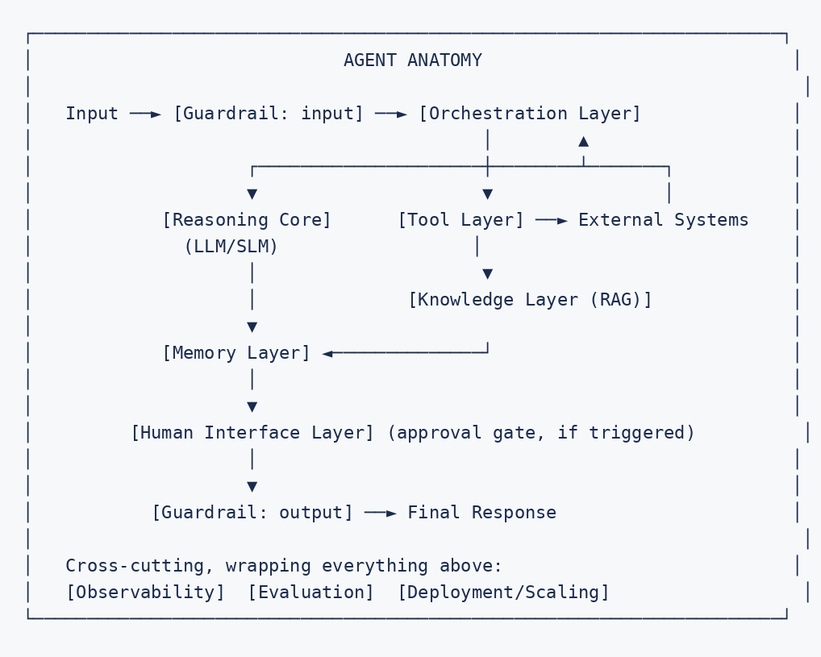

Example
Walking a single Invoice Explainability Agent request through this anatomy: input guard checks RBAC → orchestration routes to intent classification (reasoning core, SLM) → tool layer fetches billing + trip records → knowledge layer retrieves the relevant surcharge policy → memory layer supplies the user's stated preference from a prior session → reasoning core (LLM) synthesizes an explanation → output guard checks grounding → response returned. Every step is traced; the whole request was scored offline against a golden dataset before this code path was ever deployed.

Interview Questions
- List every layer in a production agent's anatomy and, for each, name one thing that breaks if it's missing entirely.
- Which layers are "cross-cutting" (apply to every request) rather than sitting inline in the request path?
- If you had to cut one layer under extreme time pressure for a v1 launch, which would you cut, and what risk would you explicitly accept?
- Follow-up (Staff level): Design review scenario — a colleague's agent design has no observability layer "because we'll add it after launch." What specific argument would you make, with a concrete scenario, for why that's the wrong sequencing?

Hands-on Lab
#### No-Code Exercise (Flowise or Dify)
- Build the anatomy as a real flow. In Flowise, build one flow for a simple support-agent use case that includes at least 5 distinct anatomy layers as separate nodes: an LLM node (reasoning core), a Custom Tool node (tool layer), a Buffer Memory node (memory layer), a Retriever node (knowledge layer), and a Moderation node (guardrail layer). Label each node in the canvas with which anatomy layer it represents.
- Map a prebuilt template. In Dify, open a prebuilt "Agent" app template and walk through its configuration panels (Model, Tools, Knowledge, Memory, Moderation). For each panel, write down which anatomy layer from this chapter it corresponds to — this trains you to read any new tool's UI through this handbook's shared vocabulary.
#### Code Exercise (Python)
- Scaffold the same anatomy as separate Python functions or files (one per layer: reasoning_core.py, tools.py, memory.py, knowledge.py, guardrails.py) with TODO bodies matching the Chapter 5 diagram. This becomes your project skeleton for Part II — you'll fill these in chapter by chapter.

Summary
A production agent is not "a prompt with tools bolted on" — it's a layered system: reasoning core, orchestration, tools, memory, knowledge, guardrails, human interface, evaluation, observability, and deployment. Missing any layer isn't a simplification, it's a specific, nameable risk you're accepting.

Chapter 6 — Mental Models

Why This Chapter Exists
Mental models are the compressed intuitions that let you reason about a new, unfamiliar agent design quickly, without re-deriving everything from first principles. This chapter collects the handbook's core analogies in one place for fast recall — especially useful right before an interview.

Learning Objectives
- Recall each core mental model on demand and apply it to a novel scenario.
- Use mental models to communicate agent design decisions to non-technical stakeholders.

The Handbook's Core Mental Models
Concept | Mental Model
Agent reasoning loop | A detective interrogating a case file — each thought is a hypothesis, each tool call is a request for evidence.
Context engineering | A whiteboard with limited space — every fact you add pushes the model's attention thinner across everything else.
Tool design | Onboarding a new contractor who has never seen the conversation — the tool's name and description are their entire briefing.
Memory | A notepad (short-term) and a filing cabinet (long-term) — not everything on the notepad is worth filing.
RAG | A librarian you can go back and forth with, not a card catalog memorized once and never questioned.
Planning | A project manager's task list vs. pure improvisation — use the task list when the structure is knowable up front.
Multi-agent orchestration | A call center router transferring calls to specialist queues, with a general fallback queue for anything unclassifiable.
LangGraph / state machines | A subway map — stations do one job, tracks define legal routes, switches decide the route based on what's aboard.
Guardrails | Seatbelts and airbags, not a better driver — assume the model will occasionally misbehave and contain the damage structurally.
Human-in-the-loop | A junior employee drafts the memo; a manager signs off before it's sent, for anything consequential.
Evaluation | A flight simulator before real flights, and a black-box flight recorder once flying live.
Cost/latency tiering | Airline seating class assignment — route each sub-task to the cheapest resource that can still do that specific job correctly.
SLM vs LLM | A generalist specialist doctor (LLM) vs. a fast triage nurse (SLM) — use the nurse for triage, the specialist for diagnosis.

Architecture Diagram — How Mental Models Chain Together
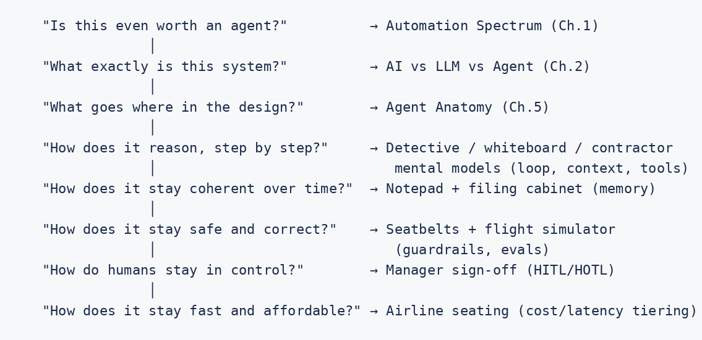

Example
When asked in an interview "design an agent for X," running through the mental-model chain above — spectrum check, definition check, anatomy sketch, then loop/memory/RAG/guardrail/eval/HITL/cost — gives you a repeatable, complete answer structure under time pressure, instead of freezing on where to start.

Interview Questions
- Pick any two mental models from the table and explain how they interact in a single real request (e.g., context engineering and memory).
- Which mental model would you use to explain guardrails to a non-technical stakeholder, and why does that framing work better than a technical explanation?
- Follow-up (Architecture level): Propose a mental model of your own for a concept not listed here (e.g., prompt caching, canary deployment) and defend why it's an accurate compression of the underlying mechanism, not just a cute analogy.

Hands-on Lab
#### No-Code Exercise (Flowise or Dify)
- Annotate a real template. Open any prebuilt agent template in Flowise or Dify (most free tiers ship a few starter templates — e.g., a customer-support bot or a research assistant). For every node in it, write down which of the 13 mental models from this chapter best explains that node's purpose. If a node doesn't map cleanly to any mental model, that's worth flagging — it may be doing more than one job.
- Recall without notes. Without looking at the table, write all 13 mental models from memory with a one-line explanation each, then check yourself against the chapter — this is the fastest pre-interview refresher in the whole handbook.
#### Code Exercise (Python)
- Add a one-line docstring to each function in your Chapter 5 anatomy skeleton, phrased using that layer's mental model (e.g., the memory module's docstring should reference "notepad vs. filing cabinet"). This makes the skeleton self-documenting in the handbook's shared vocabulary before you implement it in Part II.

Summary
Mental models are the fast-recall layer on top of the detailed mechanics in the rest of this handbook. Master the table above and you have a reliable, repeatable structure for explaining or designing any agent under time pressure — in a classroom, a design review, or an interview.

End of Part I. Part II (The 13 Core Topics, each following the full enterprise chapter template: Why it exists → Learning objectives → Fundamental concepts → Architecture diagrams → Internal workflow → Build from scratch → Flowise implementation → Python implementation → LangGraph implementation → Common mistakes → Production considerations → Interview questions → Hands-on lab → Summary) will follow in the next delivery phase.

