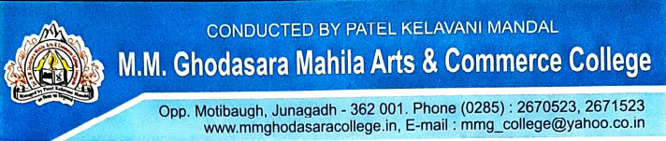

Certificate
BCA SEM – V
(Year :2026-27)
This is certify that the project report entitled “Golden Crust Cake’s” submitted to Bhakta Kavi Narsinh Mehta University-Junagadh in partial fulfilment of the requirement for the award of the degree of Bachelor of Computer Application (B.C.A.), is an authentic and original work carried out by Degama Bansi ,Sasiya Riddhi , Rathod Riya under our guidance.

The matter embodied in this project is genuine work done by the student and has not been submitted whether to this University or to any other University / Institute for the fulfilment of the any course of study.

Principal
[Dr. D. A. Dadhania]

H.O.D. Project Guide
[Dr. Raksha K. Buthani] [Dr. Raksha K. Buthani]

